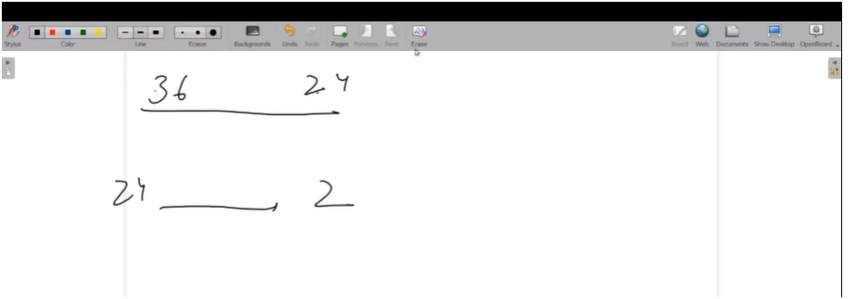

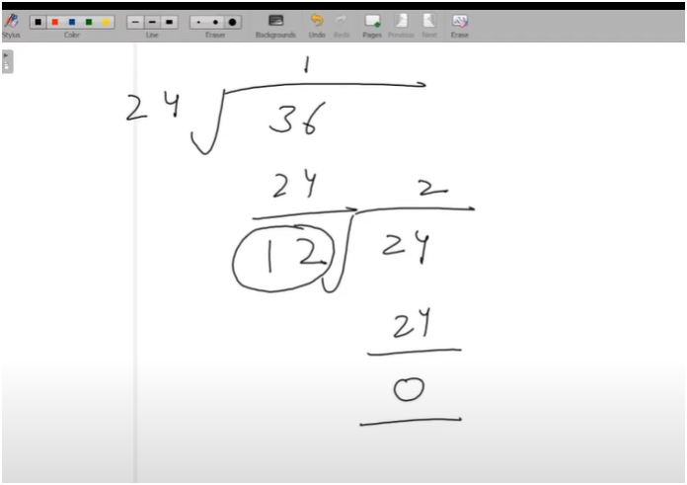

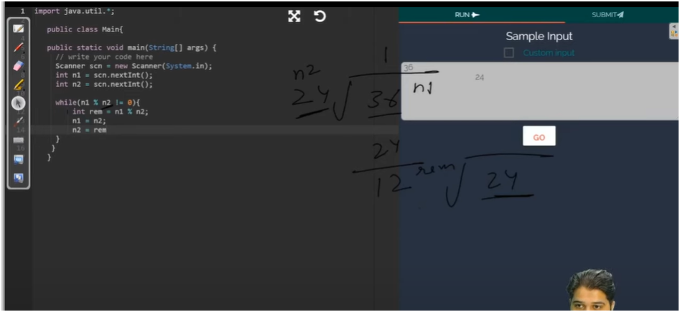

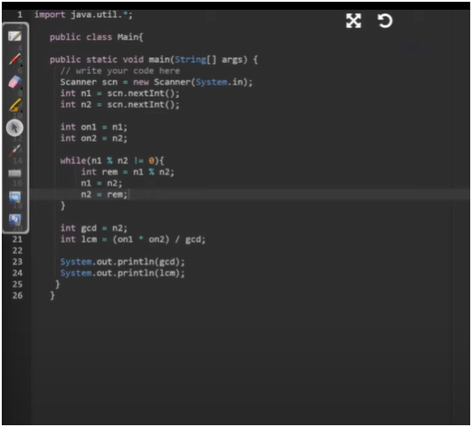



JUST TAKE IT AS ROUGH

**ALGO:-**

**TAKE TWO NUMBERS:-**

**NOW DIVIDE BOTH NUMBERS ONE WHICH DIVIDE IS DIVISOR AND ON WHICH WE ARE DOING THIS IS QUESTION AND SAVE THE RESULT TO REMAINDER**

**NOW MAKE FIRST NUMBER AS DIVISOR**

**NOW MAKE SECOND NUMBER AS REMAINDER**

**NOW GCD IS UR LAST REMAINDER**

**AND LCM IS MULTIPLICATION OF TWO ORIGINAL NUMBERS DIVIDE BY GCD**

**📌 SUMMARY:**

**\* This program calculates the GCD (Greatest Common Divisor) and LCM (Least Common Multiple)**

**\* of two given numbers using the Euclidean Algorithm.**

*

* ✅ STEPS:

* 1. Take two numbers as input.

* 2. Store the original values for LCM calculation.

* 3. Use a loop to apply Euclidean Algorithm:

* - Divide the larger number by the smaller one.

* - Save the remainder.

* - Replace the larger number with the smaller one.

* - Replace the smaller one with the remainder.

* - Repeat until remainder becomes 0.

* 4. The last non-zero number is the GCD.

* 5. Use the formula: LCM = (original_n1 * original_n2) / GCD

* 6. Print both GCD and LCM.

*

**🧠 Tip:**

**- GCD helps find common factors.**

**- LCM helps find a common multiple for timing or syncing problems.**