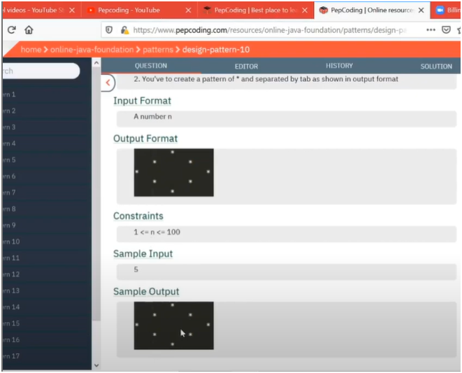

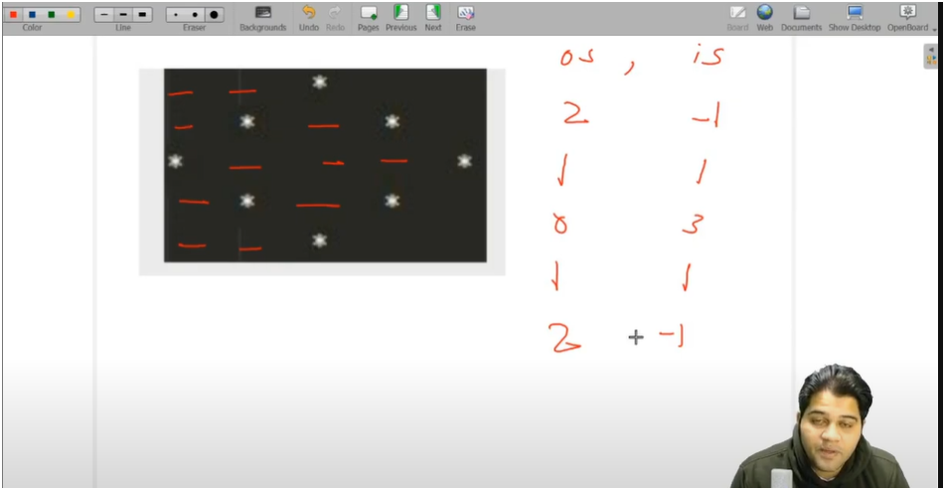

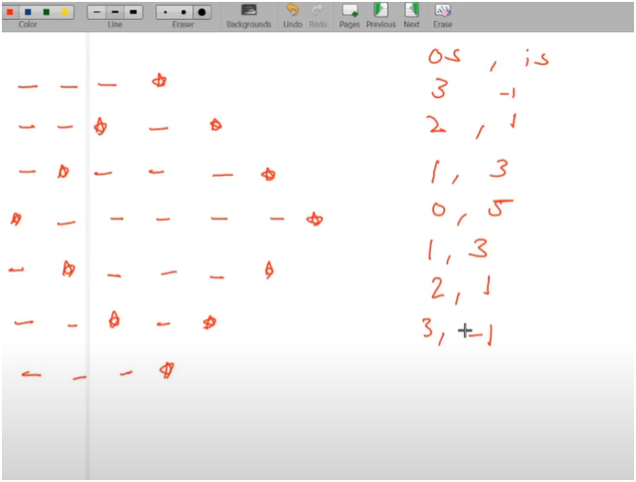

**UNDERSTANDING**

* IF U OBSERVED CAREFULLY THERE IS A PATTERN FOR OUTER SPACE AND INNER SPACE
* OUTER SPACES ARE DECREASING BY 1 TILL MIDDLE ROW AND THEN THEY ARE INCREASING BY 1 AFTER MIDDLE ROW
* INNERSPACES ARE INCREASING BY 2 TILL MIDDLE ROW AND THEN ARE DECREASING BY 2 AFTER MIDDLE ROWS
* AND ONE STAR IS PRINTED AFTER EVERY OUTER SPACES AND INNER SPACES
* EXCEPT FIRST AND LAST ROW AS HERE WE PRINTED ONLY ONE STAR AFTER OUTER SPACE AND NO STAR AFTER INNER SPACES

**ALGORITHM**

**📌 Logic Breakdown:**

1. **Input:**
   * Accepts total_rows from the user (must be odd for symmetric pattern).
2. **Initial Setup:**
   * outer_spaces = total_rows / 2 + 1 → number of tabs before the first star on each row.
   * inner_spaces = -1 → no inner space on the first row.
3. **For Each Row (i from 1 to total_rows):**

**🟢 Step 1: Print outer spaces**

* + Tabs (\t) before the first * are printed.
  + **Outer spaces decrease by 1 till the middle row**, then **increase** again.

**🟢 Step 2: Print the first \***

**🟢 Step 3: Print inner spaces**

* + Tabs between the two *s.
  + **Inner spaces increase by 2 till the middle row**, then **decrease** again.

**🟢 Step 4: Print second \***

* + Only if it's **not the first or last row** — to keep the hollow shape.

**🟢 Step 5: Update outer_spaces and inner_spaces**

* + Before middle:  
    outer_spaces--, inner_spaces += 2
  + After middle:  
    outer_spaces++, inner_spaces -= 2