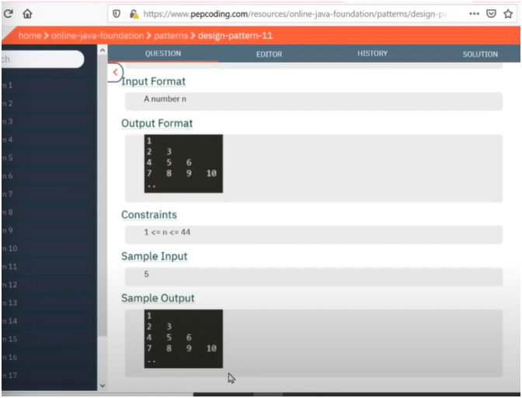

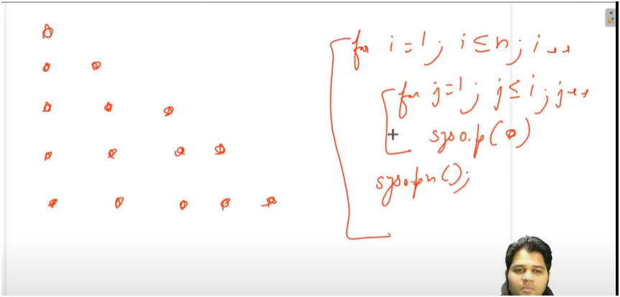

UNDERSTANDING

SIMILAR TO RIGHT ANGLE TRIANGLE PATTERN

**🎯 Goal:**

To print a **right-angle triangle pattern** with **increasing numbers** starting from 1.

**📌 How It Works:**

1. **Input:**
   * The user enters the number of rows (total_rows) for the triangle.
2. **Variables:**
   * num starts at 1 and keeps increasing with each number printed.
3. **Outer Loop (i):**
   * Runs from 1 to total_rows
   * Each iteration represents a new row in the triangle.
4. **Inner Loop (j):**
   * Runs from 1 to i (number of columns increases with each row)
   * Prints the current value of num, then increments it.

**🧱 Pattern Shape:**

* Forms a **right-angled triangle** aligned to the left.
* Numbers **increase sequentially** from top to bottom, left to right.

OUTER LOOP FOR TOTAL ROWS

INNER LOOP FOR PRINTIN INCREASE NUMBER PYRAMID