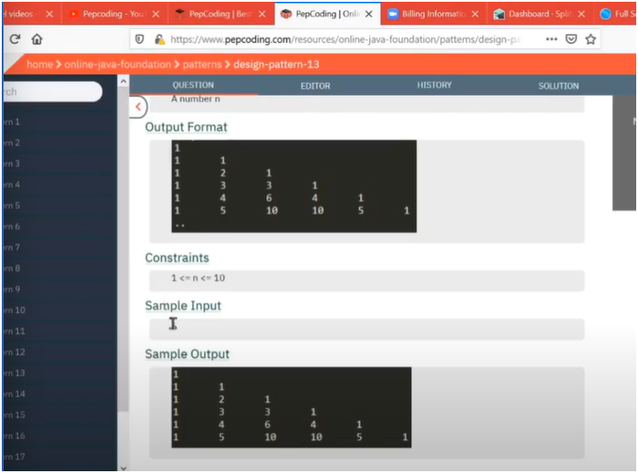

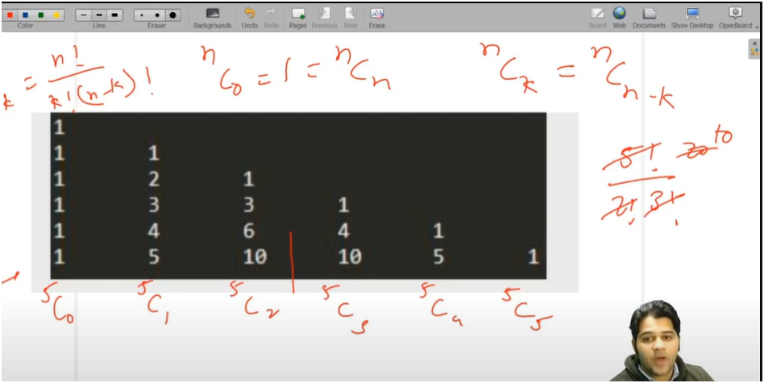

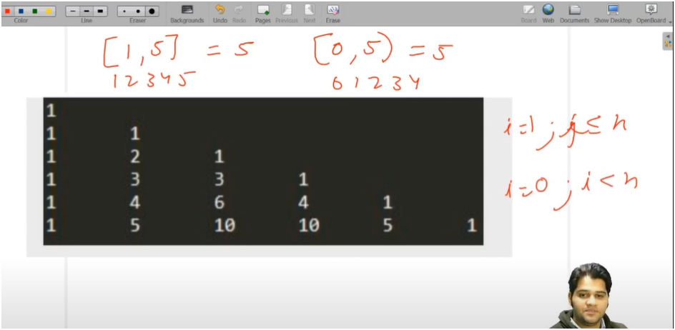

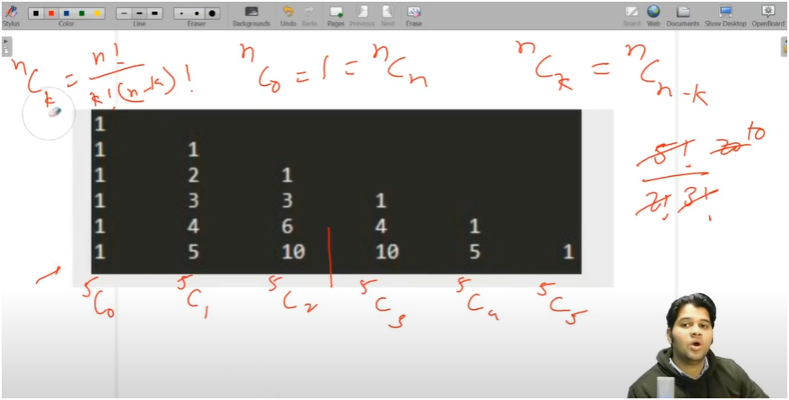

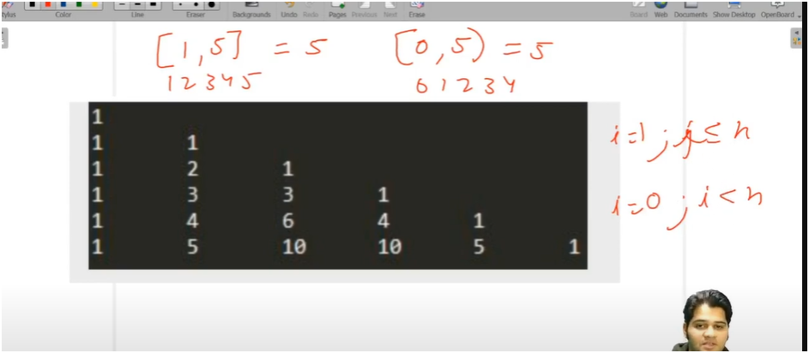

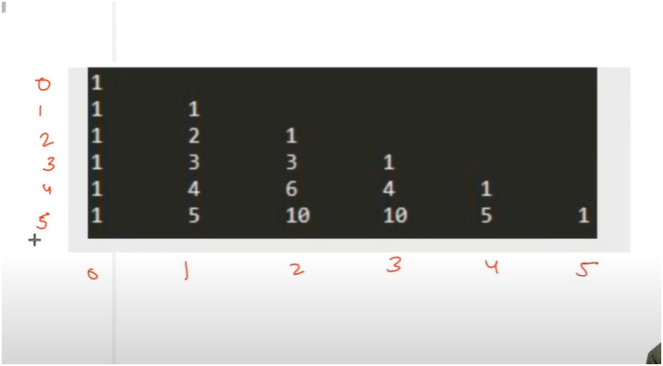

STARTING VALUE MUST ALWAYS BE ONE AS 0C0,1C0,2C0,3C0,4C0,5C0=1

SO WITH THE HELP OF FIST VALUE WE CAN GET NEXT VALUE WITH PREVIOUS VALUE WE CAN GET NEXT VALUE

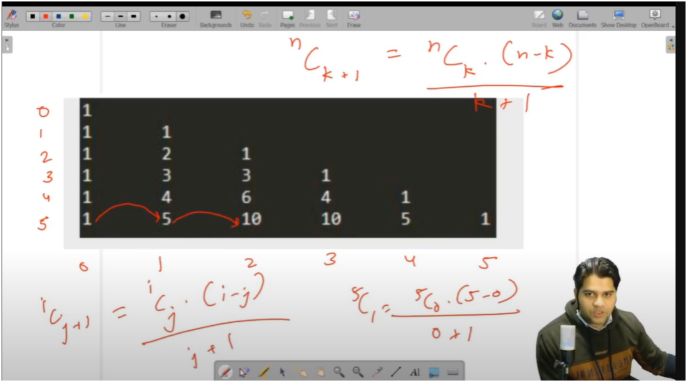

* **IF U SEE CAREFULLY THERE IS A PATTERN IN ROWS AND COLUMN**
* **HERE ROWS FROM 0 TO N THAT MEANS IF ROWS ARE 6 THEN IT WILL RUN FROM 0 TO 5** 
  + **AS 0 < N THEN START IS INCLUSIE AND LAST IS EXLCUSIVE**
  + **AS 0 <= N THEN START AND LAST BOTH ARE INCLUSIVE**
* **AND IN EACH ROW WE WANT LOOP TO RUN FROM 0 TO N+1 (BOTH INCLUSIVE) THIS BEACAUSE IF WE SEE CAREFULLY EACH ROW HAS VALUE PRINTED ONE MORE THAN ACTUAL ROW NUMBER**
  + **IF ROW NUMBER IS 2 THEN IT WILL PRINT 3 VALUES**
  + **THAT IS 0<=current row number**
* **NOW IN INSIDE LOOP WE NEED TO USE FORMULA OF PERMUTATION AND COMBINATION HERE WE APPLIED THIS FORMULA TO THE NEXT COLUMN NO MEANS WE DON’T CALCULATE FOR 0TH COLUMN AS WE KNOW ITS VALUE THAT IS 1 SO WITH THE HELP OF THIS WE CALCULATE NEXT COLUMN VALUE THAT IS 1ST COLUMN**
  + **FORMULA ICJ+1= ICJ *(I-J)/ J+1**
* **THEN STORE THIS VALUE AGAIN IN ICJ**

**ALGORITHM:-**

**\* 📌 PATTERN: PRINT PASCAL'S TRIANGLE**

**🎯 OBJECTIVE:**

**\* - Display Pascal’s Triangle based on the number of rows given by the user.**

**🧠 LOGIC:**

**\* 1. Outer loop (`i`) runs from `0` to `total_rows - 1`:**

**\* - This represents each row of the triangle.**

**\* - We start from 0 to follow Pascal's Triangle structure correctly.**

**\* 2. Inner loop (`j`) runs from `0` to `i`:**

**\* - For every row `i`, print `i + 1` values.**

**\* - The number of values in each row is always `row_index + 1`.**

**\*3. Use the **Combination Formula**:**

**\* - The value at each position in Pascal's Triangle is:**

**\* **nCr = (n!)/(r!(n-r)!)\*\***

**\* - But to optimize, we use:**

**\* `icjp1 = (icj * (i - j)) / (j + 1)`**

**\* - This avoids recalculating factorials every time and builds the next value from the current one.**

**\* - Initialize `icj = 1` at the start of every row because the first value is always 1.**

**🔍 NOTE:**

**\* - Pascal’s Triangle has symmetry.**

**\* - Each row contains coefficients of binomial expansion:**

**\* Example: Row 3 → (a + b)^3 = 1a³ + 3a²b + 3ab² + 1b³**