PRINT STARS AS PER CURRENT ROW NUMBER

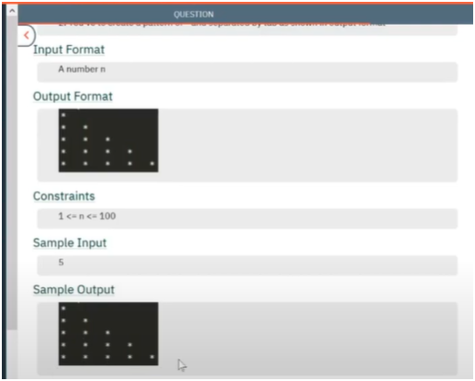

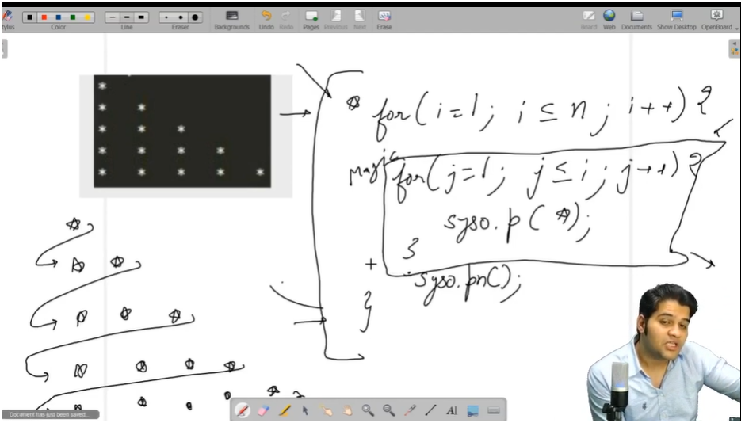

THIS PATTERN IS A GREAT EXAMPLE OF ABSTRACCTION

WHERE WE THINK MORE ABOUT UPPER LAYER AND HAVE FAITH THAT BELOW LAYER WILL WORK PROPERLY

ALGO

* FIRST LAYER LOOP WILL RUN FOR TOTAL INPUT ROWS
* AND INSIDE LAYER LOOP RUN FOR CURRENT ROW NUMBER SO THAT I CAN PRINT STAR ACCORDINGLY TO IT