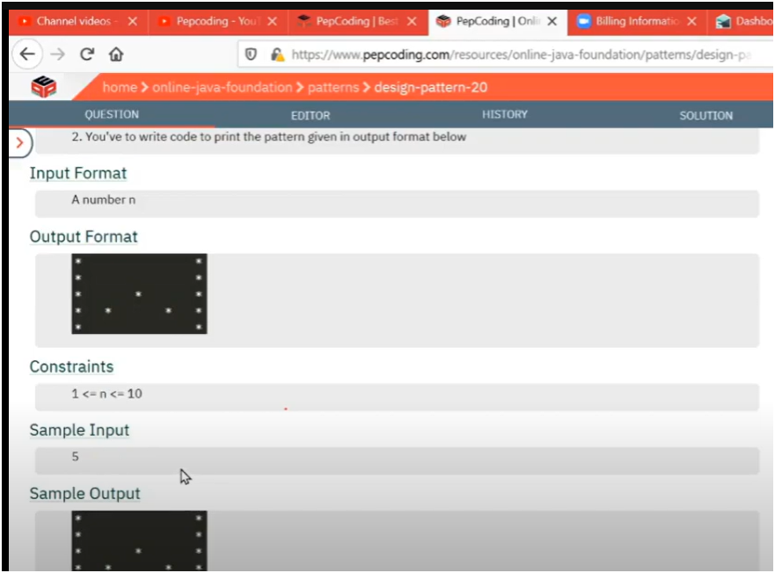

UNDERSTANDING

* **IF WE SEE CAREFULLY WE NEED TO JUST UNDERSTAND WHERE WE NEED TO PRINT STAR**
* **IF WE SEE PROERLY PATTERN STARS ARE PRINTED AT START AND END COL AND IN LEFT TO BOTTOM HALF DIAGONAL AND RIGHT TO BOTTOM HALF DIAGONAL**
* **NOW WEE NEED TO DECIDE AT WHICH ROW WE NEED TO PRINT STARS AT FIRST,END OR AT HALF DIAGONALS**
* **BEFORE MIDDLE ROW** 
  + **ALL STARS ARE PRINTED AT START AND END COLUMN**
* **AFTER MIDDLE ROW** 
  + **STARS ARE PRINTED AT LEFT TO BOTTOM HALF DIAGONAL AND RIGHT TO BOTTOM HALF DIAGONAL AND START AND END COLUMN**

ALGORITHM:-

📌 PATTERN: HOLLOW RECTANGLE WITH X IN BOTTOM HALF

🎯 OBJECTIVE:

- Print a pattern with:

1. **Full stars on the first and last columns (vertical borders)**.

2. **An X-shape (cross) in the bottom half only**.

🔢 INPUT:

- `total_rows`: number of rows and columns (since it's a square)

🧠 LOGIC FLOW:

1️⃣ OUTER LOOP (i = 1 to total_rows):

→ Controls the rows.=

2️⃣ INNER LOOP (j = 1 to total_rows):

→ Controls the columns in each row.

3️⃣ STAR PRINTING CONDITIONS:

✅ Always print star (`*`) in:

- First column (`j == 1`)

- Last column (`j == total_rows`)

✅ Additionally, in the **bottom half only** (`i > total_rows / 2`):

- Print star when:

- `i == j` → main diagonal

- `i + j == total_rows + 1` → anti-diagonal

❌ Else, print **tab (`\t`)** for spacing.

🧪 EXAMPLE OUTPUT (for total_rows = 7):