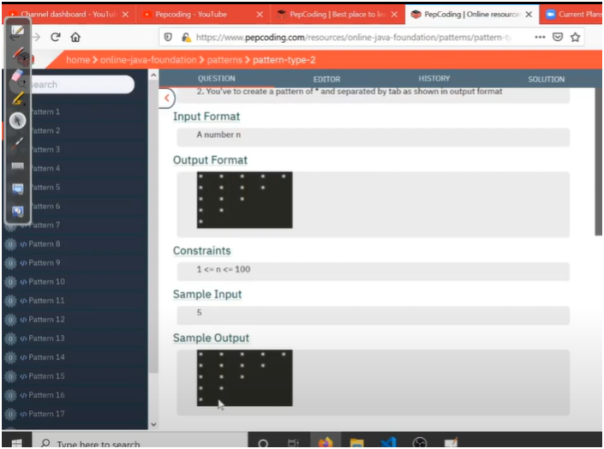

ALGO:

RUN MAIN LAYER LOOP FORM TOTAL ROWS TO 1 AS WE WANT REVERSE RIGHT ANGLE TRIANGLE(JAISE STARS CHAIYE VAISE PROGRAM LIKHO)

AND THEN RUN INSIDE LAYER LOOP FROM 1 TO CURRENT ROW TO PRINT STARS