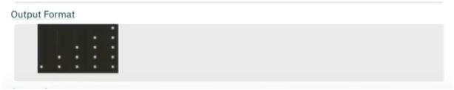

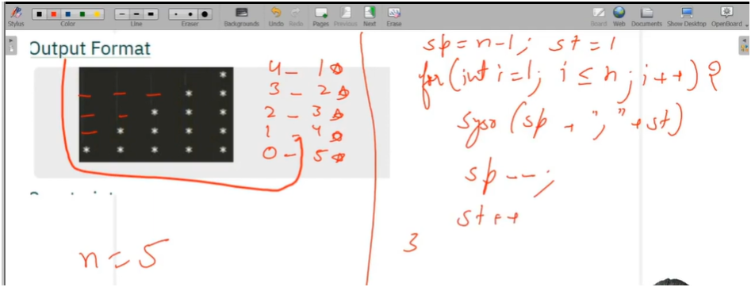

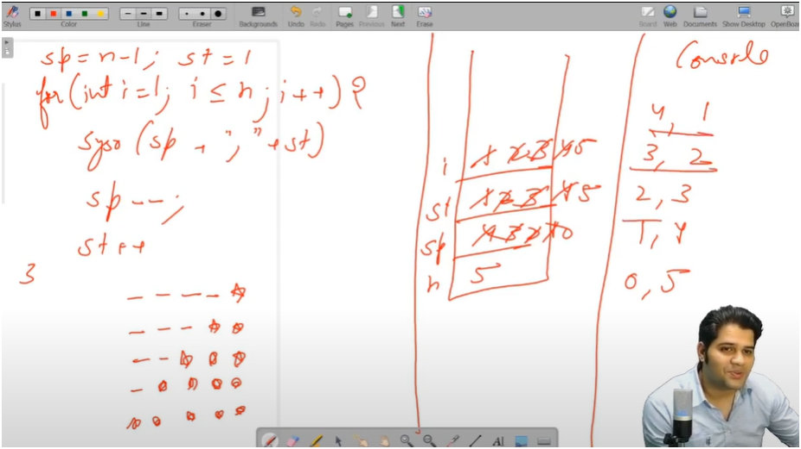

**ALGO**

* IF WE SEE PATTERN CAREFULLY WE SEE THAT WE PRINT FIRST SPACES AND THEN STARS
* AND AS WELL AS HERE SPACES ARE DECREMENTING BY 1 FOR EACH ROW AND STARS ARE INCREMENTATING BY 1
* SO WE RUN OUTSIDE LOOP FOR TOTAL_ROWS
* THEN THERE ARE TWO INSIDE LOOPS FOR SPACES AND STARS
* ONE LOOP WILL PRINT FROM 1 TO SPACES
* SECOND LOOP WILL PRINT FROM 1 TO ROWS
* AND THEN DECREMENT SPACES AND INCREMENT STARS

ALGO:-

/*

* 🧠 WORKFLOW EXPLANATION:

* 1. We take the total number of rows as input.

* 2. For each row:

* a. We first print spaces (which start from total_rows - 1 and decrease by 1 per row).

* b. Then we print stars (which start from 1 and increase by 1 per row).

* 3. Each space and star is followed by a tab (`\t`) for alignment.

*

* 🔁 LOOP STRUCTURE:

* - Outer loop (i): Runs from 1 to total_rows.

* - Inner loop 1 (j): Prints spaces → runs from 1 to `spaces`.

* - Inner loop 2 (k): Prints stars → runs from 1 to `stars`.

*

* 🔄 Update After Each Row:

* - Decrease `spaces` by 1.

* - Increase `stars` by 1.

*

* ✅ Useful Tip:

* To reverse the pattern (i.e., from bottom to top), just:

* - Start `spaces = 0` and increment.

* - Start `stars = total_rows` and decrement.

*/