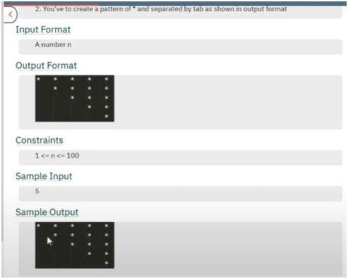

**ALGO:-**

**IF U SEE CAREFULLY THE PATTERN**

**IN THAT STARS ARE DECREMENTING BY 1 AND SPACES ARE INCREASING BY 1**

**THUS INTIALIZED STARS TO TOTAL ROWS AND SPACES TO 0**

**THUS WE NEED ONE OUTER LOOPS THAT RUN FOR TOTAL ROWS INPUTED**

**AND TWO INNER LOOPS FOR SPACES AND STARS**

**SPACES RUN FROM 1 TO SPACES**

**STARS FROM 1 TO STARS**

**THEN INCREMENT SPACE AND DECREMENT STARS**