**PRINT DIAMOND PATTERN**

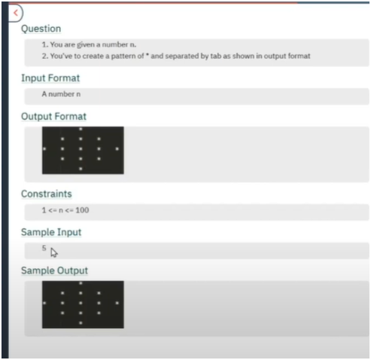

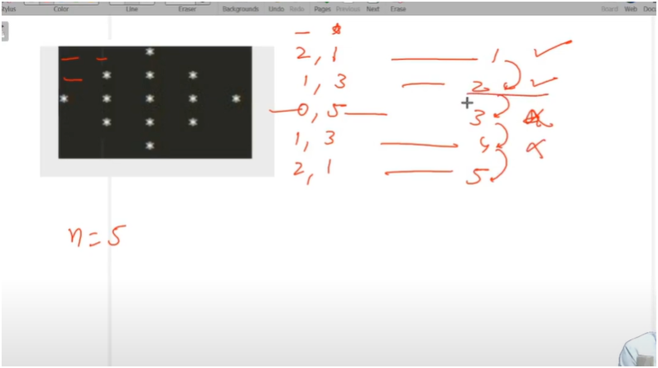

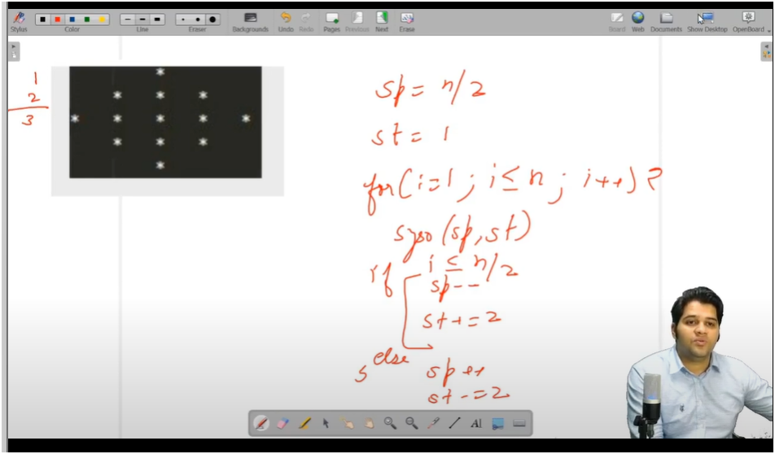

IF U OBSERVE CAREFULLY STARS AND SPACES HAVE PATTERNS

HERE SPACES ARE DECREMENTATING TILL MIDLE OF THE ROWS

AND STARS ARE INCREMENTING TILL MIDDLE OF THE ROWS

THEN AFTER MIDDLE THAT IS N/2

HERE SPACES ARE INCREMENTING

AND STARS ARE DECREMENTING BY 2

ALGO

* + **FIRST INTIALIZE SPACE TO N/2 AND STARS TO 1**
  + **THEN RUN FOR LOOP TO RUN FOR TOTAL ROWS**
  + **THEN PRINT SPACES AND STARS**
  + **THEN CHECKING IS DONE TO SEE WHETEHR U HAVE REACHED MIIDLE OF THE ROW SO THAT WE INCREMENT DECREMENT SPACES AND STARS THAT IS**
    - **BEFORE MIDDLE ROW**
    - **HERE SPACES ARE DECREMENTATING TILL MIDLE OF THE ROWS**
    - **AND STARS ARE INCREMENTING TILL MIDDLE OF THE ROWS**
  + **THEN AFTER MIDDLE THAT IS N/2** 
    - **HERE SPACES ARE INCREMENTING**
    - **AND STARS ARE DECREMENTING BY 2**