PRINT DIAGONAL BASED ON INPUT NUMBER

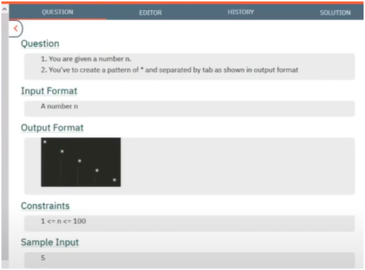

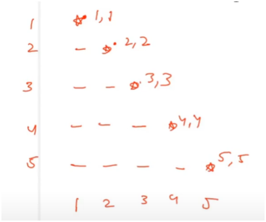

**UNDERSTANDING:-**

THERE IS A SPACE AND STAR PATTERN

IF U OBSERVED CAREFULLY STARS ARE ONLY PRINTED WHEN COLUMN AND ROW GET EQUAL THAT is i EQUALS TO j OTHER WISE PRINT SPACE

ALGO:-

🧠 ALGORITHM WORKFLOW:

* 1. Take input for `total_rows`.

* 2. Run a **nested loop**:

* - Outer loop `i` from 1 to total_rows → for rows.

* - Inner loop `j` from 1 to total_rows → for columns.

*

* 3. Inside the inner loop:

* - If `i == j` (i.e., diagonal position), print `"*"`

* - Else, print a tab space `"\t"`

*

🔢 KEY POINT:

* - Only one `*` is printed per row, and it moves diagonally from top-left to bottom-right.

* - Tabs are used for alignment.

*