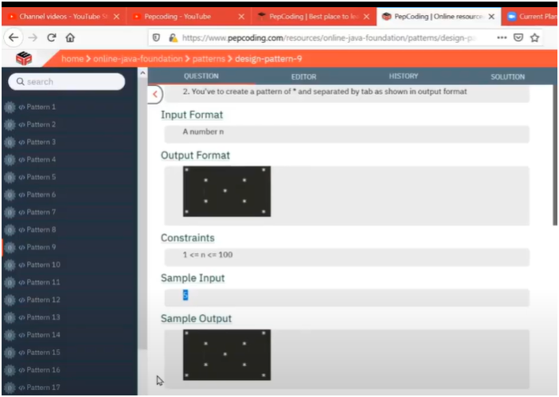

**UNDERSTANDING:-**

**IF U OBSERVED CAREFULLY IT IS COMBINING TWO DIAGONALS THAT MEANS**

**ONE DIAGONAL WHICH IS MOVING FROM LEFT TO BOTTOM USE LOGIC OF SAME_ROW==SAME COLUMN**

**SECOND DIAGONAL MOVING FROM RIGHT TO BOTTOM USE LOGIC OF CURRENT_ROW+CURRENT_Column == TOTAL_ROWS + 1**

**THEN JUST MERGE IT TO FORM CROSSS DIAGONALS**

**ALGORITHM:-**

🎯 OBJECTIVE:

* - Display an X pattern made of stars (*) on a square grid.

* - The grid size (rows = columns) is taken as user input.

🧠 LOGIC:

1. Outer loop runs from `1 to total_rows` (each row).

2. Inner loop runs from `1 to total_rows` (each column in that row).

3. Inside the inner loop:

* - If `i == j` → print star on the **main diagonal** (top-left to bottom-right).

* - Else if `i + j == total_rows + 1` → print star on the **reverse diagonal** (top-right to bottom-left).

* - Else → print a tab (`\t`) to maintain spacing.

🔍 NOTE:

* - For odd total_rows: Diagonals intersect at the center.

* - For even total_rows: Diagonals do not intersect at a single cell, causing a wider gap in the middle — this is mathematically normal.