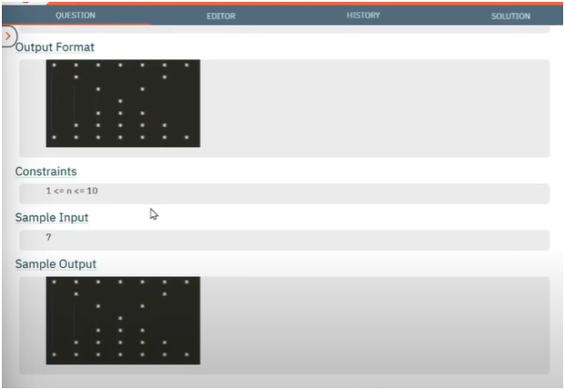

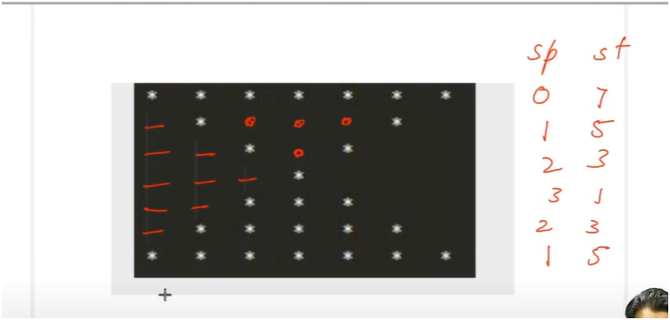

**UNDERSTANDING:-**

* **IF U OBSERVED CAREFULLY THERE IS A PATTERN IN SPACES AND STARS**
* **FIRST PRINT FILLED STAR PATTERN THEN GO FOR SPACES IN IT**
* **FILLED STAR PATTERN**
  + **IF WE SEE CAREFULLY SPACES ARE INCREASING BY 1 TILL MIDDLE ROW AND ARE DECREMENTING BY 1 AFTER MIDDLE ROW**
  + **IF WE SEE CAREFULLY STARS ARE DECREMENTING BY 2 TILL MIDDLE TOW AND ARE INCREMENTING BY 2 AFTER MIDDLE ROW**
* **SPACES IN MIDDLE HALF PATTERN**
  + **IF WE SEE IN MIDDLE HALF PATTERN SPACES ARE PRESENT IN ROWS ARE GREATER THAN STAR ROW AND SMALLER THAN MIDDLE ROW**
  + **AND AS WELL AS SPACES ARE PRESENT AFTER FIRST POSITION IN ROW AND BEFORE LAST POSITION IN ROW**

ALGORITHM:-

📌 PATTERN: HOLLOW DIAMOND STAR PATTERN

🎯 OBJECTIVE:

* - Print a diamond shape made of stars (*) that is hollow from the inside.

* - Only the borders are filled with stars; internal area is filled with spaces.

🔢 INPUT:

* - `total_rows`: Should be an **odd number** (like 5, 7, 9)

🧠 LOGIC BREAKDOWN:

1. Initialization:

* - `spaces = 0`: Spaces before stars in each row.

* - `stars = total_rows`: Initial number of stars (maximum on first row).

2. Outer Loop (i = 1 to total_rows): Controls each row of the pattern.

3. First Inner Loop (Leading SPACES):

* - Prints increasing leading spaces from top to middle.

* - Decreases again from middle to bottom.

4. Second Inner Loop (STARS + HOLLOW):

* - For every position in star loop (1 to `stars`):

* - Print `*` at start and end positions.

* - Print space (`\t`) inside to create the "hollow" effect.

* - Hollow condition is:

* - Row should not be the top or bottom.

* - Position should be between 1 and `stars` (exclusive).

5. Update Logic (to manage diamond shape):

* - First half of diamond (`i <= total_rows / 2`):

* - `spaces++`, `stars -= 2`

* - Second half of diamond (`i > total_rows / 2`):

* - `spaces--`, `stars += 2`

📌 KEY CONCEPTS:

* - Top and bottom rows: fully filled with stars.

* - Rows in-between: stars at the edges only, rest filled with tab spaces.

* - Symmetrical diamond controlled by increment/decrement of `spaces` and `stars`.

🧠 MEMORY TIP:

* - Think of it as a fully filled diamond first.

* - Then "cut out" the center part from rows 2 to mid-1 and mid+1 to end.