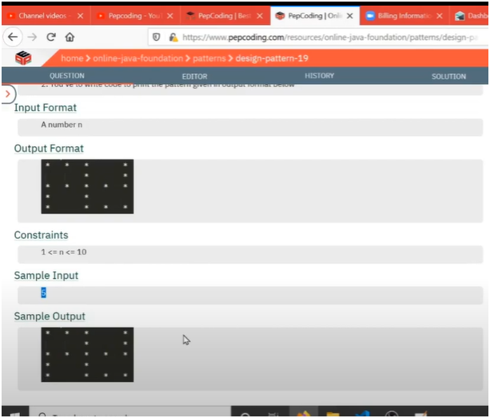

SEE EACH ROW AND ADD CONDITION

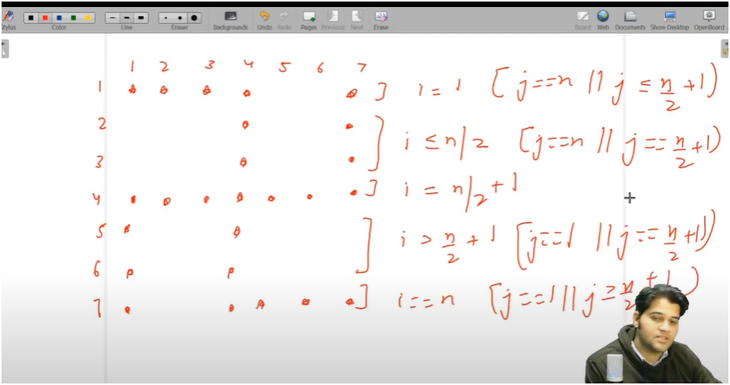

**UNDERSTANDING**

* **IF U OBSERVE CAREFULLY THE CODE IS ALL ABOUT UNDESRTANDING ROWS AND WHAT ONE MUST PRINT IN EACH ROW**
* **IF U SEE CAREFULLY EACH ROW LOOP WILL RUN FOR TOTAL NUMBER OF ROWS GIVEN**
* **NOW DIVIDE THE TOTAL ROWS INTO DIFFERENT PATS**

**FIRST PART**

* **THIS WILL COVER FIRST ROW**
  + **STARS ARE PRINTED AT LAST COLUMN AND TILL TOTAL_ROWS/2+1**
  + **ELSE SPACE**

**SECOND PART**

* **THIS WILL COVER ROWS BETWEEN START ROW AND MIDDLE ROWS**
  + **STARS ARE PRINTED AT TOTAL_ROWS/2++1 AND LAST COLUMN**
  + **ELSE SPACE**

**THIRD PART**

* **THIS WILL COVER ROWS AT POSTION TOTAL_ROWS/2++1**
  + **STARS ARE PRINTED WHOLE ROW /OR AT ALL COLUMNS**

**FOURTH PART**

* **THIS WILL COVER ROWS BETWEEN OR AFTER TOTAL_ROWS/2++1 AND LAST ROW**
  + **HERE STARS ARE PRINTED AT FIRST COL AND TOTAL_ROWS/2++1**
  + **ELSE SPACES**

**FIFTH PART**

* **THIS WILL BE THE LAST ROW**
  + **STARS ARE PRINTED AT FIRST COL AND AFTER TOTAL_ROWS/2+1 TILL END**

**ALGORITHM**

**📌 PATTERN: SWASTIK SYMBOL (Pattern for odd total_rows)**

**🎯 OBJECTIVE:**

**- Print a pattern that resembles a **Swastik**, a popular symmetrical symbol.**

**- It requires careful control of star placement in 5 distinct parts of the pattern.**

**🔢 INPUT:**

**- total_rows (must be an **odd number** like 5, 7, 9...)**

**🧠 LOGIC BREAKDOWN (Handled in 5 parts based on row number):**

**1️⃣ FIRST ROW (i == 1):**

**→ Stars at beginning (left half) and at the very last column.**

**✅ Condition: j ≤ mid || j == total_rows**

**2️⃣ UPPER HALF (excluding 1st row) (i <= mid):**

**→ Stars only at center column and last column.**

**✅ Condition: j == mid || j == total_rows**

**3️⃣ MIDDLE ROW (i == mid + 1):**

**→ Entire row filled with stars.**

**✅ Print star unconditionally for each column.**

**4️⃣ LOWER HALF (excluding last row) (i < total_rows):**

**→ Stars at first column and center column.**

**✅ Condition: j == 1 || j == mid**

**5️⃣ LAST ROW (i == total_rows):**

**→ Stars at end (right half) and at the very first column.**

**✅ Condition: j >= mid || j == 1**

**✏️ Variable:**

**- `mid` = total_rows / 2 + 1 → used to track center column.**

**📌 PATTERN VISUAL (for total_rows = 7):**

**\* * * \***

**\* \***

**\* \***

**\* * * * * * \***

**\* \***

**\* \***

**\* * * * \***

**💡 TIPS TO REMEMBER:**

**- Think of pattern in **horizontal and vertical symmetry**.**

**- Handle each section (top, middle, bottom) separately.**

**- Use `total_rows / 2 + 1` for accurate center control.**

**- Helps to draw it manually once while coding.**

**✅ Best used for pattern problems and symmetry-based logic practice.**