MAKE HOLLOW DIAMOND

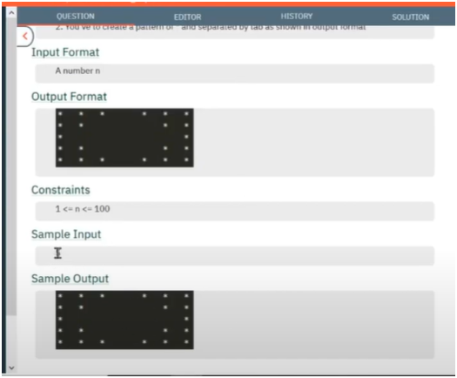

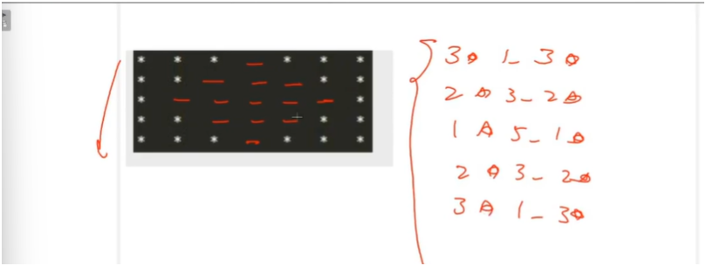

ALGO:-

**IF U OBSERVED CARREFULLY THERE IS PARTICULAR PATTERN IN SPACES STARS**

**IF WE SEE PROPERLY STARS ARE DECREASING BY 1 TILL MIDDLE ROW AND THEN INCREASE BY 1**

**SIMILAR FOR SPACES SPACES ARE INCREASED BY 2 TILL MIDDLE ROW AND THEN DECREASE BY 2**

**FOR AGAIN STARS STARS ARE DECREASING BY 1 TILL MIDDLE ROW AND THEN INCREASE BY 1**

**SO WE NEED TO MAKE CHECKS WHERE WE MUST NEED TO INCREASE AND DECREASE**

**TILL MIDDLE ROW STARS—AND SPACES+=2**

**AFTER MIDDLE ROW STARS++ AND SPACES-=2**

**THEN DO PRINTLN FOR GETTING INTO NEXT LINE**