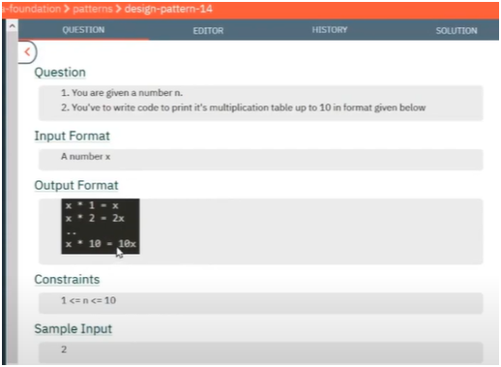

**UNDERSTANDING:-**

* **IF U OBSERVED CAREFULLY IN THIS INPUT NUMBER IS CONSTANT WHILE ITS i GETS CAHNGE CONTINUOUSLY** 
  + **LOOP WILL RUN FROM 1 TO LESS THAN 11 AND THEN MULTIPLY IT WITH INPUT NUMBER TO GET OUTPUT**