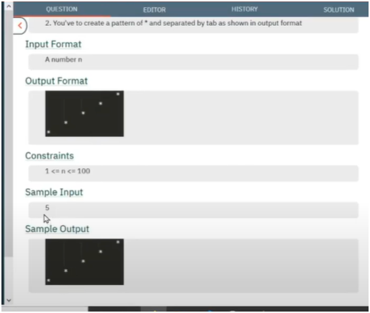

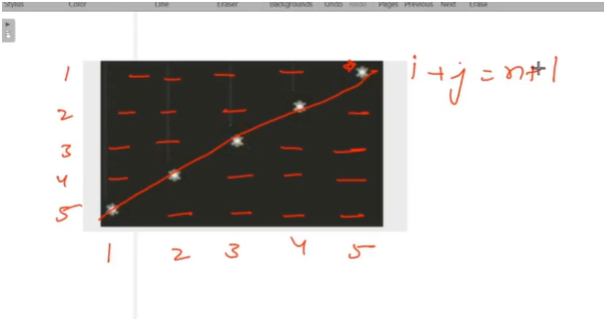

**UNDERSTANDING:**

**IF U OBSERVED CAREFULLY FOR ROWS AND COLUMNS**

**STARS ARE PRINTED ONLY WHEN SUM OF ROWS AND COLUMN GETS EQUAL TO TOTAL ROES +1**

**ELSE WE PRINTED JUST SPACE**

**ALGO:-**

* 🧠 ALGORITHM WORKFLOW:

* 1. Take input for `total_rows`.

* 2. Use a **nested loop**:

* - Outer loop `i` from 1 to total_rows → for rows.

* - Inner loop `j` from 1 to total_rows → for columns.

* 3. Inside the inner loop:

* - If `i + j == total_rows + 1`, print `"*"` (reverse diagonal condition).

* - Else, print a tab `"\t"` for spacing.

🔢 KEY POINT:

* - Only one `*` is printed per row.

* - It moves diagonally from **top-right to bottom-left**.

* - Tabs are used to maintain shape.

*

* ✅ OUTPUT SHAPE:

* - Forms a diagonal from top-right to bottom-left.