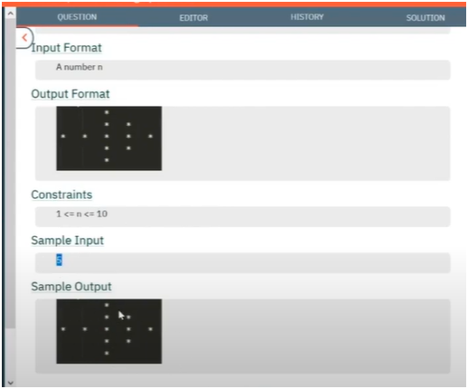

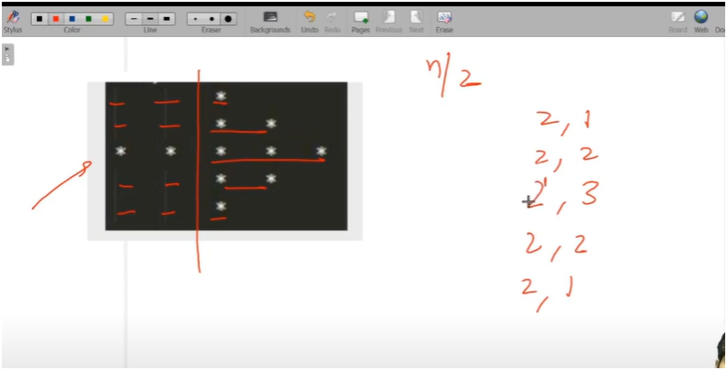

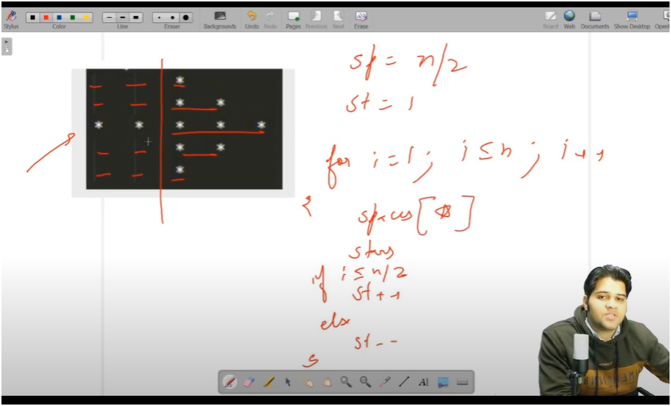

**UNDERSTANDING:-**

* **IF U SEE CAREFULLY THERE IS PATTERN IN SPACES AND STARS**
* **HERE WE DIVIDE THE ARROWS INTO TWO PARTS ITS TAIL AND ARROW ONE**
* **ARROW PART**
  + **ARROW ONE HAVE STAR PATTERN WHICH WE STUDIED EARLIER IN EVERY PATTERN**
    - **THAT TILL MIDDLE ROW STARS ARE INCREMENTING BY 1 AND THEN IT DECREMENT BY 1**
* **TAIL PART**
  + **TILL MIDDLE ROW SPACES ARE PRINTED SAME THAT IS TOTAL_ROWS/2 AND AFTERWORDS IT PRINTED STARS AND THEN AGAIN SPACES**
* **THAT MEANS FIRST PRINT SPACES THEN STARS AND THEN WRITE A CHECK LOGIC FOR INCREMENTING AND DECREMENTING STARS**
* **SIMILARLY FOR SPACES LOOP WE NEED TO WRITE CHECK LOGIC WHERE WE PRINT STARS TILL MIDDLE ROW AND THEN STARS AND THEN AGAIN SPACES**

ALGORITHM

🎯 OBJECTIVE:

- Print a pattern with a middle row filled with stars and other rows having stars on the right.

🔢 INPUT:

- `total_rows` (should be an odd number, e.g., 5, 7, etc.)

🧠 LOGIC BREAKDOWN:

1. Initialization:

- `spaces = total_rows / 2`: Controls how many columns we leave blank (left side).

- `stars = 1`: Number of stars to print per row (increases then decreases).

2. Outer Loop (Rows): Runs from 1 to `total_rows`

- Controls the vertical number of rows.

3. First Inner Loop (SPACES):

- Runs from 1 to `spaces`

- ✅ Special Case: If current row is **middle row**, print `*` instead of space, so that the middle row becomes fully filled with stars (horizontal line of the plus sign)

4. Second Inner Loop (STARS):

- Always prints stars after the spaces — the right-pointing part of the arrow.

- Number of stars increases until middle row, then decreases.

5. Star Counter Update:

- Before middle row: `stars++` (increase)

- After middle row: `stars--` (decrease)