Authapp

DOMAIN: dev-iqwsuwq0hjdquab4.us.auth0.com

CLIENTID: CEreuq7S0yxoEnbXtmJXV22zwdVT6yvZ

ROLES

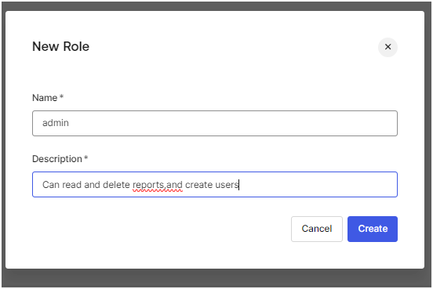

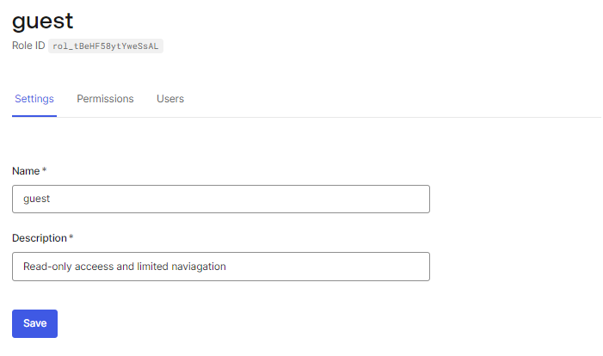

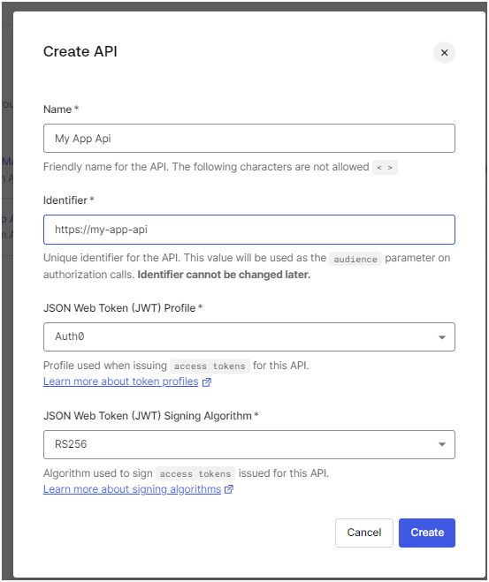

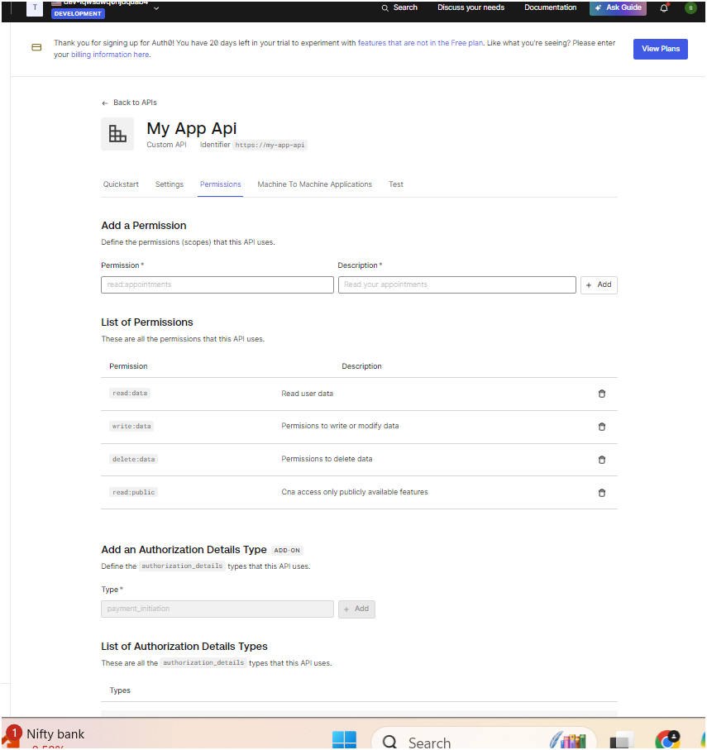

THEN GO TO USER MANAGEMENT ROLES AND SELECT API AND THEN ASSIGN PERMISSIONS TO THEM

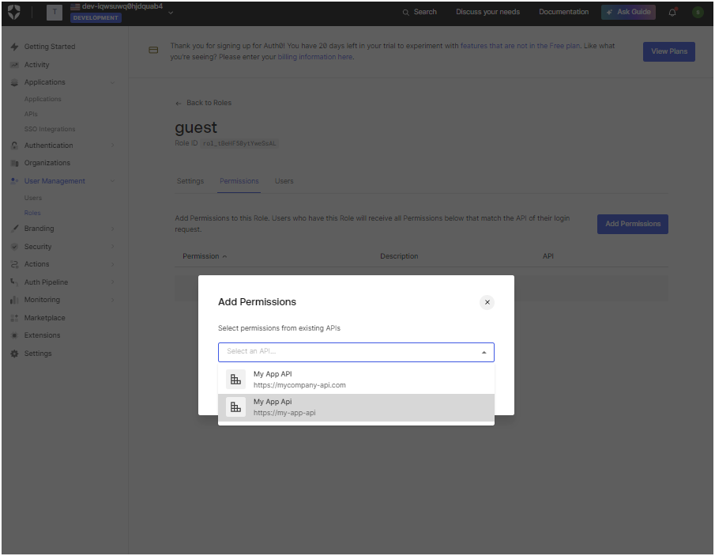

Go to actions library and create action from scratch

