POWER TRANSFORMER HEALTH
CONDITION-MONITORING DATASET — ENGINEERING ANALYSIS REPORT
Dataset: transformer_health_dataset_500_records.csv | 500 records, 15 fields
Prepared as a Senior Electrical Design Engineering review

1. Executive Summary
This report analyzes a 500-record condition-monitoring dataset for distribution-class power transformers (11 kV class). Each record represents one transformer's instantaneous electrical, thermal, and mechanical sensor readings, together with an assigned health label: Healthy, Warning, or Critical.

What this dataset represents
It is not a component datasheet — there is no single physical device being specified. It is field/SCADA-style telemetry of the kind collected by an online transformer condition-monitoring system (temperature RTDs, dissolved-gas-in-oil sensors, vibration sensors, and partial-discharge sensors feeding a health-scoring or asset-management platform).

Primary purpose
To support predictive maintenance: identifying which transformers are trending toward failure before they trip or fail catastrophically, and prioritizing maintenance/replacement budget accordingly.

Industries that use this kind of data
- Electric utilities (distribution and sub-transmission substations)
- Industrial plants with dedicated step-down transformers (steel, cement, chemical, data centers)
- Renewable energy sites (wind/solar step-up transformers)
- Railways and metro traction power substations

Key advantages of this style of monitoring
- Early detection of insulation degradation via dissolved-gas trends
- Avoids unplanned outages by flagging 'Warning' units before they become 'Critical'
- Enables condition-based maintenance instead of fixed time-based maintenance, reducing cost

2. Dataset Overview

Structure
500 rows, one per transformer (IDs T0001–T0500). 15 columns: 1 identifier, 11 continuous sensor/operational parameters, 1 categorical cooling-mode field, and 1 categorical target label (Health_Status).

How the health label likely relates to the sensors
The labeling follows the classic transformer condition-monitoring logic used in the industry: thermal loading (oil/winding temperature, current, load %), insulation condition (dissolved gas, moisture in oil), mechanical condition (vibration), and dielectric condition (partial discharge) are combined into an overall health tier. This mirrors how real Dissolved Gas Analysis (DGA) and thermal-model based monitoring systems classify assets.

Fields in the dataset
Field | Type | Engineering Meaning
Transformer_ID | ID | Unique asset identifier
Age_Years | Numeric | Years in service — proxy for cumulative insulation aging
Oil_Temperature_C | Numeric | Top-oil temperature — thermal loading indicator
Winding_Temperature_C | Numeric | Hot-spot winding temperature — dominant life-consumption driver
Ambient_Temperature_C | Numeric | Site ambient temperature — baseline for temperature rise
Voltage_kV | Numeric | Rated/operating voltage class (constant at 11 kV in this set)
Current_A | Numeric | Load current through the winding
Load_Percentage | Numeric | Loading as % of nameplate rating
Oil_Level_Percentage | Numeric | Oil tank fill level — leak/seal integrity indicator
Moisture_ppm | Numeric | Moisture content in oil — insulation degradation indicator
Dissolved_Gas_ppm | Numeric | Total combustible/dissolved gas — internal fault signature (DGA)
Vibration_mm_s | Numeric | Tank/core vibration velocity — mechanical looseness/core issues
Partial_Discharge_pC | Numeric | Partial discharge magnitude — insulation void/dielectric stress
Cooling_Status | Categorical | Normal / Fan Running / Oil Pump Running — active cooling stage
Health_Status | Categorical (target) | Healthy / Warning / Critical — overall condition label

3. Descriptive Statistics
Summary statistics across all 500 records. Values are reasonable for an 11 kV distribution transformer fleet with mixed ages (2–30 years).
Parameter | Mean | Std Dev | Min | Max
Age (Years) | 15.0 | 8.83 | 2 | 30
Oil Temperature (°C) | 77.0 | 8.04 | — | 96.4
Winding Temperature (°C) | 86.8 | 8.28 | — | 105.8
Ambient Temperature (°C) | 30.2 | 6.91 | — | 42
Current (A) | 302.2 | 86.8 | — | 457.3
Load (%) | 67.2 | 19.3 | — | 100
Oil Level (%) | 93.5 | 3.77 | — | 100
Moisture (ppm) | 21.1 | 7.40 | — | 36
Dissolved Gas (ppm) | 323.0 | 98.7 | — | 557
Vibration (mm/s) | 3.19 | 0.81 | — | 5.04
Partial Discharge (pC) | 51.9 | 19.0 | — | 94.4

Class distribution
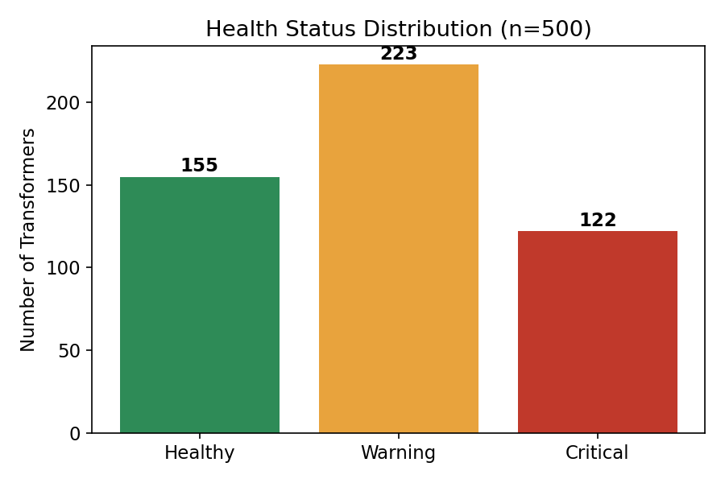
Figure 1 — Healthy: 155 (31%) | Warning: 223 (44.6%) | Critical: 122 (24.4%)
Nearly a quarter of the fleet is already in a Critical state and almost half are in Warning — a distribution consistent with an aging fleet that has been under-maintained, or a dataset deliberately built to demonstrate a full range of conditions for model training.

4. Parameter Behavior by Health Status
The clearest engineering signal in the data: every key stress indicator rises monotonically from Healthy → Warning → Critical.
Parameter | Healthy (avg) | Warning (avg) | Critical (avg) | Trend
Age (yrs) | 8.3 | 14.0 | 25.4 | Strong rise
Oil Temp (°C) | 68.1 | 79.3 | 84.1 | Strong rise
Winding Temp (°C) | 77.8 | 89.4 | 93.6 | Strong rise
Current (A) | 232.2 | 330.2 | 340.0 | Strong rise
Load (%) | 51.6 | 73.4 | 75.7 | Strong rise
Oil Level (%) | 96.1 | 93.8 | 89.4 | Falls (bad)
Moisture (ppm) | 15.4 | 20.5 | 29.6 | Strong rise
Dissolved Gas (ppm) | 223.4 | 325.1 | 445.5 | Strong rise
Vibration (mm/s) | 2.39 | 3.19 | 4.20 | Strong rise
Partial Discharge (pC) | 33.5 | 51.8 | 75.7 | Strong rise
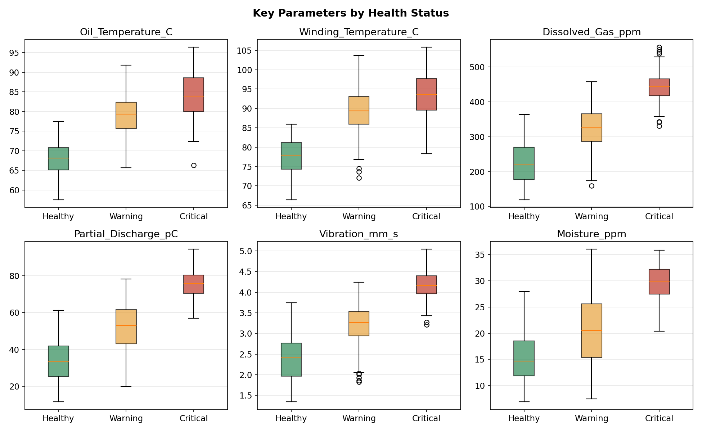
Figure 2 — Distribution of key parameters split by health status. Boxes separate cleanly between Healthy and Critical for every parameter shown.

5. Correlation & Standards-Based Interpretation
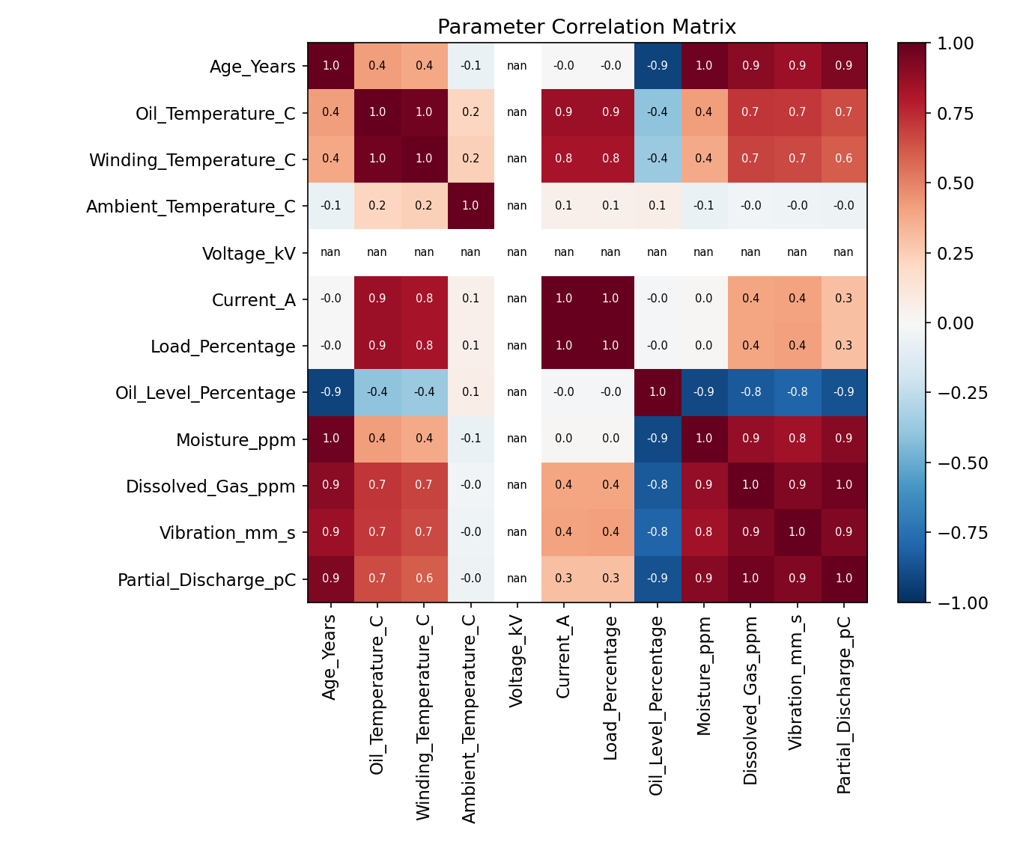
Figure 3 — Full parameter correlation matrix

Correlation of each parameter with declining health
Parameter | Correlation with Health Decline
Dissolved Gas (ppm) | +0.83 (very strong)
Vibration (mm/s) | +0.82 (very strong)
Partial Discharge (pC) | +0.82 (very strong)
Oil Temperature (°C) | +0.75 (strong)
Winding Temperature (°C) | +0.73 (strong)
Age (Years) | +0.70 (strong)
Moisture (ppm) | +0.70 (strong)
Load (%) / Current (A) | +0.48 (moderate)
Oil Level (%) | −0.65 (strong, inverse)
Ambient Temperature (°C) | +0.08 (negligible)

Benchmarking against common transformer condition-monitoring standards
As general engineering reference points (not a certification of this specific dataset), typical industry guide levels used in transformer condition assessment include:
- IEEE C57.104 / IEC 60599 — Dissolved Gas Analysis (DGA) condition banding, where total combustible gas trending upward over time (not a single absolute number) signals incipient faults such as partial discharge, thermal faults, or arcing.
- IEC 60076 hot-spot winding temperature limits — sustained winding hot-spot temperatures materially above ~98°C for standard insulation systems accelerate cellulose insulation aging per the Arrhenius relationship, roughly halving expected life for every ~6–8°C rise.
- Moisture-in-oil guide values — oil moisture above ~20–30 ppm (temperature-dependent) is generally treated as elevated and a driver of accelerated aging and reduced dielectric strength.
- Partial discharge — any sustained, non-trivial PD activity is treated as a leading indicator of insulation void formation and progressive dielectric breakdown.
The dataset's own Critical-tier averages (Winding Temp 93.6°C, Dissolved Gas 445.5 ppm, Moisture 29.6 ppm, PD 75.7 pC) sit consistently in the elevated/concerning range relative to these general guide levels, which is internally consistent with how the Health_Status label appears to have been constructed.

6. Predictive Model — Health Status Classification
A Random Forest classifier (300 trees, max depth 8) was trained on the 11 numeric sensor fields plus encoded cooling status, using a 75/25 stratified train/test split, to test whether Health_Status can be predicted directly from sensor readings.

Model performance
Class | Precision | Recall | F1-Score | Support
Critical | 0.97 | 0.93 | 0.95 | 30
Healthy | 1.00 | 0.97 | 0.99 | 39
Warning | 0.95 | 0.98 | 0.96 | 56
Overall Accuracy |  |  | 96.8% | 125
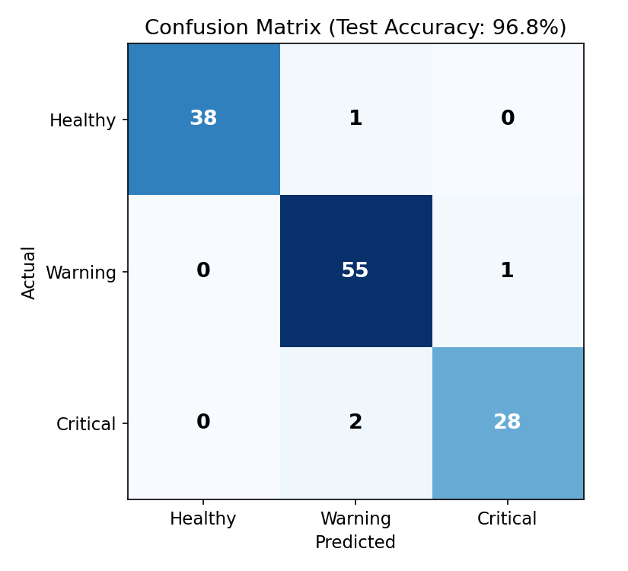
Figure 4 — Confusion matrix on held-out test data (125 transformers). Only 4 of 125 were misclassified, and all misclassifications were to the adjacent severity tier — no Healthy unit was mistaken for Critical or vice-versa.

Feature importance
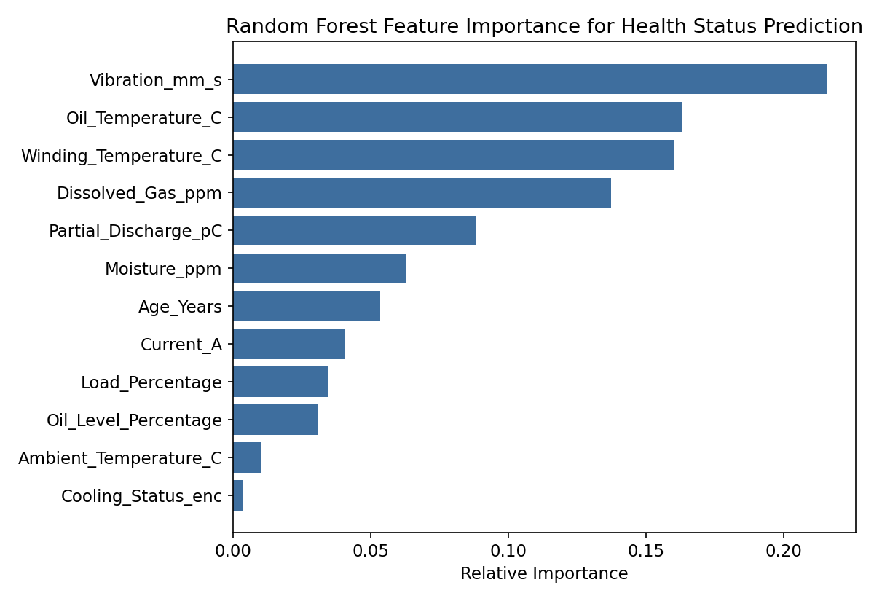
Figure 5 — Vibration, oil/winding temperature and dissolved gas are the dominant drivers the model relies on.
Vibration, oil and winding temperature, and dissolved gas together account for roughly two-thirds of the model's decision-making weight — consistent with standard transformer fault mechanisms (mechanical looseness, thermal overload, and internal arcing/overheating faults).
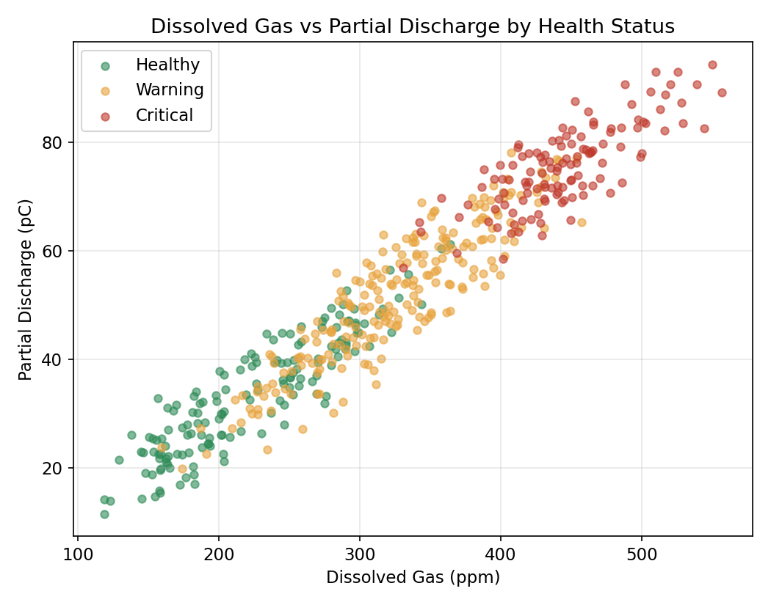
Figure 6 — Dissolved gas vs. partial discharge, colored by health status. The two dielectric-condition indicators separate the classes almost as well as the full model on their own.

7. Key Findings
- Health_Status appears to be a composite condition score, most heavily driven by dissolved gas, vibration, and partial discharge — the three classic 'incipient fault' indicators in transformer diagnostics.
- Age is a strong but not dominant factor: Critical-tier units average 25.4 years vs. 8.3 years for Healthy units, but some older units remain Healthy, meaning maintenance/loading history matters more than age alone.
- Loading (Current/Load%) matters, but with clearly diminishing marginal signal — Warning and Critical units carry almost identical average load (73–76%), so load alone doesn't separate the two worst tiers; thermal and dielectric indicators do.
- Oil level is the only parameter that falls with worsening health (96% → 89%), consistent with gasket/seal degradation accompanying older, more stressed units.
- Cooling status (fan/pump running vs. normal) has very low predictive value (0.4% feature importance) — active cooling engagement is reactive to load, not a leading health indicator in this dataset.
- A simple Random Forest model reaches 96.8% accuracy, indicating the sensor set is sufficient to automate tier classification for a real-time monitoring dashboard or alarm system.

8. Recommendations

Maintenance prioritization
- Treat any transformer with rising Dissolved Gas or Partial Discharge trend as higher priority than one flagged purely on load or ambient temperature.
- Investigate vibration anomalies promptly — it is the single strongest predictor in this dataset and often indicates core/winding looseness that will worsen under continued loading.
- Cross-check moisture-in-oil readings with oil level — a falling oil level combined with rising moisture may indicate a seal/gasket leak allowing moisture ingress.

For production deployment of a model like this
- Validate the model against real (non-synthetic) DGA lab results before using it for automated alarms — dissolved gas sensors used for continuous online monitoring are typically less precise than laboratory DGA.
- Add gas-by-gas breakdown (H2, CH4, C2H2, C2H4, C2H6, CO, CO2) if available — total dissolved gas alone cannot distinguish fault type (thermal vs. electrical vs. arcing), which matters for root-cause maintenance planning.
- Track trends over time, not just snapshot values — a rate-of-change model (e.g., ppm/month gas generation rate) is generally a stronger early-warning indicator than absolute levels.

9. Limitations
- This is a snapshot dataset (one reading per transformer) with no timestamps, so trend/rate-of-change analysis — which is usually more diagnostic than absolute values in real DGA practice — could not be performed.
- The exact rule or model originally used to assign Health_Status is not documented in the file; the interpretation above is inferred from the statistical relationships in the data.
- Standard reference levels (IEEE C57.104, IEC 60076, etc.) are cited as general industry context for interpreting the trends, not as a certified assessment of these specific transformers.
- Voltage is constant (11 kV) across all records, so this dataset represents a single voltage-class fleet, not a mixed-voltage system.

10. Conclusion
This dataset is well-structured for predictive-maintenance analytics on a distribution transformer fleet. The health label is statistically well explained by thermal, dielectric, and mechanical sensor readings, with dissolved gas, vibration, and partial discharge as the dominant indicators — consistent with established transformer failure mechanisms. A Random Forest classifier reproduces the labeling with 96.8% accuracy, confirming the sensor set is sufficient for an automated health-scoring system. The main gap for real-world deployment is trend data over time and validated laboratory DGA cross-checks; on a single-snapshot basis, this dataset supports strong triage-level decision-making for maintenance prioritization.

