
SANDIP UNIVERSITY, NASHIK
Department of Computer Science & Engineering (AI/ML)
B.Tech Second Year Project Report
Rule-Based Recommendation System for Course Selection
Submitted by:
Ayush Pal (250105231323)
Honey Verma (250105231339)
Rushikesh Rathod (250105231190)
Siddhesh Barabde (250105231278)

Under the Guidance of:
Miss Payal Nandan
Associate Professor, Department of CSE (AI/ML)
Academic Year: 2025–2026


SANDIP UNIVERSITY, NASHIK
Second Year
Department of Computer Science (AI & ML)

A PROJECT REPORT
ON
“Rule-Based Recommendation System for Course Selection”
Submitted in Partial Fulfillment of the Requirements for the
Bachelor of Technology in Computer Science (Artificial Intelligence & Machine Learning)
Submitted By:
250105231323 | AYUSH PAL
250105231339 | HONEY VERMA
250105231190 | RUSHIKESH RATHOD
250105231278 | SIDDHESH BARABDE
Academic Year: 2025 – 2026
Sandip University, Nashik, Maharashtra, India

SANDIP UNIVERSITY, NASHIK
Department of Computer Science (AI & ML)

CERTIFICATE
This is to certify that the project entitled “Rule-Based Recommendation System for Course Selection” has been successfully completed by the following students of Bachelor of Technology in Computer Science (Artificial Intelligence and Machine Learning), Sandip University, Nashik, in partial fulfillment of the requirements for the degree of B.Tech. during the academic year 2025–2026.
Enrollment No. | Student Name | Signature
250105231323 | AYUSH PAL
250105231339 | HONEY VERMA
250105231190 | RUSHIKESH RATHOD
250105231278 | SIDDHESH BARABDE
This project has been completed under our guidance and supervision. To the best of our knowledge, the work presented in this report is original and has not been submitted elsewhere for the award of any degree or diploma.
Project Guide / Supervisor  Sandip University | Head of Department  Dept. of CS (AI & ML)
Place: Nashik, Maharashtra
Date: _______________

Table of Contents
Acknowledgement 5
Abstract 6
1. Introduction 7
2. Objectives 9
3. Theory Background 10
4. Methodology 12
5. System Design 13
5.1 System Architecture 13
5.2 System Modules 13
5.3 Data Design 14
5.4 Process Flow 15
6. Rule Base Design 16
6.1 Hard Rules – Eligibility (R1–R5) 16
6.2 Soft Rules – Relevance Scoring (R6–R11) 16
6.3 Selection Rules (R12–R15) 17
6.4 Weights, Ordering and Tie-Breaking 17
7. Working of the System 18
8. Implementation and Source Code 20
9. Testing, Results and Analysis 24
9.1 Test Design 24
9.2 Scenario Tests 24
9.3 Constraint Compliance on 1,000 Synthetic Profiles 25
9.4 Relevance Compared with a Random Baseline 25
9.5 Sensitivity to the Relevance Threshold (R15) 26
9.6 Rule Activity 27
9.7 Discussion and Threats to Validity 27
10. Advantages 28
11. Limitations 29
12. Future Scope 30
13. Conclusion 31
14. References 32
15. Output 33
Appendix A: Course Catalogue 37
Appendix B: Career Paths 38

Acknowledgement
The successful completion of this project would not have been possible without the support, guidance, and encouragement of many people, and we take this opportunity to express our heartfelt gratitude to all of them.
First and foremost, we express our deepest gratitude to our project guide, Miss Payal Nandan, Associate Professor, Department of Computer Science and Engineering (AI/ML), Sandip University, for her valuable guidance, constant encouragement, and insightful feedback throughout the duration of this project. Her advice helped us to structure the problem systematically and to appreciate the importance of transparent, explainable decision-support systems.
We extend our gratitude to the entire faculty of the Department of Computer Science and Engineering, who imparted the foundational knowledge in programming, data structures, artificial intelligence, and software engineering that proved essential in completing this work.
We also acknowledge the open-source community behind Python and Matplotlib, whose tools made the implementation, evaluation, and visualisation in this project practically feasible. The academic literature on recommender systems and expert systems cited in the references guided the design of our rule base.
Finally, we thank our families and friends for their patience and support, and the Almighty for giving us the strength and perseverance to complete this project successfully.

Abstract
Every semester, engineering students must choose courses from a catalogue that is constrained by prerequisites, minimum grade requirements, semester restrictions, credit limits, and timetable slots, while also trying to align their choices with their interests and career goals. Academic advisors handle this task manually for hundreds of students, and students who register without guidance risk choosing courses they are not eligible for, overloading a semester, or drifting away from their chosen career path.
This project presents a rule-based recommendation system for course selection that automates this decision using an expert-system approach. Institutional policy and advisory knowledge are encoded as 15 explicit IF–THEN rules operating on a knowledge base of 25 courses and 10 career paths. The rule base is organised into three layers: 5 hard rules (R1–R5) that decide eligibility, 6 soft rules (R6–R11) that score the relevance of each eligible course according to interests, career goal, CGPA, workload preference, and pending core courses, and 4 selection rules (R12–R15) that enforce the credit limit, timetable-slot uniqueness, course count, and a minimum relevance score.
An inference engine evaluates every course against the rules for a given student profile, ranks the eligible courses by score, and selects a conflict-free set. Because each decision is produced by named rules, the system records a human-readable explanation for every recommended course and a rejection reason for every ineligible one. The engine is implemented in pure Python with no external dependencies and requires no training data.
The system was validated with four hand-designed student scenarios and a stress test on 1,000 synthetic student profiles. An independent validator confirmed that 0 of 1,000 recommendation sets violated any eligibility or selection constraint, whereas randomly chosen course sets violated at least one constraint for 999 of 1,000 profiles. Compared with a random choice among eligible courses, the engine raised the share of recommendations that match a student's interests or career path from 45.6% to 63.5%. A recommendation takes well under a millisecond. The evaluation uses an illustrative catalogue and synthetic students, so it demonstrates correctness and behaviour of the rules rather than real-world student satisfaction; this limitation is discussed in Chapter 9 and Chapter 11.
Keywords: recommender system, rule-based system, expert system, course selection, prerequisite checking, explainable recommendation, constraint-based filtering.

1. Introduction

1.1 Course Selection in Engineering Programmes
Modern B.Tech programmes follow a credit-based structure in which students complete a mix of core and elective courses over eight semesters. Each course carries conditions: it may require earlier courses to be completed (prerequisites), a minimum CGPA, a minimum semester level, or it may be offered only in odd or even semesters. On top of these rules, a student can register only for a limited number of credits, and two courses scheduled in the same timetable slot cannot be taken together.
Within these constraints, a student still has to decide which courses best suit their interests and career goals: a future data scientist should take Machine Learning before Deep Learning and should not fill the semester with unrelated courses. This guidance is usually given by faculty advisors, who must repeat the same checks for many students at the start of every semester.

1.2 What is a Recommendation System?
A recommendation system is a software tool that suggests items — books, films, products, or in this case courses — that are likely to be useful to a particular user. Recommender systems are usually grouped into content-based, collaborative, knowledge-based, and hybrid approaches, depending on what information they use to decide (Ricci, Rokach & Shapira, 2015). Most well-known recommenders learn from large volumes of past user behaviour. Course selection is different: the most important knowledge is not hidden in behavioural data but is already written down as academic regulations and advisory experience.

1.3 Why a Rule-Based Approach?
A rule-based recommender encodes such knowledge directly as IF–THEN rules. This approach suits course selection for four reasons.
- Regulations are rules. Prerequisites, CGPA thresholds, credit limits and slot clashes are exact conditions that must never be violated. A learned model can only approximate them; a rule enforces them.
- No training data is needed. A new course or a new programme can be supported the day its catalogue is defined, whereas data-driven methods need years of historical enrolment records.
- Decisions are explainable. Every recommendation can be justified by the rules that fired, which builds trust among students and advisors.
- Maintenance is simple. When a prerequisite or a credit limit changes, the department edits one rule or one catalogue entry instead of retraining a model.

1.4 Scope of the Project
The project builds a working rule-based engine for a B.Tech CSE (AI & ML) style programme, with a knowledge base of 25 courses and 10 career paths. The student profile consists of the semester, CGPA, completed courses, interests, career goal, workload preference and credit limit. The output lists the recommended courses with reasons, the eligible courses that were not selected, and the ineligible courses with the rule that blocked each of them.
Note: the catalogue is illustrative (modelled on a typical CSE (AI & ML) curriculum) and is not the official Sandip University syllabus. It can be replaced by the department's data without changing the engine.

1.5 Organisation of the Report
Chapter 2 states the objectives and Chapter 3 the theoretical background. Chapter 4 describes the methodology, Chapter 5 the system design, and Chapter 6 the rule base. Chapter 7 explains the working of the system through a worked example, Chapter 8 presents the implementation and source code, and Chapter 9 reports the testing, results and analysis. Chapters 10 to 12 discuss the advantages, limitations and future scope, Chapter 13 concludes the report, and Chapters 14 and 15 give the references and the program outputs. Appendices A and B list the course catalogue and the career paths.

2. Objectives
The objectives of this project were formulated so that the resulting system is technically sound, practically useful, and verifiable. Each objective is described below together with the way it is addressed.

Objective 1: Build a structured knowledge base of courses and career paths
Represent every course with the attributes that academic rules depend on — credits, difficulty, minimum semester, term of offering, prerequisites, minimum CGPA, topic tags, timetable slot, and core/elective status — and map each career goal to the courses that support it (Chapter 5, Appendix A and B).

Objective 2: Design a layered rule base
Separate rules that must always hold (hard eligibility rules) from rules that express preference (soft scoring rules) and from rules that assemble a feasible course load (selection rules). This separation keeps the policy logic and the advisory logic independent (Chapter 6).

Objective 3: Implement an inference engine that ranks and selects courses
Evaluate each course against the rules for a given student, compute a relevance score, and select the best set of courses subject to the credit limit, slot, and count constraints (Chapters 7 and 8).

Objective 4: Make every recommendation explainable
Record which rule fired and how many points it contributed for each recommended course, and record the blocking rule for each ineligible course, so that the output can be read and audited by a student or an advisor.

Objective 5: Guarantee compliance with academic constraints
Ensure by construction that no recommended set contains a completed course, an unmet prerequisite, a CGPA violation, a wrong-term course, a slot clash, or an over-credit load.

Objective 6: Evaluate the system objectively
Test the system on hand-designed scenarios and on a large set of synthetic profiles, using an independent validator for constraint compliance, a random baseline for relevance, and a sensitivity analysis of the main threshold (Chapter 9).

3. Theory Background
This chapter summarises the concepts on which the system is built: recommender systems, production-rule expert systems, constraint-based filtering with weighted scoring, and explainability.

3.1 Recommender Systems
Recommender systems help users to find items of interest in a large collection. Adomavicius and Tuzhilin (2005) describe the recommendation problem as estimating a utility function that predicts how useful an item is to a user, and then presenting the items with the highest predicted utility. In our system the utility of a course for a student is estimated by a transparent additive score computed from rules rather than by a learned model.

3.2 Categories of Recommender Systems
Table 3.1 compares the main families of recommenders and shows why a rule-based (knowledge-based) approach was selected for course selection.
Approach | Basis of recommendation | Needs history? | Explainable? | Fit for course selection
Content-based | Similarity between item features and user profile | Some | Moderate | Partial – ignores prerequisites and credit limits
Collaborative filtering | Behaviour of similar users | Yes, large | Low | Weak – cold start for new courses and students
Hybrid | Combination of the above | Yes | Moderate | Good, but complex; needs data
Constraint / knowledge-based | Explicit requirements and domain knowledge | No | High | Strong – regulations are explicit
Rule-based (expert system) | IF–THEN rules from domain experts | No | Very high | Selected – exact rules, full explanations
Table 3.1: Comparison of recommendation approaches
Burke (2002) surveyed such approaches and noted that knowledge-based recommenders are particularly suitable when items are purchased or selected infrequently and when user requirements must be matched against explicit constraints — a description that fits semester course registration well.

3.3 Rule-Based (Production) Systems
A production-rule system, the classical architecture of expert systems (Jackson, 1998), consists of three parts: a knowledge base that stores facts about the domain, a working memory that stores facts about the current problem, and an inference engine that applies rules of the form IF <condition> THEN <action> to the working memory. In forward chaining, the engine starts from the known facts and applies every rule whose condition holds until no more conclusions can be drawn (Russell & Norvig, 2020).
In this project the knowledge base is the course catalogue and the career-path table, the working memory is the student profile, and the rules are Python functions that return either a rejection reason or a number of points with an explanation. For very large rule sets, efficient matching algorithms such as Rete (Forgy, 1982) are used; with 15 rules and a few dozen courses, a direct evaluation of every rule for every course is sufficient and keeps the implementation easy to read.

3.4 Hard Constraints and Soft Preferences
Constraint-based recommenders distinguish requirements that must be satisfied from preferences that can be traded off (Felfernig & Burke, 2008). We adopt the same distinction. Hard rules act as filters: a course that breaks any of them is removed and can never be recommended. Soft rules add or subtract points, so the final score is a weighted sum of how well a course fits the student. The score is used only to order courses that are already eligible.

3.5 Explainability
Academic decisions affect a student's degree, so a recommendation that cannot be justified is unlikely to be trusted. Rule-based systems produce a trace of the rules that fired, which can be shown to the user directly. In our system this trace is generated automatically for every course and forms the ‘reason’ lines in the output (Chapter 15).

3.6 Related Work on Course Recommendation
Bendakir and Aïmeur (2006) applied association rules mined from past student data to recommend courses, and Aher and Lobo (2013) combined several machine-learning algorithms on historical data for course recommendation in an e-learning setting. Such data-driven methods are powerful when large, clean enrolment histories exist. A rule-based engine complements them: it enforces exact regulations, works without any history, and can later supply a filtered candidate list to a learned model. The survey by Lu et al. (2015) reviews the wider range of recommender-system applications, including education.

4. Methodology
The system was developed in a sequence of well-defined phases, from understanding the decision problem to validating the resulting recommendations. Table 4.1 summarises the phases and their outputs.
Phase | Activity | Output
1. Requirement analysis | Identify the checks an advisor performs when approving a course registration | List of constraints and preferences
2. Knowledge acquisition | Collect course attributes, prerequisite chains, and career-to-course mappings | Course catalogue and career paths
3. Knowledge representation | Model courses and students as Python dataclasses | Course, Student, Candidate classes
4. Rule design | Convert each constraint and preference into an IF–THEN rule with a weight | 15 rules: R1–R15
5. Inference | Filter courses with hard rules and score the rest with soft rules | Scored candidate list
6. Selection | Pick the best courses subject to credit, slot, count and relevance limits | Final recommendation set
7. Explanation | Store the fired rule and the points or reason for every decision | Readable recommendation report
8. Validation | Run scenarios, an independent validator, a random baseline and threshold sensitivity | Results in Chapter 9
Table 4.1: Development phases
The design follows two principles. First, policy before preference: no amount of interest or career alignment can make an ineligible course appear in the output. Second, traceability: every number in the final ranking can be traced back to a named rule.

5. System Design

5.1 System Architecture
The architecture follows the standard expert-system layout. The user supplies a profile through the interface; the profile is stored in working memory; the inference engine combines it with the knowledge base and the rule base; and the explanation module turns the rule trace into the final report.
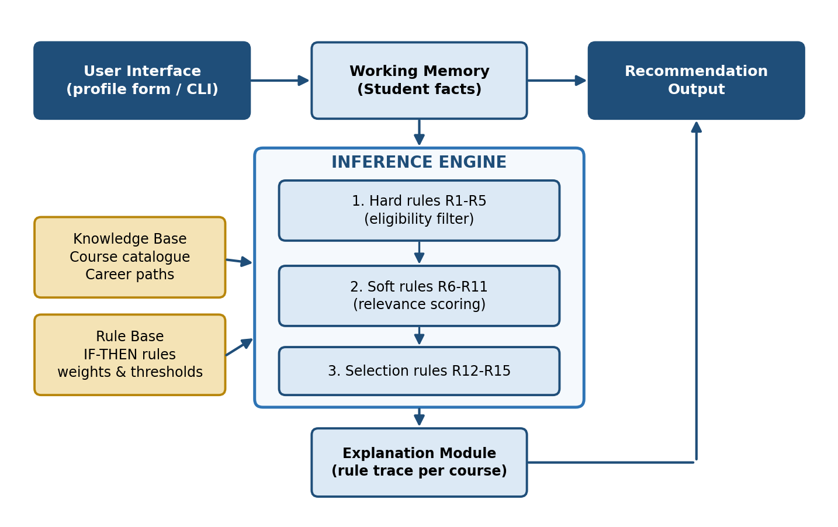
Figure 5.1: Architecture of the rule-based course recommendation system

5.2 System Modules
- Input Module – collects the student profile: semester, CGPA, completed courses, interests, career goal, workload preference, and credit limit.
- Knowledge Base Module – stores the course catalogue (COURSES) and the career-to-course mapping (CAREER_PATHS).
- Rule Base Module – holds the hard rules R1–R5, the soft rules R6–R11 and the selection parameters used by R12–R15.
- Inference Engine – evaluates every course against the rules (function evaluate) and assembles the recommendation (function recommend).
- Selection Module – walks through the ranked list and accepts a course only if the score threshold, course count, credit limit and slot constraints allow it.
- Explanation Module – attaches the rule identifier, the points and the reason to every scored course, and the blocking rule to every rejected course.
- Report Module – prints the recommended courses, the eligible-but-not-selected courses, and the ineligible courses.

5.3 Data Design
Each course in the knowledge base is described by the attributes in Table 5.1. The complete catalogue is listed in Appendix A.
Attribute | Type | Meaning
code, name | text | Course identifier and title
credits | integer | Credit value used by the credit-limit rule (R12)
difficulty | 1 / 2 / 3 | Easy, medium or hard; used by R9 and R10
min_sem | integer | Earliest semester in which the course can be taken (R4)
offered | odd / even / both | Term in which the course is offered (R5)
prereq | list of codes | Courses that must already be completed (R2)
min_cgpa | decimal | Minimum CGPA required (R3)
tags | list of text | Topic tags matched against student interests (R6)
slot | A–F | Timetable slot; two selected courses cannot share a slot (R13)
core | true / false | Core courses receive a bonus while pending (R11)
Table 5.1: Course attributes in the knowledge base
Student attribute | Example | Used by
semester | 5 | R4, R5
cgpa | 7.8 | R3, R9
completed | CS101, MA201, CS102, … | R1, R2, R8, R11
interests | ai, ml, data | R6
career | Data Scientist | R7, R8
workload | light / balanced / heavy | R10
max_credits, max_courses | 12, 5 | R12, R14
Table 5.2: Student profile attributes (working memory)

5.4 Process Flow
Figure 5.2 shows the processing of one student profile. Each course first passes through the hard rules; the survivors are scored by the soft rules, sorted, and finally screened by the selection rules.
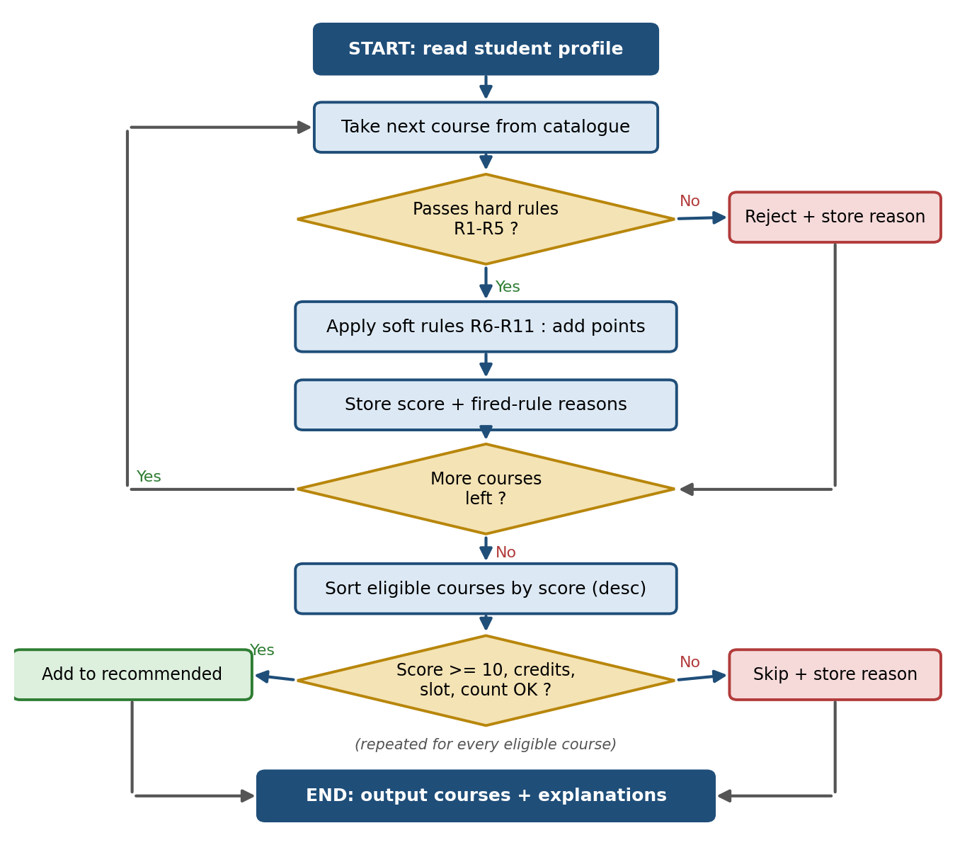
Figure 5.2: Flowchart of the recommendation process

6. Rule Base Design
The rule base contains 15 rules in three layers. Rules are identified by number (R1–R15) so that every explanation in the output can be traced back to this chapter.

6.1 Hard Rules – Eligibility (R1–R5)
A course that violates any hard rule is rejected immediately and the blocking rule is recorded. Hard rules are evaluated in the order shown.
ID | Rule (IF … THEN …) | Purpose
R1 | IF the course is already in the student's completed list THEN reject | Avoid repeating a course
R2 | IF any prerequisite of the course is not completed THEN reject and list the missing courses | Preserve the learning sequence
R3 | IF student CGPA < course minimum CGPA THEN reject | Enforce grade requirements
R4 | IF student semester < course minimum semester THEN reject | Respect programme level
R5 | IF the course is not offered in the current term (odd/even) THEN reject | Respect the academic calendar
Table 6.1: Hard (eligibility) rules

6.2 Soft Rules – Relevance Scoring (R6–R11)
Every course that passes the hard rules starts with a score of zero. Each soft rule that fires adds (or subtracts) points and records a reason string.
ID | Condition | Points | Purpose
R6 | Course tags overlap the student's interests (up to 3 tags) | +8 per matching tag | Interest alignment
R7 | Course belongs to the student's career path | +15 | Career alignment
R8 | Course is a prerequisite of a not-yet-completed course on the career path | +6 | Prioritise gateway courses
R9 | Hard course and CGPA ≥ 8.0  Hard course and CGPA < 6.5  Easy course and CGPA < 6.5 | +4  −10  +4 | Match difficulty to academic standing
R10 | Difficulty versus workload preference  light: easy / hard  balanced: medium  heavy: hard / easy | +3 / −4  +2  +3 / −2 | Respect the student's preferred load
R11 | Course is a core course of the programme that is still pending | +12 | Keep core courses on schedule
Table 6.2: Soft (scoring) rules

6.3 Selection Rules (R12–R15)
Eligible courses are sorted by score (highest first, ties broken by course code) and considered one at a time. A course is added only if all four selection rules allow it; otherwise the reason for skipping it is recorded.
ID | Rule | Default
R12 | IF adding the course would exceed the student's credit limit THEN skip | 12 credits
R13 | IF the course's timetable slot is already used by a selected course THEN skip | one course per slot
R14 | IF the maximum number of courses has been reached THEN skip | 5 courses
R15 | IF the course score is below the minimum relevance score THEN skip | score ≥ 10
Table 6.3: Selection rules

6.4 Weights, Ordering and Tie-Breaking
The point values express a simple priority order that the department can change. A career-path match (+15) is worth more than a single interest match (+8), while several interest matches can outweigh a career match. A pending core course (+12) receives a strong nudge so that core requirements are not postponed. The negative value for hard courses at low CGPA (−10) pushes them below the R15 threshold unless they are strongly aligned with the student's goals. These weights are design choices rather than learned values; Section 9.5 measures how sensitive the results are to the R15 threshold.
Hard rules are order-independent in effect (any violation rejects the course) but are evaluated in the fixed order R1→R5 so that the first blocking reason is reported consistently. Soft rules are additive and therefore commutative. Ties in score are broken alphabetically by course code so that the output is deterministic.

7. Working of the System
This chapter follows Scenario 1 from Chapter 9 step by step. The student is in semester 5 with CGPA 7.8, wants to become a Data Scientist, is interested in AI, ML and data, prefers a balanced workload, and can register for 12 credits. Nine courses are already completed: CS101, MA201, MA202, CS102, CS202, CS201, CS203, AI301 and AI308.

7.1 Stage 1 – Eligibility Filtering
Each of the 25 courses is passed through R1–R5. Completed courses are removed by R1. Computer Vision, Reinforcement Learning, Recommender Systems and Blockchain Technology are removed by R4 because they open only in semester 6, and Operating Systems is removed by R5 because it is offered only in even semesters. No course is blocked by R2 or R3 for this student, because the prerequisites of all remaining courses are satisfied and the CGPA of 7.8 meets every minimum.

7.2 Stage 2 – Relevance Scoring
The remaining courses are scored. Table 7.1 shows the calculation for Natural Language Processing (AI303) and Deep Learning (AI304).
Rule | AI303 – Natural Language Processing | AI304 – Deep Learning
R6 Interest | tags ai, ml, nlp ∩ interests ai, ml, data = ai, ml → +16 | tags ai, ml ∩ interests = ai, ml → +16
R7 Career path | on the Data Scientist path → +15 | not on the Data Scientist path → 0
R8 Gateway | does not unlock a pending path course → 0 | does not unlock a pending path course → 0
R9 CGPA fit | medium difficulty → 0 | hard, but CGPA 7.8 < 8.0 → 0
R10 Workload | medium vs balanced → +2 | hard vs balanced → 0
R11 Core | elective → 0 | elective → 0
Total score | 33 | 16
Table 7.1: Score calculation for two candidate courses

7.3 Stage 3 – Selection
The eligible courses are sorted by score and screened by R12–R15 (Table 7.2). The tie between AI302 and AI303 (both 33) is broken by course code.
Order | Course | Score | Credits (running) | Decision
1 | AI302 Data Mining and Warehousing | 33 | 3 | Selected
2 | AI303 Natural Language Processing | 33 | 6 | Selected
3 | AI306 Big Data Analytics | 25 | 9 | Selected
4 | AI304 Deep Learning | 16 | 9 + 4 = 13 > 12 | Skipped – R12 credit limit
5–11 | Seven other eligible courses | 0 – 2 | – | Skipped – R15 score below 10
Table 7.2: Selection of courses for Scenario 1

7.4 Stage 4 – Explanation and Output
Finally the system prints the recommended courses together with the fired rules and their points, lists the eligible courses that were left out with the rule that excluded them, and lists the ineligible courses with the blocking rule. The complete output of this scenario is reproduced in Chapter 15. Because the reasons come directly from the rules, the student can see, for example, that AI302 was recommended because it matches the interests ‘data’ and ‘ml’ and belongs to the Data Scientist path, and that Deep Learning was not selected only because it would exceed the credit limit.

8. Implementation and Source Code

8.1 Technology Stack
Component | Technology | Role
Programming language | Python 3 | Entire engine, evaluation and report generation
Data structures | dataclasses, typing (standard library) | Course, Student and Candidate models; rule signatures
Rule representation | Python functions in a rule table | Each rule returns a rejection reason or (points, reason)
Visualisation | Matplotlib | Architecture, flowchart and result charts in this report
External dependencies | None for the engine | Runs on any machine with Python installed
Table 8.1: Technology stack

8.2 Project Files
- course_recommender.py – knowledge base, rule base, inference engine, explanation and command-line report (about 280 lines).
- evaluate.py – scenario runner, independent constraint validator, synthetic-student generator, random baseline and threshold sensitivity analysis.
The main parts of course_recommender.py are reproduced below.

8.3 Knowledge Base
@dataclass(frozen=True)
class Course:
code: str
name: str
credits: int
difficulty: int # 1 = easy, 2 = medium, 3 = hard
min_sem: int # earliest semester in which it can be taken
offered: str # "odd", "even" or "both"
prereq: Tuple[str, ...] # course codes that must be completed
min_cgpa: float
tags: Tuple[str, ...] # topic tags used for interest matching
slot: str # timetable slot A-F
core: bool = False # core (compulsory) vs elective

COURSES = { ... } # 25 Course objects, e.g.:
C("CS101", "Programming in Python", 3, 1, 1, "both", (), 0.0,
("programming",), "A", core=True),
C("MA201", "Probability and Statistics", 3, 2, 2, "both", (), 0.0,
("mathematics", "data"), "B", core=True),
C("MA202", "Linear Algebra", 3, 2, 2, "both", (), 0.0,
("mathematics", "ai"), "C", core=True),
# ... 22 more courses (see Appendix A)
Listing 8.1: Course model and catalogue excerpt

8.4 Working Memory
@dataclass
class Student:
name: str
semester: int # semester the student is registering for
cgpa: float
completed: List[str]
interests: List[str]
career: str
workload: str = "balanced" # light | balanced | heavy
max_credits: int = 12 # credits available for this registration
max_courses: int = 5

@dataclass
class Candidate:
course: Course
score: int = 0
reasons: List[str] = field(default_factory=list)
rejected_by: Optional[str] = None
Listing 8.2: Student profile and candidate structures

8.5 Hard Rules R1–R5
# 3a. HARD rules -> return None if satisfied, otherwise a rejection reason
def r1_not_completed(s: Student, c: Course) -> Optional[str]:
return "already completed" if c.code in s.completed else None

def r2_prerequisites(s: Student, c: Course) -> Optional[str]:
missing = [p for p in c.prereq if p not in s.completed]
return f"missing prerequisite(s): {', '.join(missing)}" if missing else None

def r3_min_cgpa(s: Student, c: Course) -> Optional[str]:
return (f"CGPA {s.cgpa:.2f} below required {c.min_cgpa:.1f}"
if s.cgpa < c.min_cgpa else None)

def r4_semester_level(s: Student, c: Course) -> Optional[str]:
return (f"not open before semester {c.min_sem}"
if s.semester < c.min_sem else None)

def r5_term_offering(s: Student, c: Course) -> Optional[str]:
term = "odd" if s.semester % 2 else "even"
return (f"offered only in {c.offered} semesters"
if c.offered not in ("both", term) else None)

HARD_RULES: List[Tuple[str, Callable]] = [
("R1", r1_not_completed), ("R2", r2_prerequisites), ("R3", r3_min_cgpa),
("R4", r4_semester_level), ("R5", r5_term_offering),
]
Listing 8.3: Hard (eligibility) rules

8.6 Soft Rules R6–R11
# 3b. SOFT rules -> return (points, reason) or None
def r6_interest(s: Student, c: Course):
hits = [t for t in c.tags if t in s.interests][:3]
return (8 * len(hits), f"matches interest(s): {', '.join(hits)}") if hits else None

def r7_career(s: Student, c: Course):
if c.code in CAREER_PATHS.get(s.career, []):
return 15, f"part of the {s.career} career path"

def r8_gateway(s: Student, c: Course):
path = [x for x in CAREER_PATHS.get(s.career, []) if x not in s.completed]
unlocks = [x for x in path if c.code in COURSES[x].prereq]
if unlocks:
return 6, f"gateway course, unlocks {', '.join(unlocks)}"

def r9_cgpa_fit(s: Student, c: Course):
if c.difficulty == 3 and s.cgpa >= 8.0:
return 4, "high CGPA - suited for an advanced course"
if c.difficulty == 3 and s.cgpa < 6.5:
return -10, "difficult course for the current CGPA"
if c.difficulty == 1 and s.cgpa < 6.5:
return 4, "easier course helps to improve CGPA"

WORKLOAD_POINTS = {"light": {1: 3, 2: 0, 3: -4},
"balanced": {1: 0, 2: 2, 3: 0},
"heavy": {1: -2, 2: 0, 3: 3}}

def r10_workload(s: Student, c: Course):
p = WORKLOAD_POINTS[s.workload][c.difficulty]
if p:
level = ["", "easy", "medium", "hard"][c.difficulty]
return p, f"{level} course vs '{s.workload}' workload preference"

def r11_pending_core(s: Student, c: Course):
if c.core:
return 12, "pending core course of the programme"

SOFT_RULES: List[Tuple[str, Callable]] = [
("R6", r6_interest), ("R7", r7_career), ("R8", r8_gateway),
("R9", r9_cgpa_fit), ("R10", r10_workload), ("R11", r11_pending_core),
]
Listing 8.4: Soft (scoring) rules

8.7 Inference Engine and Selection
MIN_SCORE = 10 # R15: courses scoring below this are not relevant enough to recommend

# ---------------------------------------------------------------- 4. INFERENCE ENGINE
def evaluate(s: Student) -> List[Candidate]:
"""Forward-chain every course through the hard rules, then the soft rules."""
out = []
for course in COURSES.values():
cand = Candidate(course)
for rid, rule in HARD_RULES:
why = rule(s, course)
if why:
cand.rejected_by = f"{rid}: {why}"
break
if cand.rejected_by is None:
for rid, rule in SOFT_RULES:
res = rule(s, course)
if res:
pts, why = res
cand.score += pts
cand.reasons.append(f"{rid} ({pts:+d}) {why}")
out.append(cand)
return out

def recommend(s: Student):
"""Returns (selected, skipped_for_constraints, rejected)."""
cands = evaluate(s)
eligible = sorted((c for c in cands if c.rejected_by is None),
key=lambda c: (-c.score, c.course.code))
rejected = [c for c in cands if c.rejected_by]
selected, skipped, credits, slots = [], [], 0, set()
for c in eligible: # R12 - R15 selection rules
if c.score < MIN_SCORE:
skipped.append((c, f"R15: relevance score below {MIN_SCORE}"))
elif len(selected) >= s.max_courses:
skipped.append((c, "R14: maximum course count reached"))
elif credits + c.course.credits > s.max_credits:
skipped.append((c, "R12: credit limit would be exceeded"))
elif c.course.slot in slots:
skipped.append((c, "R13: timetable slot clash"))
else:
selected.append(c)
credits += c.course.credits
slots.add(c.course.slot)
return selected, skipped, rejected
Listing 8.5: Inference engine (evaluate) and selection (recommend)

8.8 Running the System
python course_recommender.py # runs a demo student and prints the report
python evaluate.py # scenarios, 1000-student stress test, sensitivity
To use the engine for another programme, replace the COURSES and CAREER_PATHS tables with the department's data; to change policy, edit the corresponding rule function or its weights.

9. Testing, Results and Analysis

9.1 Test Design
Three kinds of tests were carried out: (i) four hand-designed scenarios whose expected behaviour was checked by hand, (ii) a stress test on 1,000 synthetic student profiles with an independent constraint validator, and (iii) a threshold sensitivity analysis. The synthetic profiles were generated with a fixed random seed (2026) with semester 3–7, CGPA 5.0–9.6, a completed-course set that is consistent with the prerequisites, 2–4 random interests, a random career goal and workload preference, and a credit limit of 9–15.
Important: the catalogue is illustrative and the students are synthetic. The results therefore show that the rules behave as designed and how the parameters influence the output; they are not a measurement of real student satisfaction.

9.2 Scenario Tests
Scenario | Profile | Recommended courses | Behaviour observed
1 – Data Scientist aspirant | Sem 5, CGPA 7.8, balanced | AI302, AI303, AI306 (9 cr) | Deep Learning skipped by R12; semester-6 courses blocked by R4; OS blocked by R5
2 – Low-CGPA software track | Sem 4, CGPA 6.1, light | CS301, CS302 (6 cr) | Algorithms (needs 6.5) blocked by R3; AI electives blocked by R2; easy CS302 favoured by R9/R10
3 – High-CGPA ML researcher | Sem 6, CGPA 8.9, heavy | AI307, AI305, AI310 (9 cr) | Hard courses rewarded by R9/R10; odd-term courses blocked by R5
4 – Early-stage security aspirant | Sem 3, CGPA 7.2, balanced | CS203, CS102, CS202 (10 cr) | 18 courses blocked (mostly R2); CS203 ranked first as gateway to the security path (R8)
Table 9.1: Summary of scenario results (full outputs in Chapter 15)
In every scenario the recommended courses were checked manually against the catalogue: all prerequisites were met, no slot was repeated, and the credit limit was respected. Scenario 4 shows the value of R2: a semester-3 student who has completed only two courses is correctly shown that most of the catalogue is not yet accessible, along with the exact missing prerequisites.

9.3 Constraint Compliance on 1,000 Synthetic Profiles
A separate validator re-checks each recommendation set directly against the catalogue, without calling the rule functions, for completed courses, prerequisites, CGPA, semester level, term, credit total, slot uniqueness and course count.
Measure | Result
Synthetic student profiles tested | 1,000
Recommendation sets with any constraint violation – rule-based engine | 0 of 1,000
Sets with at least one violation – 4 courses drawn at random from the catalogue | 999 of 1,000
Average number of courses recommended per student | 2.26
Average credits recommended per student | 6.93
Students who received no recommendation | 22 (2.2%)
Time per recommendation (development machine) | well under 1 ms (mean ≈ 0.04 ms)
Table 9.2: Results of the synthetic stress test
The engine produced no invalid recommendation set, whereas almost every set of randomly chosen courses violated at least one rule. This confirms that the hard and selection rules work as intended and that a policy-blind recommender would be unusable for registration.

9.4 Relevance Compared with a Random Baseline
To measure whether the scoring rules improve the quality of the recommendations, they were compared with a baseline that chooses randomly among the courses that pass the hard rules while respecting the credit, slot and count limits. A recommended course is counted as relevant if it matches at least one of the student's interest tags or lies on the student's career path, and as career-aligned if it lies on the career path.
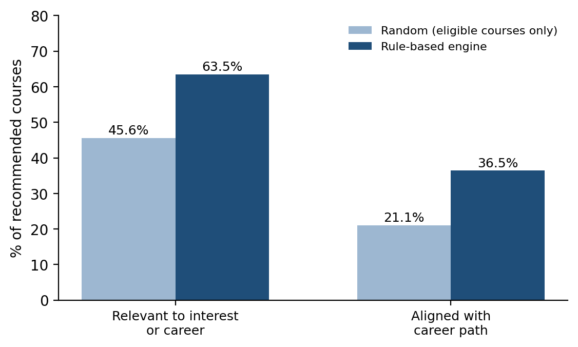
Figure 9.1: Rule-based engine versus random selection among eligible courses
The engine raised relevance from 45.6% to 63.5% and career alignment from 21.1% to 36.5%. Because the relevance measure uses the same information that the soft rules use, an improvement over random is expected by construction; the comparison verifies that the scoring works, but it does not replace a study with real students and advisors.

9.5 Sensitivity to the Relevance Threshold (R15)
R15 controls how relevant a course must be before it is recommended. Table 9.3 and Figure 9.2 show the effect of changing the threshold on the same 1,000 profiles.
R15 threshold | Avg. courses | Avg. credits | Relevance (%) | Career-aligned (%) | Students with none | Invalid sets
0 | 2.81 | 8.39 | 55.5 | 29.3 | 5 | 0
5 | 2.43 | 7.4 | 64.2 | 34 | 13 | 0
10 (chosen) | 2.26 | 6.93 | 63.5 | 36.5 | 22 | 0
15 | 1.68 | 5.17 | 78.1 | 48.2 | 61 | 0
20 | 1.2 | 3.73 | 84.7 | 47.2 | 214 | 0
Table 9.3: Effect of the R15 threshold
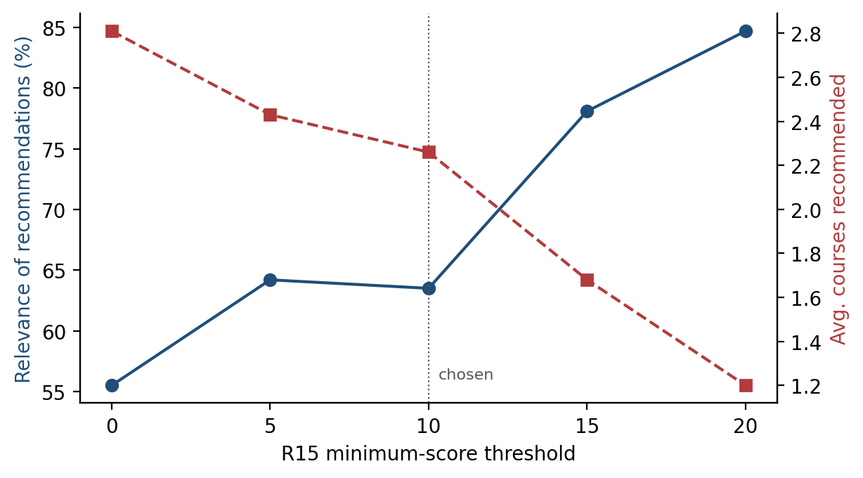
Figure 9.2: Relevance versus number of recommended courses for different R15 thresholds
A higher threshold gives more relevant but fewer recommendations, and leaves more students with none; a threshold of zero fills the credit budget but with weaker matches. A value of 10 was chosen as a balance: it requires at least a moderate interest, career or core-course signal while leaving only 2.2% of profiles without a recommendation. The number of invalid sets stays at zero for every threshold, showing that safety comes from the hard and selection rules and not from the tuning parameter.

9.6 Rule Activity
Rule | Fired in recommended courses | Share of all recommendations
R6 | 902 | 39.9%
R7 | 825 | 36.5%
R8 | 807 | 35.7%
R9 | 267 | 11.8%
R10 | 1,003 | 44.4%
R11 | 1,656 | 73.3%
Table 9.4: How often each soft rule contributed to a recommendation (2,260 recommendations in total)
R11 (pending core course) and R10 (workload) contribute most often, R6 and R7 shape the elective choices, and R9 fires in about one in eight recommendations, mainly for students at the extremes of the CGPA range.

9.7 Discussion and Threats to Validity
- Synthetic data. Students were generated randomly, so real preference patterns are not represented.
- Illustrative catalogue. The 25-course catalogue is smaller than a real one; more courses would give the scoring rules more room to differentiate.
- Circular relevance metric. Relevance is defined from the same interest and career information that the soft rules use, so it verifies rule behaviour, not usefulness to a human.
- Heuristic weights. The point values were set by design; different departments may prefer different priorities.
- Low recommendation count. The average of about 2 courses per student reflects the strict eligibility filtering, credit limit and the R15 threshold on a small catalogue.

10. Advantages

10.1 Transparency and Explainability
Every recommendation is accompanied by the rules that produced it, and every rejection by the rule that blocked it. Students and advisors can read, question and correct the reasoning, which is not possible with black-box models.

10.2 Guaranteed Policy Compliance
Prerequisites, CGPA limits, term restrictions, credit limits and slot clashes are enforced as hard conditions. In the stress test, none of the 1,000 recommendation sets violated any of them.

10.3 No Training Data Required
The system can be deployed as soon as the catalogue and rules are defined. There is no cold-start problem for new students, new courses or new programmes.

10.4 Easy Maintenance and Customisation
Changing a policy means editing one rule or one catalogue entry. Departments can adjust the weights, the threshold and the career paths without any machine-learning expertise.

10.5 Speed and Low Cost
A recommendation takes well under a millisecond on an ordinary computer. The engine uses only the Python standard library and needs no GPU, database or cloud service.

11. Limitations

11.1 Manually Defined Knowledge
All course data, career paths and weights must be entered and maintained by people. If the catalogue is out of date, the recommendations are out of date.

11.2 Heuristic Weights
The point values are reasonable design choices but are not learned from outcomes such as grades or student satisfaction, so they may not be optimal for every student.

11.3 Coarse Interest Modelling
Interests are matched through a fixed vocabulary of tags. A student whose interests are not covered by the tags, or who is undecided, receives weaker personalised guidance.

11.4 Greedy Selection
Courses are added in score order until a limit is reached. This is fast and explainable but not guaranteed to be optimal: in Scenario 1 the 4-credit Deep Learning course was skipped and three credits remained unused, although a different combination might have used the credit budget more fully.

11.5 Limited Evaluation
The system was evaluated on an illustrative catalogue and synthetic students. It has not been tested with real students, grades or advisors, and no claim is made about real-world acceptance.

11.6 No Learning from Feedback
The rule base does not adapt automatically when students accept or reject recommendations.

12. Future Scope

12.1 Web Interface
A form-based interface, for example built with Streamlit, would let students enter their profile and view recommendations with expandable explanations instead of using the command line.

12.2 Integration with the University ERP
Connecting the system to the student information system would automatically load completed courses, CGPA and the live timetable, and could pass the recommended courses to the registration workflow.

12.3 Hybrid Recommendation
The rule engine can act as a safe filter that supplies only eligible courses to a learned model such as collaborative filtering on past enrolments, combining guaranteed compliance with data-driven personalisation.

12.4 Rule and Weight Learning
Association-rule mining of historical enrolment and grade data could suggest new rules (for example, which elective combinations lead to better results) and help to calibrate the weights.

12.5 Optimal Course-Load Planning
Replacing the greedy selection by a constraint-satisfaction or integer-programming solver would find the highest-scoring feasible set of courses, and a multi-semester planner could map the complete path to graduation.

12.6 Feedback Loop
Collecting acceptance and rejection of recommendations, and later course outcomes, would allow the department to refine the rules and evaluate the system with real users.

13. Conclusion
This project designed, implemented and evaluated a rule-based recommendation system for course selection. The system encodes academic regulations and advisory experience in 15 IF–THEN rules arranged in three layers — eligibility, scoring and selection — and applies them through a small inference engine to a knowledge base of courses and career paths.
The evaluation showed that the layered design achieves its main goals. On 1,000 synthetic profiles, no recommendation set violated any prerequisite, CGPA, term, credit or slot constraint, while randomly chosen sets almost always did. The scoring rules increased the share of recommendations that match a student's interests or career path over a random choice among eligible courses, and the threshold analysis showed the trade-off between the relevance and the number of recommendations. Each recommendation and each rejection is accompanied by a readable explanation, and the whole process runs in well under a millisecond on ordinary hardware.
The work also has clear limits. The catalogue is illustrative, the students in the evaluation are synthetic, the weights are heuristic, and the selection is greedy. These limitations point directly to the future work described in Chapter 12: a user interface, integration with real academic data, hybrid recommendation, learned weights and optimal course-load planning.
In conclusion, when the domain knowledge is explicit and decisions must be justified, a rule-based recommender is a practical, transparent and dependable foundation for academic decision support, and it provides a solid baseline on which more advanced data-driven techniques can be built.

14. References
[1] Ricci, F., Rokach, L., & Shapira, B. (Eds.). (2015). Recommender Systems Handbook (2nd ed.). Springer.
[2] Adomavicius, G., & Tuzhilin, A. (2005). Toward the next generation of recommender systems: A survey of the state-of-the-art and possible extensions. IEEE Transactions on Knowledge and Data Engineering, 17(6), 734–749.
[3] Burke, R. (2002). Hybrid recommender systems: Survey and experiments. User Modeling and User-Adapted Interaction, 12(4), 331–370.
[4] Felfernig, A., & Burke, R. (2008). Constraint-based recommender systems: Technologies and research issues. Proceedings of the 10th International Conference on Electronic Commerce (ICEC '08).
[5] Jackson, P. (1998). Introduction to Expert Systems (3rd ed.). Addison-Wesley.
[6] Russell, S., & Norvig, P. (2020). Artificial Intelligence: A Modern Approach (4th ed.). Pearson.
[7] Forgy, C. L. (1982). Rete: A fast algorithm for the many pattern/many object pattern match problem. Artificial Intelligence, 19(1), 17–37.
[8] Bendakir, N., & Aïmeur, E. (2006). Using association rules for course recommendation. Proceedings of the AAAI Workshop on Educational Data Mining.
[9] Aher, S. B., & Lobo, L. M. R. J. (2013). Combination of machine learning algorithms for recommendation of courses in E-Learning System based on historical data. Knowledge-Based Systems, 51, 1–14.
[10] Lu, J., Wu, D., Mao, M., Wang, W., & Zhang, G. (2015). Recommender system application developments: A survey. Decision Support Systems, 74, 12–32.

15. Output
The following listings are the unedited outputs produced by the system (function report) for the four test scenarios of Chapter 9. Each listing shows the recommended courses with the fired rules, the eligible courses that were not selected, and the ineligible courses with the blocking rule.

15.1 Scenario 1
========================================================================
Student : Scenario 1 - Data Scientist aspirant | Semester 5 | CGPA 7.80
Career : Data Scientist | Interests: ai, ml, data
Workload: balanced | Credit limit: 12
========================================================================
RECOMMENDED COURSES
1. AI302 Data Mining and Warehousing [3 cr, slot E] score=33
- R6 (+16) matches interest(s): data, ml
- R7 (+15) part of the Data Scientist career path
- R10 (+2) medium course vs 'balanced' workload preference
2. AI303 Natural Language Processing [3 cr, slot F] score=33
- R6 (+16) matches interest(s): ai, ml
- R7 (+15) part of the Data Scientist career path
- R10 (+2) medium course vs 'balanced' workload preference
3. AI306 Big Data Analytics [3 cr, slot C] score=25
- R6 (+8) matches interest(s): data
- R7 (+15) part of the Data Scientist career path
- R10 (+2) medium course vs 'balanced' workload preference
Total credits: 9

ELIGIBLE BUT NOT SELECTED
AI304 Deep Learning (score 16) -> R12: credit limit would be exceeded
(7 more eligible course(s) skipped: relevance score below 10)

NOT ELIGIBLE
CS204 Operating Systems -> R5: offered only in even semesters
AI305 Computer Vision -> R4: not open before semester 6
AI307 Reinforcement Learning -> R4: not open before semester 6
AI310 Recommender Systems -> R4: not open before semester 6
CS306 Blockchain Technology -> R4: not open before semester 6
Output 1: Scenario 1 - Data Scientist aspirant

15.2 Scenario 2
========================================================================
Student : Scenario 2 - Low-CGPA software track | Semester 4 | CGPA 6.10
Career : Software Developer | Interests: web, software
Workload: light | Credit limit: 12
========================================================================
RECOMMENDED COURSES
1. CS301 Web Technologies [3 cr, slot A] score=31
- R6 (+16) matches interest(s): web, software
- R7 (+15) part of the Software Developer career path
2. CS302 Software Engineering [3 cr, slot B] score=30
- R6 (+8) matches interest(s): software
- R7 (+15) part of the Software Developer career path
- R9 (+4) easier course helps to improve CGPA
- R10 (+3) easy course vs 'light' workload preference
Total credits: 6
(4 more eligible course(s) skipped: relevance score below 10)

NOT ELIGIBLE
AI302 Data Mining and Warehousing -> R4: not open before semester 5
AI303 Natural Language Processing -> R2: missing prerequisite(s): AI301
AI304 Deep Learning -> R2: missing prerequisite(s): AI301
AI305 Computer Vision -> R2: missing prerequisite(s): AI301
AI306 Big Data Analytics -> R4: not open before semester 5
AI307 Reinforcement Learning -> R2: missing prerequisite(s): AI301
AI310 Recommender Systems -> R2: missing prerequisite(s): AI301
CS303 Cloud Computing -> R4: not open before semester 5
CS304 Mobile App Development -> R4: not open before semester 5
CS305 Design and Analysis of Algorithms -> R3: CGPA 6.10 below required 6.5
CS306 Blockchain Technology -> R4: not open before semester 6
SEC301 Cyber Security -> R4: not open before semester 5
Output 2: Scenario 2 - Low-CGPA software track

15.3 Scenario 3
========================================================================
Student : Scenario 3 - High-CGPA ML researcher | Semester 6 | CGPA 8.90
Career : ML Engineer | Interests: ai, ml, research
Workload: heavy | Credit limit: 13
========================================================================
RECOMMENDED COURSES
1. AI307 Reinforcement Learning [3 cr, slot D] score=46
- R6 (+24) matches interest(s): ai, ml, research
- R7 (+15) part of the ML Engineer career path
- R9 (+4) high CGPA - suited for an advanced course
- R10 (+3) hard course vs 'heavy' workload preference
2. AI305 Computer Vision [3 cr, slot B] score=38
- R6 (+16) matches interest(s): ai, ml
- R7 (+15) part of the ML Engineer career path
- R9 (+4) high CGPA - suited for an advanced course
- R10 (+3) hard course vs 'heavy' workload preference
3. AI310 Recommender Systems [3 cr, slot F] score=16
- R6 (+16) matches interest(s): ai, ml
Total credits: 9
(4 more eligible course(s) skipped: relevance score below 10)

NOT ELIGIBLE
CS303 Cloud Computing -> R5: offered only in odd semesters
CS304 Mobile App Development -> R5: offered only in odd semesters
CS305 Design and Analysis of Algorithms -> R5: offered only in odd semesters
SEC301 Cyber Security -> R5: offered only in odd semesters
Output 3: Scenario 3 - High-CGPA ML researcher

15.4 Scenario 4
========================================================================
Student : Scenario 4 - Early-stage security aspirant | Semester 3 | CGPA 7.20
Career : Cyber Security Analyst | Interests: security, networks
Workload: balanced | Credit limit: 12
========================================================================
RECOMMENDED COURSES
1. CS203 Computer Networks [3 cr, slot B] score=51
- R6 (+16) matches interest(s): networks, security
- R7 (+15) part of the Cyber Security Analyst career path
- R8 (+6) gateway course, unlocks SEC301, CS306, CS303
- R10 (+2) medium course vs 'balanced' workload preference
- R11 (+12) pending core course of the programme
2. CS102 Data Structures and Algorithms [4 cr, slot D] score=20
- R8 (+6) gateway course, unlocks CS204, CS306
- R10 (+2) medium course vs 'balanced' workload preference
- R11 (+12) pending core course of the programme
3. CS202 Object Oriented Programming [3 cr, slot E] score=14
- R10 (+2) medium course vs 'balanced' workload preference
- R11 (+12) pending core course of the programme
Total credits: 10

ELIGIBLE BUT NOT SELECTED
MA202 Linear Algebra (score 14) -> R12: credit limit would be exceeded
(1 more eligible course(s) skipped: relevance score below 10)

NOT ELIGIBLE
CS201 Database Management Systems -> R2: missing prerequisite(s): CS102
CS204 Operating Systems -> R2: missing prerequisite(s): CS102
AI301 Introduction to Machine Learning -> R4: not open before semester 4
AI302 Data Mining and Warehousing -> R2: missing prerequisite(s): CS201
AI303 Natural Language Processing -> R2: missing prerequisite(s): AI301
AI304 Deep Learning -> R2: missing prerequisite(s): AI301, MA202
AI305 Computer Vision -> R2: missing prerequisite(s): AI301
AI306 Big Data Analytics -> R2: missing prerequisite(s): CS201
AI307 Reinforcement Learning -> R2: missing prerequisite(s): AI301
AI308 Data Visualization -> R4: not open before semester 4
AI310 Recommender Systems -> R2: missing prerequisite(s): AI301, CS201
CS301 Web Technologies -> R2: missing prerequisite(s): CS202
CS302 Software Engineering -> R2: missing prerequisite(s): CS202
CS303 Cloud Computing -> R2: missing prerequisite(s): CS203
CS304 Mobile App Development -> R2: missing prerequisite(s): CS202
CS305 Design and Analysis of Algorithms -> R2: missing prerequisite(s): CS102
CS306 Blockchain Technology -> R2: missing prerequisite(s): CS203, CS102
SEC301 Cyber Security -> R2: missing prerequisite(s): CS203
Output 4: Scenario 4 - Early-stage security aspirant

Appendix A: Course Catalogue
Table A.1 lists the illustrative catalogue used in the project. Difficulty: 1 = easy, 2 = medium, 3 = hard.
Code | Course | Cr | Diff | Min sem | Offered | Prereqs | Min CGPA | Slot | Type
CS101 | Programming in Python | 3 | 1 | 1 | both | - | 0.0 | A | Core
MA201 | Probability and Statistics | 3 | 2 | 2 | both | - | 0.0 | B | Core
MA202 | Linear Algebra | 3 | 2 | 2 | both | - | 0.0 | C | Core
CS102 | Data Structures and Algorithms | 4 | 2 | 2 | both | CS101 | 0.0 | D | Core
CS202 | Object Oriented Programming | 3 | 2 | 3 | both | CS101 | 0.0 | E | Core
CS201 | Database Management Systems | 3 | 2 | 3 | both | CS102 | 0.0 | A | Core
CS203 | Computer Networks | 3 | 2 | 3 | both | CS101 | 0.0 | B | Core
CS204 | Operating Systems | 4 | 3 | 4 | even | CS102 | 6.0 | C | Core
AI301 | Introduction to Machine Learning | 4 | 2 | 4 | even | CS101, MA201 | 6.0 | D | Elective
AI302 | Data Mining and Warehousing | 3 | 2 | 5 | odd | CS201, MA201 | 6.0 | E | Elective
AI303 | Natural Language Processing | 3 | 2 | 5 | odd | AI301 | 6.5 | F | Elective
AI304 | Deep Learning | 4 | 3 | 5 | odd | AI301, MA202 | 7.0 | A | Elective
AI305 | Computer Vision | 3 | 3 | 6 | even | AI301 | 7.0 | B | Elective
AI306 | Big Data Analytics | 3 | 2 | 5 | odd | CS201 | 6.0 | C | Elective
AI307 | Reinforcement Learning | 3 | 3 | 6 | even | AI301 | 7.5 | D | Elective
AI308 | Data Visualization | 2 | 1 | 4 | both | CS101 | 0.0 | E | Elective
AI310 | Recommender Systems | 3 | 2 | 6 | even | AI301, CS201 | 6.5 | F | Elective
CS301 | Web Technologies | 3 | 2 | 4 | both | CS202 | 0.0 | A | Elective
CS302 | Software Engineering | 3 | 1 | 4 | both | CS202 | 0.0 | B | Elective
CS303 | Cloud Computing | 3 | 2 | 5 | odd | CS203 | 6.0 | C | Elective
CS304 | Mobile App Development | 3 | 2 | 5 | odd | CS202 | 6.0 | D | Elective
CS305 | Design and Analysis of Algorithms | 4 | 3 | 5 | odd | CS102 | 6.5 | E | Elective
CS306 | Blockchain Technology | 3 | 2 | 6 | even | CS203, CS102 | 6.0 | F | Elective
SEC301 | Cyber Security | 3 | 2 | 5 | odd | CS203 | 6.0 | B | Elective
HS301 | Entrepreneurship and Startups | 2 | 1 | 3 | both | - | 0.0 | F | Elective
Table A.1: Course catalogue

Appendix B: Career Paths
Table B.1 lists the courses associated with each career goal (used by rules R7 and R8).
Career goal | Supporting courses
Data Scientist | MA201, AI301, AI302, AI306, AI308, AI303, AI310
ML Engineer | CS102, AI301, AI304, AI305, AI303, AI307
Software Developer | CS102, CS202, CS201, CS301, CS302, CS304, CS305
Web Developer | CS202, CS201, CS301, CS303, SEC301
Cyber Security Analyst | CS203, CS204, SEC301, CS306, CS303
Cloud Engineer | CS203, CS204, CS303, AI306, SEC301
Data Analyst | MA201, CS201, AI308, AI302, AI306
Researcher | MA201, MA202, AI301, AI304, AI307, CS305
Entrepreneur | HS301, CS301, CS302, CS304, AI308
Mobile App Developer | CS202, CS304, CS301, CS302
Table B.1: Career-to-course mapping

