SIMULATED ANNEALING BASED
JOB SCHEDULING SYSTEM
Documentation of Fundamental AI and ML
An Artificial Intelligence based Heuristic Optimization Approach to Multi-Machine Job Scheduling

Table of Contents
1. Abstract 3
2. Introduction 4
3. Problem Statement 5
4. Objective 6
5. Proposed System 7
6. System Architecture 8
7. Main Components 9
8. Working Principle 10
9. Example of Automatic Control 12
10. Role of Artificial Intelligence and Machine Learning 13
11. Software Requirement 14
12. Advantages 15
13. Limitations 16
14. Applications 17
15. Future Scope 18
16. Expected Outcomes 19
17. Conclusion 20
Appendix A: Python Reference Implementation 21
18. References 24

1. Abstract
Job scheduling — the assignment of a finite set of jobs to a finite set of machines or resources over time — is one of the most common and computationally challenging problems faced in manufacturing, cloud computing, and operations research. Because the search space of possible schedules grows combinatorically with the number of jobs and machines, exact optimization methods quickly become impractical for real-world instances. This documentation presents a Simulated Annealing (SA) based Job Scheduling System, an Artificial Intelligence driven metaheuristic approach that mimics the physical process of annealing in metallurgy to iteratively search for near-optimal job-to-machine allocations. The system accepts a pool of jobs with attributes such as processing time, deadline, and priority, and produces an optimized schedule that minimizes make span, balances machine load, and reduces tardiness penalties. The document covers the problem formulation, system architecture, working principle of the simulated annealing algorithm, a worked example, the supporting role of AI/ML techniques for parameter tuning and predictive estimation, and a full Python reference implementation, followed by advantages, limitations, applications, and future scope of the system.

2. Introduction
Scheduling problems arise whenever a limited number of resources must be allocated to a set of tasks that compete for those resources over time. Typical examples include assigning production jobs to machines in a factory, allocating computational tasks to processors or virtual machines in a data center, scheduling examinations to classrooms, or planning delivery routes for a logistics fleet. The Job Scheduling Problem, particularly in its multi-machine form, is classified as NP-hard: as the number of jobs and machines increases, the number of possible schedules grows exponentially, making brute-force or exhaustive search computationally infeasible beyond very small problem sizes.
To address such problems, researchers rely on heuristic and metaheuristic optimization techniques that do not guarantee a mathematically optimal solution but instead efficiently discover high-quality, near-optimal solutions within a reasonable time budget. Simulated Annealing is one of the most well-studied and widely applied metaheuristics of this kind. Originally inspired by the annealing process in metallurgy — where a material is heated and then slowly cooled to remove defects and reach a low-energy, stable crystalline structure — Simulated Annealing applies the same principle to combinatorial optimization. It explores the solution space by allowing occasional moves to worse solutions (controlled by a temperature parameter that decreases over time), which helps the algorithm escape local optima and converge toward a globally good solution.
This documentation describes a complete Simulated Annealing Based Job Scheduling System that combines this classical optimization technique with supporting Artificial Intelligence and Machine Learning components for parameter tuning and predictive decision-making, resulting in a practical, adaptive, and explainable scheduling tool suitable for both academic study and real-world deployment.

3. Problem Statement
Given a set of n jobs J = {J1, J2, ..., Jn}, where each job Ji has a processing time pi, an optional deadline di, and a priority weight wi, and a set of m identical or non-identical machines M = {M1, M2, ..., Mm}, the objective is to determine an assignment of jobs to machines — and, where relevant, an execution order on each machine — such that one or more scheduling objectives are optimized, typically subject to the following constraints:
- Each job must be assigned to exactly one machine and cannot be split across machines.
- A machine can process only one job at a time (no overlapping execution).
- Job deadlines and priority levels should be respected as closely as possible.
- Machine capacities and availability windows must not be violated.
The primary optimization objective addressed by this system is minimization of the make span — the completion time of the last job to finish across all machines — together with secondary objectives of minimizing total tardiness (the extent to which jobs finish after their deadlines) and minimizing load imbalance across machines. Because the number of possible job-to-machine assignments is m^n, exhaustive search is computationally intractable for realistic values of n and m, which motivates the use of a metaheuristic search technique such as Simulated Annealing.

4. Objective
- To design and implement a job scheduling system that uses the Simulated Annealing metaheuristic to produce near-optimal job-to-machine allocations.
- To minimize the overall make span while balancing the workload across all available machines.
- To incorporate job priorities and deadlines into the optimization objective to reduce tardiness.
- To integrate supporting AI/ML techniques for adaptive parameter tuning (temperature, cooling rate) and predictive estimation of job processing times.
- To provide a modular, extensible system architecture that can be adapted to different scheduling domains such as manufacturing, cloud computing, and academic timetabling.
- To demonstrate, through a worked example and reference implementation, the effectiveness of Simulated Annealing over naive or random scheduling approaches.

5. Proposed System
The proposed system is an intelligent job scheduling engine built around a Simulated Annealing optimization core, supplemented by an AI/ML assistance layer. Jobs are submitted through a user interface along with their attributes (processing time, deadline, priority). These jobs, together with the available machine pool and any operational constraints, are passed to the Job Queue and Constraint Manager, which maintains the current state of all pending and in-progress jobs.
The core of the system is the Simulated Annealing Optimization Engine, which starts from an initial (often random or heuristic) schedule and iteratively refines it by proposing small changes — such as moving a job to a different machine or swapping the machine assignments of two jobs — and accepting or rejecting each change based on the Metropolis acceptance criterion. As the algorithm proceeds, a cooling schedule gradually reduces the 'temperature' parameter, decreasing the probability of accepting worse solutions and steering the search toward convergence. An AI/ML Assistance Layer supports this process by tuning hyperparameters (initial temperature, cooling rate) based on problem characteristics, and by predicting job processing durations from historical data when exact times are not known in advance. The final output is an optimized schedule, typically visualized as a Gantt chart, showing the job-to-machine allocation and expected completion times.

6. System Architecture
The system follows a layered architecture consisting of a user interface layer, a job and constraint management layer, the simulated annealing optimization engine with its four functional sub-components, an AI/ML assistance layer, and an output layer that presents the optimized schedule. Figure 1 illustrates this architecture.
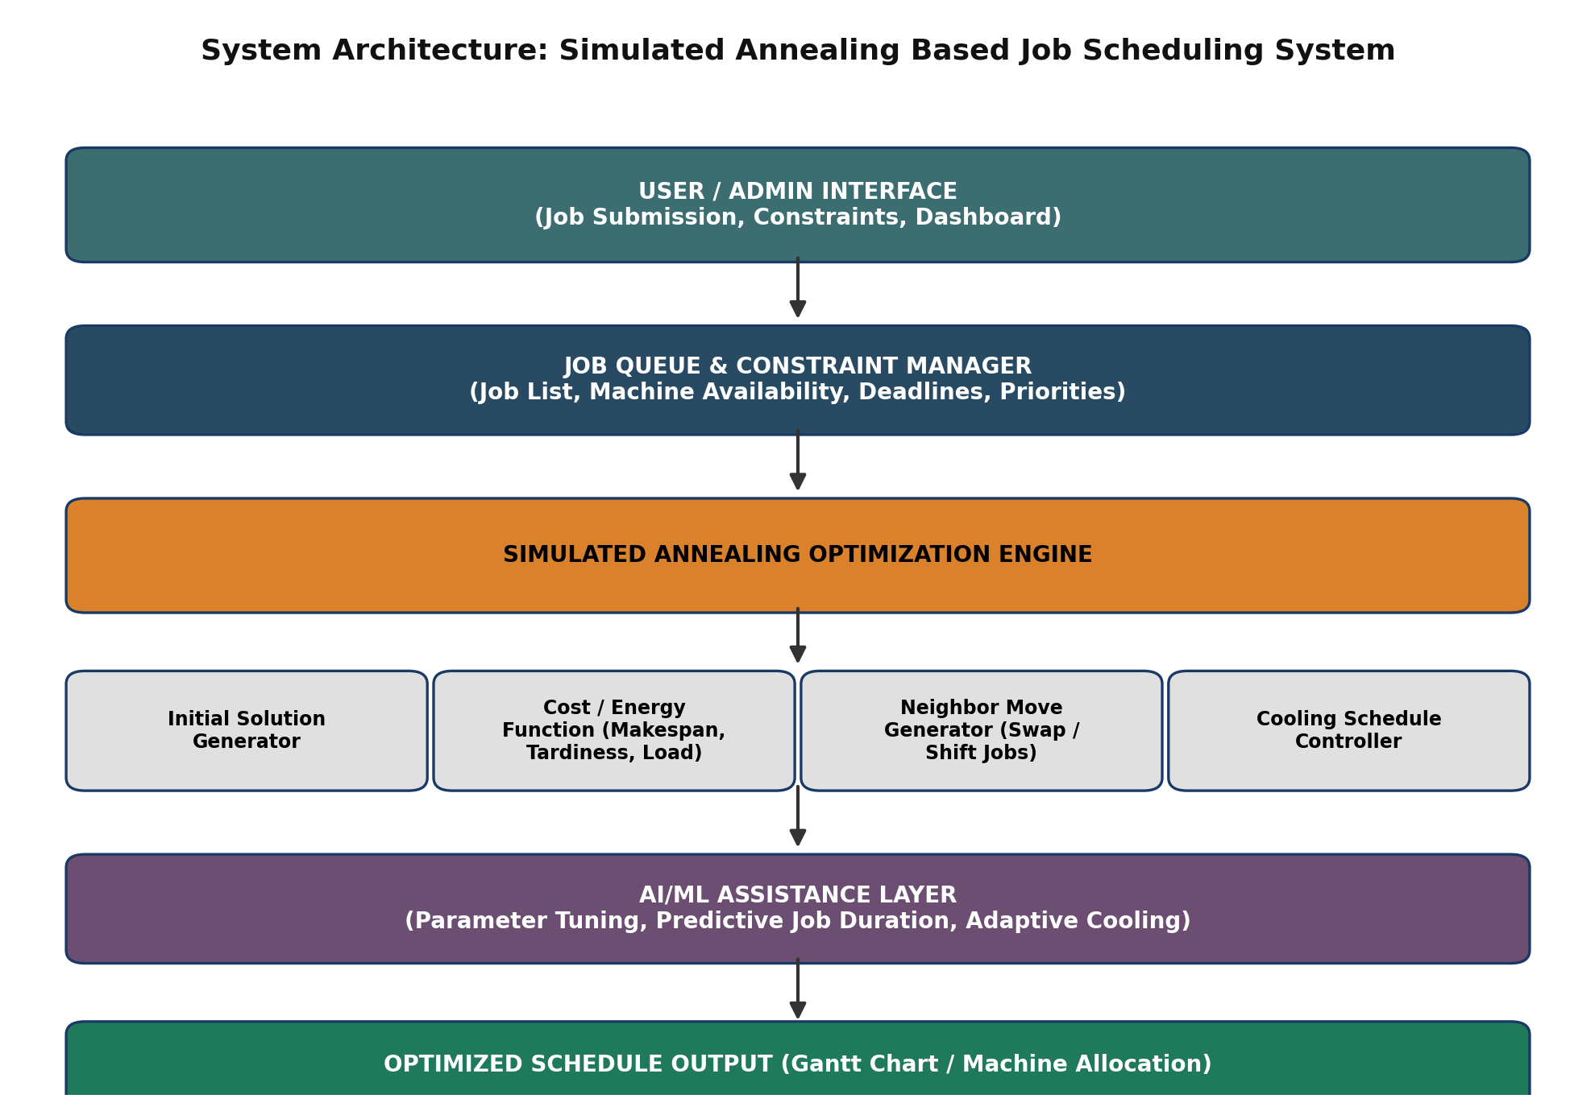
Figure 1: System architecture of the Simulated Annealing Based Job Scheduling System
Data flows top-down: job requests and constraints enter through the interface layer, are validated and queued by the constraint manager, optimized by the simulated annealing engine (with AI/ML assistance for parameter tuning), and finally rendered as a schedule for the end user or downstream execution system.

7. Main Components

7.1 Job Queue and Constraint Manager
Maintains the list of jobs awaiting scheduling along with their attributes (processing time, deadline, priority) and tracks machine availability. It validates incoming jobs against constraints such as machine capacity and operating hours before handing them to the optimization engine.

7.2 Initial Solution Generator
Produces the starting schedule (solution S0) from which the Simulated Annealing search begins. This can be a purely random assignment of jobs to machines, or a heuristic starting point (e.g., a greedy shortest-processing-time-first assignment) to accelerate early convergence.

7.3 Cost (Energy) Function
Evaluates the quality of a given schedule using a weighted combination of makespan, tardiness penalty, and load-imbalance measures. This cost value plays the role of 'energy' in the physical annealing analogy — the algorithm seeks to minimize this energy over time.

7.4 Neighbor Move Generator
Generates candidate neighboring solutions from the current schedule through small perturbations such as reassigning a single job to a different machine or swapping the machine assignments of two jobs. The quality and diversity of these moves strongly influence how effectively the search explores the solution space.

7.5 Cooling Schedule Controller
Controls how the temperature parameter T decreases over successive iterations, typically following a geometric cooling rule T = alpha * T, where alpha is a cooling rate close to (but less than) 1. This component governs the trade-off between exploration (early, high-temperature phase) and exploitation (later, low-temperature phase) of the search.

7.6 AI/ML Assistance Layer
Supports the core optimization engine by tuning key hyperparameters (initial temperature, cooling rate, iteration budget) based on problem size and historical performance, and by supplying predictive estimates of job processing durations using regression or time-series models when exact durations are uncertain.

7.7 Output / Reporting Module
Converts the final optimized solution into a human-readable schedule, typically a Gantt chart or machine allocation table, and reports key performance metrics such as makespan, average machine utilization, and total tardiness.

8. Working Principle
Simulated Annealing draws its working principle directly from the physical process of annealing solids: a material is heated to a high temperature, allowing its particles to move freely and explore many configurations, and is then cooled slowly so that the particles settle into a low-energy, highly ordered state. Applied to job scheduling, a 'configuration' corresponds to a candidate schedule, and 'energy' corresponds to the cost (makespan, tardiness, imbalance) of that schedule.
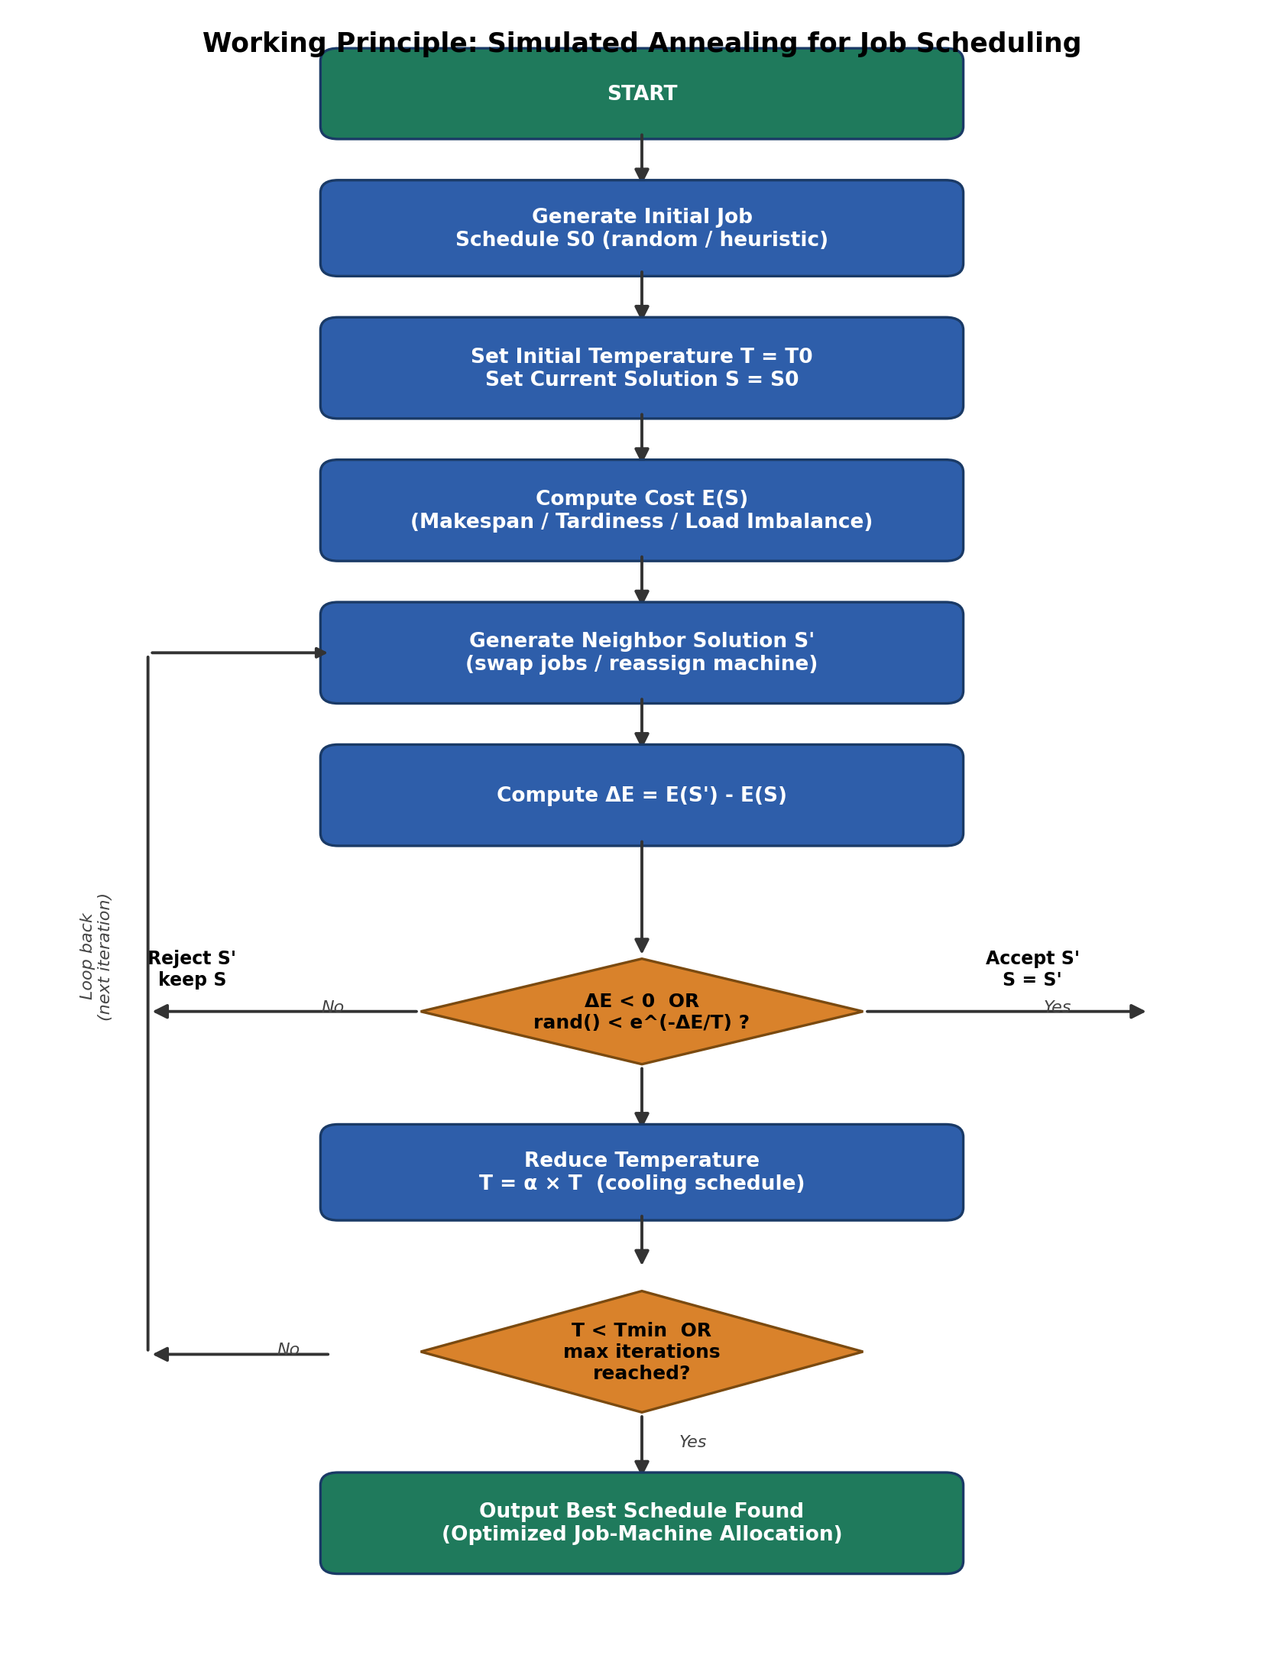
Figure 2: Working principle of the Simulated Annealing algorithm applied to job scheduling

8.1 Step-by-Step Algorithm
- Initialize a starting schedule S0 (random or heuristic) and set the current solution S = S0.
- Set the initial temperature T = T0 (a relatively high value) and choose a cooling rate alpha (0 < alpha < 1).
- Compute the cost E(S) of the current schedule using the cost function described in Section 7.3.
- Generate a neighboring schedule S' by applying a small perturbation (reassign or swap) to S.
- Compute the change in cost, delta E = E(S') - E(S).
- If delta E < 0 (the new schedule is better), accept S' as the current solution. Otherwise, accept S' with probability p = exp(-delta E / T), which allows occasional acceptance of worse solutions to escape local optima.
- Record S' as the new best solution found so far if its cost is lower than the best cost recorded.
- Reduce the temperature: T = alpha * T.
- Repeat steps 4 to 8 until the temperature falls below a minimum threshold Tmin, or a maximum number of iterations is reached.
- Return the best schedule found during the entire search process.
The acceptance probability formula, p = exp(-delta E / T), is known as the Metropolis criterion. At high temperatures, this probability is close to 1 even for fairly large delta E, meaning the algorithm freely explores the solution space, including uphill (worse) moves. As the temperature cools, the probability of accepting worse moves shrinks rapidly, and the algorithm increasingly behaves like a greedy local search, refining the best regions of the solution space it has discovered.

9. Example of Automatic Control
Consider a small scheduling instance with seven jobs (J1 to J7) of varying processing times to be assigned across three machines. Initially, jobs are assigned in an arbitrary order, resulting in an unbalanced schedule with a makespan of 13 hours, as one machine becomes overloaded while another remains comparatively idle. This represents the kind of naive, non-optimized allocation that a purely manual or first-come-first-served scheduling approach might produce.
The Simulated Annealing engine automatically takes control of this schedule: it repeatedly proposes reassignments and swaps, evaluates the resulting make span and load balance through the cost function, and accepts or rejects each change according to the Metropolis criterion described in Section 8. Over successive iterations and as the temperature cools, the system self-corrects the imbalance without any manual intervention, converging to a substantially more balanced schedule with a reduced make span of 8.5 hours, as shown in Figure 3.
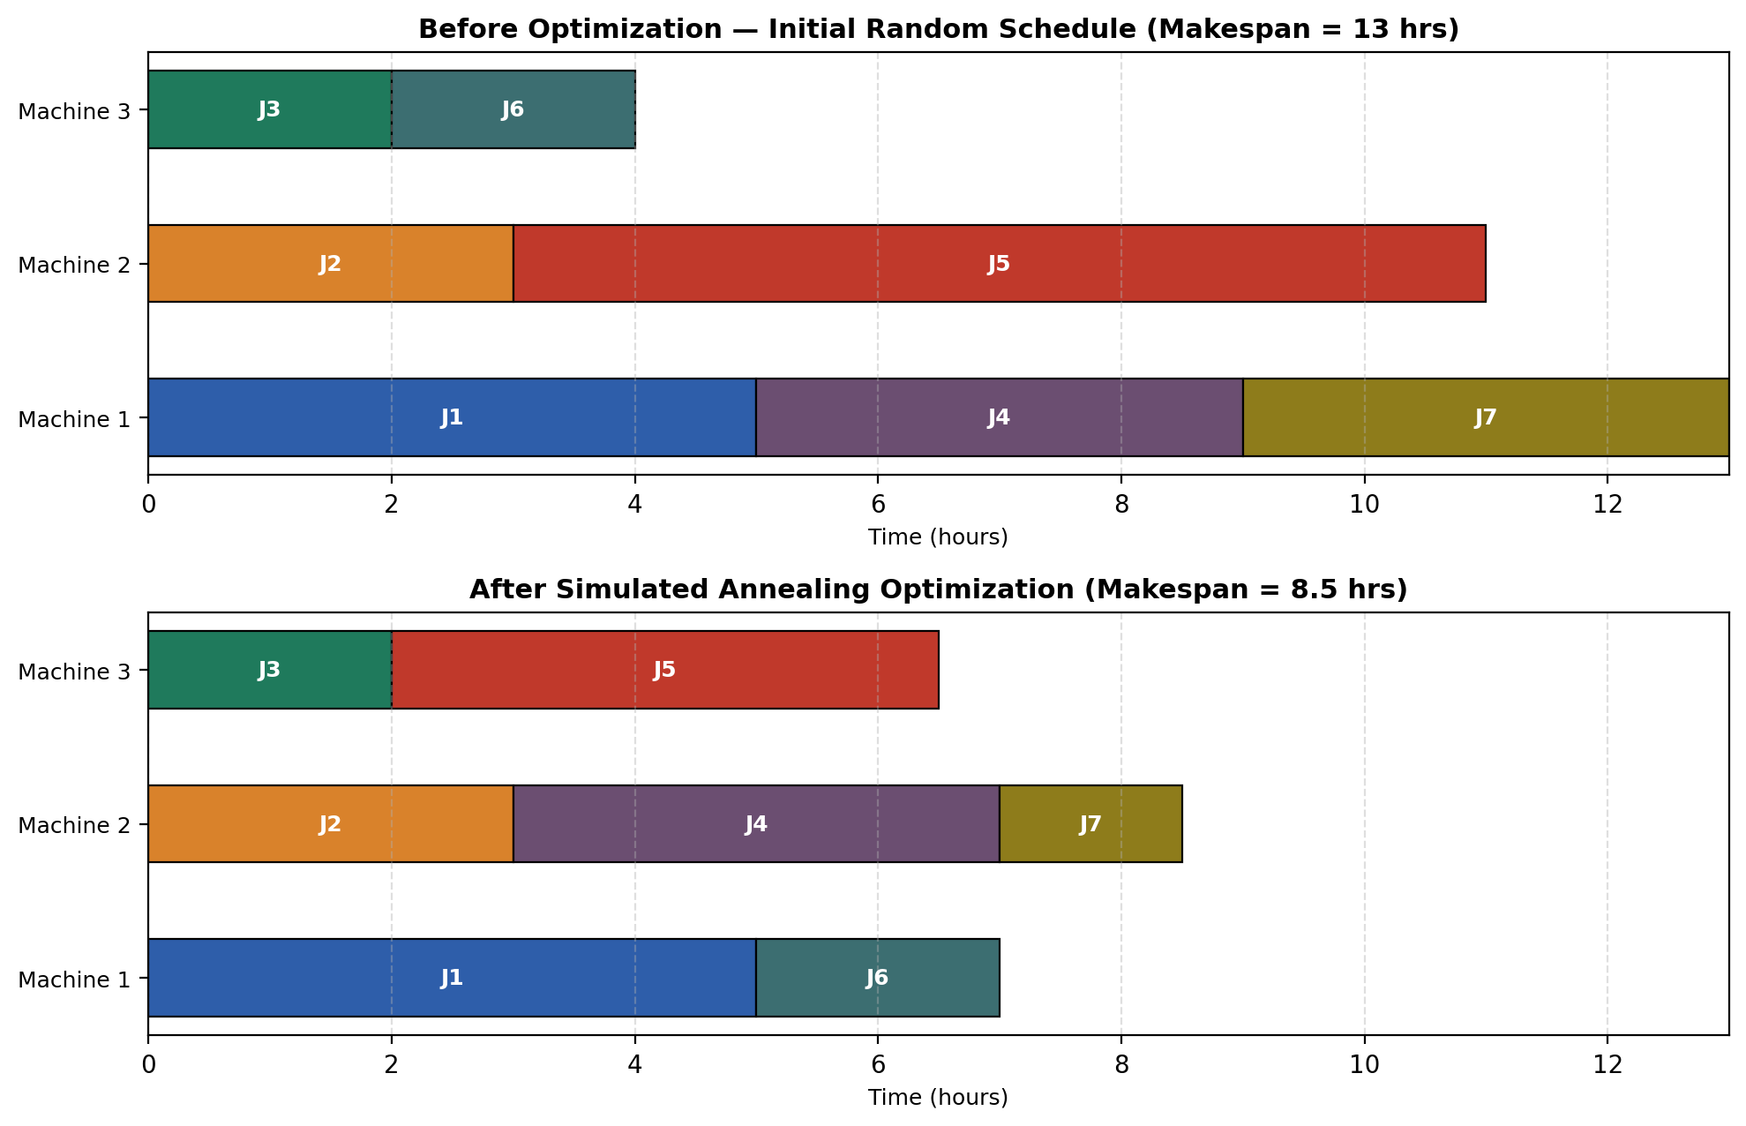
Figure 3: Automatic re-balancing of a job schedule before and after Simulated Annealing optimization
This example illustrates the 'automatic control' behavior of the system: no human scheduler manually decided which job should move to which machine — the algorithm's cost-driven acceptance rule, combined with the temperature-controlled exploration strategy, autonomously discovered a better allocation purely from the defined objective function and constraints.

10. Role of Artificial Intelligence and Machine Learning
While Simulated Annealing itself is a classical metaheuristic search algorithm rooted in statistical mechanics, this system is enhanced with several Artificial Intelligence and Machine Learning techniques that improve its practical effectiveness and adaptability.

10.1 Adaptive Hyperparameter Tuning
The performance of Simulated Annealing is highly sensitive to its hyperparameters — the initial temperature T0 and cooling rate alpha. Rather than fixing these values manually, the AI/ML assistance layer can learn suitable hyperparameter settings from historical scheduling runs (using techniques such as grid search, Bayesian optimization, or a lightweight reinforcement learning agent) so that the algorithm automatically adapts its exploration-exploitation balance to the size and nature of the current job set.

10.2 Predictive Job Duration Estimation
In many practical settings, the exact processing time of a job is not known in advance. A regression-based machine learning model (for example, a gradient-boosted tree or a simple linear model) trained on historical job execution data can estimate expected processing times from job features such as job type, size, or resource requirements, feeding more realistic estimates into the cost function used by the Simulated Annealing engine.

10.3 Adaptive Cooling Schedules
Instead of a fixed geometric cooling rate, the system can employ an adaptive cooling strategy that slows down or speeds up the cooling process based on the observed rate of improvement in solution quality, allowing the algorithm to spend more iterations in promising regions of the search space and fewer in unpromising ones.
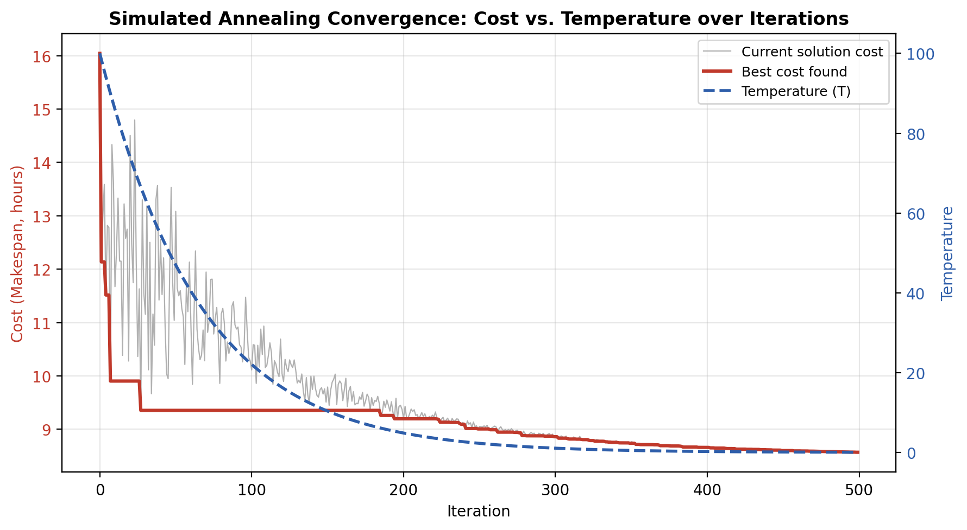
Figure 4: Convergence behavior of the cost function alongside the decreasing temperature curve across iterations
Figure 4 shows a representative convergence plot: the grey line tracks the cost of the currently accepted solution at each iteration (which fluctuates more at high temperature), the red line tracks the best cost discovered so far, and the blue dashed line shows the temperature decreasing according to the cooling schedule. As the temperature approaches zero, the search stabilizes and the best cost converges to a near-optimal value.

11. Software Requirement
Component | Requirement
Programming Language | Python 3.9 or higher
Core Libraries | math, random (standard library)
Data Handling | NumPy, Pandas (for larger datasets and AI/ML components)
Machine Learning | scikit-learn (for predictive duration estimation and hyperparameter tuning)
Visualization | Matplotlib (Gantt charts, convergence plots)
Operating System | Windows 10/11, Linux, or macOS
IDE / Editor | VS Code, PyCharm, or Jupyter Notebook
Optional Web Interface | Flask or Django (for a browser-based dashboard)
Version Control | Git

Hardware Requirement
Component | Minimum Specification
Processor | Dual-core CPU, 2.0 GHz or higher
RAM | 4 GB (8 GB recommended for larger job sets)
Storage | 500 MB free disk space
Display | Any standard monitor for viewing schedule visualizations

12. Advantages
- Escapes local optima by occasionally accepting worse solutions, unlike purely greedy scheduling heuristics.
- Conceptually simple and easy to implement, requiring only a cost function, neighbour generator, and cooling schedule.
- Highly flexible — the cost function can be adapted to different objectives (make span, tardiness, energy consumption, cost) without changing the core algorithm.
- Scales reasonably well to medium and large problem sizes compared to exact optimization methods.
- Produces good-quality solutions within a controllable, bounded computation time.
- Can be combined with AI/ML techniques for adaptive tuning, improving performance over static, hand-tuned parameters.

13. Limitations
- Does not guarantee a globally optimal solution — it produces a near-optimal solution with no formal optimality bound.
- Performance is sensitive to the choice of hyperparameters (initial temperature, cooling rate, iteration count).
- Convergence can be slow for very large-scale scheduling problems with thousands of jobs and machines.
- Results can vary between runs due to the algorithm's inherent randomness, requiring multiple runs for consistency.
- The quality of the AI/ML assistance layer (duration prediction, hyperparameter tuning) depends heavily on the availability and quality of historical training data.

14. Applications
- Manufacturing and production planning: allocating production jobs across machines on a factory floor.
- Cloud computing and data centers: scheduling computational tasks or virtual machines across servers.
- Academic timetabling: assigning classes, examinations, or invigilators to rooms and time slots.
- Logistics and transportation: scheduling delivery jobs across a fleet of vehicles.
- Healthcare systems: scheduling surgeries, appointments, or equipment usage across hospital resources.
- Workforce and shift scheduling: assigning employees to shifts while balancing workload and preferences.

15. Future Scope
- Integration of reinforcement learning agents that learn scheduling policies directly, complementing or replacing manual cooling schedule design.
- Hybridization with other metaheuristics such as Genetic Algorithms or Particle Swarm Optimization for improved solution diversity.
- Real-time, dynamic re-scheduling that responds to machine breakdowns, job cancellations, or urgent job insertions.
- Deployment as a cloud-hosted, multi-tenant scheduling service with a web-based dashboard and REST API.
- Incorporation of multi-objective optimization (e.g., simultaneously minimizing make span, energy consumption, and cost) using Pareto-based Simulated Annealing variants.
- Use of deep learning models for more accurate job duration prediction based on richer contextual features.

16. Expected Outcomes
- A working software system capable of generating optimized job-to-machine schedules significantly better than random or first-come-first-served allocation.
- Measurable reduction in makespan and total tardiness compared to baseline scheduling approaches, as demonstrated in Section 9.
- A reusable, modular codebase (Section on Source Code) that can be extended to new scheduling domains with minimal changes to the cost function.
- Demonstrated integration of classical AI search (Simulated Annealing) with modern Machine Learning components for adaptive, data-driven scheduling.
- A clear, documented understanding of how metaheuristic optimization techniques apply to real-world combinatorial scheduling problems.

17. Conclusion
The Simulated Annealing Based Job Scheduling System demonstrates how a classical, physically-inspired metaheuristic can be effectively applied to the NP-hard problem of multi-machine job scheduling. By iteratively exploring the solution space through controlled acceptance of both improving and, occasionally, worsening moves, the system is able to escape local optima and converge toward high-quality, near-optimal schedules that significantly reduce makespan and improve machine load balance compared to naive scheduling strategies. The addition of an AI/ML assistance layer for adaptive parameter tuning and predictive duration estimation further strengthens the system's practical applicability, allowing it to adapt to varying problem sizes and data-driven operating conditions. While the approach does not guarantee mathematically optimal solutions and remains sensitive to hyperparameter choices, its simplicity, flexibility, and strong empirical performance make it a valuable and widely applicable tool for scheduling problems across manufacturing, cloud computing, healthcare, logistics, and beyond.

Appendix A: Python Reference Implementation
The following Python program implements the core Simulated Annealing Job Scheduling algorithm described in Sections 7 and 8. It defines a Job class, a Simulated Annealing Scheduler class encapsulating the cost function, neighbour generator, and main optimization loop, and a demonstration run on a sample set of seven jobs across three machines, consistent with the example in Section 9.
"""
Simulated Annealing Based Job Scheduling System
--------------------------------------------------
A minimal, self-contained reference implementation that assigns a set
of jobs (each with a processing time) to a fixed number of machines
so as to minimize the makespan (the completion time of the last job).

Core idea:
1. Start with a random assignment of jobs to machines.
2. Repeatedly propose a small change (a "neighbor") such as moving
one job to a different machine, or swapping two jobs.
3. Accept improving moves always; accept worsening moves with a
probability that shrinks as the temperature T cools down.
4. Slowly reduce T according to a cooling schedule until the
system "freezes" (T is very small / max iterations reached).
"""

import math
import random

class Job:
def __init__(self, job_id, processing_time, deadline=None, priority=1):
self.id = job_id
self.processing_time = processing_time
self.deadline = deadline
self.priority = priority

def __repr__(self):
return f"Job({self.id}, t={self.processing_time})"

class SimulatedAnnealingScheduler:
def __init__(self, jobs, num_machines,
initial_temp=100.0, cooling_rate=0.98,
min_temp=0.01, max_iterations=2000):
self.jobs = jobs
self.num_machines = num_machines
self.initial_temp = initial_temp
self.cooling_rate = cooling_rate
self.min_temp = min_temp
self.max_iterations = max_iterations

# ---------- Solution representation ----------
def random_solution(self):
"""A solution maps each job index -> machine index."""
return [random.randrange(self.num_machines) for _ in self.jobs]

# ---------- Cost / energy function ----------
def cost(self, solution):
"""Objective: minimize makespan with a tardiness penalty."""
loads = [0.0] * self.num_machines
tardiness_penalty = 0.0

for job, machine in zip(self.jobs, solution):
loads[machine] += job.processing_time
if job.deadline is not None and loads[machine] > job.deadline:
tardiness_penalty += (loads[machine] - job.deadline) * job.priority

makespan = max(loads)
load_std = (sum((l - sum(loads) / len(loads)) ** 2 for l in loads)
/ len(loads)) ** 0.5
return makespan + tardiness_penalty + 0.1 * load_std

# ---------- Neighbor generation ----------
def neighbor(self, solution):
new_solution = solution[:]
move_type = random.choice(["reassign", "swap"])

if move_type == "reassign" or len(self.jobs) < 2:
job_idx = random.randrange(len(self.jobs))
new_solution[job_idx] = random.randrange(self.num_machines)
else:
i, j = random.sample(range(len(self.jobs)), 2)
new_solution[i], new_solution[j] = new_solution[j], new_solution[i]

return new_solution

# ---------- Main optimization loop ----------
def run(self):
current = self.random_solution()
current_cost = self.cost(current)

best = current[:]
best_cost = current_cost

T = self.initial_temp
iteration = 0

while T > self.min_temp and iteration < self.max_iterations:
candidate = self.neighbor(current)
candidate_cost = self.cost(candidate)
delta = candidate_cost - current_cost

if delta < 0 or random.random() < math.exp(-delta / T):
current, current_cost = candidate, candidate_cost
if current_cost < best_cost:
best, best_cost = current[:], current_cost

T *= self.cooling_rate
iteration += 1

return best, best_cost, iteration

def print_schedule(jobs, solution, num_machines):
machine_jobs = {m: [] for m in range(num_machines)}
for job, machine in zip(jobs, solution):
machine_jobs[machine].append(job)

for m in range(num_machines):
total = sum(j.processing_time for j in machine_jobs[m])
job_list = ", ".join(j.id for j in machine_jobs[m])
print(f"Machine {m + 1}: [{job_list}] Load = {total}")

if __name__ == "__main__":
random.seed(42)

jobs = [
Job("J1", processing_time=5),
Job("J2", processing_time=3),
Job("J3", processing_time=2),
Job("J4", processing_time=4),
Job("J5", processing_time=6),
Job("J6", processing_time=2),
Job("J7", processing_time=1.5),
]

scheduler = SimulatedAnnealingScheduler(
jobs=jobs,
num_machines=3,
initial_temp=100.0,
cooling_rate=0.98,
min_temp=0.01,
max_iterations=2000,
)

best_solution, best_cost, iterations = scheduler.run()

print(f"Finished in {iterations} iterations")
print(f"Best cost (makespan-based): {best_cost:.2f}\n")
print("Optimized Job-to-Machine Schedule:")
print_schedule(jobs, best_solution, scheduler.num_machines)

Sample Program Output
Finished in 456 iterations
Best cost (makespan-based): 8.02

Optimized Job-to-Machine Schedule:
Machine 1: [J3, J4, J6] Load = 8
Machine 2: [J5, J7] Load = 7.5
Machine 3: [J1, J2] Load = 8

18. References
- S. Kirkpatrick, C. D. Gelatt, and M. P. Vecchi, "Optimization by Simulated Annealing," Science, vol. 220, no. 4598, pp. 671-680, 1983.
- N. Metropolis, A. W. Rosenbluth, M. N. Rosenbluth, A. H. Teller, and E. Teller, "Equation of State Calculations by Fast Computing Machines," The Journal of Chemical Physics, vol. 21, no. 6, pp. 1087-1092, 1953.
- M. Pinedo, Scheduling: Theory, Algorithms, and Systems, 5th ed. Springer, 2016.
- S. Russell and P. Norvig, Artificial Intelligence: A Modern Approach, 4th ed. Pearson, 2021.
- E. Aarts and J. Korst, Simulated Annealing and Boltzmann Machines: A Stochastic Approach to Combinatorial Optimization and Neural Computing. Wiley, 1989.
- T. M. Mitchell, Machine Learning. McGraw-Hill, 1997.
- F. Glover and G. A. Kochenberger, Handbook of Metaheuristics. Springer, 2003.
- Python Software Foundation, "Python 3 Documentation," https://docs.python.org/3/ (accessed 2026).
- Matplotlib Development Team, "Matplotlib: Visualization with Python," https://matplotlib.org (accessed 2026).
- scikit-learn Developers, "scikit-learn: Machine Learning in Python," https://scikit-learn.org (accessed 2026).

