**UI Verification Report**

Prepared by: Siddhesh Khairnar  
Contact: [sbmk02@gmail.com](mailto:sbmk02@gmail.com) | <https://www.linkedin.com/in/siddhesh-khairnar>  
Demo Site: <https://www.saucedemo.com/>

* **Introduction: -**

This report summarizes the UI verification performed on the SauceDemo e-commerce web application. As a demonstration platform for manual quality assurance testing, SauceDemo provides multiple distinct user profiles with purposely varied behaviours and intentional bugs. The aim of this project was to evaluate the usability, responsiveness, visual consistency, and reliability of key shopping features—highlighting both expected user flows and notable defects.

* **Components and Features Tested -**

The verification covered the following components:

* **Login Page:** Validation of username and password fields, error message handling, and login form responsiveness.
* **Product Inventory Page:** Accuracy of product images, titles, descriptions, prices, and “Add to cart” button layout. Sorting functionality was also evaluated.
* **Shopping Cart:** Add/remove operations, cart badge updates, price calculation, and cart page layout.
* **Checkout Info and Overview:** Required field validations, field independence, user flow from checkout info to overview, and final order placement.
* **Cross-browser and Mobile Checks:** Key interactions were retested in both Chrome and Firefox browsers; mobile view was checked for layout issues.
* **Notable Issues Observed: -**

Several significant bugs and inconsistencies were encountered during testing:

1. For the **problem_user**, all product images appeared as dog photos regardless of the actual product, and the cart accepted only two items. During checkout, typing into the ‘Surname’ field erased the entered ‘First Name’, causing major data loss and form confusion.
2. The **locked_out_user** was unable to log in, as expected, and received the proper locked account error message.
3. Using the **performance_glitch_user**, the entire website experience was extremely slow and glitchy, although all core features were eventually accessible.
4. The **error_user** revealed multiple functional defects: sorting any product list triggered a visible application error message; product descriptions on detail pages failed to render; items could only be removed from the cart page, not from the product list; and checkout allowed bypassing mandatory fields but ultimately failed to complete an order.
5. While testing as a **visual_user**, the product grid’s lead image changed to a dog picture after any sorting operation. Product prices became inconsistent, and several visual/UI alignment bugs were present: misaligned “Add to cart” and “Checkout” buttons as well as misplaced cart controls throughout.
6. As a **standard_user**, applications worked correctly across all tested scenarios, with no visual or functional issues encountered. This confirmed the happy path and served as a baseline for other user accounts.

* **Summary: -**

SauceDemo delivers a robust e-commerce workflow for standard users, but also exposes intentional functional and UI bugs in alternate user profiles, making it ideal for QA practice. This project documented all encountered issues with clear reproduction steps and supporting screenshots. All bugs are logged in detail within the bug log, and associated screenshots are provided for reference.

**Recommendations -**

Priority should be given to resolving the image rendering bug found in the problem_user and visual_user accounts, field interaction issues on the checkout form, and all critical path sorting and description failures for the error_user. Visual alignment and responsiveness problems, as well as performance slowdowns, should also be addressed to improve the overall demo experience. Retesting is advised after each fix.

If you would like this formatted into a downloadable .docx, you can paste the above into Word and apply normal headings and paragraph styles for a clean, professional appearance.

Here are some Screenshots of Standard User: -

1. **Product list: -**

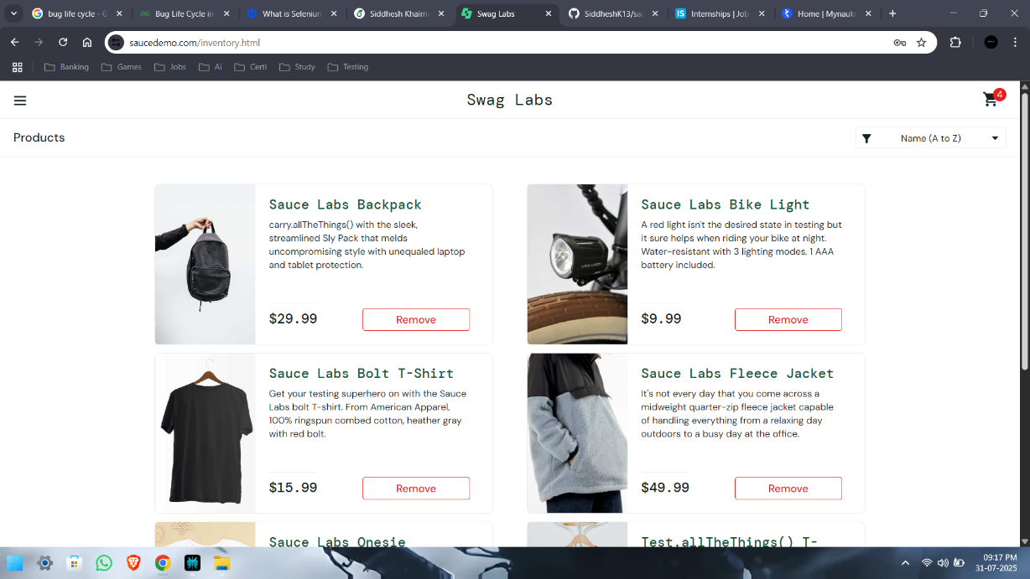

1. **Cart page: -**

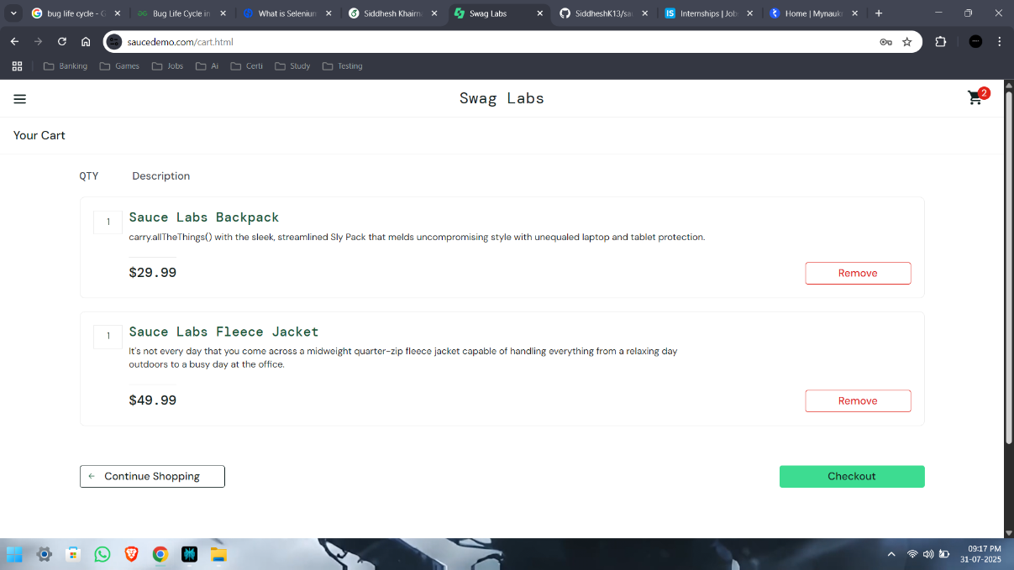

1. **Checkout Details page: -**

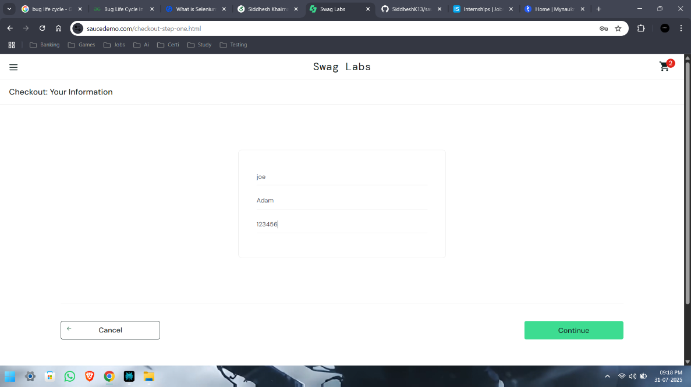

1. **Checkout Overview Page: -**

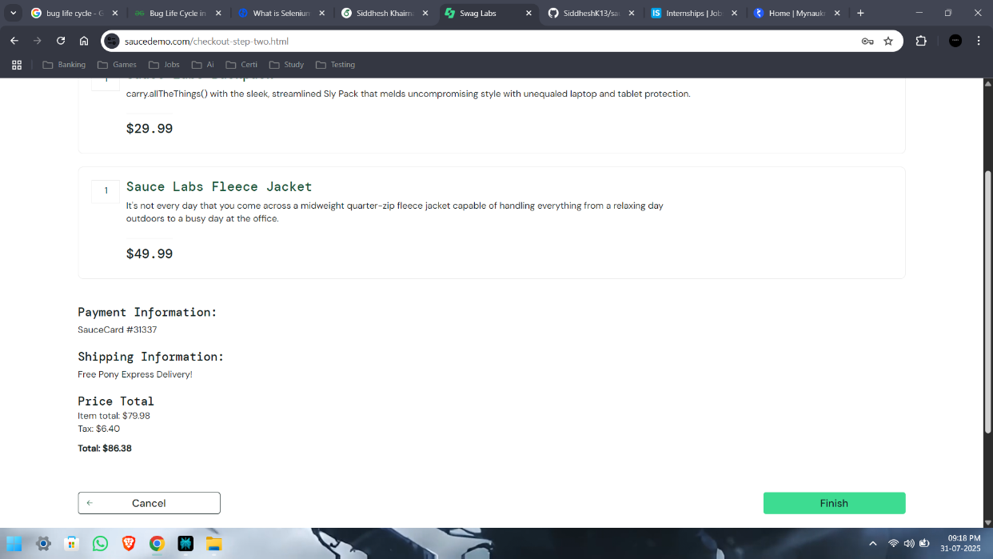

1. **Order placed page: -**

