RA2311026011010
Siddhesh Khankhoje

Hybrid and Electric Vehicles
CLA-1 Assesment

Problem Statement:
Modern gasoline engines use three-way catalytic converters (TWC) to control exhaust emissions.
The Oxygen Storage Capacity (OSC) of the catalytic converter plays a critical role in maintaining stoichiometric air–fuel ratio by absorbing and releasing oxygen during transient engine operation.
The OSC of the oxidation catalyst depends on:
- Catalyst volume (L)
- Washcoat loading (g/L)
- CeO₂ weight fraction in the washcoat
- Utilisation efficiency (η)
The objective of this work is to:
- Develop a physics-based OSC model
- Generate lookup tables (LUTs) for OSC
- Visualize the sensitivity of OSC using:
  - Volume vs Washcoat loading
  - Volume vs CeO₂ wt. fraction
  - Volume vs Utilisation efficiency
- Create OSC contour plots and a 3D surface plot for calibration and injector-control applications.

Solution:
- Lookup table:
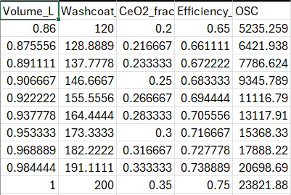

- Volume v/s Wash coat loading
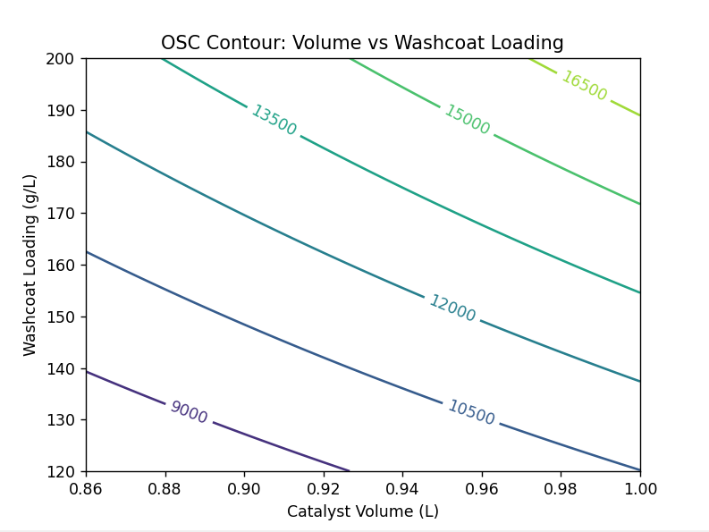

- Volume v/s Ceria (CeO2) %weight fraction
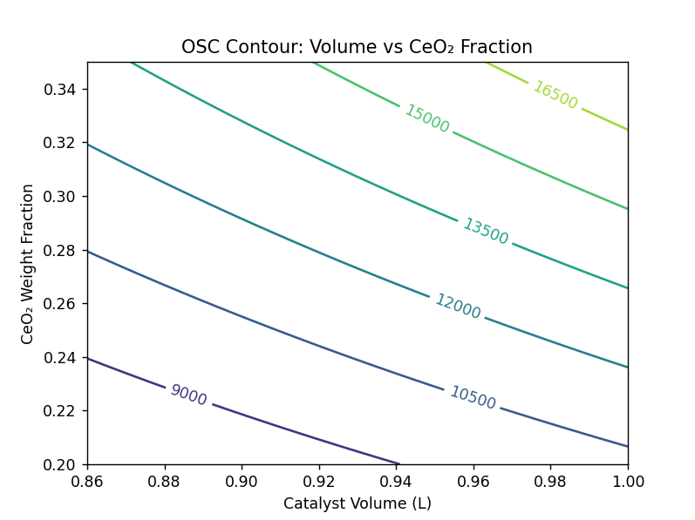
- Volume v/s Utilisation efficiency
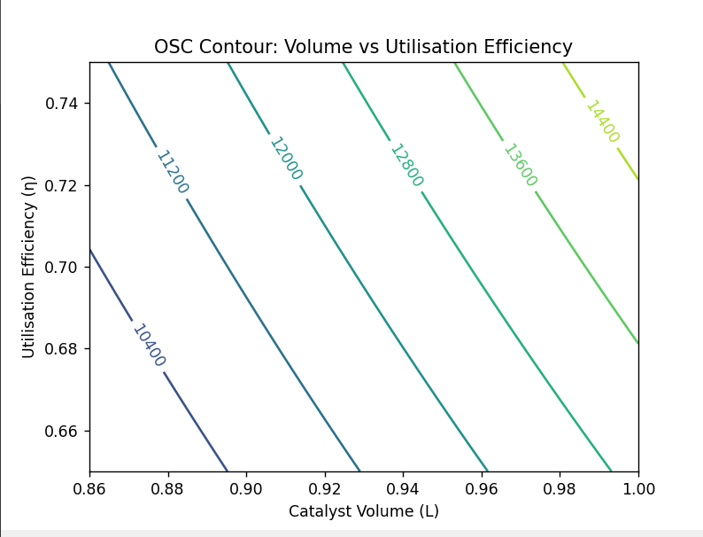

- 3D Surface Plot: OSC
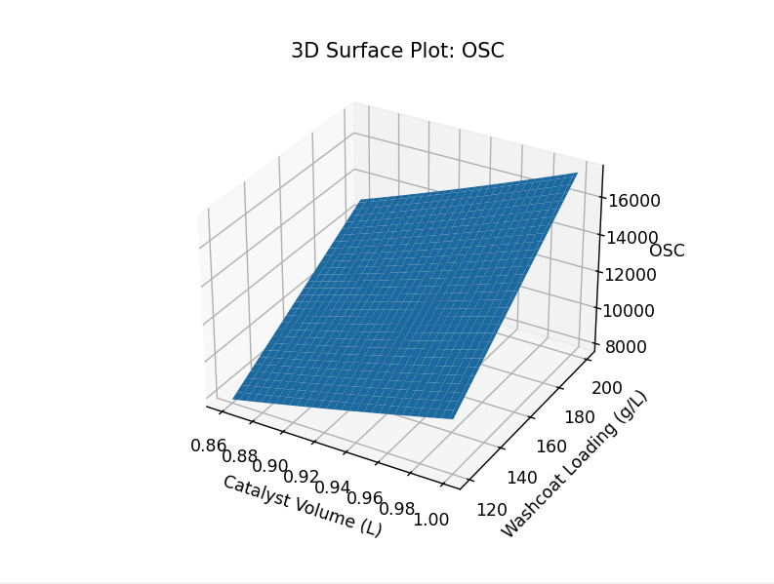

- Program (Python code):
- import numpy as np
- import pandas as pd
- import matplotlib.pyplot as plt
- from mpl_toolkits.mplot3d import Axes3D

- # ===============================
- # CONSTANTS
- # ===============================
- CPSI = 750
- k_factor = 5.5
- O2_PER_G_CEO2 = 0.11

- # Nominal values
- washcoat_nom = 160 # g/L
- ceo2_nom = 0.275 # wt fraction
- eta_nom = 0.70

- # ===============================
- # AXES RANGES
- # ===============================
- volume = np.linspace(0.86, 1.0, 60)
- washcoat = np.linspace(120, 200, 60)
- ceo2_frac = np.linspace(0.20, 0.35, 60)
- eta = np.linspace(0.65, 0.75, 60)

- # ===============================
- # OSC FUNCTION
- # ===============================
- def compute_osc(volume, washcoat, ceo2_frac, eta):
- washcoat_mass = volume * washcoat
- ceo2_mass = washcoat_mass * ceo2_frac
- stored_o2 = ceo2_mass * O2_PER_G_CEO2 * eta
- osc_geom = CPSI * k_factor * volume
- return osc_geom * stored_o2

- # ===============================
- # 1. Volume vs Washcoat Loading
- # ===============================
- V1, W = np.meshgrid(volume, washcoat)
- OSC_vw = compute_osc(V1, W, ceo2_nom, eta_nom)

- plt.figure()
- c1 = plt.contour(V1, W, OSC_vw)
- plt.clabel(c1)
- plt.xlabel("Catalyst Volume (L)")
- plt.ylabel("Washcoat Loading (g/L)")
- plt.title("OSC Contour: Volume vs Washcoat Loading")
- plt.show()

- # ===============================
- # 2. Volume vs CeO2 wt fraction
- # ===============================
- V2, C = np.meshgrid(volume, ceo2_frac)
- OSC_vc = compute_osc(V2, washcoat_nom, C, eta_nom)

- plt.figure()
- c2 = plt.contour(V2, C, OSC_vc)
- plt.clabel(c2)
- plt.xlabel("Catalyst Volume (L)")
- plt.ylabel("CeO₂ Weight Fraction")
- plt.title("OSC Contour: Volume vs CeO₂ Fraction")
- plt.show()

- # ===============================
- # 3. Volume vs Utilisation Efficiency
- # ===============================
- V3, E = np.meshgrid(volume, eta)
- OSC_ve = compute_osc(V3, washcoat_nom, ceo2_nom, E)

- plt.figure()
- c3 = plt.contour(V3, E, OSC_ve)
- plt.clabel(c3)
- plt.xlabel("Catalyst Volume (L)")
- plt.ylabel("Utilisation Efficiency (η)")
- plt.title("OSC Contour: Volume vs Utilisation Efficiency")
- plt.show()

- # ===============================
- # 4. FILLED OSC CONTOUR
- # ===============================
- plt.figure()
- plt.contourf(V1, W, OSC_vw)
- plt.colorbar(label="OSC")
- plt.xlabel("Catalyst Volume (L)")
- plt.ylabel("Washcoat Loading (g/L)")
- plt.title("Filled OSC Contour: Volume vs Washcoat")
- plt.show()

- # ===============================
- # 5. 3D SURFACE PLOT
- # ===============================
- fig = plt.figure()
- ax = fig.add_subplot(111, projection="3d")
- ax.plot_surface(V1, W, OSC_vw)
- ax.set_xlabel("Catalyst Volume (L)")
- ax.set_ylabel("Washcoat Loading (g/L)")
- ax.set_zlabel("OSC")
- ax.set_title("3D Surface Plot: OSC")
- plt.show()

- # ===============================
- # 6. LOOKUP TABLE (LUT)
- # ===============================
- volume_lut = np.linspace(0.86, 1.0, 10)
- washcoat_lut = np.linspace(120, 200, 10)
- ceo2_lut = np.linspace(0.20, 0.35, 10)
- eta_lut = np.linspace(0.65, 0.75, 10)

- osc_lut = compute_osc(volume_lut, washcoat_lut, ceo2_lut, eta_lut)

- lut = pd.DataFrame({
- "Volume_L": volume_lut,
- "Washcoat_g_per_L": washcoat_lut,
- "CeO2_fraction": ceo2_lut,
- "Efficiency_eta": eta_lut,
- "OSC": osc_lut
- })

- print("\n=== OSC LOOKUP TABLE ===\n")
- print(lut)

- lut.to_csv("osc_lookup_table.csv", index=False)

