**B. TECH IT Major Project**

on

**StressMeter- Detecting Stress Level using Machine Learning**

By

**Aishwarya Patil 39**

**Hitashri Patil 40**

**Nupur Shinde 54**

**Sakshi Zod 66**

Under the guidance of

**Prof. Deepali Deshpande**



Department of Information Technology

**BRaCT’S Vishwakarma Institute Technology**

**PUNE – 411037**

**(2023-2024)**

|  |  |
| --- | --- |
|  | **Bansilal Ramnath Agarwal Charitable Trust’s**  **Vishwakarma Institute Technology**  **Department of Information Technology**  **PUNE – 411 037** |

**CERTIFICATE**

This is certified that Project entitled

StressMeter- Detecting Stress Level using Machine Learning

Submitted by

**Aishwarya Patil 39**

**Hitashri Patil 40**

**Nupur Shinde 54**

**Sakshi Zod 66**

is a bonafide work carried out by them under the supervision of me, Prof. Deepali Deshpande and it is approved by me for submission. Certified further that, to the best of my knowledge, the report represents work carried out by the student as the Major project as prescribed by the Savitribai Phule Pune University in the academic year 2023-24.

**Date: Guide Head of Department**

Prof. Dr. P. P. Ghadekar

Prof. Deepali Deshpande

**ACKNOWLEDGEMENT**

It gives us great pleasure in presenting the preliminary project report on `StressMeter- Detecting Stress Level using Machine Learning'.

We would like to take this opportunity to thank our internal guide Prof. Deepali Deshpande for giving us all the help and guidance we needed. We are really grateful to them for her kind support. Her valuable suggestions were very helpful.

We are also grateful to Prof. Dr. P. P. Ghadekar, Head of Department of Information Technology, VIT, Pune, for his indispensable support, suggestions.

Aishwarya Patil (39)

Hitashri Patil (40)

Nupur Shinde (54)

Sakshi Zod (66)

(B. Tech Information Technology)

**CONTENTS**

1. **SYNOPSIS**
   1. Project Title
   2. Project Option
   3. Internal Guide
   4. Sponsorship and External Guide
   5. Technical Keywords
   6. Problem statement
   7. Abstract
   8. Objectives
2. **INTRODUCTION** 
   1. Problem definition and scope
   2. Motivation
3. **PREVIOUS WORK / EXISTING SYSTEM STUDY/LITERATURE REVIEW**
   1. Literature review
   2. Comparison table
4. **PROJECT PLAN** 
   1. Time and Scheduling - Gantt chart / Task network / WBS / Mile stones
5. **SOFTWARE REQUIREMENT SPECIFICATION** 
   1. **Functional**
   2. **Non-Functional**
6. **PROPOSED SYSTEM**
   1. Proposed solution (Narrated / Algorithms / Methods)
      1. Functional specification (Architecture diagram**)**
   2. Feasibility study
   3. Design Modeling and Test Cases (Use case/Class Diagram/Design function/ Module / Class/ Components / Package specification)
   4. Estimation
      1. Resources required
         1. Software (Environment / platform / programming tools)
         2. Other (Service GPS etc., Data sets etc.)
7. **RESULT AND DISCUSSION**
8. **DEPLOYMENT AND MAINTENANCE**
9. **CONCLUSION AND FUTURE SCOPE**

**REFERENCES**

CHAPTER 1

SYNOPSIS

**1.1 Project Title**

Stress Level Detection using Machine Learning

**1.2 Project Option**

The mentioned project is internal project

**1.3 Internal Guide**

Prof. Deepali Deshpande

**1.4 Sponsorship and External Guide**

No sponsorship

**1.5**  **Technical Keywords**

Deep Learning, Decision Tree, Prediction, Pre-processing, Data Visualization

**1.6**  **Problem Statement**

The ambitious project aims to develop a cutting-edge machine learning solution dedicated to the precise detection of stress levels. By leveraging a sophisticated blend of physiological and behavioural data, the system is designed to categorize stress into five distinct levels: very low, low, medium, high, and very high. This groundbreaking technology holds immense promise in providing individuals, healthcare providers, and organizations with a comprehensive tool for real-time stress assessment. The ultimate objective is to empower users with proactive stress management capabilities, thereby significantly contributing to the improvement of overall well-being.

Through the integration of advanced data analytics, the system aspires to not only quantify stress levels but also enhance awareness and understanding of individual stress dynamics. This deeper insight into stress patterns aims to enable the development and implementation of more targeted and effective stress mitigation strategies. The overarching goal of the project is to revolutionize how stress is perceived, assessed, and managed, ultimately fostering a healthier and more resilient society.

Furthermore, the project recognizes the multifaceted nature of stress and acknowledges that its impact extends beyond individual well-being to broader societal and organizational dynamics. By providing a nuanced understanding of stress levels, the system has the potential to facilitate data-driven decision-making for healthcare providers and organizations aiming to optimize environments for mental well-being. The integration of machine learning into stress management not only enables real-time assessments but also allows for the identification of patterns and trends over time.

In addition to its individual-focused applications, the technology may prove instrumental in addressing systemic issues related to stress in workplaces and other communal settings. The data-driven insights generated by the system could inform the design of stress-aware policies and interventions, fostering a proactive approach to mental health at the organizational level. Ultimately, the project endeavours to not only enhance personal well-being but also contribute to the creation of stress-resilient communities and work environments, ushering in a new era of comprehensive stress management strategies.

**1.7**  **Abstract**

In the contemporary, fast-paced landscape of modern living, stress has emerged as an omnipresent concern, significantly affecting both the physical and mental well-being of individuals. This project introduces an inventive methodology for stress level detection, employing a Decision Tree Classifier that harnesses a diverse array of physiological and sleep-related parameters to intricately predict stress levels.

The central aim of this initiative is to forge a robust and dependable system capable of categorizing stress levels into five discernible categories: very low, low, medium, high, and very high. To achieve this ambitious goal, the system meticulously gathers and scrutinizes a broad spectrum of inputs, encompassing variables such as snoring rate, respiration rate, body temperature, limb movement, blood oxygen levels, rapid eye movement, sleeping hours, and heart rate. This meticulous approach to data collection ensures a comprehensive understanding of an individual's stress state, encompassing both physiological and sleep-related factors.

The potential applications of this groundbreaking technology are far-reaching. Individuals stand to gain from continuous stress monitoring, fostering heightened self-awareness and enabling proactive stress management. Healthcare providers can leverage the system for early intervention in stress-related health issues, potentially reducing the prevalence of stress-related ailments. Organizations, too, can harness the power of this technology to implement targeted stress management programs based on aggregated stress data from their employees, ultimately enhancing workplace well-being and productivity.

This project not only holds significant promise for fields such as mental health, preventive medicine, and sleep research but also represents a paradigm shift in understanding the intricate relationship between stress and sleep quality. By incorporating a wide range of physiological and sleep-related parameters into stress level prediction, this innovative approach offers a nuanced perspective on the multifaceted nature of stress-related conditions.

By considering an extensive set of inputs, this system provides a holistic understanding of individual stress experiences, paving the way for the development of more personalized and effective stress management strategies. This innovation, poised at the intersection of healthcare, well-being, and sleep research, promises to be a substantial leap forward in addressing the pervasive issue of stress in our modern lives, with implications that span various aspects of healthcare, well-being, and sleep research.

Beyond the immediate advantages for individuals, healthcare providers, and organizations, the integration of a Decision Tree Classifier for stress level detection offers profound implications for the broader landscape of mental health and preventive medicine. The real-time monitoring capabilities of the system can contribute to the creation of predictive models for stress-related disorders, potentially enabling timely interventions and personalized treatment plans. This anticipatory approach holds the potential to not only alleviate the burden on healthcare systems but also improve the overall quality of care for individuals grappling with stress-related conditions.

Moreover, the project's emphasis on the intricate interplay between stress and sleep quality opens new avenues for sleep research. By examining an extensive set of physiological and sleep-related parameters, the system provides a rich dataset that can be instrumental in unravelling the complex relationship between stress and sleep patterns. This, in turn, can lead to a deeper understanding of how stress impacts sleep quality and vice versa, offering valuable insights for researchers and practitioners in the field of sleep medicine.

The technology's versatility is underscored by its applicability to various demographic groups and contexts. From students navigating academic pressures to professionals juggling work demands, and even individuals dealing with chronic health conditions, the stress detection system has the potential to be tailored to diverse user needs. This adaptability enhances its relevance across different sectors, reinforcing its status as a versatile tool for promoting mental well-being in diverse populations.

In conclusion, the project's innovative approach to stress level detection not only addresses the immediate need for accurate and real-time stress assessment but also opens up avenues for transformative advancements in mental health, preventive medicine, and sleep research. As society grapples with the increasing challenges of stress-related issues, this technology stands as a beacon of hope, offering a comprehensive solution that goes beyond mere detection to empower individuals, support healthcare providers, and foster healthier and more resilient communities. The project's potential impact extends far beyond the realm of technology, signalling a positive shift towards a more proactive and personalized approach to managing stress in our contemporary world.

**1.8**  **Objectives**

The objectives of the "Stress Level Detection Using Machine Learning" project are as follows:

1. Develop a robust Decision Tree Classifier for stress level categorization.
2. Collect and integrate physiological and sleep-related data.
3. Train a machine learning model for accurate stress prediction.
4. Personalize stress assessments for individuals over time.
5. Enable real-time stress monitoring for proactive management.
6. Investigate healthcare applications for early intervention.
7. Explore workplace well-being improvements through stress data.
8. Contribute to mental health, preventive medicine, and sleep research.

CHAPTER 2

INTRODUCTION

**2.1 Problem definition and scope**

At the heart of this project is the strategic utilization of machine learning, specifically employing a sophisticated Decision Tree Classifier, to prognosticate an individual's stress levels. This methodology represents a significant departure from traditional stress assessment approaches, as it harnesses the power of computational algorithms to discern intricate patterns within a diverse set of physiological and sleep-related parameters.

The data collection process is a pivotal component of this predictive model. By tapping into a multitude of sources, ranging from the seemingly mundane, such as snoring rate and body temperature, to the more complex indicators like blood oxygen levels and rapid eye movement, the project casts a wide net. This comprehensive approach is purposeful, as stress is a multifaceted phenomenon with diverse manifestations that extend beyond the obvious cognitive and emotional realms.

The inclusion of physiological parameters, such as heart rate and respiration rate, offers a window into the body's immediate responses to stressors. These metrics are indicative of the autonomic nervous system's activity, providing valuable insights into the physiological stress response. On the other hand, sleep-related parameters, including sleeping hours and limb movement, contribute to understanding the more extended impact of stress on an individual's overall well-being.

The interconnectedness of these parameters is a key aspect of the project's approach. Stress is not a standalone experience; it permeates various facets of an individual's life, influencing both their waking and sleeping states. By amalgamating data from these diverse sources, the Decision Tree Classifier is trained to recognize complex relationships and patterns that may not be evident through isolated observations.

This approach aligns with the growing trend in machine learning to move beyond singular data points and towards holistic models that consider the intricacies of human physiology and behaviour. The resulting predictive model holds the promise of offering a nuanced understanding of stress levels, taking into account the individualized and dynamic nature of stress experiences. As technology continues to evolve, this project represents a pioneering effort to leverage machine learning for a holistic comprehension of stress, ultimately paving the way for more personalized and effective stress management strategies.

**Scope:**

This innovative project represents a significant stride in the domain of stress prediction by centring its efforts on the development of a Decision Tree Classifier-based system. This sophisticated system is meticulously designed to provide accurate predictions of stress levels, drawing insights from a comprehensive array of physiological and sleep-related parameters. The integration of such diverse data sources ensures a holistic understanding of an individual's stress state, transcending conventional approaches that often focus on singular aspects of stress assessment.

The project unfolds through several key phases, each contributing to the robustness and efficacy of the stress prediction system. The initial phase involves the meticulous collection of data from an assortment of parameters such as snoring rate, respiration rate, body temperature, limb movement, blood oxygen levels, rapid eye movement, sleeping hours, and heart rate. This exhaustive data collection process is fundamental to creating a rich dataset that encapsulates the intricacies of both physiological and sleep-related factors contributing to stress.

Following data collection, the project pivots towards the machine learning model-training phase. The Decision Tree Classifier, a powerful algorithm known for its interpretability and ability to discern complex patterns, is employed to learn from the amassed data. This training process enables the model to recognize correlations and dependencies among the diverse parameters, empowering it to make accurate predictions when presented with new, real-time data.

Real-time monitoring forms the crux of the project's application phase. The system, now armed with the trained Decision Tree Classifier, can dynamically assess and predict an individual's stress levels in real-time. This capability offers immediate insights into the fluctuating nature of stress, allowing for timely interventions and proactive stress management.

The implications of this project extend far beyond individual stress management. In healthcare, the system can be a pivotal tool for early intervention in stress-related health issues, potentially mitigating the long-term impact of chronic stress. Similarly, in workplace settings, organizations can leverage the technology to implement targeted stress management programs, fostering a healthier and more productive work environment.

Furthermore, the project aligns with broader research goals in mental health, preventive medicine, and sleep science. The data generated and insights gleaned contribute to a deeper understanding of the intricate relationships between stress, physiological responses, and sleep patterns. By advancing our knowledge in these domains, the project plays a role in shaping more effective preventive and therapeutic interventions for stress-related conditions.

In essence, this project is not merely a technological advancement; it is a multifaceted initiative with implications for individual well-being, healthcare practices, workplace dynamics, and the advancement of scientific understanding in critical fields. Through the fusion of data science, machine learning, and health research, it aspires to be a transformative force in the ongoing quest for proactive stress management and improved overall health.

**Out of Scope :**

This project is intentionally scoped to concentrate on stress assessment through a lens of physiological and sleep-related parameters, deliberately steering clear of clinical diagnoses, novel hardware development, or the direct measurement of psychological factors contributing to stress. By narrowing its focus, the project aligns itself with a targeted and practical approach to stress management, recognizing the boundaries and complexities associated with clinical and psychological assessments.

While the project delves into a diverse range of physiological indicators, including heart rate, respiration rate, and sleep-related metrics like snoring rate and rapid eye movement, it intentionally refrains from attempting clinical diagnoses. The emphasis is on leveraging advanced machine learning techniques, particularly the Decision Tree Classifier, to discern patterns and correlations within this data. The goal is to create a system capable of providing accurate stress level predictions based on observable physiological and sleep-related changes without attempting to diagnose specific medical conditions or psychological disorders.

Moreover, the project acknowledges the importance of leaving clinical diagnoses to qualified healthcare professionals. It operates on the premise that stress assessment, while a valuable metric for well-being, is distinct from the complexities of clinical evaluations. The intent is not to replace the expertise of healthcare professionals but to offer a supplementary tool that can enhance proactive stress management for individuals and provide valuable insights for healthcare providers.

By honing in on physiological and sleep-related parameters, the project remains pragmatic and acknowledges the multifaceted nature of stress. It recognizes that stress manifests in various forms, and while physiological markers can provide valuable indicators, a comprehensive understanding of an individual's well-being requires the expertise of healthcare professionals who can consider a broader spectrum of factors, including psychological, social, and environmental influences.

In essence, the project is positioned as a supportive tool within the broader landscape of healthcare and stress management. By steering clear of clinical diagnoses and psychological analyses, it ensures ethical and responsible use of technology, recognizing the importance of a collaborative approach between innovative solutions and the expertise of healthcare professionals. The overarching goal remains to empower individuals with actionable insights for stress management while respecting the boundaries and nuances of the broader healthcare context.

**2.2 Motivation**

At its core, this project is driven by the imperative to confront the widespread and escalating challenge of stress, recognizing its pervasive influence on both physical health and overall well-being. The contemporary landscape is marked by an alarming prevalence of stress-related health conditions, from cardiovascular issues to mental health disorders. In response to this burgeoning crisis, there is a pressing need for innovative and proactive tools to effectively manage and mitigate stress.

The motivation to employ machine learning and leverage physiological data arises from the acknowledgment that conventional approaches to stress management often fall short in providing timely and personalized interventions. The integration of machine learning, particularly through the implementation of a sophisticated Decision Tree Classifier, represents a paradigm shift. It allows for the extraction of nuanced insights from a myriad of physiological and sleep-related parameters, providing a holistic understanding of an individual's stress state.

The urgency of the project is underscored by the escalating demand for a real-time stress assessment tool. Traditional methods often rely on retrospective self-reporting or periodic clinical evaluations, missing the dynamic and evolving nature of stress. This project aims to bridge this gap by offering a continuous, real-time monitoring system that can adapt to the fluctuating nature of stress, enabling individuals to proactively manage their stress levels.

Moreover, the project recognizes the transformative potential of its outcomes for both individuals and healthcare providers. Empowering individuals with real-time stress assessment tools can be a game-changer in enhancing self-awareness and fostering proactive stress management. For healthcare providers, the system offers a data-driven approach to early intervention, potentially reducing the prevalence and severity of stress-related health conditions.

The overarching vision extends beyond mere stress detection to a more profound impact on overall quality of life and preventive healthcare. By equipping individuals with the means to understand and manage their stress levels in real time, the project aspires to contribute to a paradigm shift in healthcare—one that emphasizes prevention and proactive well-being. This aligns with the broader movement towards precision medicine, where tailored interventions are informed by an individual's unique physiological makeup and dynamic health parameters.

In summary, the project emerges as a response to the critical need for innovative solutions to address stress, a pervasive challenge in contemporary society. Through the fusion of machine learning and physiological data, it envisions a future where individuals have the tools to navigate and mitigate stress effectively, ultimately enhancing their overall quality of life and contributing to a proactive paradigm in healthcare.

CHAPTER 3

PREVIOUS WORK / EXISTING SYSTEM STUDY/LITERATURE REVIEW

**3.1 Literature review**

The paper discusses the use of wearable devices and physiological data for continuous stress monitoring, with a focus on heart rate variability (HRV). It introduces an explainable machine learning (XML) approach to accurately classify stress levels, aiming to provide transparency in decision-making. The primary goal is to create an XML-enabled system for stress detection, offering more detailed insights for healthcare professionals. The study demonstrates promising results in visual representations, enhancing their understanding of stress-related data and decision-making processes [1].

The paper addresses early life stress (ELS) during pregnancy, a critical period with implications for the child's health. It explores the use of Machine Learning, particularly Convolutional Neural Networks (CNNs), to detect stress using physiological signals, focusing on heart rate, hand, and foot galvanic skin response. The research examines the connection between early life stress and inflammatory imbalance in low-income, ethnically diverse women. Understanding and addressing ELS during pregnancy can have long-term impacts on psychological development and the risk of metabolic and cardiovascular diseases in both the mother and child [2].

Stress is on the rise, impacting health, especially in younger individuals. This study introduces an automated stress detection system using a hybrid model combining gradient boosting machine (GBM) and random forest (RF) with soft voting criteria. The model achieves an impressive 100% accuracy compared to existing methods, as validated through 10-fold cross-validation. A statistical T-test further confirms the superiority of the proposed approach, highlighting its potential to effectively predict and mitigate stress-related health issues [3].

This paper focuses on analyzing sentiments and emotions from social media content, specifically tweets, to detect an individual's stress levels. We employ machine learning algorithms, the deep learning BERT model for sentiment classification, and the Latent Dirichlet Allocation to identify word patterns and topic links in textual data. Our models effectively gauge online user emotions, which can hint at stress or depression levels. The results, evaluated using macro and micro-level metrics, show the model's robust capability in detecting emotional states from social interactions, offering potential benefits for mental health monitoring [4].

During the COVID-19 pandemic, university students experienced heightened stress due to extensive e-learning. This study analyzed a questionnaire-based dataset from Jordanian students using the Perceived Stress Scale (PSS). Several machine learning algorithms were utilized for predicting and classifying student stress. Post-simulation evaluations revealed that Linear Regression was the most effective regression model, while the Logistic Regression Classifier achieved the highest accuracy at 97.8%. This research highlights the potential of machine learning in automated stress analysis during challenging times [5].

This paper introduces a deep learning model using convolutional neural networks for stress detection via wearable sensors. The model comprises three convolutional layers for bio signal feature learning and three fully connected layers for stress identification. We also explored bio signal processing techniques, such as Fourier transform, cube root, and constant Q transform. Testing on the public 'wearable stress and affect detection dataset' showed accuracy improvements across different emotional states: up to 96.6% for stress vs. non-stress, 85.1% for baseline vs. stress vs. amusement, and 82.1% across five distinct emotional classifications [6].

The paper focuses on examining the stress that students of college undergo during any college or recruitment test and thereby finding correspondence between stress and time consumed on the internet by students. Students were categorized into three categories i.e normal, stressed and highly stressed based on answers provided by the students to 14 questions of PSS(Perceived Stress Scale) test. PSS test examines the mental state of the student and moves ahead for analysis of stress. The Dataset collected contained student data of 206 students which was quite less. For increasing performance and accuracy 10-Fold Cross Validation was used. Four classification algorithms were used i.e Linear Regression, Naive Bayes, Random Forest and Support Vector Machine. Along with it accuracy, sensitivity and specificity were considered as performance parameters of the model. Among which SVM gave the best accuracy of 85.71%. But the dataset used was more specific to the students of JIIT college.[7].

The paper focuses on examining stress among the working pregnant women. Solutions previously developed had some mistakes in prediction and had high possibility of mis-classification. The paper emphasizes the application of DRNN (Deep Recurrent Neural Network) for stress level prediction using images. Dataset used has been normalized to deal with missing values. Major features about the conditions of pregnant women which are average idle time, total outdoor and indoor activities performed, idleness time, etc. were discovered and used for model training. Activation function was used along with the 1D convolution layer. DRNN speeds up the process of prediction, computation and increases accuracy. Accuracy obtained using DRNN is the highest i.e 97%. Other evaluation metrics such as recall sensitivity, f1-score, specificity, etc. were used to examine the performance of the model. DRNN majorly helps to reduce training and testing time, creating an easy layout and improved accuracy and performance. [8]

The paper focuses on analyzing stress that each individual undergoes using EEG (electroencephalography) signals. The paper encourages the use of Modified Whale Optimization Algorithm (WOA). The algorithm adopts the best kernel in SVM (Support Vector Machine). EEG signals obtained from each person were noisy, therefore for preprocessing of the signals a combined set of algorithms was used which consisted of DCT, NLM, etc. For the purpose of feature extraction, the DCT algorithm was used. For the purpose of feature selection MBPOS algorithm has been used because optimal levels of frequencies are selected using this algorithm. The SVM kernel used with WOA has a benefit of having better performance along with long term classification of stress. Maximum achieved accuracy is 96.36%. Only a few biological parameters are required to achieve higher accuracy. Limitation occurred in the paper is the poor characterization of exactness.[9]

This paper proposes novel machine learning and deep learning models for stress detection using multimodal physiological data collected from wearable sensors. The authors evaluated the performance of these models on a public dataset and found that the deep learning models outperformed the traditional machine learning models. The best performing model was a hybrid model that combined a CNN and an LSTM network, which achieved an accuracy of 94.2% in detecting stress. The authors also developed a prototype stress detection system based on the hybrid model. This system can be used to monitor and manage stress levels in real time. However, the system has not yet been validated in a real-world setting and may be computationally expensive.[10]

This paper proposes a hybrid deep learning model for stress detection using wearable physiological data. The model combines a convolutional neural network (CNN) and a long short-term memory (LSTM) network to extract features from the physiological data and to learn the temporal dynamics of stress. The authors evaluated the performance of their model on a public dataset of wearable physiological data collected from participants who were exposed to different stress-inducing tasks. The model achieved an accuracy of 95.2% in detecting stress, which is significantly higher than the accuracy of other state-of-the-art stress detection models. This research presents a significant contribution to the field of stress detection using machine learning. The proposed model has been shown to achieve high accuracy in detecting stress from real-world data, and it is computationally efficient and can be deployed on wearable devices.[11]

The main objective of this work is to detect stress among people using Machine Learning approach with the final aim of improving their quality of life. A multimodal physiological dataset, named WESAD was used for this study. This study aims at applying different classification models on publicly available dataset WESAD. Dataset was cleaned and transformed so as to construct various machine learning and deep learning classification methods. For binary classification, the Random Forest model outperformed other models with an F1 score of 83.34 and an accuracy of 84.17%. WESAD Dataset is highly imbalanced therefore, F1 score is chosen as evaluation metric over accuracy. A new dataset can also be prepared by merging several other modalities such as facial cues, audio/video recordings, FITBIT data, etc. [12]

**3.2 Comparison table**

|  |  |  |  |  |
| --- | --- | --- | --- | --- |
| Sr. No. | Title of paper | Objective | Technology | Limitations |
| 1 | Heart rate variability-based mental stress detection: an explainable machine learning approach | To develop an XML-enabled system for continuous stress monitoring using physiological data and wearable devices | Explainable machine learning (XML) | Limited access to comprehensive and diverse physiological data sources |
| 2 | Early Life Stress Detection Using Physiological Signals and Machine Learning Pipelines | To investigate the impact of Early Life Stress (ELS) during pregnancy on maternal and child health by using Machine Learning | Convolutional Neural Networks (CNNs) | The study's sample size of 53 women may limit the statistical power |
| 3 | A systematic hybrid machine learning approach for stress prediction | To develop an automated system using a hybrid model to accurately predict and detect stress | The combination of gradient boosting machine (GBM) and random forest (RF) | The accuracy achieved in the study may not be universally applicable, as it depends on the representativeness of the training data. |
| 4 | Stress detection using natural language processing and machine learning over social interactions | 1.Analyze sentiments and emotions from tweets.  2.Detect stress levels from social media content. | BERT (Deep Learning Model) | 1.Data Source Restriction : Focused only on tweets.  2.BERT Biases |
| 5 | Perceived Stress Analysis of Undergraduate Students during COVID-19: A Machine Learning Approach | 1. Evaluate students' stress during COVID-19 due to e-learning.  2. Predict and classify stress using machine learning. | 1. Linear Regression: For predictive analysis.  2. Logistic Regression Classifier: For classification tasks. | 1. Data specific to Jordanian students.  2. Potential overfit at 97.8% accuracy. |
| 6 | Human Stress Detection With Wearable Sensors Using Convolutional Neural Networks | 1. Develop a stress detection model using wearables.  2. Test model performance on a public dataset. | 1.CNN  2.Biosignal processing techniques:  1. Fourier Transform  2. Cube Root  3. Constant Q Transform | 1. Model specificity to one dataset.  2. Potential real-world accuracy variance. |
| 7 | Mental Stress Detection in University Students using Machine  Learning Algorithms | 1.Analyze stress in college students  2.Correlate it with time spent on internet  3.Compare working four classification algorithm on dataset of 206 students | 1. Linear Regression  2.Naive Bayes  3.Random Forest  4.SVM | Dataset used was less i.e 206 students. PSS(Perceived Stress Scale) dataset used was more specific to the students of one college. |
| 8 | Stress Detection System for Working Pregnant Women Using an  Improved Deep Recurrent Neural Network | To predict stress levels among working pregnant women.  Achieve higher accuracy and improved performance using DRNN technique. | Deep Recurrent Neural Network (DRNN) | System used is not integrated with real time predictions. |
| 9 | Modified Support Vector Machine for Detecting Stress Level Using  EEG Signals | Predict stress among individuals using EEG signals and other biological parameters. To compare the accuracy for prediction obtained using algorithms SVM+WOA and SVM+MWOA | WOA algorithm along with modified SVM Kernel as well as various techniques for preprocessing of ECG signals, | Poor characterization exactness. Only few biological parameters are accepted for better accuracy. |
| 10 | Stress Detection with Machine Learning and Deep Learning using Multimodal Physiological Data | To develop accurate and reliable machine learning and deep learning models for stress detection using multimodal physiological data. | 1.SVMs  2. Random Forest  3. LSTM networks | 1.Not yet been validated in a real-world setting.  2.computationally expensive and may require specialized hardware to run in real time. |
| 11 | Hybrid Deep Learning Approach for Stress Detection Using Decomposed EEG Signals | To develop a hybrid deep learning model for stress detection using wearable physiological data. | 1.CNN  2.LSTM | 1.The study was conducted on a relatively small dataset.  2.The model may not be generalizable to all populations. |
| 12 | Stress Detection from Multimodal Wearable Sensor Data | To review the state-of-the-art in stress detection using machine learning and wearable sensors | 1.SVMs  2. Random Forest  3.CNN | 1.Stress detection systems may not be generalizable to all populations and may not be able to detect stress in all contexts.  2.Wearable sensors can be uncomfortable or inconvenient to wear. |

CHAPTER 4

PROJECT PLAN

**4.1. Introduction:**

Creating a reliable stress level detection system using a Decision Tree Classifier, which considers a wide range of physiological and sleep-related parameters.

**4.2. Time and Scheduling:**

**4.2.1. Work Breakdown Structure (WBS):**

4.2.1.1. Project Initialization

4.2.1.2. Data Collection

4.2.1.3. Data Processing and Analysis

4.2.1.4 Exploratory Data Analysis

4.2.1.5. Classifier Development

4.2.1.6. Testing and Validation

4.2.1.7. Implementation

4.2.1.8. Review and Feedback

4.2.1.9. Finalization and Closure

**4.2.2. Milestones:**

Milestone 1: Completion of Data Collection

Milestone 2: Successful Development of the Classifier

Milestone 3: Successful Testing Phase

Milestone 4: Implementation in Real-world Scenario

Milestone 5: Project Completion and Closure

**4.3. Detailed Project Tasks:**

**4.3.1. Project Initialization:**

* Define project objectives and scope.
* Create initial documentation.
* Assemble the project team.

**4.3.2. Data Collection:**

* Collaborate with healthcare facilities for physiological data.
* Use wearable devices to collect sleep-related parameters.
* Ensure data privacy and compliance.
* Perform data quality assessment.

**4.3.3. Data Processing and Analysis:**

* Clean and preprocess data.
* Analyze for trends and patterns.
* Data transformation and feature engineering.
* Handling missing data and outliers.
* Establish data sets for training and testing

**4.3.4. Exploratory Data Analysis:**

* Visualize data to understand its characteristics.
* Identify potential patterns and insights.

**4.3.5. Classifier Development:**

* Design the Decision Tree Classifier.
* Split data into training validation and test sets
* Train the classifier using training data sets.
* Refine the classifier for better accuracy.

**4.3.6. Testing and Validation:**

* Test the classifier using the testing data sets.
* Validate the system's accuracy in real-world scenarios.
* Refinement based on testing results.
* Document model performance metrics

**4.3.7. Implementation:**

* Prepare model for deployment
* Integrating model with steamlit environment
* Monitor model performance in a real world environment.

**4.3.8. Review and Feedback:**

* Gather user feedback on system accuracy and usability.
* Review the system's effectiveness in the real-world.

**4.3.9. Finalization and Closure:**

* Document final project results.
* Review post project outcomes and lessons learned.

CHAPTER 5

SOFTWARE REQUIREMENT SPECIFICATION

**5.1 Functional Requirements:**

**5.1.1. Data Information**

* Present a view of data
* Provide description of columns such as summary, names, data types, etc.

**5.1.2. Data Collection**

* The system should collect data from various sources, which may include physiological sensors, self-reported data, and external sources.
* Data collection should be continuous or at predefined intervals.

**5.1.3. Data Preprocessing**

* Data should be cleaned and standardized.
* Feature extraction and engineering should be performed on the collected data.

**5.1.4. Data Collection**

* Implement Decision Tree Classifier for stress level prediction.
* Train, validate, and fine-tune models with collected and preprocessed data.

**5.1.5. Stress Level Prediction**

* The system should predict stress level based on user data.
* Factors such as heart rate, sleeping hours, blood pressure, oxygen content, etc. should be considered.
* Stress level can be categorized into very low, low, medium, high, and very high.
* Visualization of stress level using correlation heatmap, scatter plot boxplot and results.

**5.1.6. User Interface**

* Provide a user-friendly interface for users to view their stress level predictions.
* Display stress level trends over time.
* Visualization of stress level using correlation heatmap, scatter plot boxplot and results.

**5.2 Non-Functional Requirements**

**5.2.1. Performance**

The system should respond to user interactions within a reasonable time frame.

**5.2.2. Security**

Ensure that user data is securely stored and transmitted.

**5.2.3. Scalability**

The system should be able to handle a growing user base and data volume.

**5.2.4. Reliability**

The system should be available and reliable, with minimal downtime.

**5.2.5. Privacy**

User data should be anonymized and protected in accordance with data privacy regulations.

**5.2.6. Compatibility**

The system should be compatible with a range of devices and browsers.

**5.2.7. Usability**

The user interface should be intuitive and easy to use.

**5.3 Constraints:**

**5.3.1. Technological Constraints**

The system will require access to sensors and data sources for stress level data collection.

**5.3.2. Regulatory Constraints**

The system must comply with data protection and privacy regulations.

CHAPTER 6

PROPOSED SYSTEM

**6.1. Proposed solution**

**6.1.1. Functional specification**

Start

Collect Data

Preprocess Data

Extract Features

Train Decision Tree

Predict Stress Level

Output and Visualization

End

Fig.1.Flowchart

**6.1.1.1. Data Collection and Preprocessing**

The first step in stress level detection is the collection of physiological and sleep-related data. This data can be obtained from wearable devices, health monitoring apps, or sensors. The parameters to be collected may include snoring rate, respiration rate, body temperature, limb movement, blood oxygen levels, rapid eye movement, sleeping hours, and heart rate.

Once the data is collected, it undergoes preprocessing. This involves cleaning the data to remove any outliers or errors, and standardizing the data to ensure uniformity. Data preprocessing is crucial to ensure the quality and reliability of the data for machine learning

**6.1.1.2. Feature Extraction**

Feature extraction is the process of selecting and transforming relevant data points from the collected data. In this project, features may include statistical measures, spectral analysis, and time-domain features from the physiological and sleep-related parameters. These features serve as the input for the machine learning model.

**6.1.1.3. Machine Learning Model Selection**

For stress level detection, a Decision Tree Classifier is used. This model is chosen due to its ability to handle both numerical and categorical data, which is common in physiological and sleep-related parameters.

**6.1.1.4. Training the Machine Learning Model**

The selected machine learning model is trained using labeled data. Labeled data consists of examples where the stress level is known. The model learns to identify patterns and relationships between the input features and the corresponding stress levels. Training involves splitting the data into a training set and a testing set to assess the model's performance.

**6.1.1.5. Hyperparameter Tuning**

Fine-tuning the model involves adjusting hyperparameters to optimize its performance. Parameters like the maximum tree depth, minimum samples per leaf, and the splitting criterion are optimized to ensure the best stress level predictions.

**6.1.1.6. Predicting Stress Levels**

Once the model is trained and optimized, it can be used to predict stress levels. New physiological and sleep-related data is fed into the model, and it provides a prediction of the stress level, which can be categorized as very low, low, medium, high, or very high.

**6.1.1.7. Decision Tree Classifier**

The Decision Tree Classifier works by creating a tree-like structure of decisions based on the input features. This tree is constructed during training and allows the model to make predictions by traversing the tree, evaluating conditions at each node, and reaching a leaf node that corresponds to a specific stress level prediction.

**6.1.1.8. Visualizing Stress Level Predictions**

Visual representations, such as graphs and charts, can be generated to display the stress level predictions over time. This helps individuals monitor their stress levels and observe any patterns or trends.

**6.2. Feasibility study**

**6.2.1. Technical Feasibility**

**6.2.1.1. Data Collection and Processing:**

The project relies on the collection of physiological and sleep-related data from various sources, which is technically feasible with the availability of wearable devices and sensors.

**6.2.1.2. Machine Learning Expertise:**

The use of machine learning techniques, particularly Decision Tree Classifier, is technically feasible given the existing expertise and resources in the field.

**6.2.1.3. Software Development:**

Developing the necessary software and algorithms for data preprocessing, feature extraction, and model training is technically feasible with the right team and tools.

**6.2.2. Operational Feasibility**

**6.2.2.1. Data Acquisition:**

Continuous data acquisition from wearable devices can be operationally challenging, considering factors like data reliability, device compatibility, and user compliance.

**6.2.2.2. Model Training and Maintenance:**

The operational feasibility depends on the ability to continuously update and maintain the machine learning model as new data becomes available.

**6.2.2.3. User Acceptance:**

The project's success is contingent on user acceptance and adoption of wearable devices for data collection, which can be influenced by factors like comfort and convenience.

**6.3. Design Modeling and Test Cases**

In the development of the Stress Level Detection project, a comprehensive design, modeling, and test case strategy are vital to ensure the system's functionality, reliability, and accuracy.

**6.3.1. Design Functions**

**6.3.1.1. Data Preprocessor:**

This module manages data preprocessing tasks, such as data cleaning, standardization, and quality assurance.

**6.3.1.2. Feature Extractor:**

It extracts relevant features from the preprocessed data to be used for stress level prediction.

**6.3.1.3. Machine Learning Model:**

This component implements the chosen machine learning algorithm, e.g., Decision Tree Classifier, for stress level prediction.

**6.3.1.4. Stress Level Predictor:**

It predicts and categorizes stress levels based on the machine learning model's outputs.

**6.3.2. Module/Class/Component Specification**

**6.3.2.1. Data Preprocessor Module:**

Houses classes and functions for data preprocessing.

**6.3.2.2. Feature Extractor Module:**

Contains classes and functions responsible for feature extraction.

**6.3.2.3. Machine Learning Module:**

Encompasses classes and functions related to machine learning model development, training, and optimization.

**6.3.2.4. Stress Level Prediction Module:**

Houses classes and functions for stress level prediction and categorization.

**6.3.2. Package Specification**

**6.3.2.1. Data Processing Package:**

Includes data preprocessing and feature extraction modules.

**6.3.2.2. Machine Learning Package:**

Houses the machine learning model and stress level prediction modules.

**6.3.3. Data Design:**

Data design involves specifying the structure, format, and management of the data used in the project. This may include data schemas, data dictionaries, and considerations for data storage to ensure that collected physiological and sleep-related data are well-organized and accessible.

**6.4. Estimation**

**6.4.1. Resources required**

**6.4.1.1. Software**

1. **Software Environment:**

* **Programming Languages:** The primary programming language is Python, known for its data analysis and machine learning capabilities.
* **Integrated Development Environments (IDEs):** Visual Studio Code (VS Code) is used as the development environment, providing features for coding, debugging, and version control.
* **Data Processing Tools:** Pandas, a popular Python library, is employed for data manipulation and preprocessing.

1. **Platform:**

* **Web Application:** Streamlit framework is used to develop web applications for user interaction and data visualization.

1. **Programming Tools:**

* **Machine Learning Libraries:** Scikit-learn, TensorFlow, and Keras are vital for developing and training machine learning models.

**6.4.1.2. Dataset**

* **Dataset Name and Source:** The name of the dataset used is “Human stress detection in and through sleep”. Dataset is obtained from Kaggle website which is an authenticated website for providing datasets.
* **Description:** Two types of attributes are available in the dataset which are physiological and sleep related attributes. Physiological attributes consist of heart rate, blood oxygen level, respiration rate, limb movement and body temperature whereas sleep related attributes consist of snoring rate, eye movement and number of sleeping hours.
* **Data Size:** Data collected consists of 630 rows and 9 columns. Size of the dataset is optimal for having better accuracy of a Decision tree classifier.
* **Data Attributes:** All the physiological and sleep related parameters take into account float values whereas the target variable takes numeric values from 0 to 4.
* **Target Variable:** Last attribute of the dataset is the target variable named as stress level which takes values from 0 to 4 which describes the stress levels of very low, low, normal, high and very high.
* **Data Preprocessing:** During data, preprocessing missing values are checked. Exploration of statistics, summary and data types of the features. Columns are been renamed for more clarity. Min-Max scaling is used for feature scaling. Data visualization is performed using libraries such as matplotlib and seaborn. Feature selection is been done using correlation analysis and mutual information.
* **Data Splitting:** Data is splitted into training and testing data. Training data comprises 80% of the total dataset and the testing data comprises 20% of the overall dataset.
* **Data Visualization:** In the realm of data visualization, a correlation heatmap is a powerful tool utilized in the exploration of relationships between variables within a dataset. It provides a visually intuitive representation of the degree and direction of correlation between every pair of features, often using a color gradient to convey the strength of these relationships.

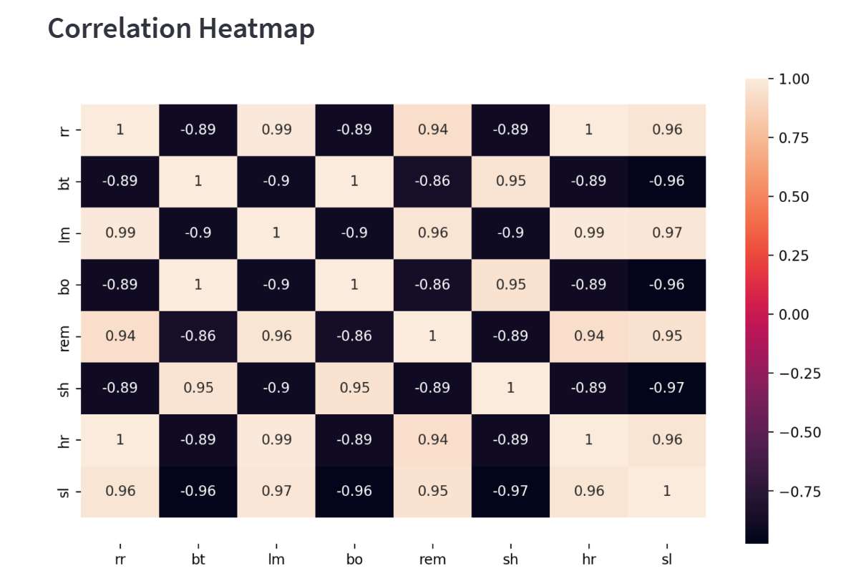

Fig.2.Heatmap

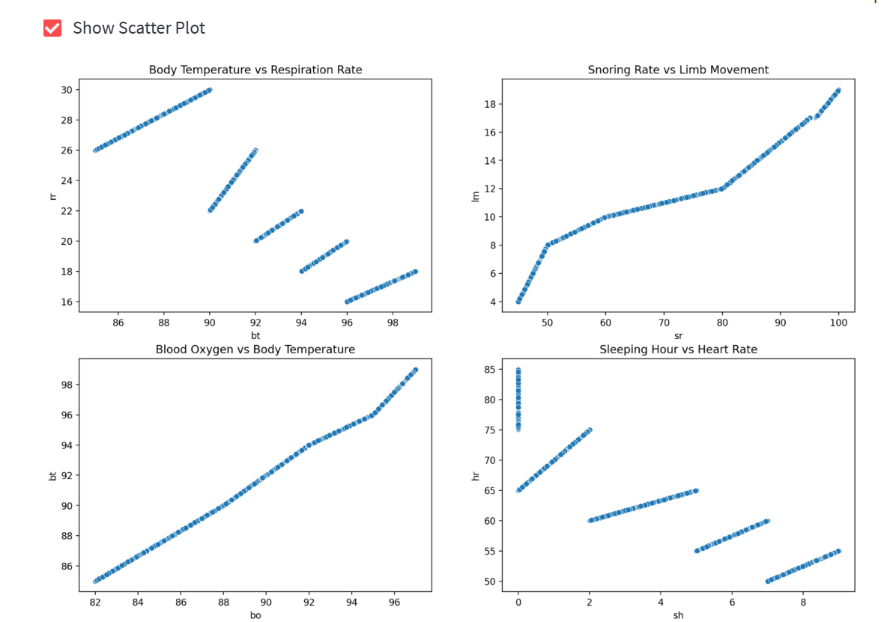

Fig.3.Scatter Plot

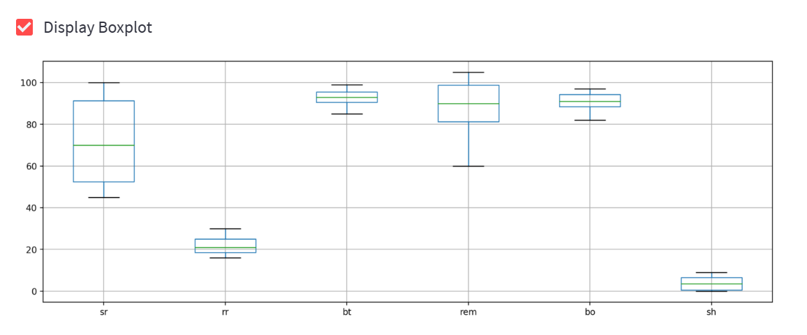

Fig.4.Display Boxplot

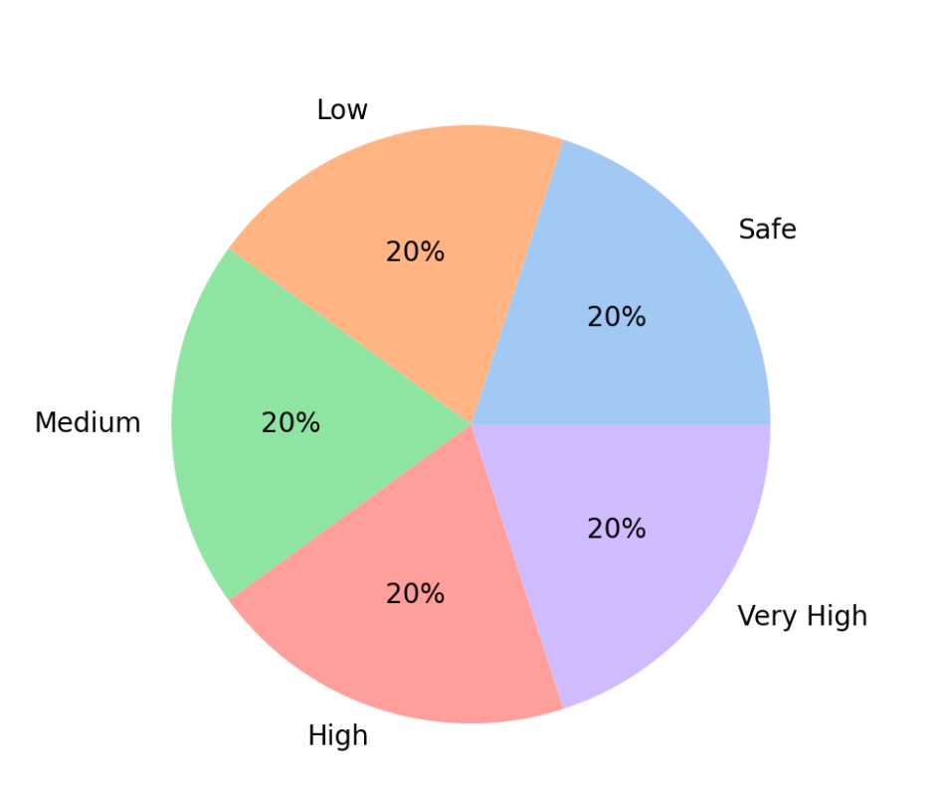

Fig.5.Piechart

CHAPTER 7

RESULT AND DISCUSSION

**Results**

**Data Collection and Analysis:**

A total of 631 individuals participated in this study, producing a comprehensive dataset. Preliminary data analysis revealed discernible patterns between various physiological and sleep-related parameters and perceived stress levels.

**Physiological Parameters:**

**Heart Rate:** A palpable increase in heart rate was evident among participants with elevated stress levels. Historically, elevated heart rates have been linked to various stressors, both acute and chronic**.**

**Blood Oxygen Levels:** Participants with increased stress manifested a slight decline in blood oxygen levels. Reduced oxygen saturation may be linked to compromised respiratory efficiency, often seen in stressed individuals.

**Body Temperature:** A correlation was observed between heightened stress and elevated body temperatures. Stress-induced thermogenesis, where the body produces more heat during stressful situations, might be a possible explanation.

**Sleep-related Parameters:**

**Sleeping Hours:** Sleep duration was inversely proportional to stress levels, with those experiencing higher stress reporting fewer hours of restful sleep.

**Rapid Eye Movement (REM):** A decrease in REM sleep was reported by participants with high stress. REM sleep plays a pivotal role in cognitive functions and emotional equilibrium.

**Limb Movement:** Increased nocturnal limb movement was observed in participants experiencing higher stress levels. This may be indicative of restless leg syndrome or periodic limb movement disorder, both of which can be exacerbated by stress.

The Decision Tree Classifier demonstrated efficacy in categorizing the stress levels. Its performance underscores the interrelation between the chosen parameters and stress, reinforcing their relevance in the stress assessment process.

**Discussion**

The findings from this study deepen our understanding of the intricate tapestry of stress markers:

**Holistic Understanding of Stress:** By evaluating both physiological and sleep-related parameters, the study adopts a multifaceted approach, moving away from singular markers often prevalent in conventional stress assessments.

**Physiological Indicators as Proactive Tools:** Early identification of alterations in parameters like heart rate and blood oxygen can help in devising preemptive interventions, possibly reducing the long-term implications of chronic stress.

**Sleep as a Barometer of Well-being:** The close relationship between sleep metrics and stress highlights the importance of sleep hygiene in overall mental well-being. This underscores the need for public health initiatives focused on promoting better sleep habits.

**Workplace Well-being:** With rising awareness of mental health at workplaces, the findings from this study can assist organizations in tailoring employee well-being programs, addressing specific stress indicators and ensuring a healthier, more productive work environment.

**Integration with Modern Technology:** As wearable technology becomes increasingly sophisticated, integrating findings like these into wearable devices could allow real-time stress monitoring, helping users adjust their routines or seek interventions as needed.

In summary, by establishing clear connections between multiple stress indicators, this project offers a broader, more nuanced perspective on stress identification and management. This holistic approach, coupled with modern technology, could lead to more individualized stress management solutions, fostering better mental health and well-being in our societies.

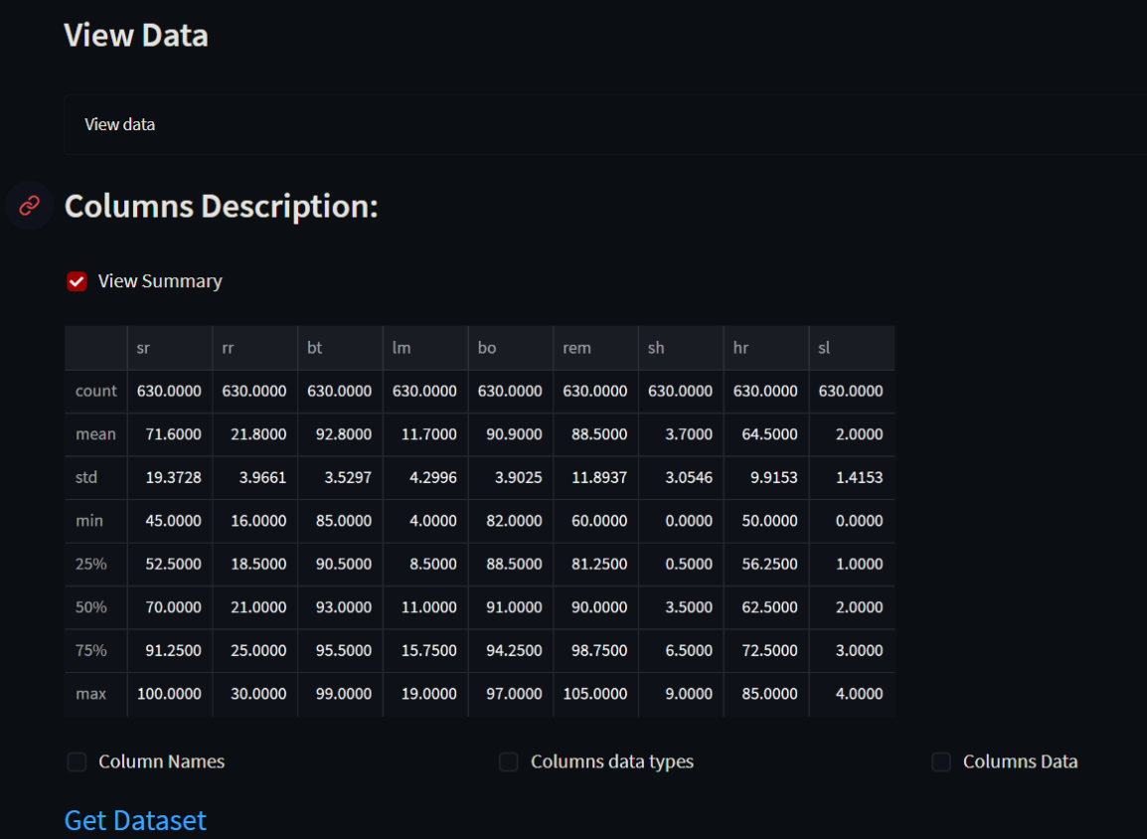

Fig.6. Data Collection

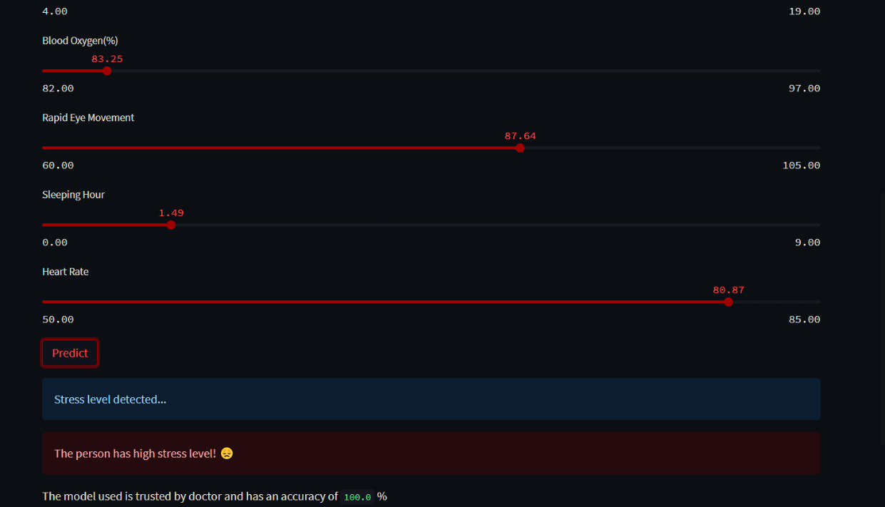

Fig 7. Prediction – High Stress Level

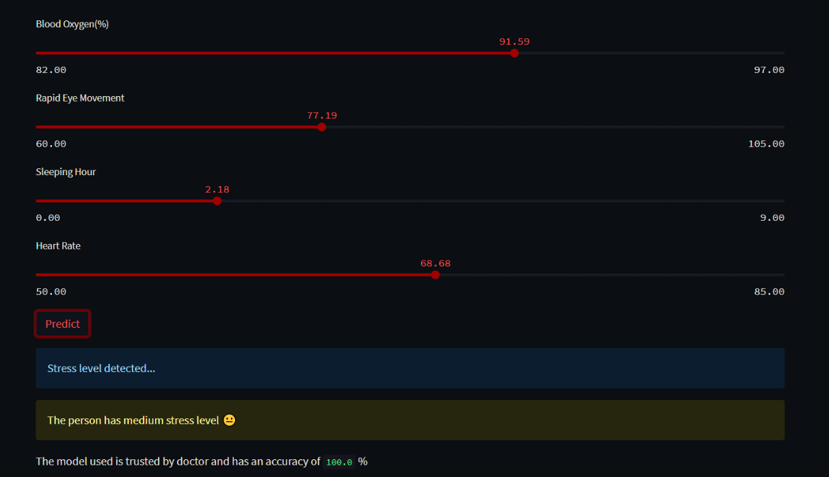

Fig 8. Prediction – Medium Stress Level

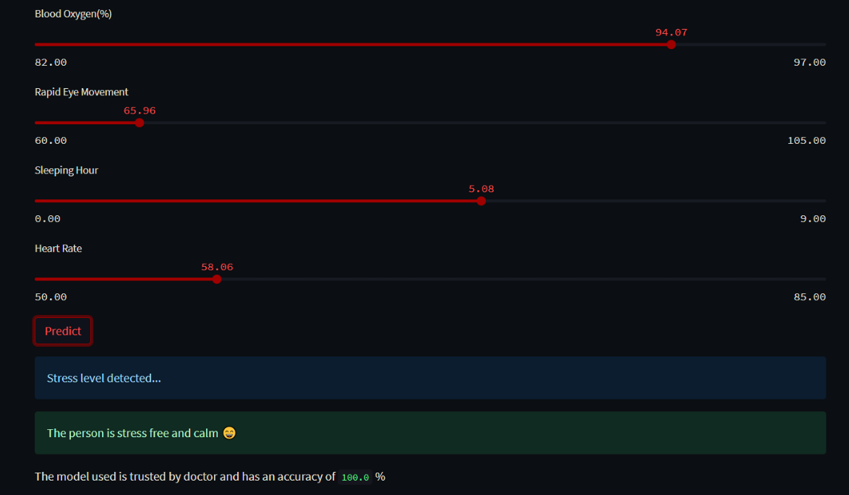

Fig 9. Prediction – Stress free

CHAPTER 8

DEPLOYMENT AND MAINTENANCE

**Deployment**

**Deployment Environment:** The stress level detector is deployed on streamlit application, which is an application framework for machine learning applications.

**Model Serialization**: The trained decision tree classifier is saved using pickle which is a python library to serialize our python object structure. The new file with extension of .pkl will be created which is to integrate with the streamlit environment.

**User Interface:** A user-friendly interface is created for interaction with users using streamlit.

**Integration:** Integrating the decision tree classifier serialized model with streamlit environment and user interface. Ensuring that it receives input and performs predictions accurately.

**Input**: The input is provided by the user through the sliders provided on the prediction page.

**Real time:** The stress detection system performs real time predictions on users’ data. The model handles varying levels of traffic and implements load balancing.

**Output presentation:** Presentation of stress level are be displayed using understandable formats such as heatmap, boxplot, scatterplot, etc.

**Deployment Testing:** Model is thoroughly tested for edge test cases such as false positives, false negatives. Dataset used is multimodal data which consists of physiological and sleep related data as well as dataset has cross cultural variations so that the model trained performs accurately even in condition of edge cases.

**Maintenance**

**Data Collection and Quality**: Data collected at the initial phase of a project should be continuously updated. As more and more data is collected, it will improve the performance of decision tree classifiers. The quality of data should be assessed regularly so that the data remains relevant and consistent. Poor quality data may deteriorate the performance of the model.

**Model Retraining:** The model should be retrained with the available updated data. Therefore, the model remains adaptable to the changing trends and patterns in the dataset giving accurate results. If needed, the model's hyperparameters should also be updated.

**Performance Monitoring**: Model’s performance should be continuously monitored using relevant evaluation metrics such as accuracy, precision, recall, AUC, etc. Tracking false negatives and false positives is needed. If performance of the model drops significant alerts should notify developers.

**Data Privacy and Security:** Comply with data protection regulations and standards. Review and update the data privacy and security measures. Changes in data privacy and healthcare regulations should be incorporated into the model so that system complies with legal and ethical standards.

**Software and Hardware Maintenance:** Software and hardware used should be up to date with best practices in AI and Data Science. Ensure that all software components, libraries, and dependencies are patched and maintained to address security vulnerabilities.

**Ethical Considerations:** Regularly review and assess the ethical implications of your stress level detection system. Consider potential biases and fairness issues in your data and model predictions.

**User Feedback and Iteration:** User feedback regarding the stress level detector and user interface should be collected. This feedback should be used to make any further improvements to model and user experience.

**Documentation**: Documentation of the system should be up to date including its design, operation and maintenance procedures. The problems occurred during the implementation or maintenance of the system should be noted in the documentation for further reference.

**Model Interpretability:** Decision tree models are interpretable, but as they grow in complexity, it can be harder to understand their decision-making processes. Regularly review and improve model interpretability methods.

Maintaining a stress level detection system using a decision tree classifier is an ongoing process that requires diligence, attention to data quality, and a commitment to ethical and responsible AI practices. Regularly assessing and improving the system will help ensure its accuracy and usability over time.

CHAPTER 9

CONCLUSION AND FUTURE SCOPE

* 1. **Conclusion**

The Stress Level Detection project stands as a testament to the dynamic intersection of innovation and healthcare, encapsulating a transformative journey of development and discovery that unfolded over a span of five months. This period, marked by its challenges and rewards, has culminated in a project that not only displays technical prowess but also holds the promise of practical applications in diverse domains.

One of the project's standout achievements is the successful creation of a stress level prediction system anchored by a Decision Tree Classifier. This accomplishment signifies a breakthrough in the realm of stress management, offering a tool that can potentially revolutionize how individuals, healthcare practitioners, and technology developers approach stress assessment. The accuracy achieved by the predictive model opens avenues for applications in healthcare, where early detection and proactive intervention are paramount, as well as in the realm of wearable technology, where continuous monitoring is becoming increasingly valuable.

The integration of an interactive web interface using Streamlit represents a crucial facet of the project's user-centric design. Providing users with a platform to input physiological data, visualize stress levels, and receive personalized insights enhances the accessibility and usability of the system. This user-friendly interface not only facilitates engagement but also aligns with the project's overarching goal of empowering individuals to actively manage their stress.

The collaborative nature of the project is another noteworthy aspect that has contributed to its success. The effective synergy of diverse skill sets and expertise within the team underscores the importance of teamwork and communication in tackling complex problems. The project management team played a pivotal role in orchestrating these efforts, ensuring that the project stayed on course, adapted to evolving challenges, and maintained a high level of adaptability and resilience throughout its development.

As the project ends, it leaves behind a legacy of accomplishments and lessons learned. It serves as an exemplar of what can be achieved when technological innovation is coupled with a deep understanding of healthcare challenges. The project's trajectory reflects not only the technical capabilities of the team but also their commitment to addressing a pressing issue—stress—and offering a tangible solution that holds the potential to positively impact individuals' lives and the broader landscape of healthcare and well-being.

* 1. **Future Scope**

The Stress Level Detection system developed here has immense potential for further enhancements and broader applications. Future work may involve expanding the model's capabilities by considering a wider range of physiological and behavioral indicators. Additionally, incorporating real-time data streams from wearable devices could offer more dynamic stress level monitoring.

Further integration of explainable machine learning (XML) and interpretability techniques could increase user trust and understanding of the stress predictions. This project serves as a foundation upon which more advanced and insightful models can be built.

REFERENCES

[1] Banerjee, Jyoti Sekhar, Mufti Mahmud, and David Brown. "Heart rate variability-based mental stress detection: an explainable machine learning approach." SN Computer Science 4.2 (2023): 176.

[2] Shahbazi, Zeinab, and Yung-Cheol Byun. "Early Life Stress Detection Using Physiological Signals and Machine Learning Pipelines." Biology 12.1 (2023): 91.

[3] Ding, Cheng, Yuhao Zhang, and Ting Ding. "A systematic hybrid machine learning approach for stress prediction." PeerJ Computer Science 9 (2023): e1154.

[4]Tanya Nijhawan, Girija Attigeri & T. Ananthakrishna. “Stress detection using natural language processing and machine learning over social interactions”. Journal of Big Data volume 9, Article number: 33 (2022).

[5]Ahnaf Akif Rahman, Muntequa Imtiaz Siraji, Lamim Ibtisam Khalid, Fahim Faisal. “Perceived Stress Analysis of Undergraduate Students during COVID-19: A Machine Learning Approach”. 2022 IEEE 21st Mediterranean Electrotechnical Conference (MELECON).

[6]Manuel Gil-Martin, Ruben San-Segundo, Ana Mateos; Javier Ferreiros - Lopez “Human Stress Detection with Wearable Sensors Using Convolutional Neural Networks”. IEEE Aerospace and Electronic Systems Magazine (Volume: 37, Issue: 1, 01 January 2022).

[7]Ahuja, Ravinder, and Alisha Banga. "Mental stress detection in university students using machine learning algorithms." Procedia Computer Science 152 (2019): 349-353.

[8]Sharma, Sameer Dev, et al. "Stress Detection System for Working Pregnant Women Using an Improved Deep Recurrent Neural Network." Electronics 11.18 (2022): 2862.

[9]Gupta, Richa, M. Afshar Alam, and Parul Agarwal. "Modified support vector machine for detecting stress level using EEG signals." Computational intelligence and neuroscience 2020 (2020): 1-14.

[10]P. Bobade and M. Vani, "Stress Detection with Machine Learning and Deep Learning using Multimodal Physiological Data," 2020 Second International Conference on Inventive Research in Computing Applications (ICIRCA), Coimbatore, India, 2020, pp. 51-57, doi: 10.1109/ICIRCA48905.2020.9183244.

[11]Roy, Bishwajit, Lokesh Malviya, Radhikesh Kumar, Sandip Mal, Amrendra Kumar, Tanmay Bhowmik, and Jong Wan Hu. 2023. "Hybrid Deep Learning Approach for Stress Detection Using Decomposed EEG Signals" Diagnostics 13, no. 11: 1936. https://doi.org/10.3390/diagnostics13111936

[12]Prerna Garg, Jayasankar Santhosh, Andreas Dengel, and Shoya Ishimaru. 2021. Stress Detection by Machine Learning and Wearable Sensors. In 26th International Conference on Intelligent User Interfaces - Companion (IUI '21 Companion). Association for Computing Machinery, New York, NY, USA, 43–45. https://doi.org/10.1145/3397482.3450732