**SQL Analysis**

Analysis done on PostgreSQL Platform.

Results got from the Analysis is the same with which we got from the data visualization technique using Tableau.(See ‘Customer_Demographic_Analysis.pdf’)

**Q1. Gender Contribution:**

SELECT

count(male_accounts)* 100.0 /(select count(*) from black_friday) AS Male_account,

count(female_accounts)* 100.0 /(select count(*) from black_friday) AS Female_account

FROM(

SELECT

CASE WHEN gender = 'M' THEN 1 END male_accounts,

CASE WHEN gender = 'F' THEN 1 END female_accounts

FROM black_friday

) black_friday

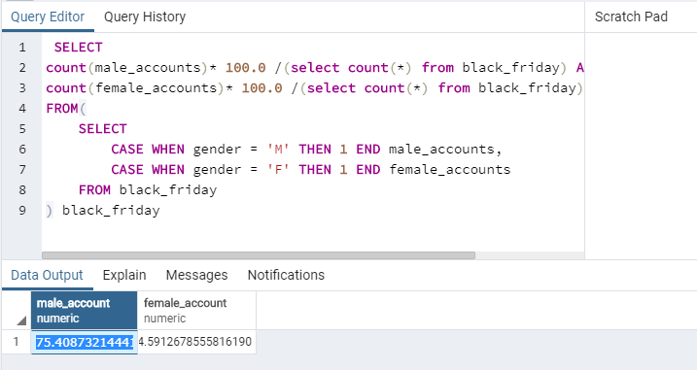

**Q2. Sales Distribution in every city:**

SELECT

CASE WHEN city_category = 'A' THEN 'city_A'

WHEN city_category = 'B' THEN 'city_B'

ELSE 'city_C' END AS CITY,

SUM(purchase) AS purch

FROM black_friday

GROUP BY 1

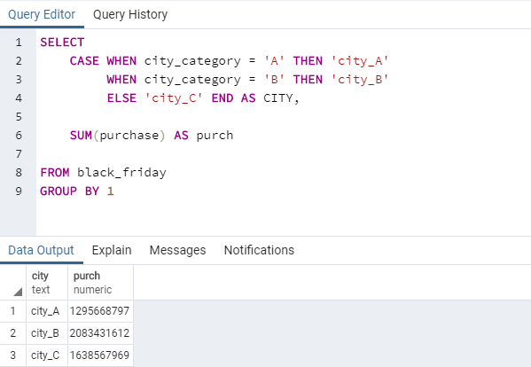

**Q3. 10 products with highest amount of sales**

SELECT

product_id AS Product_ID,

SUM(purchase) AS Total

FROM black_friday

GROUP BY product_id

ORDER BY Total DESC

LIMIT 10

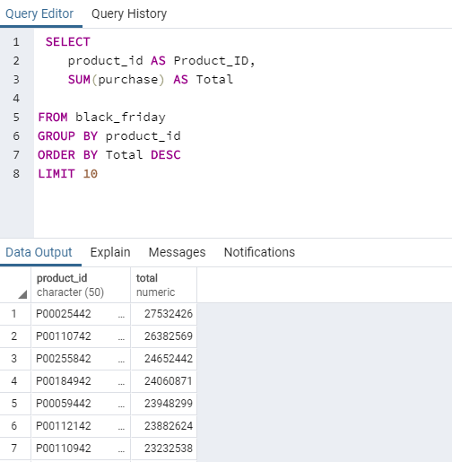

Conclusion is done in the end of the Tableau Report.