1 Based on what you have learnt in the class, do the following steps:

a. Create a new folder

b. Put the following files in the folder

Code.txt

Log.txt

Output.txt

c. Stage the Code.txt and Output.txt files

d. Commit them

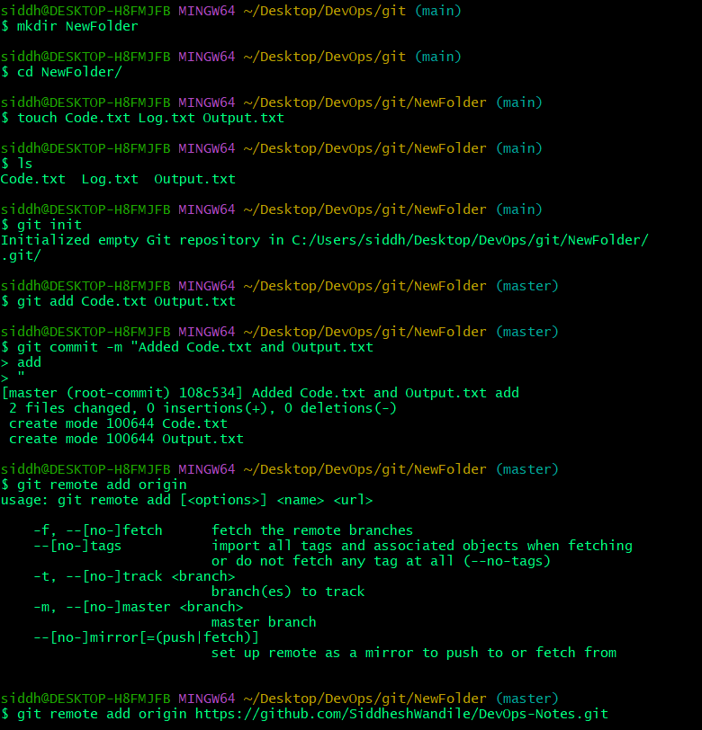 e. And finally push them to GitHub

**=>**

**­2. Tasks to Be Performed:**

1. Create a Git working directory with feature1.txt and feature2.txt in the master branch

2. Create 3 branches develop, feature1 and feature2

3. In develop branch create develop.txt, do not stage or commit it

4. Stash this file and check out to feature1 branch

5. Create new.txt file in feature1 branch, stage and commit this file

6. Checkout to develop, unstash this file and commit

7. Please submit all the Git commands used to do the above step  
=>

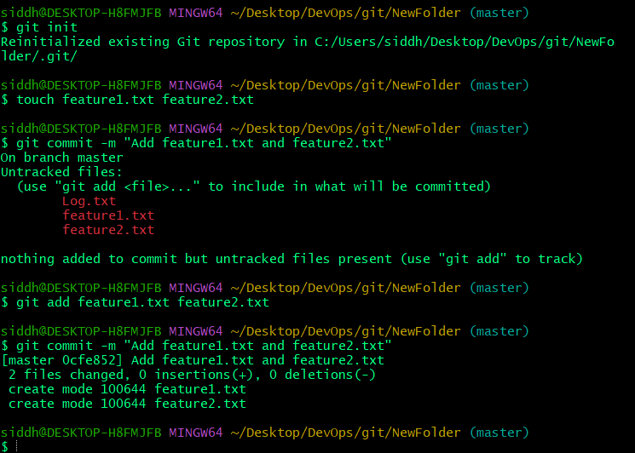1.

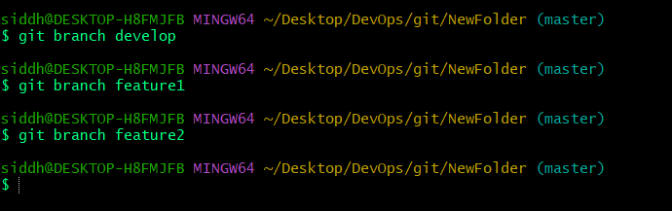

2.

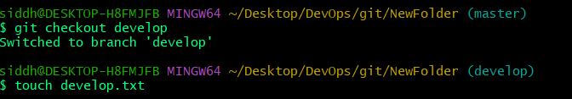3.

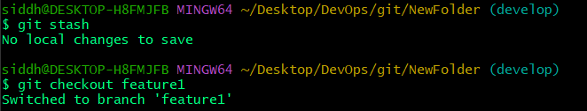

4.

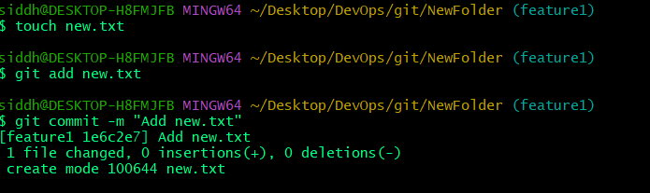

5.

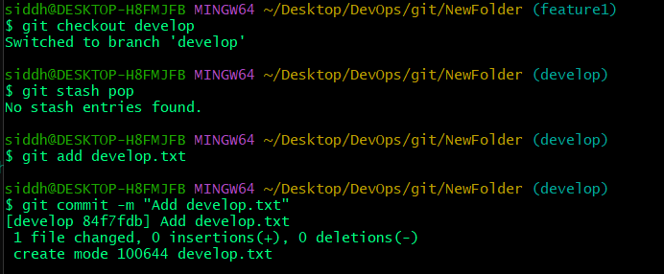

6.

**3. Tasks to Be Performed:**

1. Create a Git working directory, with the following branches:

Develop

F1

f2

2. In the master branch, commit main.txt file

3. Put develop.txt in develop branch, f1.txt and f2.txt in f1 and f2 respectively

4. Push all these branches to GitHub

5. On local delete f2 branch

6. Delete the same branch on GitHub as well

=> **Step 1**

git init

git branch develop

git branch f1

git branch f2

**Step 2**

touch main.txt

git add main.txt

git commit -m "Add main.txt in the master branch"

**Step 3**

git checkout develop

touch develop.txt

git add develop.txt

git commit -m "Add develop.txt in develop branch"

git checkout f1

touch f1.txt

git add f1.txt

git commit -m "Add f1.txt in f1 branch"

git checkout f2

touch f2.txt

git add f2.txt

git commit -m "Add f2.txt in f2 branch"

**Step 4**

git remote add origin https://github.com/SiddheshWandile/DevOps-Notes.git

git push -u origin master

git push -u origin develop

git push -u origin f1

git push -u origin f2

**Step 5**

git branch -d f2

**Step 6**

git push origin --delete f2

**4. Tasks to Be Performed:**

1. Put master.txt on master branch, stage and commit

2. Create 3 branches: public 1, public 2 and private

3. Put public1.txt on public 1 branch, stage and commit

4. Merge public 1 on master branch

5. Merge public 2 on master branch

6. Edit master.txt on private branch, stage and commit

7. Now update branch public 1 and public 2 with new master code in private

8. Also update new master code on master

9. Finally update all the code on the private branch

=> **Step 1**

git init

touch master.txt

git add master.txt

git commit -m "Add master.txt on master branch"

**Step 2**

git branch public1

git branch public2

git branch private

**Step 3**

git checkout public1

touch public1.txt

git add public1.txt

git commit -m "Add public1.txt on public1 branch"

**Step 4**

git checkout master

git merge public1 -m "Merge public1 into master"

**Step 5**

git checkout public2

touch public2.txt

git add public2.txt

git commit -m "Add public2.txt on public2 branch"

git checkout master

git merge public2 -m "Merge public2 into master"

**Step 6**

git checkout private

echo "Updated content for master.txt" >> master.txt

git add master.txt

git commit -m "Edit master.txt on private branch"

**Step 7**

git checkout public1

git merge private -m "Update public1 with private branch changes"

git checkout public2

git merge private -m "Update public2 with private branch changes"

**Step 8**

git checkout master

git merge private -m "Update master with private branch changes"

**Step 9**

git checkout private

git merge master -m "Update private branch with new master code"

**5. Tasks to Be Performed**:

1. Create a Git Flow workflow architecture on Git

2. Create all the required branches

3. starting from e feature branch, push the branch to the master, following the architecture

4. Push an urgent.txt on master using hotfix