

A Project Report On

**School Management System**

**By**

Siddhesh Bhor

**Batch:** 2022-7400

**Center: Mumbai**

Under the Guidance of

**Chittaranjan Ghosh.**

**Technical Trainer**

**EduBridge**

(School of coding)

**Introduction:**

School Management System manages student, teacher and funds information in the school with regard to funds management. It improves existing system. It has the facility of maintaining the details of the student, teacher and funds thereby reducing the manual work. It will save time and energy which are spending in making reports and collecting data. School Management System can be accessed throughout the School with proper login provided.

**Modules:**

* Student Module
* Teacher Module
* Admin (School) Module

I have developed this Application in **Java .**

The main objective of the School management system is to reduce manual work and time. It is difficult and time-consuming to collect fees information of each student and payment (Salary) information of each teacher. To avoid this problem, we have planned to develop a console-based School management system.

In Admin module, admin can add, update, delete, search,pay salary and receive fees. He can also view the total number of student and total number of teacher at present in the school.

* It manages the details of student records, teacher records, and funds management records.
* Saves the time of account and faculties.
* This system makes student information and teacher information more secure.

**Modules :**

* **Admin Module:** Admin can able to handle Student portal and Teacher portal. It maintain student and teacher funds of school.

**Software Requirements :**

**Language:** Java.

**IDE:** Eclipse for Java EE Developers.

**Operating System:** Microsoft Windows.

Screenshot: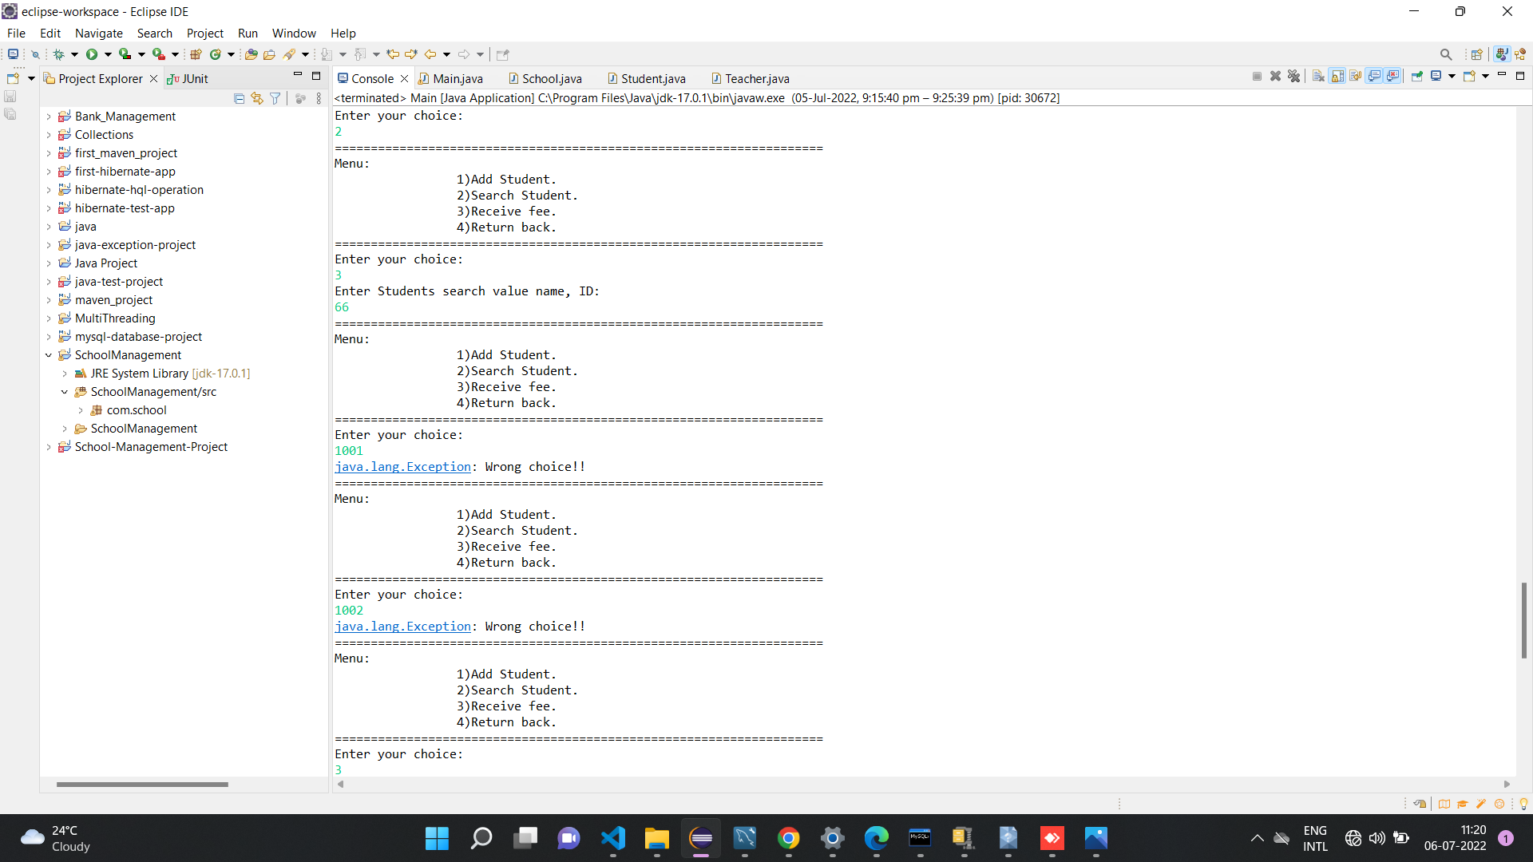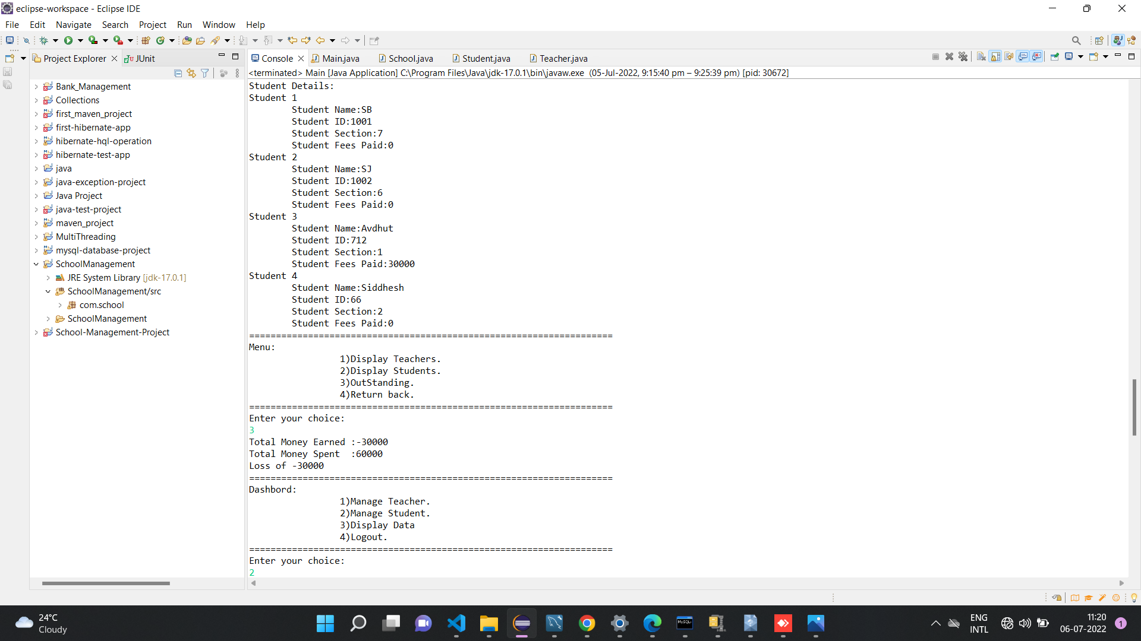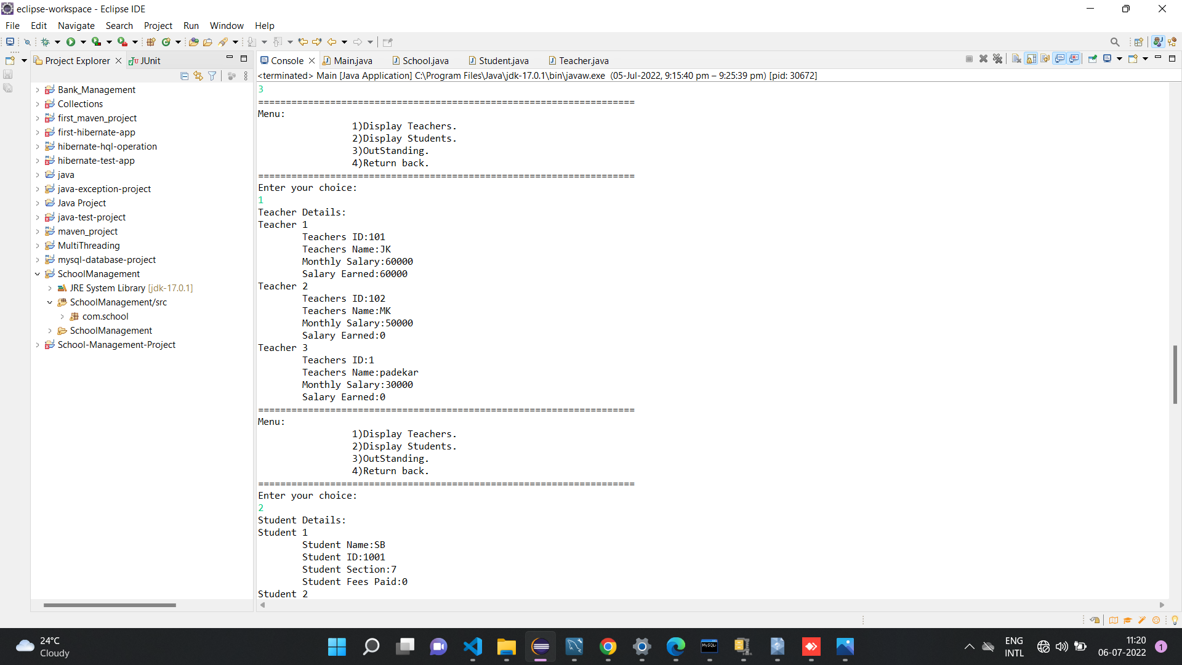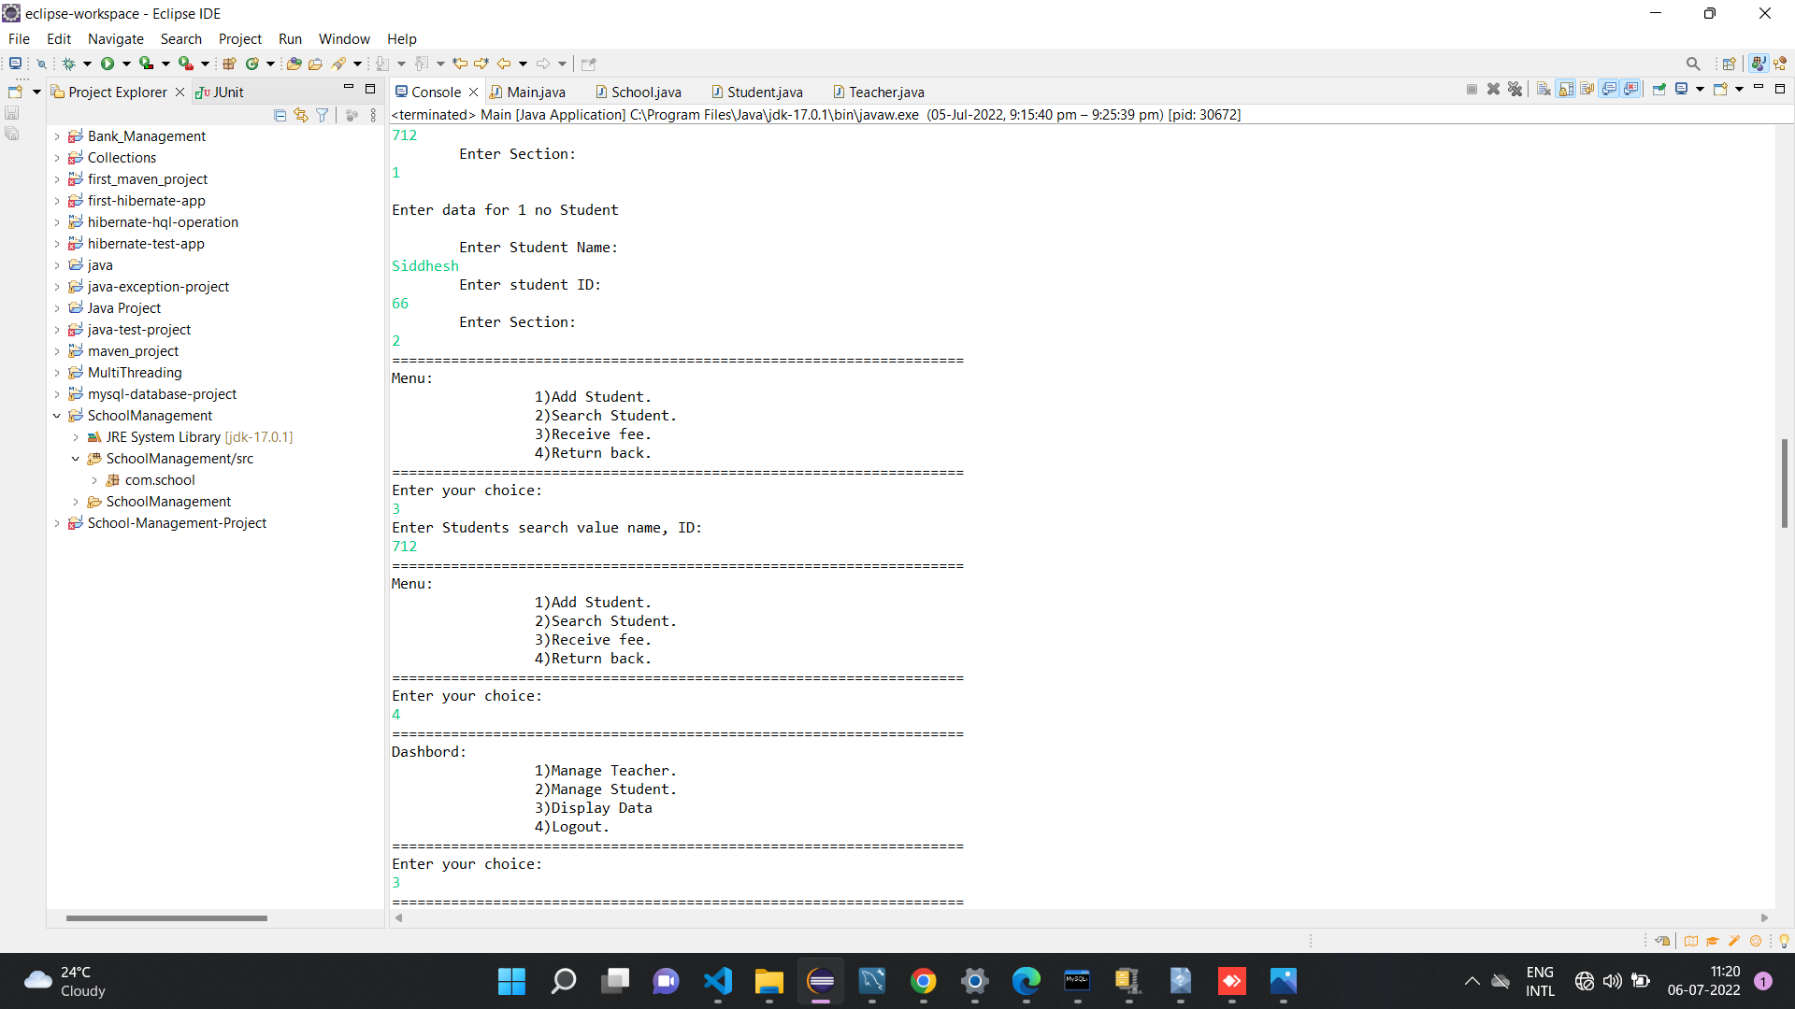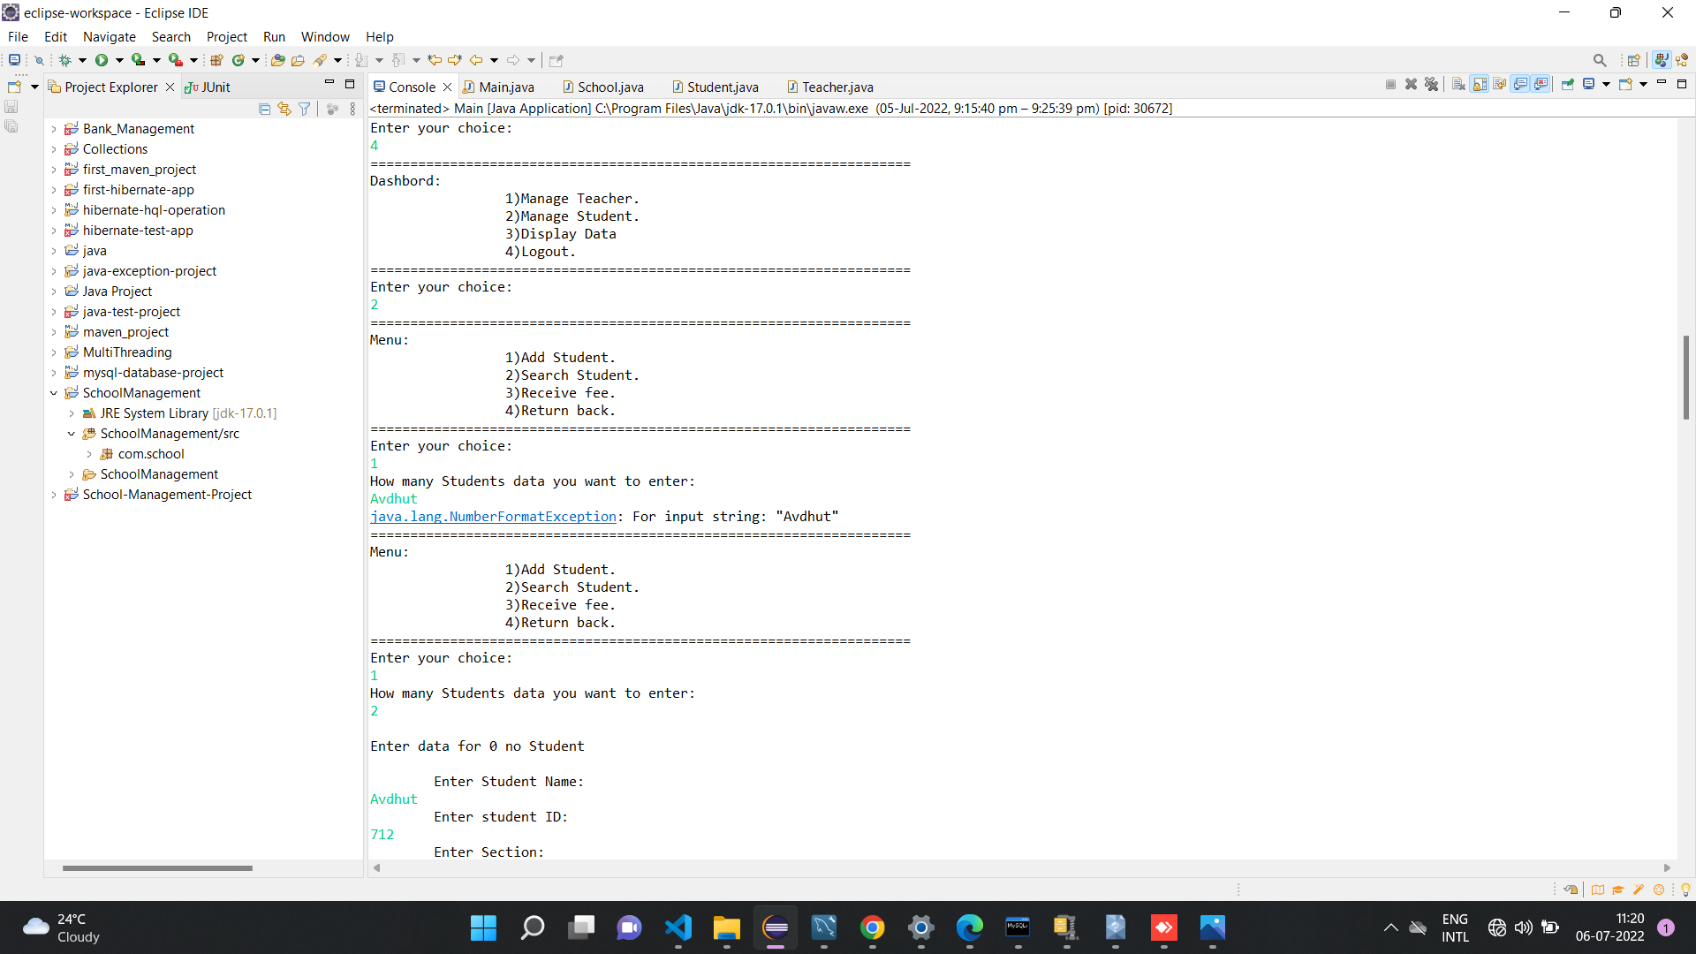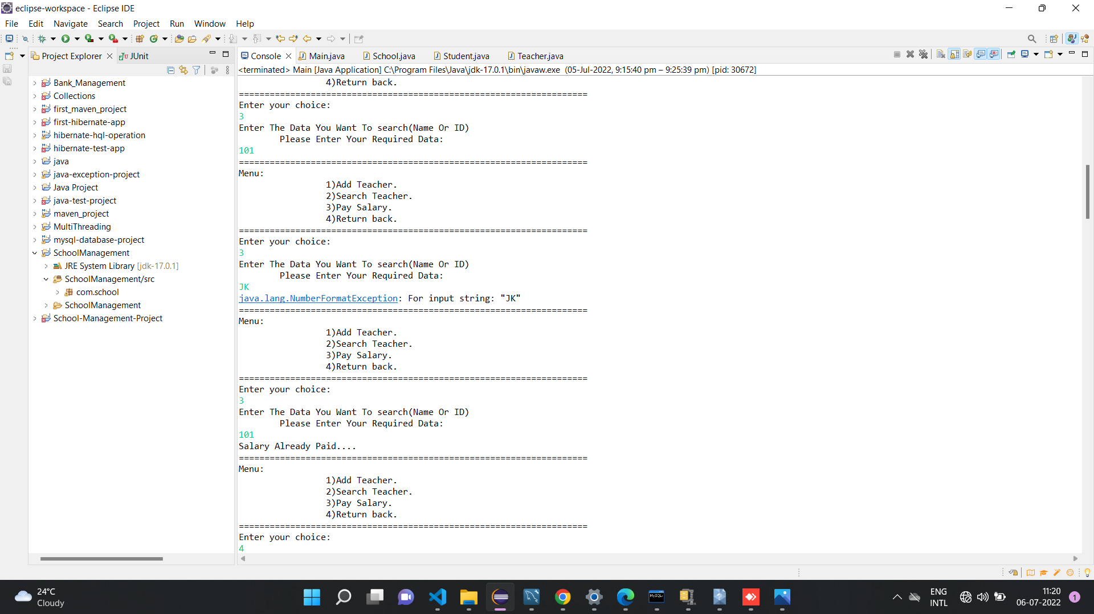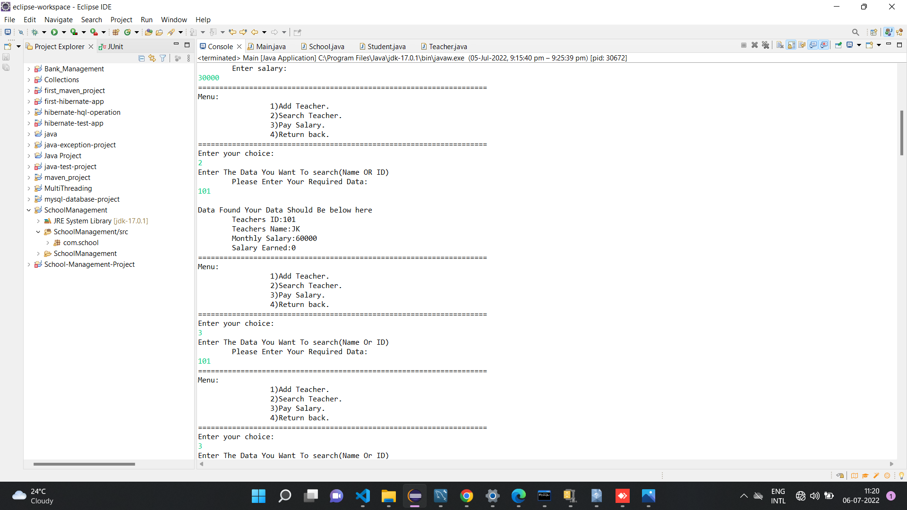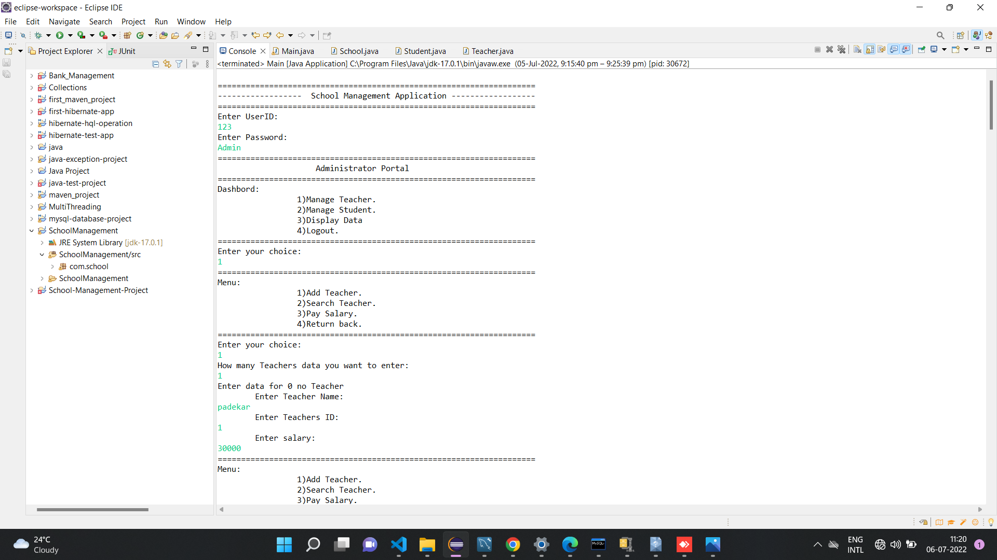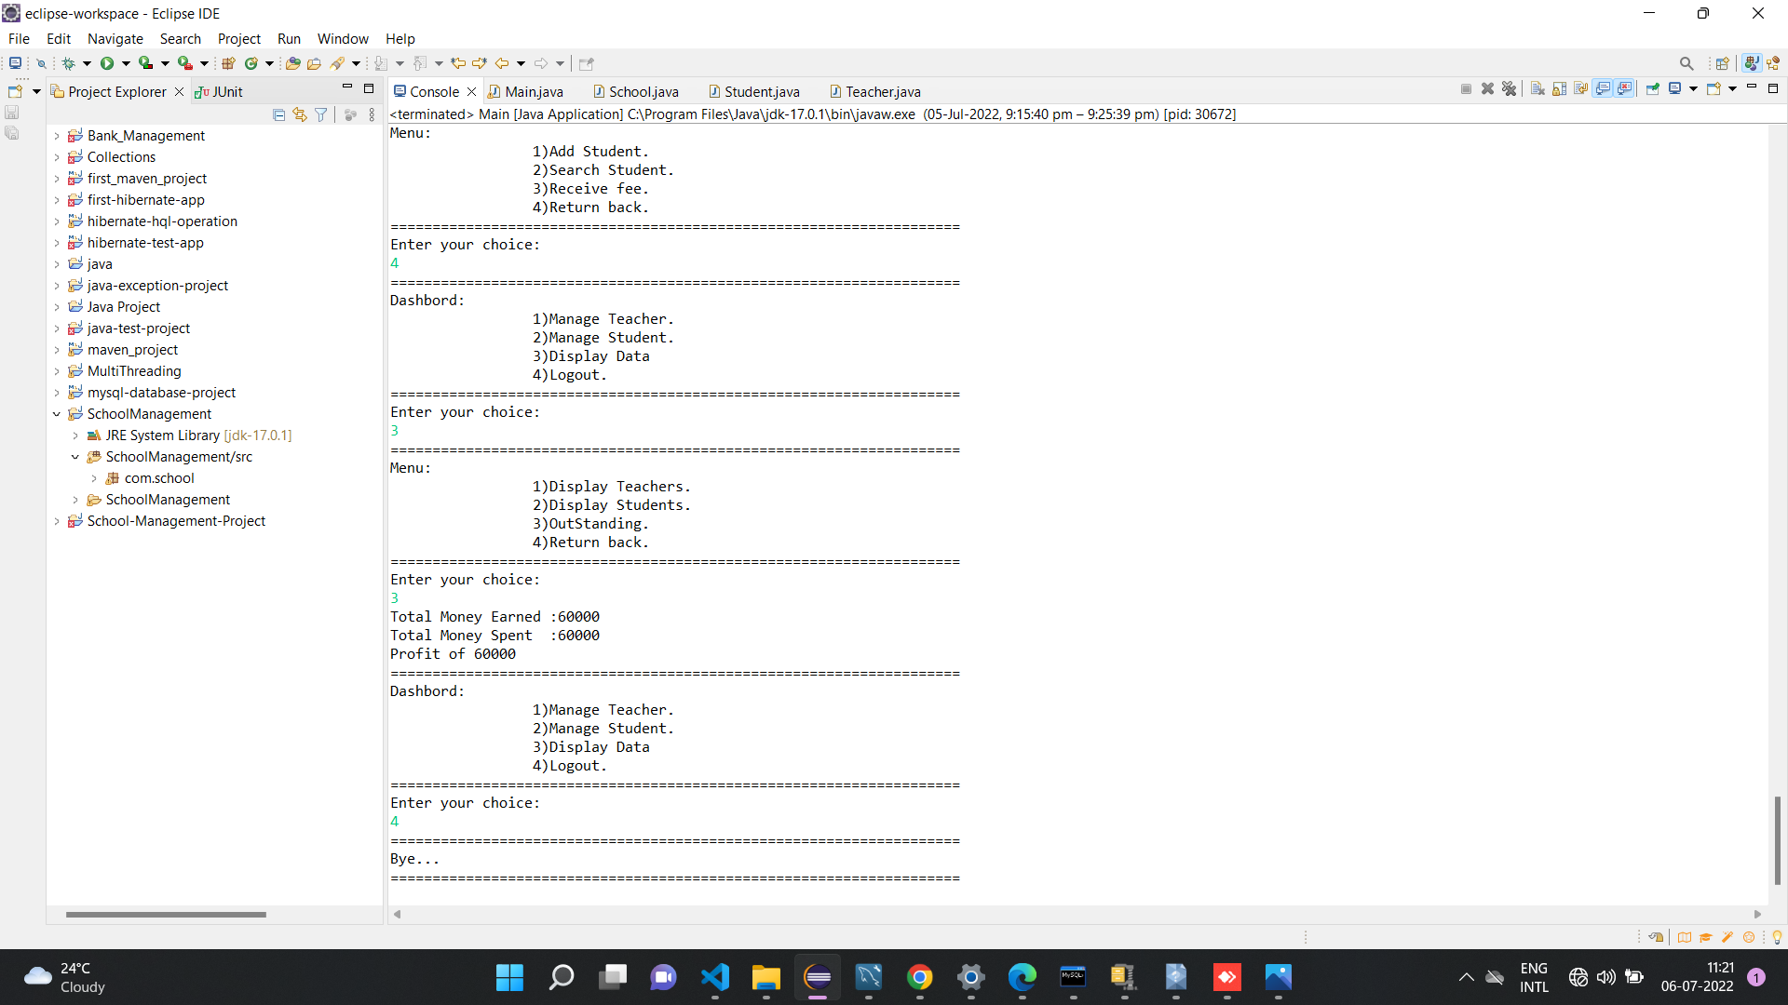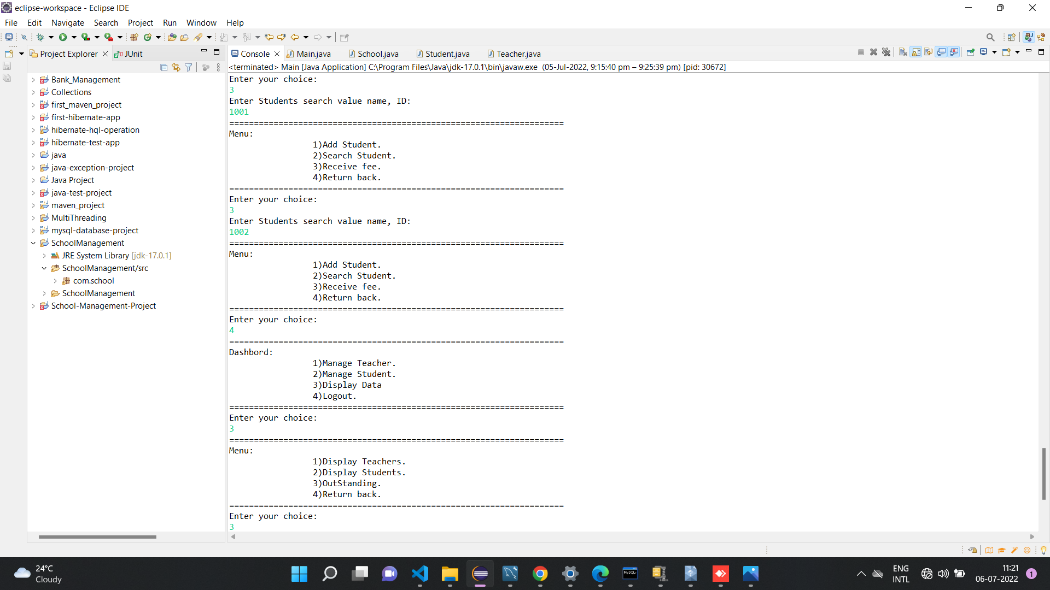

**Thank you…..**