# **SaveEasy**

*While automating web based applications, we often come across situations where we download data from internet. Sometimes it gets tedious and painful. SaveEasy aims to provide an easy to use, configurable and reusable snippet to save all types of files , in all leading browsers. It takes care of the exceptional cases as well, such as whether to replace the file and other system exceptions. You can configure course of action in such cases and by setting variable values on the main workflow. For more details, please go through the video here*

1. So Let’s go through the each step to understand how this workflow is build and how you can use it. High level workflow looks like below.

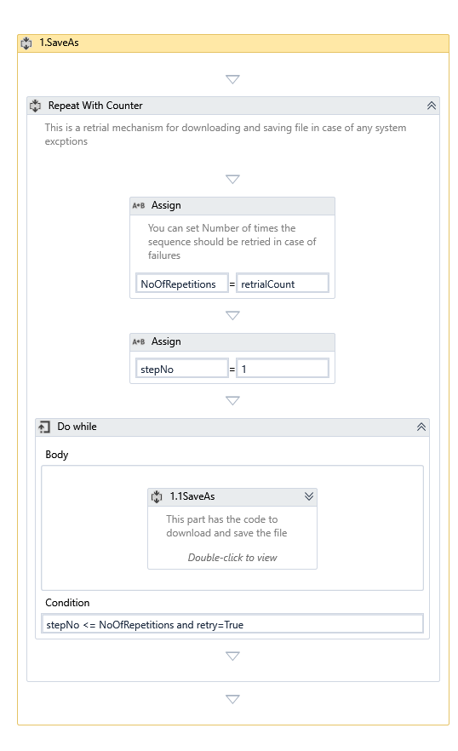

1. Input parameters of this workflow are listed in Variables tab, where we can set following properties

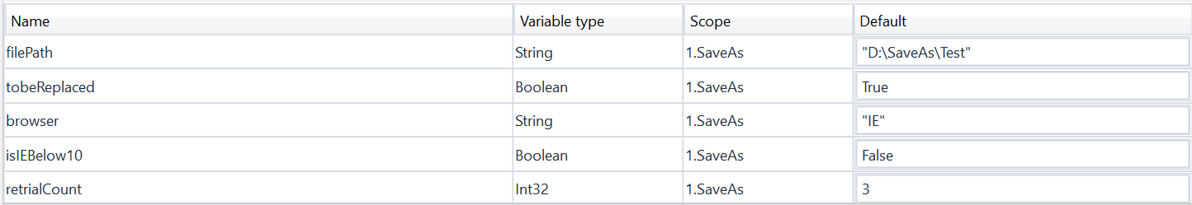

1. filePath: Directory where you want to save the files
2. tobeReplaced: Set true if you prefer to replace the file if it already exists in the directory
3. browser:Name of browser you are working on. {“IE”,”Chrome”,”Firefox”}
4. isIEBelow10: Set true if you are using Internet explore version older than 10
5. retrialCount : Number of times you want to retry in case of failures
6. 1.1 SaveAs sequence takes care of downloading the files and saving it to specified folder.
7. Switch statement takes browser as expression and depending on the value, browser specific selector settings are done

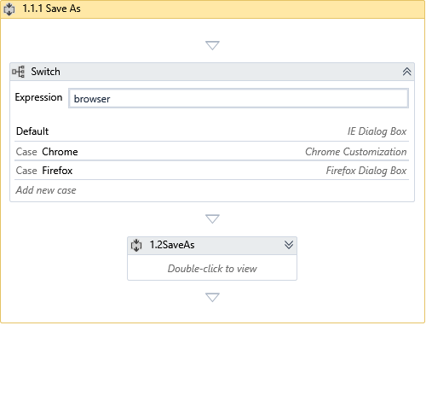

1. Inside switch, application value in the selector corresponding to particular browser is set for two selectors
2. SaveAsSelector: Attach window selector for initial save as popup
3. ConfirmSaveAsSelector: Attach window selector for confirm pop up whether to replace the existing file

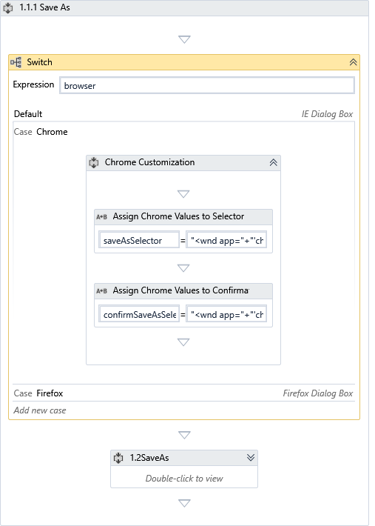

1. 1.2SaveAs actually takes care of checking if the save as pop up is appearing, then typing filepath, and saving, replacing file if exists already

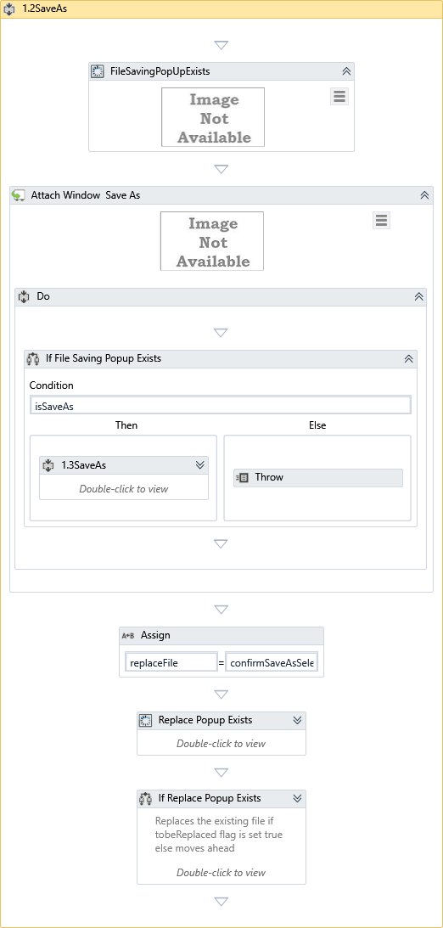

1. In case if tobeReplaced is set to False, bot clicks on No and then Cancel

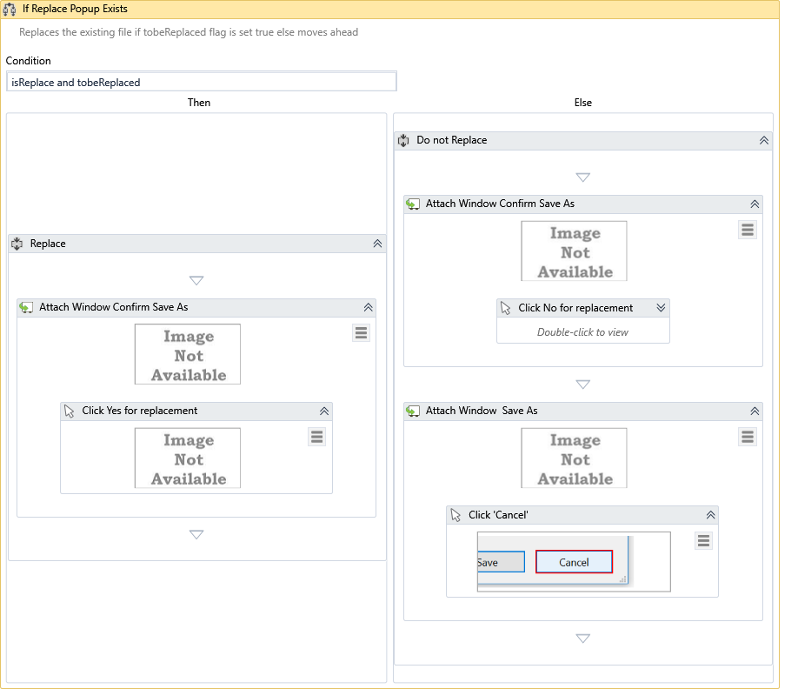

1. It has been tested on Windows 7,8 and 10 versions and for all the above browsers with their latest versions.
2. Please reach out at [siddheshwarkore01@gmail.com](mailto:siddheshwarkore01@gmail.com) in case of queries.