UTILITY USAGE PREDICTION TOOL
Project Report

Submitted by
Siddhi Mohite

Internship Organization
CodeVedX AI/ML Internship

Project Number: 1

Submission Date:
5 jun 2026

TABLE OF CONTENTS

1. Introduction
2. Project Objectives
3. Problem Statement
4. Technologies Used
5. System Design
6. Project Implementation
7. Results and Output
8. Challenges Faced
9. Future Scope
10. Conclusion

1. INTRODUCTION

Utility consumption prediction plays an important role in efficient resource management and planning. Accurate prediction of utility usage helps individuals and organizations optimize consumption, reduce waste, and make informed decisions.

The Utility Usage Prediction Tool is a Python-based Machine Learning application developed to analyze historical utility consumption data and predict future usage patterns. The system provides a user-friendly menu-driven interface that allows users to manage utility records, train prediction models, and generate forecasts.

The project demonstrates the practical application of Machine Learning concepts, data handling techniques, and software development principles in solving real-world prediction problems.

2. PROJECT OBJECTIVES

The main objectives of this project are:

• To develop a utility usage prediction system using Python.

• To store and manage utility consumption data efficiently.

• To train a Machine Learning model using historical utility data.

• To generate future utility usage predictions based on input values.

• To implement data validation and exception handling mechanisms.

• To provide a simple and user-friendly menu-driven interface.
• To demonstrate the practical implementation of Machine Learning in predictive analytics.

3. PROBLEM STATEMENT

Utility consumption often varies due to multiple factors, making it difficult to estimate future usage accurately through manual calculations. Inaccurate predictions can lead to inefficient resource allocation and planning.

The objective of this project is to build a Machine Learning-based prediction system that analyzes historical utility usage data and provides reliable future consumption estimates. The system should allow users to store data, train predictive models, and generate predictions in an efficient and user-friendly manner.

4. TECHNOLOGIES USED

The following technologies and tools were used in the development of this project:

• Python – Core programming language used for application development.

• Pandas – Used for data manipulation and CSV file handling.

• NumPy – Used for numerical computations and data processing.

• Scikit-Learn – Used for building and training the Machine Learning model.

• CSV Files – Used for storing utility usage records.

• Git – Used for version control and project management.

• GitHub – Used for project hosting and collaboration.

• Visual Studio Code – Used as the development environment.

5. SYSTEM DESIGN

The Utility Usage Prediction Tool follows a supervised Machine Learning approach. The system uses historical utility consumption data to train a predictive model capable of estimating future utility usage.

The workflow of the system is as follows:

1. Data Collection – Utility usage records are stored in a CSV file.

2. Data Preprocessing – The data is cleaned and prepared for model training.

3. Feature Selection – Relevant input features are selected from the dataset.

4. Model Training – A Linear Regression model from the Scikit-Learn library is trained using the historical data.

5. Prediction – The trained model generates future utility usage predictions based on user inputs.

6. Result Display – The predicted utility usage value is displayed through the console interface.

The system architecture ensures efficient data handling, model training, and prediction generation while maintaining simplicity and usability.

6. PROJECT IMPLEMENTATION

The project was implemented using Python and Machine Learning libraries.

Implementation Steps:

• A dataset containing historical utility usage records was stored in CSV format.

• Pandas was used to read and manage the dataset.

• NumPy was used for numerical operations and data processing.

• The Linear Regression algorithm from Scikit-Learn was used to train the prediction model.

• The application was divided into multiple modules for better code organization.

• A menu-driven interface was developed to allow users to add data, train the model, and generate predictions.

• Exception handling techniques were implemented to improve reliability and prevent invalid user inputs.

The modular design makes the project easy to maintain, understand, and extend in the future.

7. RESULTS AND OUTPUT

The Utility Usage Prediction Tool successfully predicts future utility consumption using historical data and Machine Learning techniques.

The Linear Regression model was trained using utility usage records and was able to generate numerical predictions based on user inputs.
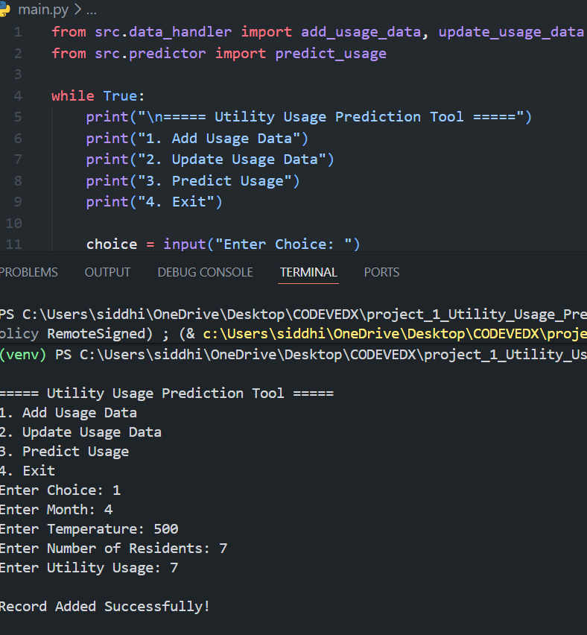
Utility Usage Prediction Tool Running in Terminal & Successful Record Storage

The application provides quick and efficient predictions, demonstrating the practical application of Machine Learning in utility consumption forecasting.

Challenges Faced During Project Development :
- Data Preparation
Cleaning and organizing the dataset into a suitable format for model training required careful preprocessing.

- Model Selection
Choosing an appropriate machine learning algorithm and tuning it for better performance was a learning experience.

- Dependency Management
Installing and configuring Python libraries such as Pandas, NumPy, and Scikit-learn occasionally led to environment-related issues.

- Project Structure Organization
Maintaining a clean folder structure and separating data, source code, and models required proper planning.

- Debugging and Testing
Identifying and fixing errors in data handling, model training, and prediction logic took considerable effort.

Future Scope :

- Enhanced Prediction Accuracy
Advanced machine learning algorithms can be integrated to improve prediction performance.
- Real-Time Data Integration
The system can be connected to live utility usage data sources for real-time predictions.

- Interactive User Interface
A graphical web-based dashboard can be developed for easier user interaction.

- Data Visualization
Charts and graphs can be added to help users better understand usage trends and predictions.

- Cloud Deployment
The application can be deployed on cloud platforms, making it accessible from anywhere.

- Scalability
The system can be expanded to handle larger datasets and support multiple utility categories.

10. CONCLUSION

The Utility Usage Prediction Tool successfully demonstrates the application of Machine Learning techniques for predicting future utility consumption. The project was developed using Python, Pandas, NumPy, and Scikit-Learn, with Linear Regression used as the prediction algorithm.

The system allows users to manage utility data, train a predictive model, and generate utility usage forecasts through a simple menu-driven interface. The project helped in understanding data handling, model training, prediction techniques, and software development practices.

Overall, the project achieved its objective of providing an efficient and user-friendly solution for utility usage prediction while strengthening practical knowledge of Machine Learning and Python programming.

