STUDENT PERFORMANCE PREDICTION SYSTEM

AI/ML Internship Project Report

Submitted By:
Siddhi Mohite

Internship Organization
CodeVedx

Technologies Used
Python, Pandas, NumPy, Matplotlib,
Seaborn, Scikit-learn, Flask

Submission Date
04 June 2026

1. Abstract

The Student Performance Prediction System is a Machine Learning project developed to predict students' final examination marks using academic factors such as attendance, study hours, and internal assessment marks. The project utilizes data preprocessing, exploratory data analysis, machine learning model training, and web application development. Multiple machine learning algorithms were evaluated, and the best-performing model was integrated into a Flask-based web application for real-time predictions.

---

2. Introduction

Educational institutions continuously seek methods to improve student performance and identify students who may require additional academic support. Traditional evaluation methods are often time-consuming and may not provide early insights into student outcomes.

Machine Learning provides an efficient approach for analyzing student-related data and predicting academic performance. This project focuses on predicting final examination marks based on important academic indicators.

---

3. Objectives

• Analyze student academic performance data.

• Perform data cleaning and preprocessing.

• Visualize relationships among different features.

• Train and evaluate machine learning models.

• Compare model performance.

• Predict final marks accurately.

• Develop a Flask-based web application for user interaction.

---

4. Tools and Technologies Used

Programming Language:
• Python

Libraries:
• Pandas
• NumPy
• Matplotlib
• Seaborn
• Scikit-learn
• Flask
• Joblib

Development Environment:
• Visual Studio Code
• GitHub

---

5. Dataset Description

The dataset contains student academic information and performance indicators.

Input Features:
• Attendance (%)
• Study Hours
• Internal Marks

Target Variable:
• Final Marks

These features were used to train machine learning models for predicting final examination scores.

---

6. Data Preprocessing

Data preprocessing was performed to improve data quality and model performance.

Steps Performed:
• Loaded dataset using Pandas.
• Checked for missing values.
• Removed duplicate records.
• Cleaned and organized the dataset.
• Saved the processed dataset for further analysis.

The cleaned dataset was then used for visualization and model training.

---

7. Exploratory Data Analysis (EDA)

Exploratory Data Analysis was conducted to understand relationships between variables.

Visualizations Created:
• Correlation Heatmap
• Model Comparison Graph
• Distribution Analysis
• Feature Relationship Analysis

Key Findings:
• Attendance positively influences final marks.
• Study hours contribute significantly to student performance.
• Internal marks show a strong relationship with final mark
• Correlation analysis helped identify important predictive features. 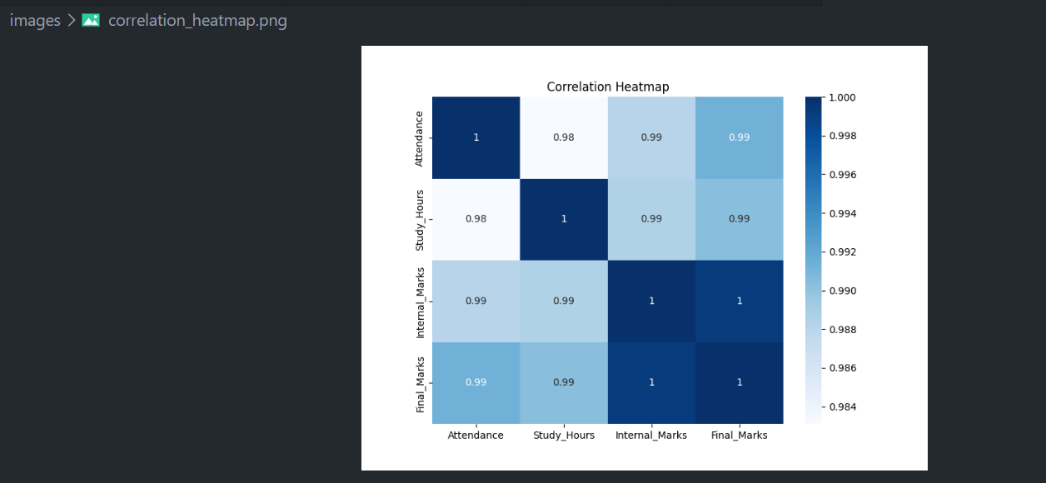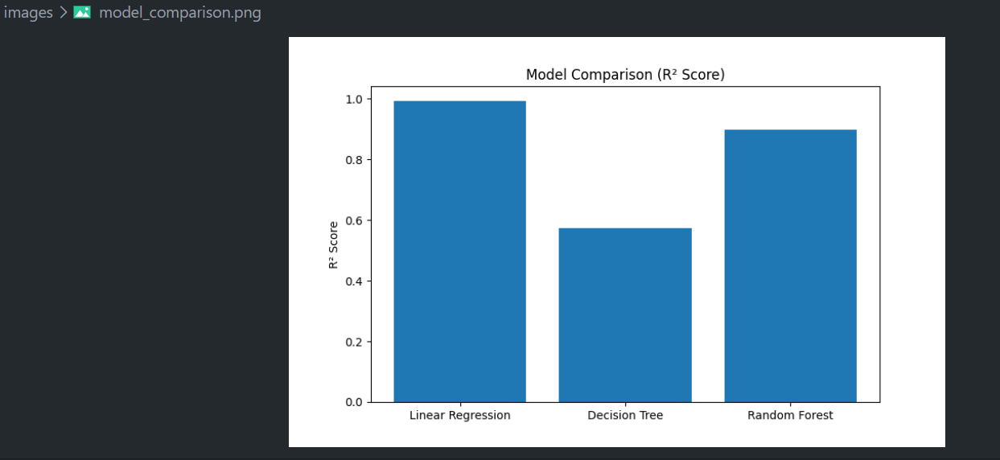

---

8. Machine Learning Model Development

The following machine learning algorithms were implemented:

1. Linear Regression
2. Decision Tree Regressor
3. Random Forest Regressor

The dataset was divided into training and testing sets before model training.

Models were evaluated using standard regression metrics to identify the best-performing algorithm.

---

9. Model Evaluation and Results

Evaluation Metrics:
• Mean Absolute Error (MAE)
• R² Score

Results Obtained:
• MAE = 0.25
• R² Score = 0.99

Among all tested algorithms, Linear Regression achieved the best performance and provided highly accurate predictions.

The results indicate that the selected features are effective in predicting student academic performance.

---

10. Flask Web Application

To improve usability, a Flask-based web application was developed.

Features:
• User-friendly interface.
• Accepts attendance, study hours, and internal marks.
• Predicts final marks instantly.
• Integrates the trained machine learning model.

The web application demonstrates practical deployment of the machine learning solution.
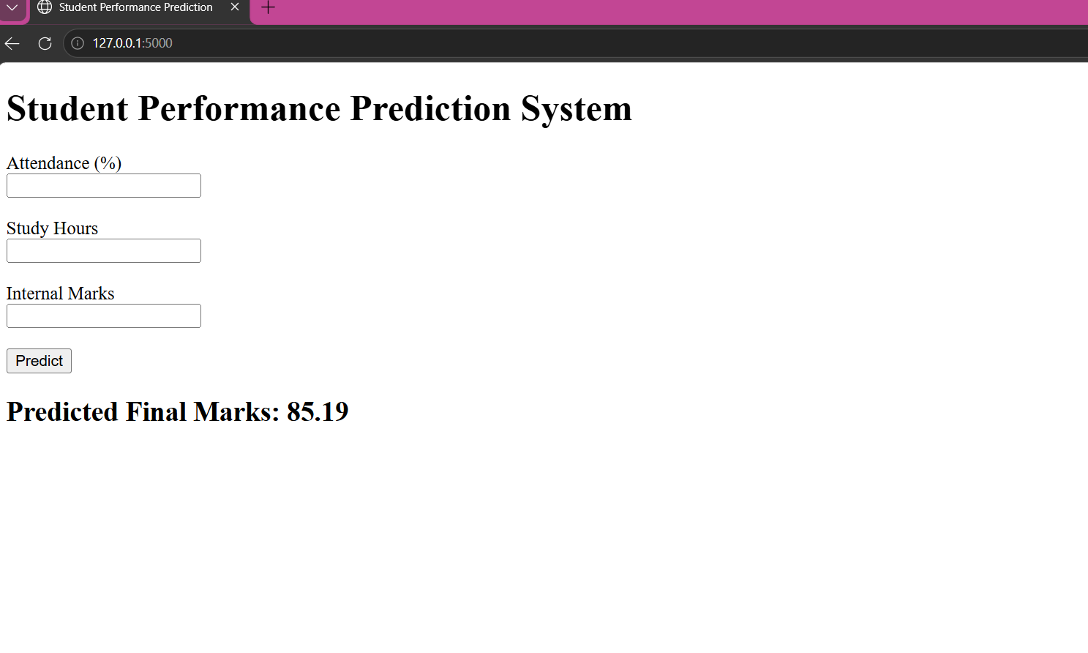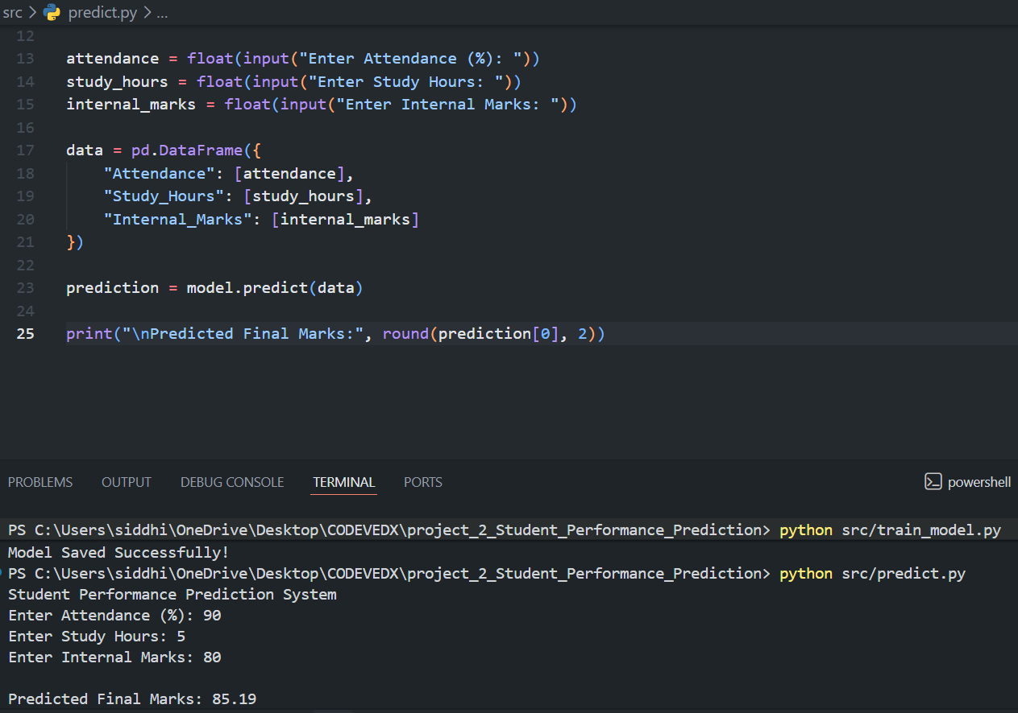---

11. Conclusion

The Student Performance Prediction System successfully predicts students' final marks using machine learning techniques.

The project involved data preprocessing, exploratory data analysis, model development, model evaluation, and deployment through a Flask web application.

The achieved R² Score of 0.99 demonstrates strong predictive performance and validates the effectiveness of the selected features.

---

12. Future Scope

• Use larger real-world datasets.
• Add more academic and behavioral features.
• Improve prediction accuracy using advanced algorithms.
• Integrate a database system.
• Deploy the application on cloud platforms.
• Develop a complete student performance dashboard.

---

13. References

• Python Documentation
• Pandas Documentation
• NumPy Documentation
• Matplotlib Documentation
• Scikit-learn Documentation
• Flask Documentation
• GitHub Documentation

---

Thank You

