Live Auction System: Design and Implementation of a Real-Time Web-Based Auction Platform
1 | Siddhi Karhekar | 1032232132
2 | Diya Rane | 1032232045
3 | Taneesha Badhe | 1032232190
4 | Atharva Hemade | 1032232249
Abstract—
This paper describes the development of a web application called Live Auction System implemented using Java Servlets, Java Server Pages (JSP), JDBC, and MySQL. It offers a multi-user environment where buyers, sellers, and administrators can engage in live online auctions. The software architecture incorporates MVC with a DAO layer that encapsulates database interactions. It supports user roles, SHA-256 encryption of passwords, use of PreparedStatement to prevent SQL injection, automatic auction management process, AJAX to perform real-time bid updates, and Swing GUI for administration tasks. The system is packaged as a WAR file in an Apache Tomcat server with a normalized database schema.
Keywords—Java Servlets; JSP; MVC; Online Auction; JDBC; MySQL; AJAX; Real-Time Web Application; Role-Based Access Control

I. INTRODUCTION
Auctioning systems on the Internet have gained popularity because they offer a platform where prices are discovered based on market competition. Unlike other e-commerce sites which employ a set price model, auctions provide an opportunity for competitive bidding, thus prices generated by the market. The development of technology has made it possible to develop auctioning systems that run almost real-time within browsers without using special client software.
The following paper presents the architecture, design and implementation of a Live Auction System (LAS), which is a full stack web application written entirely in Java. The LAS provides support for multiple roles in an auction including sellers who list their items and plan timed auctions, buyers who compete for items during scheduled auctions, and finally a Swing desktop application for administrators.
Internet auction systems have become popular since they provide a medium through which prices can be determined via market competition. In other online stores where the pricing system used involves fixed prices, there is no room for competitive bidding; hence the price created by the market is not achieved. With advancements in technology, it is now possible to create auction systems that operate in near real-time within a browser and without any client-side application.
This paper outlines the design, architecture, and implementation of a live auction system (LAS). It is a full-stack web application built using pure Java. The LAS facilitates multi-roles in an auction, namely sellers who list items and schedule auctions, buyers who bid on items in scheduled auctions, and finally, a Swing application that serves as an administrator's role.
II. SYSTEM ARCHITECTURE
A. Architectural Pattern
The architecture is implemented as a Java EE web application (WAR) running on Apache Tomcat. There are three layers, namely:
(1) The Presentation Layer, which includes JSP templates and CSS/JavaScript files;
(2) The Business Logic Layer, which comprises Java Servlets and helper classes; and
(3) The Data Access Layer, which involves a MySQL relational database accessed using JDBC in DAO classes.
The advantage here is that any change made to the view layer (JSP templates) will not necessitate any change in the business logic layer. Also, the DAO design pattern will ensure that all SQL queries are encapsulated and shielded from the controller classes. The DAO classes will generate domain objects (POJOs), which will be used by the servlets to set request attributes.
B. Technology Stack
Table I summarizes the technologies and frameworks employed in the system.
TABLE I
Technology Stack Summary
Technology | Role / Scope
Java Servlets 4.0 | HTTP request handling (Controller)
JavaServer Pages 2.3 | HTML view rendering (View)
JSTL 1.2 | JSP expression language tags
MySQL 8.0 | Relational data persistence
MySQL Connector/J 8.0.33 | JDBC driver for MySQL
Apache Tomcat 9/10 | Servlet container / web server
Apache Maven 3.x | Build and dependency management
Java Swing | Desktop admin panel (standalone)
C. Application Layers
The Model layer is made up of four entity classes: User, Item, Auction, and Bid. They are basic Java objects that have fields of specified data types that correspond to columns in the database. Fields that will be filled through JOIN statements like sellerName and winnerName are part of these transient fields.
Four classes constitute the DAO layer: UserDAO, ItemDAO, AuctionDAO, and BidDAO. All these classes use PreparedStatements only. There is also a buildDetailQuery() method in the AuctionDAO class, which creates a complicated query involving multiple joins and aggregate functions (MAX, COUNT) in order to get current bidding information in a single database access.
There are six servlets and one filter in the controller layer. SessionFilter catches all the protected URLs and ensures authentication and authorization before the execution of servlet code. Table II illustrates the association between servlet names and their URL patterns.
TABLE II
Servlet URL Mapping and Responsibilities
Servlet | URL | Responsibility
AuthenticationServlet | /auth | Login, registration, logout
ItemServlet | /item | Item creation & file upload
AuctionServlet | /auction | Auction CRUD, winner select
BidServlet | /bid | Bid placement & AJAX status
SellerServlet | /seller | Seller / admin dashboard
BuyerServlet | /buyer | Buyer bid history & wins
III. DATABASE DESIGN
A. Schema Overview
The database live_auction_db uses the InnoDB storage engine for foreign key constraint enforcement and transactional support. It comprises four tables: users, items, auctions, and bids. Table III provides a high-level summary.
TABLE III
Database Tables Overview
Table | Rows | Primary Purpose
users | 5 (seed) | Stores credentials, roles
items | variable | Auction products & images
auctions | variable | Bidding windows & state
bids | variable | Individual bid records
B. Entity Relationships
Schema Organization
The database schema is organized in the following way. Users table serves as the root table, which means that all other tables link to it. Items table contains a many-to-one relationship with the users table through seller_id attribute, because a single user can have many items to sell. Auctions table contains a one-to-one relationship with the items table via unique item_id attribute.
Bids table contains many-to-one relationship with the auctions table as well as with the users table; that is, a single user can make many bids on various auctions. The ON DELETE CASCADE rule is applied to all foreign key attributes, while ON DELETE SET NULL rule applies only to the winner_id attribute. Using DECIMAL(12,2) data type guarantees precision when storing financial information.
C. Auction Lifecycle State Machine
The statuses field in the auctions table uses an ENUM data type and can have one of the four possible values – scheduled, active, ended, or cancelled. The valid state transitions are: scheduled to active (occurs when the system time becomes greater than the start_time), and active to ended (when the system time exceeds the end_time).
These transitions are carried out automatically in the AuctionDAO.syncStatuses() method, where two UPDATE queries are used:
UPDATE auctions SET statuses='active' WHERE statuses='scheduled' AND NOW() >= start_time; UPDATE auctions SET statuses='ended' WHERE statuses='active' AND NOW() > end_time;
syncStatuses() method gets invoked prior to each auction fetching, thereby eliminating any need for scheduling a thread.
IV. IMPLEMENTATION
A. Authentication and Session Management
The AuthenticationServlet receives GET requests for the login and register pages and POST requests for user credentials. On successful login, an HttpSession is initialized with a timeout period of 30 minutes of inactivity. The User object with logged-in credentials is stored in the session with the key loggedUser.
Validations during registration include: non-empty name, email, password, and role parameters; email validity by matching a regular expression pattern; minimum six-character password length; role limited to buyer and seller; and unique email validation against the users table. The passwords are hashed with SHA-256 using the method PasswordUtil.hash().
On logout, the session is invalidated by HttpSession.invalidate(), and the login page is navigated to. The SessionFilter validates the loggedUser key in the session for every incoming request to a secure URL; if not present, then navigation occurs to the login page with the URI appended as the next parameter.
B. Item and Auction Management
Creating an auction involves two servlets. ItemServlet processes the multipart form submission with information about the item as well as its optional image upload. Uploaded images are saved in the uploads folder located under the web app’s root directory, using Unix millisecond timestamped filenames to prevent naming conflicts. Using @MultipartConfig ensures file size limit is 5 MB, with an overall limit of 10 MB per request.
ItemServlet persists the item and then uses RequestDispatcher.forward() to forward the request to AuctionServlet. The latter saves the auction record with status='scheduled' and redirects the browser to the seller’s dashboard. Winner selection happens through the seller’s HTTP POST to /auction?action=selectWinner, where AuctionServlet checks that the auction is 'ended', belongs to the requesting user, and calls AuctionDAO.selectWinner().
C. Bidding Engine
The placeBid() servlet method imposes the following validation procedure: (1) the caller should have the buyer role; (2) the auction’s status should be ‘active’, and the current time should be between [start_time, end_time]; (3) the value of the new bid should be higher than or equal to the lowest possible bid, which is calculated using the formula: max(currentHighestBid, item.startPrice)+0.01.
The calculation of the minimum bid is done using Big Decimal calculations in order to avoid rounding errors caused by floating-point arithmetic..
D. Real-Time Features
Real-time feedback is facilitated by two client-side approaches, which have been implemented in the main.js file. The first approach is the countdown timer (startCountdown), where the JavaScript setInterval is used to count down from the set number every second. When the time when the auction ends is reached, the page will automatically refresh, facilitating synchronization with the server.
The other approach for real-time feedback is the bid polling (startBidPolling). Using the JavaScript XMLHttpRequest API, it polls the server for new data every five seconds by sending a request to the /bid?action=status endpoint. The endpoint responds with an extremely lightweight JSON object, consisting of only the highest bid, total number of bids, and auction status.
E9
V. SECURITY ANALYSIS
A. SQL Injection Prevention
A. Protection Against SQL Injection
Use of java.sql.PreparedStatement for all database access operations at the DAO layer. User input values are never concatenated into SQL queries by using strings. Typesafe binding of the parameters takes place (int, string, bigdecimal, timestamp). Thus, user input is guaranteed to be interpreted as data and not SQL code. Protection against
B. Password Security
Passwords are never stored in plaintext. The PasswordUtil.hash() method computes the SHA-256 digest of the UTF-8-encoded password string and returns a 64-character hexadecimal representation. Verification uses a constant-time string comparison via MessageDigest to prevent timing oracle attacks. The database schema declares the password column as VARCHAR(255), providing headroom for migration to bcrypt or Argon2 in future iterations.
It is acknowledged that SHA-256 without a salt is vulnerable to rainbow table attacks. A production deployment should replace the current hashing implementation with bcrypt (work factor >= 12) or Argon2id. This is identified as a priority for future work.
C. Role-Based Access Control
The system enforces a three-tier role hierarchy: buyer, seller, and admin. Access control is implemented at two layers. The SessionFilter performs coarse-grained checks: requests to /seller/* and /item/* are rejected unless the authenticated user holds the seller or admin role. Fine-grained checks within individual servlets enforce business rules: only the seller who created an auction may select its winner; only users with the buyer role may place bids.
D. File Upload Security
Uploaded images are subject to: a maximum file size of 5 MB enforced by @MultipartConfig; filename sanitization that strips path separators and prefixes a timestamp; and storage outside the application’s class path (in the uploads/ static asset directory). Content-type validation via MIME sniffing is noted as a future hardening measure.
E. Session Security
Sessions are invalidated on explicit logout, preventing session fixation. The 30-minute inactivity timeout limits the window for session hijacking. Sensitive operations (login, registration, bid placement) are submitted via HTTP POST, preventing credential leakage in server logs or browser history. Deployment in production should enforce HTTPS to protect session tokens and credentials in transit.
VI. RESULTS AND DISCUSSION
A. Functional Coverage
The implemented system fulfils all planned functional requirements. The five core workflows are: (1) User Registration and Login; (2) Auction Creation by sellers, including item listing, image upload, and schedule specification; (3) Live Bidding by buyers, with real-time display updates; (4) Auction Completion with automatic status transition and seller-initiated winner selection; and (5) Dashboard Views for both sellers and buyers presenting relevant auction and bid history.
The system correctly enforces all business rules: sellers cannot bid on their own items, buyers cannot create auctions, bids below the minimum are rejected with an informative error message, and expired auctions are automatically closed on the next server interaction.
B. Performance Considerations
The current implementation creates a new JDBC connection per DAO method call. While adequate for a small-scale deployment or academic evaluation, this approach does not scale for concurrent user loads typical of production auction systems. The primary bottleneck is connection acquisition latency. Replacement of DBConnection with a pool such as HikariCP (minimum pool size 5, maximum 20) is the highest-priority performance improvement identified.
The syncStatuses() mechanism, while simple, executes two UPDATE statements on every auction list fetch. For systems with thousands of auctions, a partial index on (status, end_time) would reduce the scan cost significantly. An alternative is a background scheduler thread (ScheduledExecutorService) that runs syncStatuses() on a one-minute interval, eliminating the per-request overhead.
C. Comparison with Related Work
Commercial auction platforms such as eBay use WebSocket connections for real-time bid notification, delivering updates with sub-second latency. The polling approach employed here introduces a latency of up to five seconds per update cycle. For an educational or small-scale deployment this is acceptable; for a high-concurrency production system, migration to the Jakarta WebSocket API (JSR 356) is recommended. The architectural foundations laid by the MVC/DAO pattern would support such a migration without major restructuring.
VII. CONCLUSION
This paper has presented the design and implementation of the Live Auction System, a Java-based web application that provides a complete real-time online auction experience. The system demonstrates the application of established software engineering principles—MVC architecture, DAO pattern, role-based access control, and prepared-statement-based data access—within the Java EE ecosystem.
The implemented system supports three user roles, a four-state auction lifecycle with automatic transitions, a real-time bidding engine with AJAX polling, multipart file upload, and a companion Swing administration console. Security mechanisms address SQL injection, password storage, session management, and authorization at multiple enforcement layers.
Future work will focus on: (i) replacing the per-request JDBC connection model with a HikariCP connection pool; (ii) upgrading the SHA-256 password hash to bcrypt or Argon2id with per-user salts; (iii) replacing the AJAX polling mechanism with Jakarta WebSocket for push-based real-time notification; (iv) adding server-side pagination to auction and bid listing queries; and (v) introducing integration tests backed by an in-memory H2 database to validate DAO behaviour under concurrent writes.
VIII. REFERENCES
[1] Oracle Corporation, “Java Servlet Technology,” Oracle Java EE Documentation, 2023. [Online]. Available: https://docs.oracle.com/javaee/
[2] Apache Software Foundation, “Apache Tomcat 10 Documentation,” 2024. [Online]. Available: https://tomcat.apache.org/
[3] Oracle Corporation, “MySQL 8.0 Reference Manual,” 2024. [Online]. Available: https://dev.mysql.com/doc/
[4] OWASP Foundation, “OWASP Top Ten 2021: A03 Injection,” 2021. [Online]. Available: https://owasp.org/Top10/
[5] B. Eckel, Thinking in Java, 4th ed. Upper Saddle River, NJ: Prentice Hall, 2006.
[6] R. Johnson et al., Expert One-on-One J2EE Design and Development. Indianapolis, IN: Wiley, 2002.

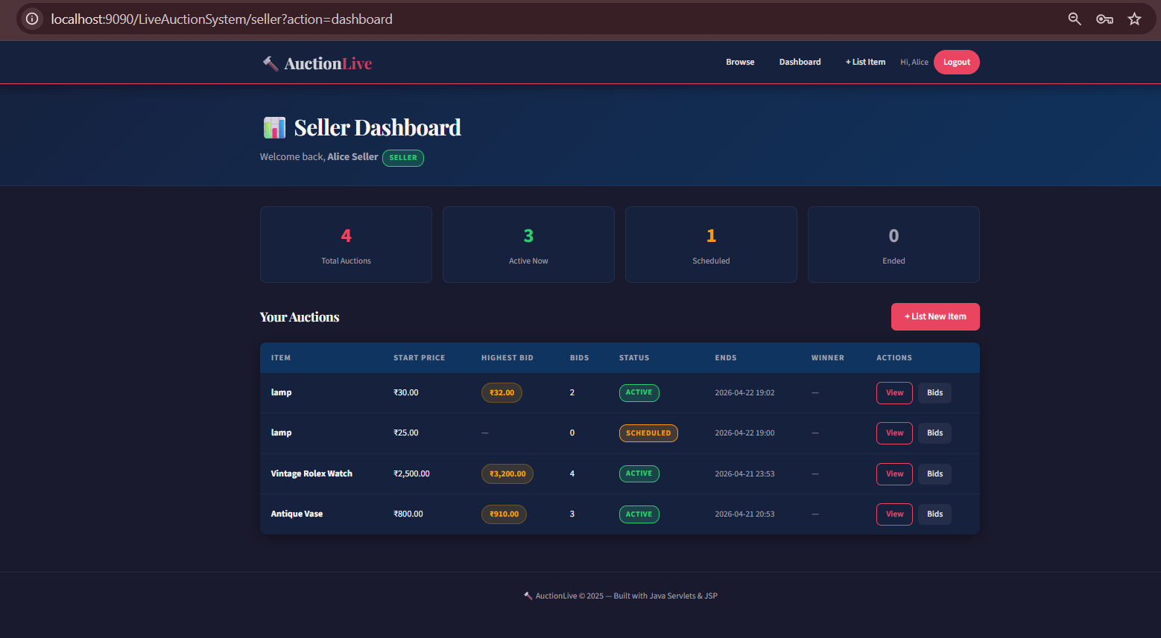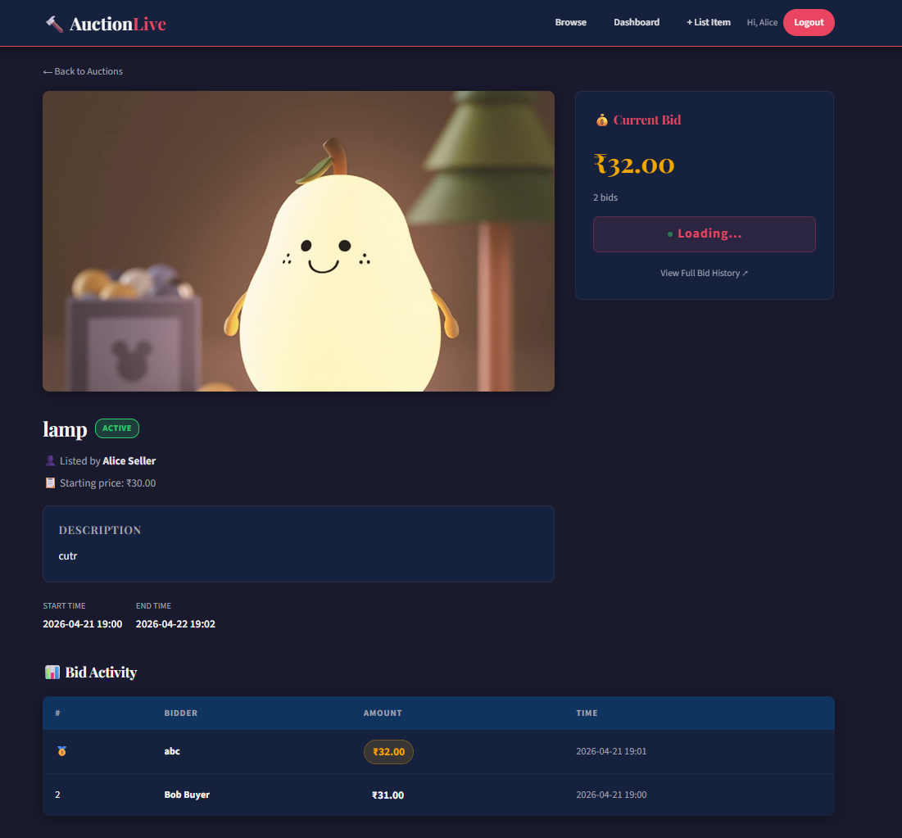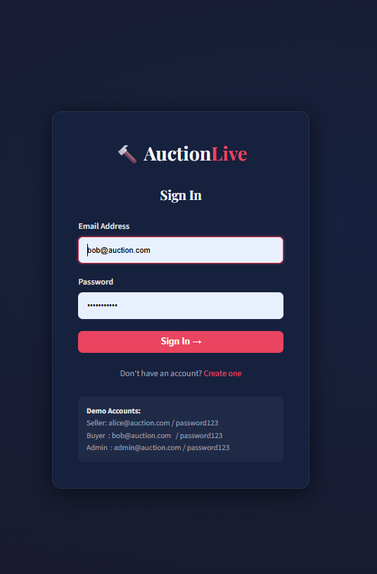

[7] HikariCP, “HikariCP: A solid, high-performance, JDBC connection pool at last,” GitHub Repository, 2024. [Online]. Available: https://github.com/brettwooldridge/HikariCP
[8] NIST, “FIPS PUB 180-4: Secure Hash Standard (SHS),” National Institute of Standards and Technology, 2015.
[9] I. Fette and A. Melnikov, “The WebSocket Protocol,” RFC 6455, IETF, Dec. 2011.
[10] E. Gamma, R. Helm, R. Johnson, and J. Vlissides, Design Patterns: Elements of Reusable Object-Oriented Software. Reading, MA: Addison-Wesley, 1994.

