DAY12

Q23: Write a program to calculate library fine based on late days as follows:

First 5 days late: ₹2/day

Next 5 days late: ₹4/day

Next 20 days late: ₹6/day

More than 30 days: Membership Cancelled.

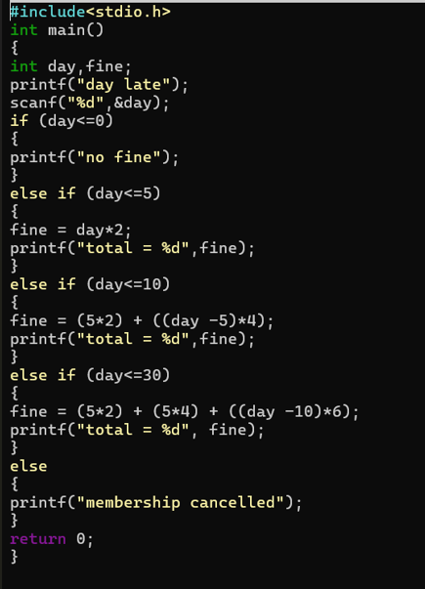
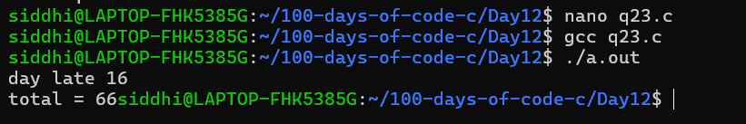

Q24: Write a program to calculate electricity bill based on units consumed with these rates:

First 100 units at ₹5/unit

Next 100 units at ₹7/unit

Next 100 units at ₹10/unit

Above at ₹12/unit
