DAY14

Q27: Write a program to print the sum of the first n odd numbers.

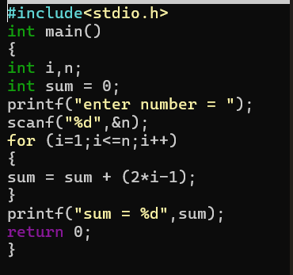
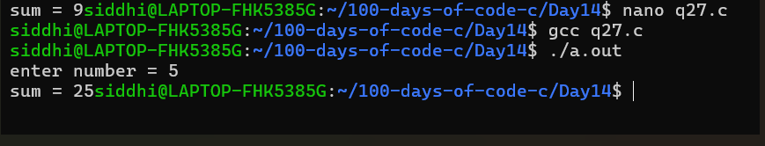

Q28: Write a program to print the product of even numbers from 1 to n.

