DAY15

Q29: Write a program to calculate the factorial of a number.
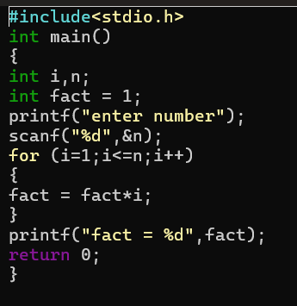
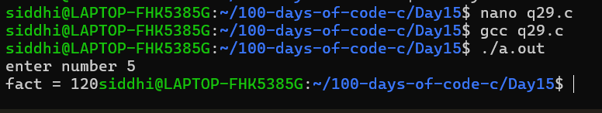

Q30: Write a program to reverse a given number.
