Day10

Q19: Write a program to classify a triangle as Equilateral, Isosceles, or Scalene based on its side lengths.

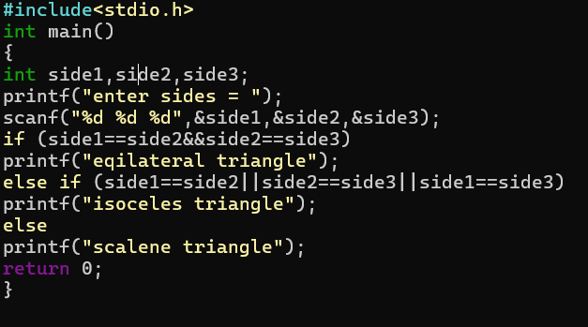

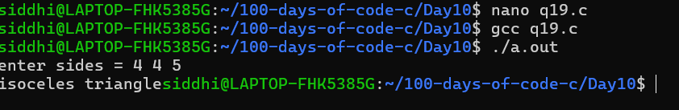

Q20: Write a program to display the day of the week based on a number (1–7) using switch-case.

