Day03

Q5: Write a program to convert temperature from Celsius to Fahrenheit.

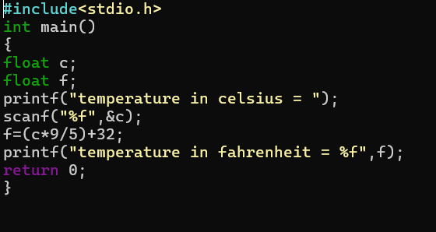
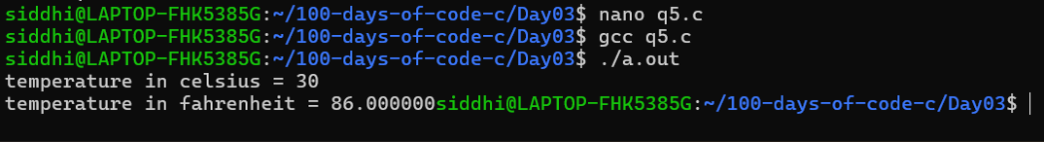

Q6: Write a program to swap two numbers using a third variable.
