Day04

Q7: Write a program to swap two numbers without using a third variable.

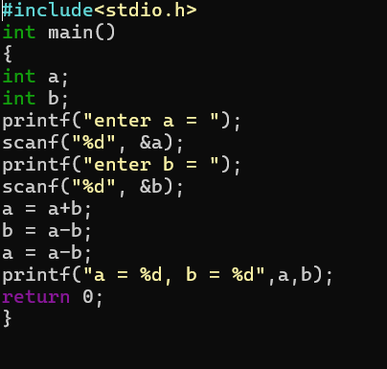
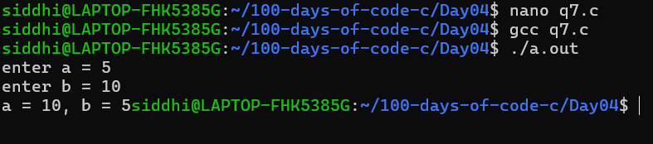

Q8: Write a program to find and display the sum of the first n natural numbers.

