Day05

Q9: Write a program to calculate simple and compound interest for given principal, rate, and time.

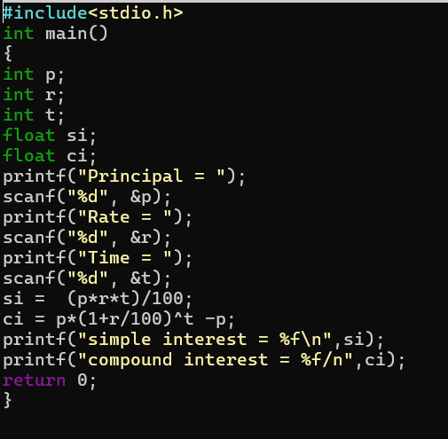

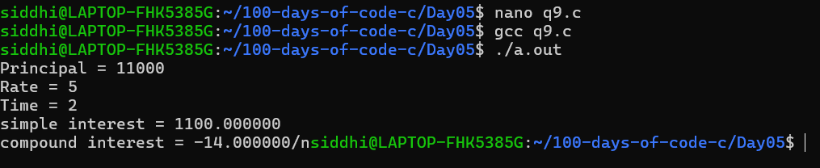

Q10: Write a program to input time in seconds and convert it to hours: minutes: seconds format.
