Day08

Q15: Write a program to input a character and check whether it is an uppercase alphabet, lowercase alphabet, digit, or special character.

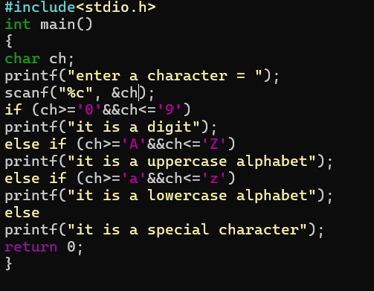

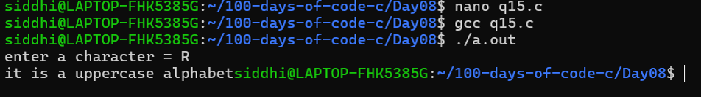

Q16: Write a program to input three numbers and find the largest among them using if–else.

