PROJECT DOCUMENTATION
Inventory Management System for Small Businesses
Prepared By: Siddhi Shinde
Domain: Business / Retail Tech
1. Project Title
Inventory Management System for Small Businesses
2. Objective
The objective of this project is to build a secure, web-based software application for small retail shops and warehouses. This system helps them digitalize their stock, track products, manage suppliers, record sales automatically, and receive alerts when items are running out.
3. Problem Statement
Small retail shops and local warehouses usually track their stock manually using paper notebooks or basic Excel sheets. This old-school method causes several major business problems:
• Poor Inventory Visibility: Business managers cannot see accurate, real-time stock levels.
• Stockouts and Overstocking: Shops unexpectedly run out of fast-selling items, or waste money buying too much slow-moving stock.
• Revenue Loss: Delays in reordering items lead directly to missed customer demands and lost profits.
• Human Errors: Manual data entry frequently leads to mistakes in sales logging and missing records.
4. Features Implemented
• Admin and Staff Role-Based Authentication (JWT): Restricts critical access. Staff users can only view and update stock quantities via custom forms, while the Admin has full system control over user creation and hard deletions.
• Product CRUD with Categories: Complete options to Create, Read, Update, and Delete products mapped under dynamic categories linked to unique supplier records.
• Sales Recording with Auto Stock Deduction: Logging a new customer sale automatically decreases that product's stock count in the Supabase PostgreSQL database instantly and calculates the total price dynamically.
• Low-Stock Alert System: If an item's quantity drops below a safe threshold, a warning badge appears on the dashboard, and a non-spam transactional email notification is fired instantly via Flask-Mail.
• Data Visualization Dashboard: Displays dynamic visual bar and line charts using Chart.js to show inventory trends, top products, and monthly sales health at a single glance.
5. Technologies Used
• Backend Framework: Python and Flask Web Framework (REST API Architecture)
• Database Management: PostgreSQL Engine distributed securely via cloud infrastructure on Supabase
• Database ORM Layer: SQLAlchemy Core Object-Relational Mapper (ORM Models: User, Product, Supplier, Sales)
• Frontend Interface: Clean HTML5 templates styled with utility-first Bootstrap and Tailwind CSS components
• Core Extensions: PyJWT (Token Security), Flask-Mail/smtplib (Email Automation), and ReportLab (Native PDF/CSV Generation Engine)
• Version Control: Git CLI and GitHub Remote Cloud Repository Platform
6. Project Workflow
1. Login Phase: The user logs in securely. The system encodes user payload details into a secure HTTP-Only JWT Cookie and evaluates access status (Admin vs Staff).
2. Dashboard Phase: Upon entering, the web UI queries the database via SQLAlchemy to compile data sums and maps active metrics onto Chart.js components.
3. Operational Phase: Authorized supervisors add new products, define safety threshold values, and manage contact indices inside the Supplier Directory tables.
4. Transaction Phase: When a sale is processed, a database transaction drops stock counts. If quantities breach safe bounds, an isolated background SMTP notification is triggered.

7. Screenshots

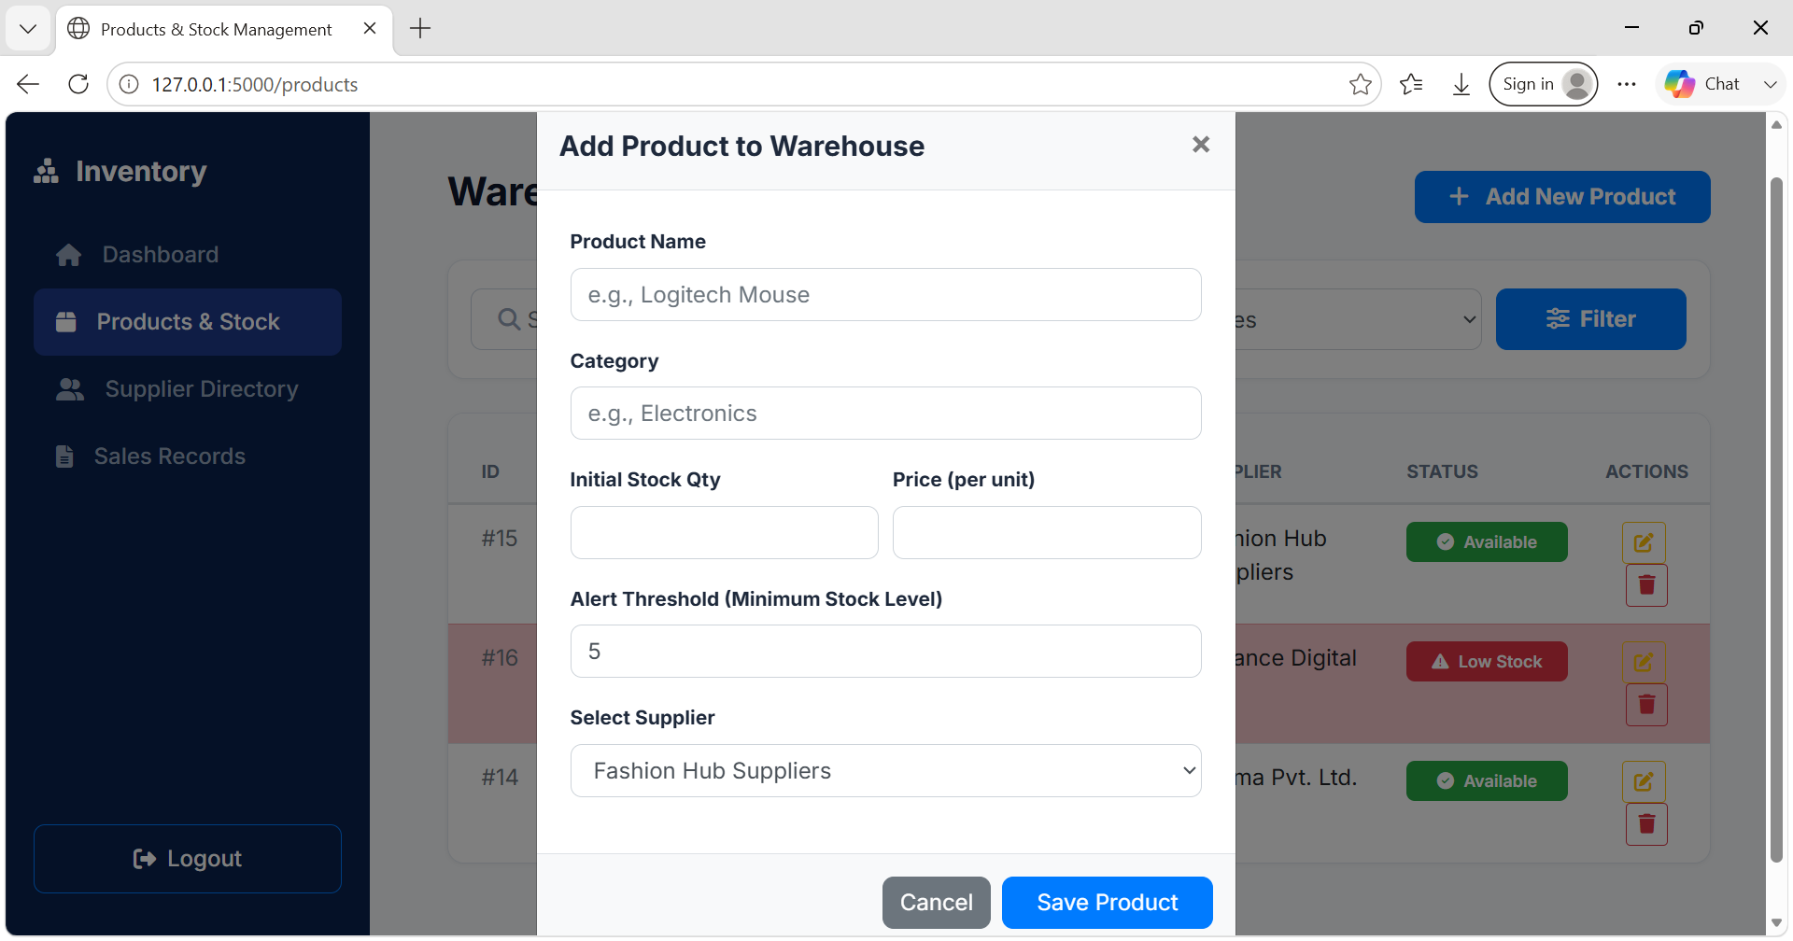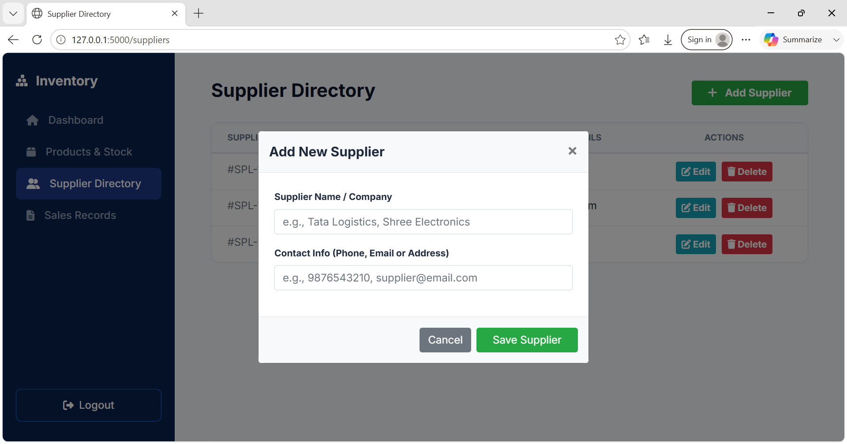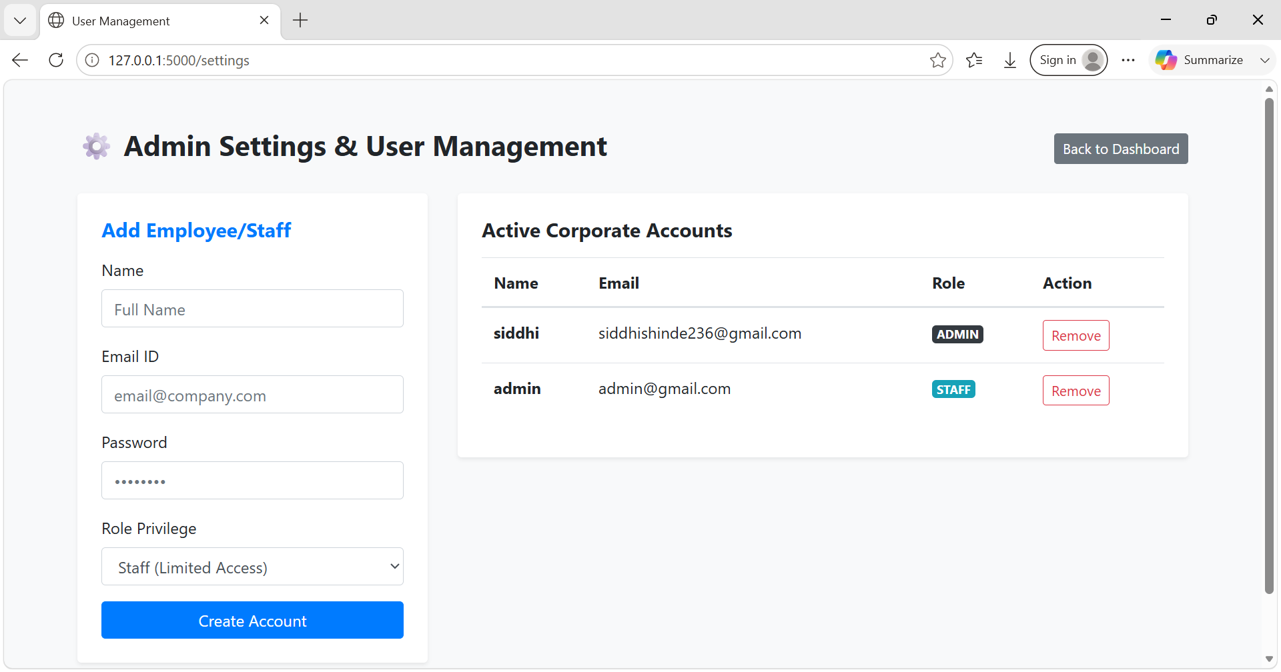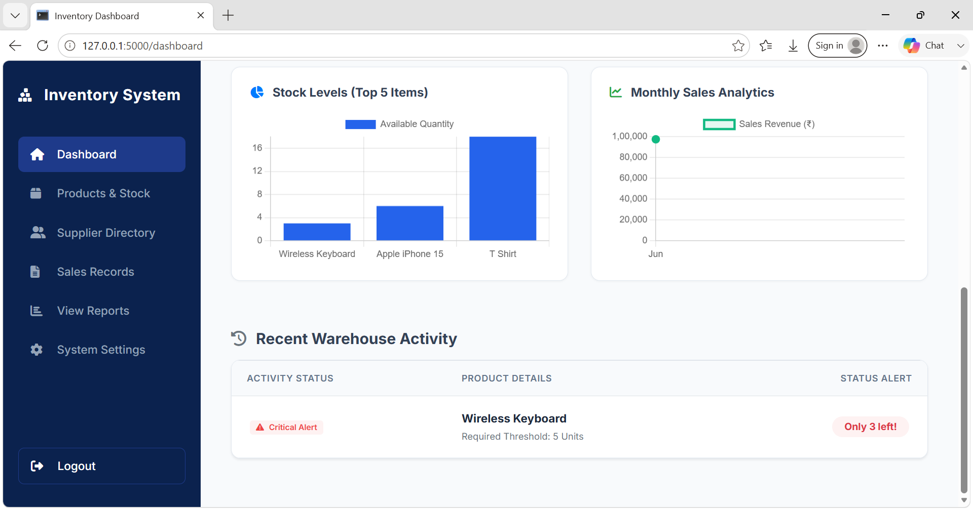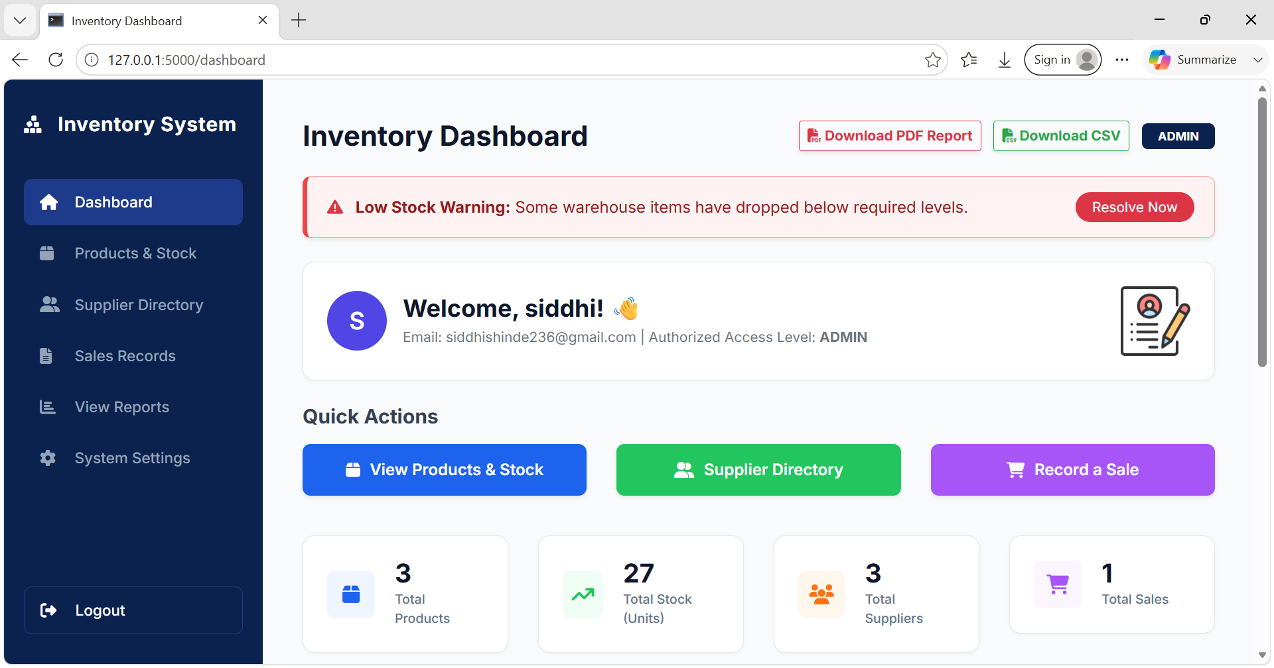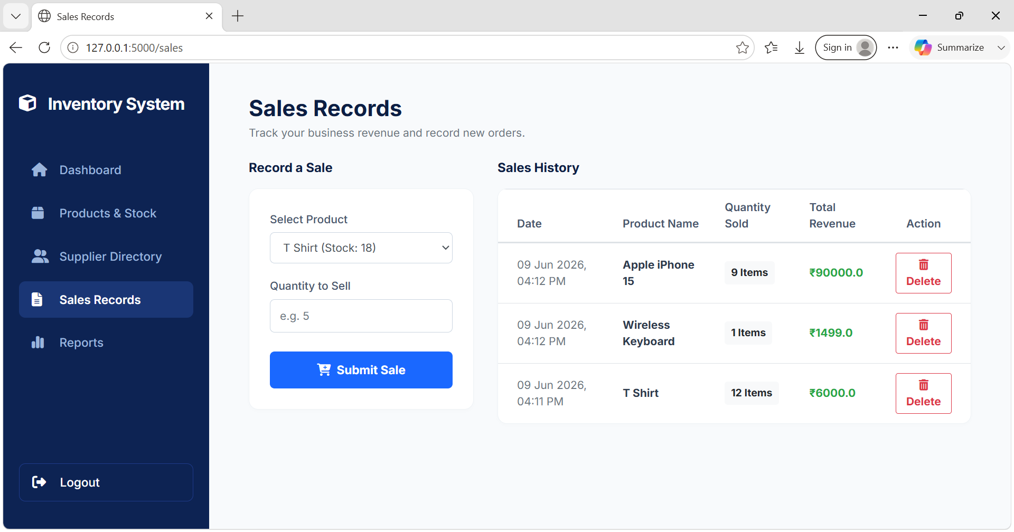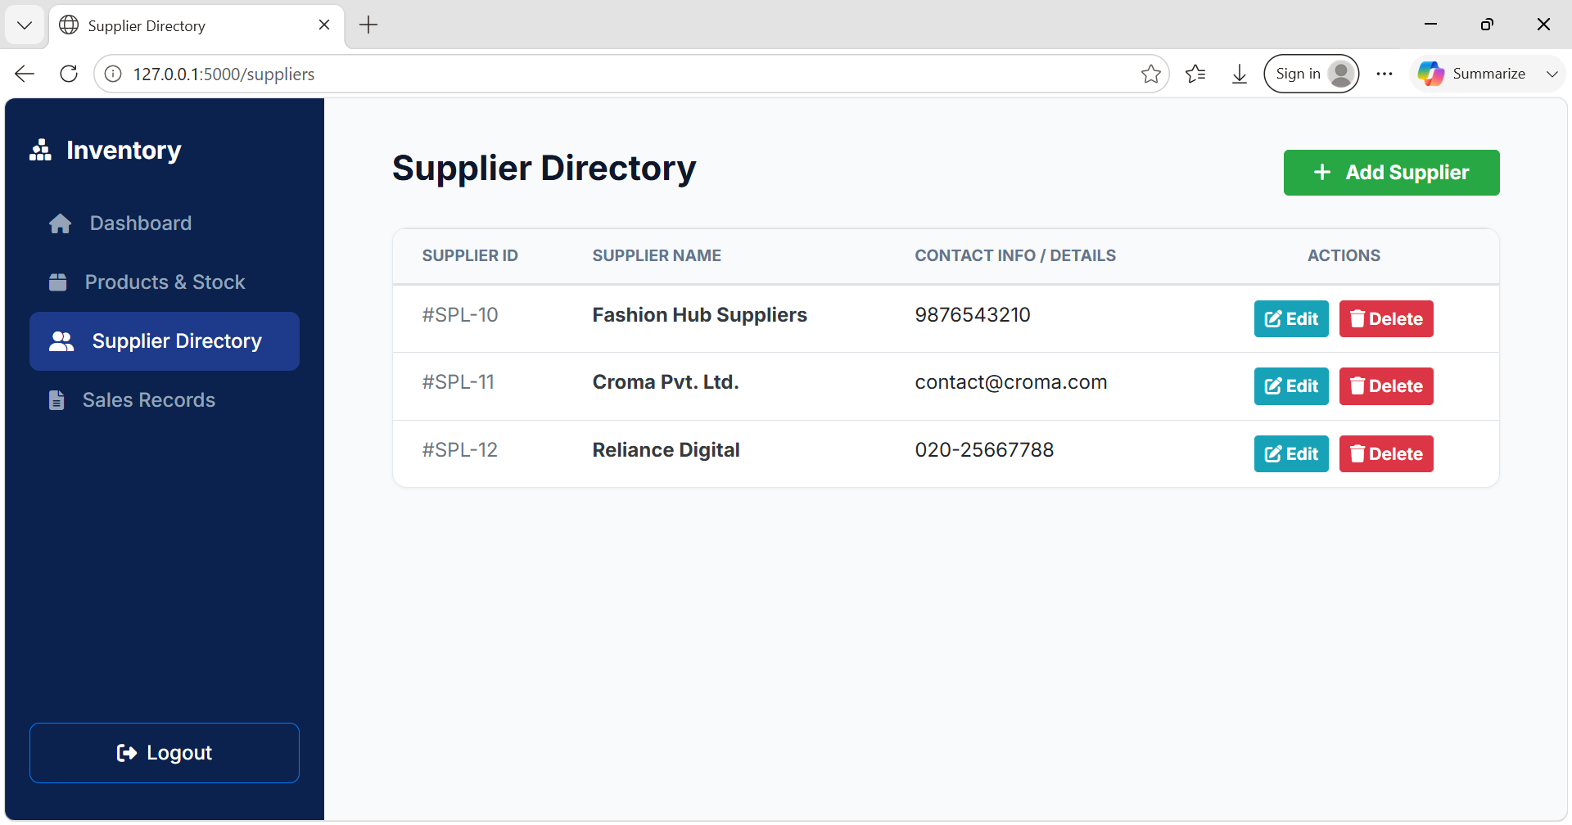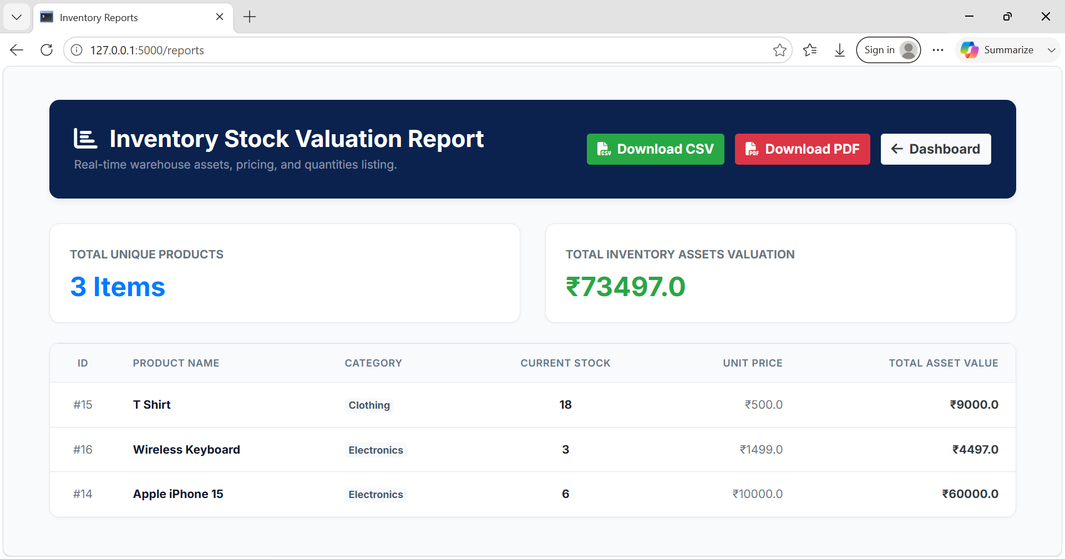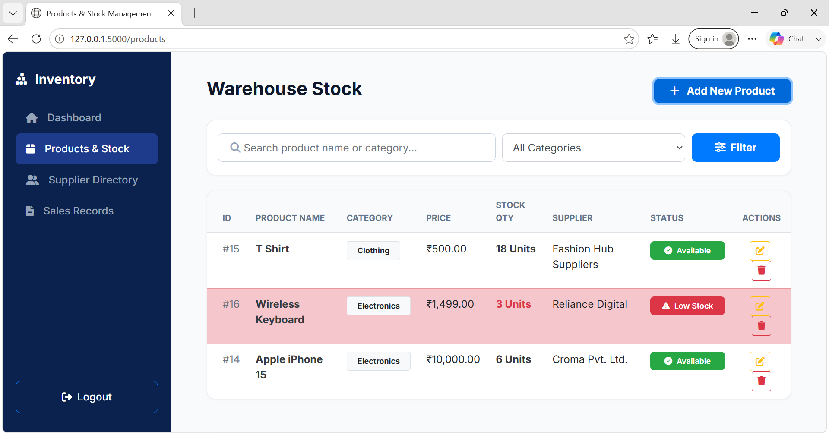
8. Challenges Faced & Remediation
Challenge: During an initial development cycle, a critical security vulnerability occurred. A local configuration environment file (.env) containing the live Supabase PostgreSQL master connection string and a functional Gmail SMTP application password was accidentally committed and pushed to the public GitHub repository.
Solution: To secure the cloud infrastructure immediately, a strict .gitignore layer was configured to block further tracking of variable files. Utilizing advanced Git CLI terminal commands, the public repository history was purged completely by setting up an isolated orphan branch pipeline (git checkout --orphan followed by a forced push git push -f origin main). This entirely eliminated the compromised history from public cache. Replacement infrastructure tokens and credentials were regenerated across both Supabase and Google Security panels, successfully achieving production environment hardening.
9. Learning Outcomes
- Gained hands-on expertise in connecting a Python Flask server seamlessly to a remote PostgreSQL engine using structured Object-Relational Mapping (SQLAlchemy).
- Mastered atomic transactional database workflows, automated background tasks (email dispatch), and dynamic binary file generation (ReportLab for PDF/CSV compilation).
- Developed industry-level corporate software development habits, including Git security practices, environment file encryption, and Role-Based Access Control (RBAC).
10. Future Enhancements
• Barcode Scanner API Integration: Allowing operators to scan items directly using a mobile device camera to speed up warehouse stock management.
• Demand Forecasting Analytics: Integrating simple Machine Learning regressions to predict upcoming consumer sales spikes and auto-suggest reorder supplies.
• Automated Client Billing Engine: Automatically generating and exporting customer billing invoices into clean downloadable PDF documents.
11. GitHub Repository Link
🔗 Repository URL: https://github.com/Siddhi-Shinde-dev/Inventory-Management-System

