NAME: SIDDHI SHEWALE

CLASS:AIA-2

ROLL NO-2213483

BATCH-B

**WTL ASSIGNMENT NO-1**

AIM: Create a Registration form and Admission form using HTML and CSS.

Code:

<!DOCTYPE html>

<html>

<head>

<style>

body{

font-family: Arial, Helvetica, sans-serif;

background-color: lightblue;

font-size:100%;

}

.container {

padding: 50px;

background-color: lightblue;

}

input[type=text], input[type=email],input[type=number],input[type=submit],input[type=radio] textarea {

width: 25%;

padding: 15px;

margin: 5px 0 22px 0;

display: inline-block;

border: none;

background: #f1f1f1;

}

div {

padding: 10px 0;

}

hr {

border: 1px solid #f1f1f1;

margin-bottom: 25px;

}

.registerbtn {

background-color: #4CAF50;

color: white;

padding: 16px 20px;

margin: 8px 0;

border: none;

cursor: pointer;

width: 100%;

opacity: 0.9;

}

.button {

background-color: #4CAF50;

width: 10%;

</style>

<h2>REGISTRATION FORM</h2>

<body>

<form action="/action_page.php">

<label>First name:</label><br>

<input type="text" id="fname" name="fname" value="Enter your first name"><br><br>

<label>Last name:</label><br>

<input type="text" id="lname" name="lname" value="Enter your last name"><br><br>

<label>Your Age:</label><br>

<input type="number" id="name" name="age" value="Enter age"><br><br>

<label>Email id:</label><br>

<input type="email" id="name" name="email" value="Enter your valid Mail"><br><br>

<label>Gender:</label><br>

<input type="radio" id="gender" name="gender" value="male">

<label for="gender">male</label><br>

<input type="radio" id="gender" name="gender" value="female">

<label for="gender">female</label><br>

<br>

<label>

Phone :

</label>

<input type="text" name="phone" size="10"/> <br> <br>

<label>

Course :

</label>

<select>

<option value="Course">Course</option>

<option value="BCA">BCA</option>

<option value="BBA">BBA</option>

<option value="B.Tech">B.Tech</option>

<option value="MBA">MBA</option>

<option value="MCA">MCA</option>

<option value="M.Tech">M.Tech</option>

</select> <br>

<br>

<button class="button">Register</button>

</form>

</body>

</head>

</html>

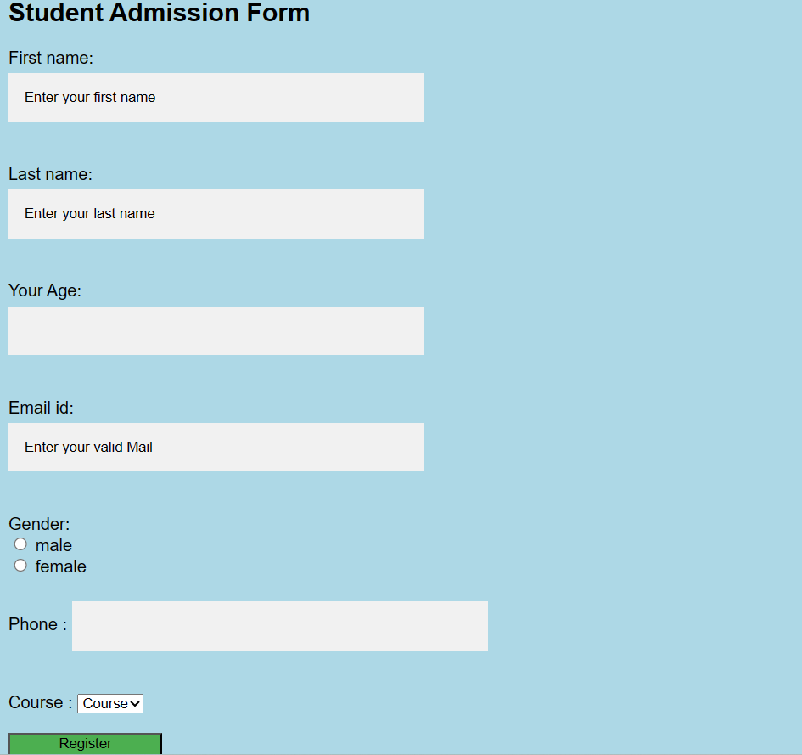

CODE: COMPANY REGISTRATION FORM

<!DOCTYPE html>

<html lang="en">

<head>

    <meta charset="UTF-8">

    <meta name="viewport" content="width=device-width, initial-scale=1.0">

    <title>Document</title>

    <style >

      h1{ color:rgb(156, 35, 53);

        font-size: 155%;

    }

    #f1{

        color:red

    }

    .button {

  background-color: #4CAF50;

  width: 10%;

    }

    body{

        font-size: 140%;

       background-color:antiquewhite

    }

    </style>

</head>

<body>

    <h1><b>COMPANY REGISTRATION FORM</b></h1>

    <hr>

    <form action="/action.php">

        <b><lable>Name:<lable id="f1">*</lable></lable></b>

        <input type="text">

         <br>

         <br>

       <b><lable>phone number:<lable id="f1">*</lable></lable></b>

        <input type="text">

        <br>

        <br>

        <b><lable>email_id:<lable id="f1">*</lable></lable></b>

        <input type="email" placeholder="ex:myname@example.com">

        <br>

        <br>

        <b><lable>Address:</lable></b>

        <input type="text" placeholder="enter your address here">

        <br>

        <br>

        <b><lable>City:</lable></b>

        <input type="text" >

        <br>

        <br>

        <b><lable>Pincode:</lable></b>

        <input type="text" >

        <br>

        <br>

        <label><b>Gender:</b><lable id="f1">*</lable></label>

        <input type="radio" id="gender" name="gender" value="male">

        <label for="gender">male</label>

        <input type="radio" id="gender" name="gender" value="female">

        <label for="gender">female</label><br>

        <br>

        <br>

        <label><b>Type of Business:</b></label>

        <br>

        <input type="checkbox" id="internet" name="internet" value="Internet">

        <label for="internet"> Internet</label><br>

        <input type="checkbox" id="wholesale" name="wholesale" value="wholesale">

        <label for="wholesale"> wholesale</label><br>

        <input type="checkbox" id="Student" name="Student" value="Student">

        <label for="student"> Student</label><br><br>

        <b><lable>About yourself:</lable></b>

        <input type="text" placeholder="tell something about yourself">

        <br>

        <br>

        <button class="button">Register</button>

    </form>

</body>

</html>

OUTPUT:

