NAME: SIDDHI SHEWALE

CLASS:AIA-2

ROLL NO-2213483

BATCH-B

**WTL ASSIGNMENT NO-2**

AIM:

Write a HTML script using HTML tags and CSS features for Coffee: Shop; Flower Shop; Car Service.

**1)coffee shop**

Code:

<!DOCTYPE html>

<html>

<head>

<style>

body {

background-image: url('background.jpg');

background-repeat: no-repeat;

background-attachment: fixed;

background-size: cover;

}

h1 {

color: #C8AD7F;

font-family: Arial,sans-serif;

font-size: 300%;

text-align:center;

}

p {

color: #E6BFA3;

font-family: courier;

font-size: 160%;

}

</style>

</head>

<body background="background.jpg">

<h1>Coffee House</h1>

<p ><strong>---it's great day to have coffee.</strong>

<br>

<br>

<br>

<br>

Select your coffee--</p>

<br>

<br>

<p style="color:white;"><strong>

<input type="checkbox" name="expresso" value="expresso">

<label for="expresso"> Expresso</label><br>

<br>

<input type="checkbox" name="mocha" value="mocha">

<label for="mocha" >mocha</label><br>

<br>

<input type="checkbox" name="latte" value="latte">

<label for="latte"> latte</label><br>

<br>

<input type="checkbox" name="cappuccino" value="cappuccino">

<label for="cappuccino"> cappuccino</label><br>

<br>

<input type="PAY" value="PAY">

</p>

</strong>

</form>

</body>

</html>

OUTPUT:

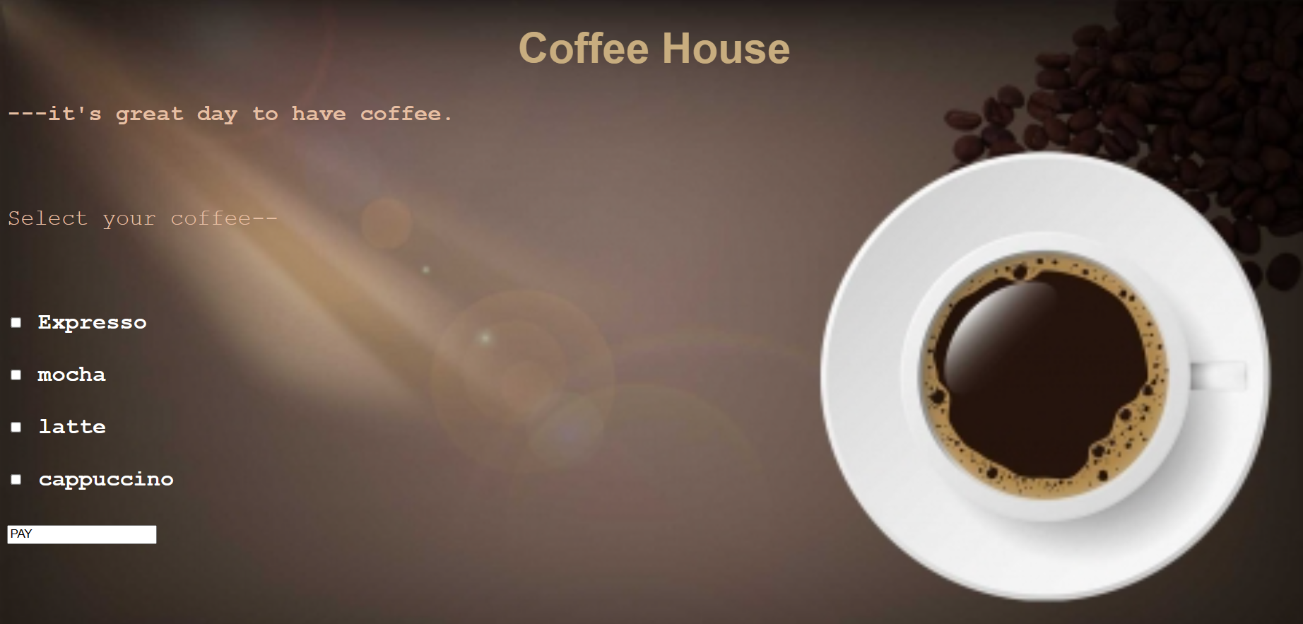

**Flower Shop**

Html code:

<!DOCTYPE html>

<html lang="en">

<head>

<meta charset="UTF-8">

<meta name="viewport" content="width=device-width, initial-scale=1.0">

<title>Document</title>

<link rel="stylesheet" href="flower.css">

</head>

<body>

<H1><b>FLORID</b> </H1>

<pre><h2> fresh feelings for your love...</h2></pre>

<div class="f1" id="E1">box1</div>

<div class="f1" id="E2">box2</div>

<div class="f1" id="E3">box3</div>

<div class="f1" id="E4">box4</div>

<div class="f1" id="E5">box5</div>

<div class="f2" id="E6">Orchids-/200</div>

<div class="f2" id="E7">Roses-/100</div>

<div class="f2" id="E8">Tulips-/250</div>

<div class="f2" id="E9">Daisy-/150</div>

<div class="f2" id="E10">Lily-/150</div>

</body>

</html>

Css code:

body{

background-image: url("bg.jpg");

background-repeat: no-repeat;

background-attachment: fixed;

background-size: cover;

}

H1{

font-style: italic;

color:aliceblue;

font-size: 600%;

text-align: center;

text-decoration: underline;

}

h2{

color:#E6E6FA;

font-size: 200%;

font-style: italic;

}

.f1{

height: 200px;

width: 200px;

color:aliceblue;

border: 2px solid #bfbea8;

display: inline-block;

margin:40px;

background-color: aliceblue;

}

.f2{

border: 6px solid #bfbea8;

display: inline-block;

margin:100px;

margin-top:2px;

background-color: aliceblue;

}

#E1{

background-image: url("orchids.jpeg");

}

#E2{

background-image: url("rose.jpeg");

}

#E3{

background-image: url("tulip.jpeg");

}

#E4{

background-image: url("daisy.jpeg");

}

#E5{

background-image: url("lily.jpeg");

}

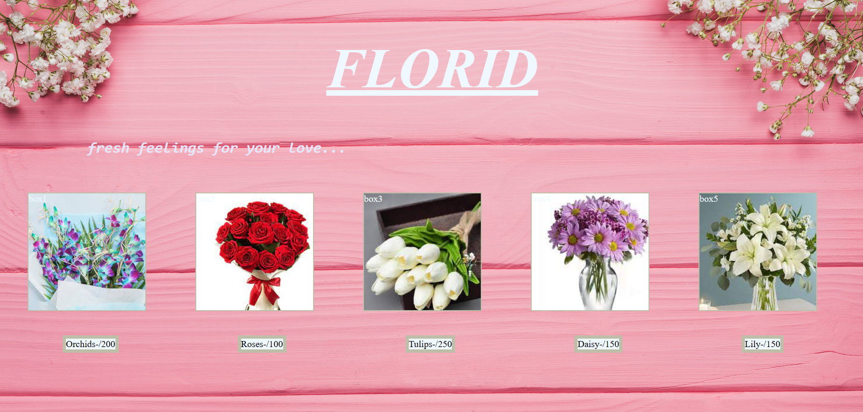

**3)Car service**

HTMLCODE

<!DOCTYPE html>

<html lang="en">

<head>

<meta charset="UTF-8">

<meta name="viewport" content="width=device-width, initial-scale=1.0">

<title>Document</title>

<link rel="stylesheet" href="car.css">

</head>

<body>

<h1>Shiv -Shambhu CAR service center</h1>

<hr>

<a >Indapur-Baramati road, Pune, Maharashtra,India </a><br>

<a > &phone;: 8856880179</a><br>

<a >&#128231:abc@gmail.com</a><br>

<a >cus_services:24&#x2718;7</a>

<div class="f1" id="box1"><h2>Car wash available</h2></div>

<div class="f1" id="box2"><h2>engine service</h2></div>

<div class="f1" id="box3"><h2>Wheel alignmet</h2></div>

<div class="f1" id="box4"><h2>interior detail</h2></div>

<div class="f1" id="box5"><h2>car polish</h2></div>

</body>

</html>

CSS code:

body{

/* background-image: url("img1.jpg");

background-repeat: no-repeat;

background-attachment: fixed;

background-size: cover; */

text-align: center;

background-color:black ;

color: aliceblue;

}

h2{

color: red;

}

.f1{

width: 300px;

height: 450px;

border: 2px solid #bfbea8;

display: inline-block;

border-radius: 5%;

}

#box1{

color:rgb(220, 159, 6) ;

position: absolute;

bottom: 0px ;

left: 20px;

background-image:url("wash.jpg") ;

background-repeat: no-repeat;

}

#box2{

position: absolute;

bottom: 0px;

left: 270px;

background-image:url("engine.jpg") ;

background-repeat: no-repeat;

height: 530px;

}

#box3{

position: absolute;

bottom: 0px ;

right: 20px;

background-image:url("wheel..jpg") ;

background-repeat: no-repeat;

}

#box4{

position: absolute;

bottom: 0px;

right: 270px;

background-image:url("interior.jpg") ;

background-repeat: no-repeat;

height: 530px;

}

#box5{

position: absolute;

bottom: 0px;

right: 540px;

background-image:url("polish.jpg") ;

background-repeat: no-repeat;

height: 580px;

}

a{

position:absolute;

  right: 10px;

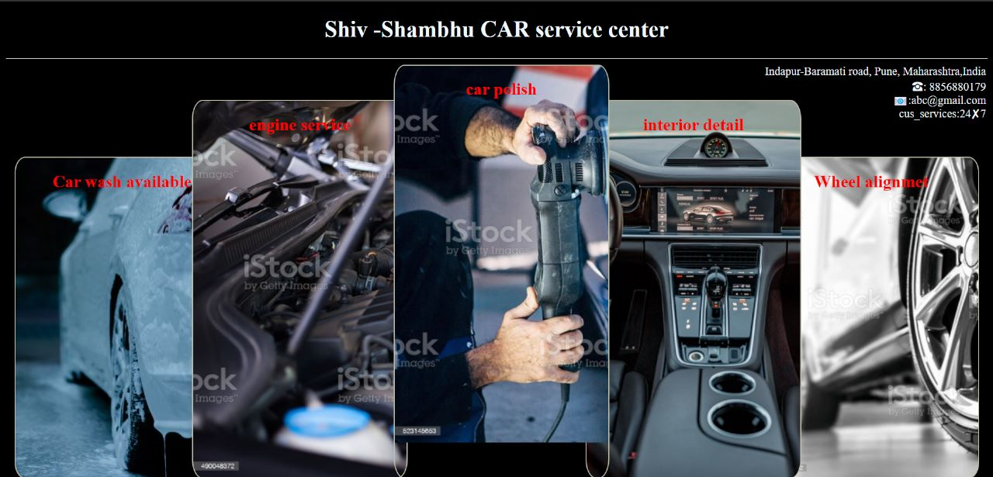}

**4)Library Management:**

CODE :-

<!DOCTYPE html>

<html>

<head>

<title>Library Management System</title>

<link rel="stylesheet" href="mystyle.css">

<style>

body {

font-family: Arial, sans-serif;

background-color: #ffffff;

margin: 0;

padding: 0;

}

h1 {

color: brown;

text-align: center;

margin-top: 20px;

}

table {

font-family: Arial, sans-serif;

border-collapse: collapse;

width: 80%;

margin: 30px auto;

}

th, td {

border: 1px solid #dddddd;

text-align: left;

padding: 12px;

}

th {

background: #f2f2f2;

}

tr:nth-child(even) {

background-color: #ffffff;

}

img {

max-width: 100px;

max-height: 120px;

display: block;

margin: 0 auto;

}

form {

max-width: 400px;

margin: 0 auto;

padding: 20px;

background-color: #ffffff;

border: 1px solid #dddddd;

border-radius: 8px;

}

label {

display: block;

font-weight: bold;

margin-bottom: 10px;

}

input[type="text"],

input[type="date"] {

width: 100%;

padding: 8px;

margin-bottom: 20px;

border: 1px solid #cccccc;

border-radius: 4px;

}

button {

background-color: #4CAF50;

color: white;

padding: 12px 20px;

border: none;

border-radius: 4px;

cursor: pointer;

font-size: 16px;

}

button:hover {

background-color: #45a049;

}

</style>

</head>

<body>

<h1>Library Management System</h1>

<img src="C:\Users\SEJAL SHINDE\OneDrive\Desktop\WTL Assignments\book3.png";width="250" height="280"><br><br>

<!-- Book List Table -->

<table>

<tr>

<th>Book Image</th>

<th>Book Title</th>

<th>Author</th>

<th>Genre</th>

<th>Availability</th>

</tr>

<tr>

<td><img src="C:\Users\SEJAL SHINDE\OneDrive\Desktop\WTL Assignments\book1.png" alt="Book 1"></td>

<td>The Great Gatsby</td>

<td>F. Scott Fitzgerald</td>

<td>Classic</td>

<td>Available</td>

</tr>

<tr>

<td><img src="C:\Users\SEJAL SHINDE\OneDrive\Desktop\WTL Assignments\book2.png" alt="Book 2"></td>

<td>To Kill a Mockingbird</td>

<td>Harper Lee</td>

<td>Classic</td>

<td>Available</td>

</tr>

<!-- Add more book entries as needed -->

</table>

<!-- Book Borrow Form -->

<form>

<label for="book-title">Book Title:</label>

<input type="text" id="book-title" name="book-title" required>

<label for="user-name">Your Name:</label>

<input type="text" id="user-name" name="user-name" required>

<label for="return-date">Return Date:</label>

<input type="date" id="return-date" name="return-date" required>

<button type="submit">Borrow Book</button>

</form>

</body>

</html>

Output:

