NAME: SIDDHI SHEWALE

AIA-2

ROLL. NO: 2213483

**WTL LAB ASSIGNMENT NO-3**

1. **Create an alert, conform, prompt box in one form**

</head>

<body>

<label class="a1"></label>

<input type="button" onclick="warning()" value="ALERT"/>

<label class="a1"></label>

<input type="button" onclick="greet()" value="PROMPT"/>

<label class="a2">Enter your Email:</label>

<input type="email"/>

<input type="button" onclick="confirm()" value="click here to confirm email"/>

<!-- <img src="lily.jpeg" onclick="test('clickd!')"/> -->

</body>

</html>

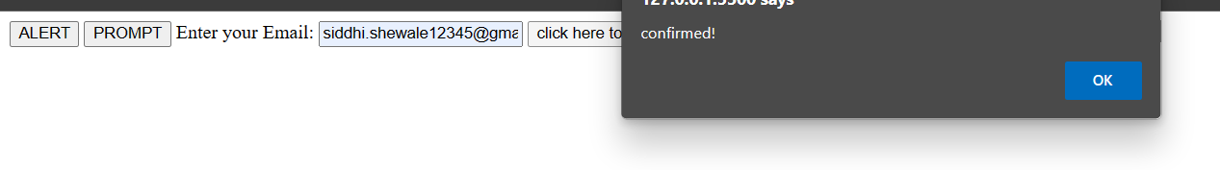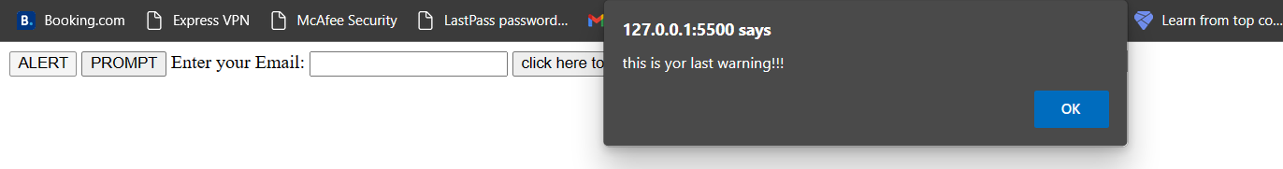

1. **A) Create arithmetic operations by using button**

<!DOCTYPE html>

<html lang="en">

<head>

<meta charset="UTF-8">

<meta name="viewport" content="width=device-width, initial-scale=1.0">

<title>Arithmetic Operations</title>

<style>

body {

font-family: Arial, sans-serif;

text-align: center;

}

h1 {

margin-top: 30px;

}

.container {

display: flex;

justify-content: center;

margin-top: 20px;

}

.input-box {

width: 100px;

text-align: center;

margin-right: 20px;

}

.button {

padding: 10px 20px;

background-color: #007bff;

color: #fff;

border: none;

border-radius: 4px;

cursor: pointer;

font-size: 16px;

margin-top: 10px;

}

.result {

font-size: 24px;

margin-top: 20px;

}

</style>

</head>

<body>

<h1>Arithmetic Operations</h1>

<div class="container">Enter num1:

<input type="text" class="input-box" id="num1" >

</div>

<div class="container">Enter num2:

<input type="text" class="input-box" id="num2" >

</div>

<div class="container">

<button class="button" onclick="add()">Addition</button></div></br>

<button class="button" onclick="subtract()">Subtraction</button></br>

<button class="button" onclick="multiply()">Multiplication</button></br>

<button class="button" onclick="divide()">Division </button></br>

</div>

<div class="container">Result:

<input type="text" class="result" id="result" readonly>

</div>

<script>

function add() {

const num1 = Number(document.getElementById("num1").value);

const num2 = Number(document.getElementById("num2").value);

const result = num1 + num2;

document.getElementById("result").value = result;

}

function subtract() {

const num1 = Number(document.getElementById("num1").value);

const num2 = Number(document.getElementById("num2").value);

const result = num1 - num2;

document.getElementById("result").value = result;

}

function multiply() {

const num1 = Number(document.getElementById("num1").value);

const num2 = Number(document.getElementById("num2").value);

const result = num1 * num2;

document.getElementById("result").value = result;

}

function divide() {

const num1 = Number(document.getElementById("num1").value);

const num2 = Number(document.getElementById("num2").value);

if (num2 === 0) {

alert("The second number cannot be zero.");

return;

}

const result = num1 / num2;

document.getElementById("result").value = result;

}

</script>

</body>

</html>

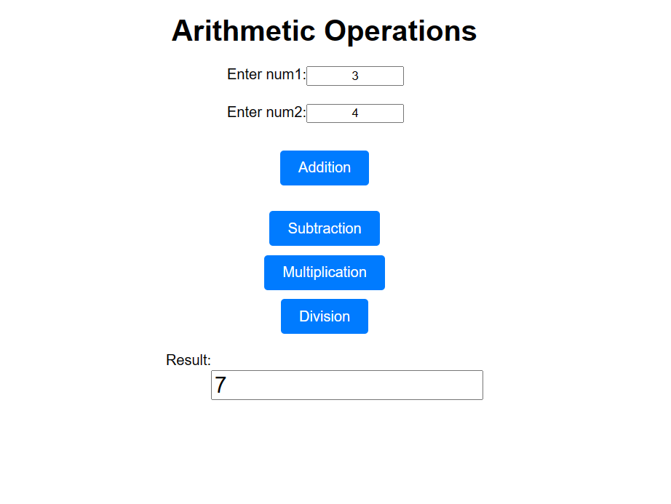**2 B) Create arithmetic operations by using drop down**

<!DOCTYPE html>

<html lang="en">

<head>

<meta charset="UTF-8">

<meta name="viewport" content="width=device-width, initial-scale=1.0">

<title>Arithmetic Operations</title>

<style>

body {

font-family: Arial, sans-serif;

text-align: center;

}

h1 {

margin-top: 30px;

}

.container {

display: flex;

justify-content: center;

margin-top: 20px;

}

.input-box {

width: 100px;

text-align: center;

margin-right: 20px;

}

.button {

padding: 10px 20px;

background-color: #007bff;

color: #fff;

border: none;

border-radius: 4px;

cursor: pointer;

font-size: 16px;

margin-top: 10px;

}

.result {

font-size: 24px;

margin-top: 20px;

}

</style>

</head>

<body>

<h1>Arithmetic Operations</h1>

<div class="container">

<input type="text" class="input-box" id="num1" placeholder="Number 1">

<input type="text" class="input-box" id="num2" placeholder="Number 2">

<select id="operation" class="input-box">

<option value="add">Addition (+)</option>

<option value="subtract">Subtraction (-)</option>

<option value="multiply">Multiplication (*)</option>

<option value="divide">Division (/)</option>

</select>

</div>

<div class="container">

<button class="button" onclick="calculate()">Calculate</button>

</div>

<div class="container">

<input type="text" class="result" id="result" readonly>

</div>

<script>

function calculate() {

const num1 = Number(document.getElementById("num1").value);

const num2 = Number(document.getElementById("num2").value);

const operation = document.getElementById("operation").value;

let result;

switch (operation) {

case "add":

result = num1 + num2;

break;

case "subtract":

result = num1 - num2;

break;

case "multiply":

result = num1 * num2;

break;

case "divide":

if (num2 === 0) {

alert("The second number cannot be zero.");

return;

}

result = num1 / num2;

break;

default:

alert("Invalid operation selected.");

return;

}

document.getElementById("result").value = result;

}

</script>

</body>

</html>

1. 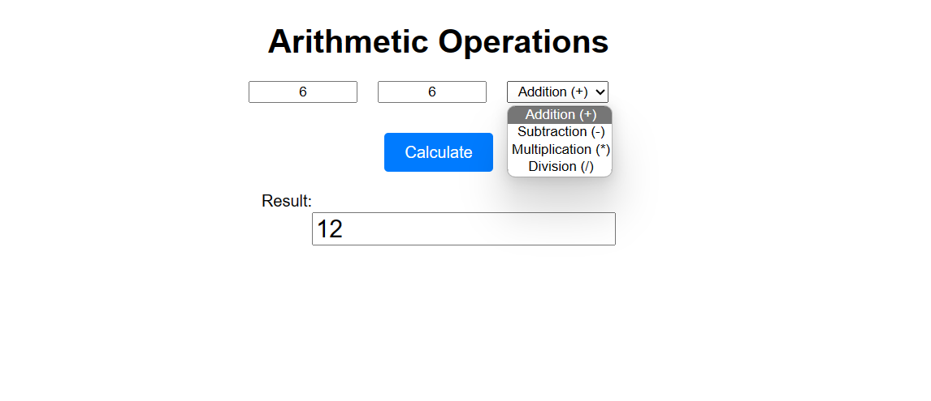**Create a form where all the above functions are used.**

<!DOCTYPE html>

<html>

<head>

<title>Enquiry Form</title>

<script>

function showAlert() {

alert("This is an alert message!");

}

function showPrompt() {

const userInput = prompt("Please enter your name:");

if (userInput) {

alert("Hello, " + userInput + "!");

} else {

alert("You didn't enter a name.");

}

}

function showConfirmation() {

const result = confirm("Are you sure you want to proceed?");

if (result) {

alert("You clicked OK!");

} else {

alert("You clicked Cancel!");

}

}

function performAddition() {

const num1 = parseFloat(prompt("Enter the first number:"));

const num2 = parseFloat(prompt("Enter the second number:"));

if (!isNaN(num1) && !isNaN(num2)) {

const sum = num1 + num2;

alert("The sum is: " + sum);

} else {

alert("Invalid input. Please enter valid numbers.");

}

}

function performSubtraction() {

const num1 = parseFloat(prompt("Enter the first number:"));

const num2 = parseFloat(prompt("Enter the second number:"));

if (!isNaN(num1) && !isNaN(num2)) {

const difference = num1 - num2;

alert("The difference is: " + difference);

} else {

alert("Invalid input. Please enter valid numbers.");

}

}

</script>

</head>

<body>

<h1>Enquiry Form</h1>

<button onclick="showAlert()">Show Alert</button>

<button onclick="showPrompt()">Show Prompt</button>

<button onclick="showConfirmation()">Show Confirmation</button>

<button onclick="performAddition()">Addition</button>

<button onclick="performSubtraction()">Subtraction</button>

</body>

</html>

