NAME:SIDDHI SHEWALE

ROLL_NO:2213483

AIA2(B)

**WTL ASSIGNMENT NO:4**

1. Create one button on every click of button different colors should be applied to background.

<!DOCTYPE html>

<html lang="en">

<head>

<meta charset="UTF-8">

<meta name="viewport" content="width=device-width, initial-scale=1.0">

<title>Color Changing Button</title>

<style>

body {

font-family: Arial, sans-serif;

background-color: #f8f8f8;

margin: 0;

padding: 0;

display: flex;

justify-content: center;

align-items: center;

min-height: 100vh;

}

button {

padding: 10px 20px;

font-size: 16px;

border: none;

border-radius: 4px;

cursor: pointer;

}

</style>

</head>

<body>

<button id="colorButton">Change Color</button>

<script>

const colorButton = document.getElementById("colorButton");

const colors = ["#FF5733", "#33FFA8", "#337BFF", "#E033FF", "#FF3399"];

let currentColorIndex = 0;

colorButton.addEventListener("click", function () {

document.body.style.backgroundColor = colors[currentColorIndex];

currentColorIndex = (currentColorIndex + 1) % colors.length;

});

</script>

</body>

</html>



1. Create one button on every click of button different images should be applied.

<!DOCTYPE html>

<html lang="en">

<head>

<meta charset="UTF-8">

<meta name="viewport" content="width=device-width, initial-scale=1.0">

<title>Random Image Background</title>

<style>

body {

font-family: Arial, sans-serif;

background-color: #f8f8f8;

margin: 0;

padding: 0;

display: flex;

justify-content: center;

align-items: center;

min-height: 100vh;

background-size: cover;

background-repeat: no-repeat;

}

button {

padding: 10px 20px;

font-size: 16px;

border: none;

border-radius: 4px;

cursor: pointer;

}

</style>

</head>

<body>

<button id="imageButton">Change Image</button>

<script>

const imageButton = document.getElementById("imageButton");

const body = document.body;

imageButton.addEventListener("click", function () {

const imageUrl = `url('https://picsum.photos/536/354?random=${Math.random()}')`;

body.style.backgroundImage = imageUrl;

});

</script>

</body>

</html>



1. Declare a java script array of colors say colors=[“Red”,”Green”,”Blue”]. Accept a value from user and add it to the array if the value is not present in the array.

<!DOCTYPE html>

<html lang="en">

<head>

<meta charset="UTF-8">

<meta name="viewport" content="width=device-width, initial-scale=1.0">

<title>Color Array Manipulation</title>

</head>

<body>

<script>

// Initial array of colors

const colors = ["Red", "Green", "Blue"];

// Function to display the current array

function displayColors() {

console.log(colors);

}

// Function to add a color to the array if not already present

function addColor() {

const userInput = prompt("Enter a color:");

if (userInput !== null && userInput !== "") {

const color = userInput.trim(); // Remove leading/trailing spaces

if (!colors.includes(color)) {

colors.push(color);

console.log(`Added "${color}" to the array.`);

} else {

console.log(`"${color}" is already in the array.`);

}

}

displayColors(); // Display the updated array

}

// Call the initial display function

displayColors();

// Call the addColor function when the page loads

addColor();

</script>

</body>

</html>

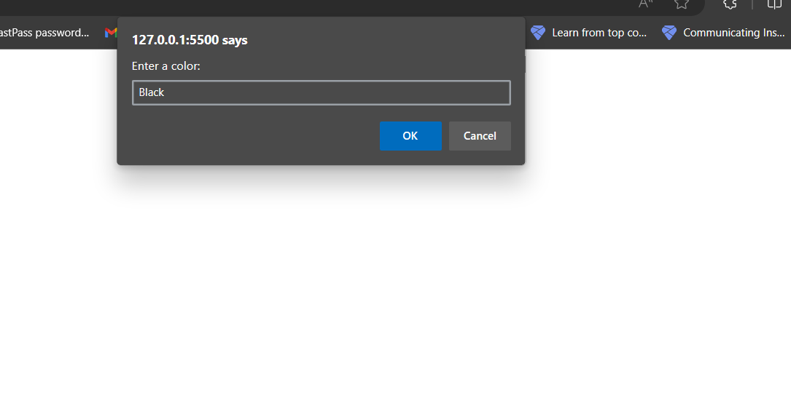

4)Declare a java script string array of colors and background color to heading from dropdown, if font color and background color is same no change should be reflected.

<!DOCTYPE html>

<html lang="en">

<head>

<meta charset="UTF-8">

<meta name="viewport" content="width=device-width, initial-scale=1.0">

<title>Font and Background Color</title>

</head>

<body>

<h1 id="heading">Heading Text</h1>

<label for="fontColor">Font Color:</label>

<input type="color" id="fontColor">

<label for="bgColor">Background Color:</label>

<input type="color" id="bgColor">

<button id="applyButton">Apply Colors</button>

<script>

const heading = document.getElementById("heading");

const fontColorInput = document.getElementById("fontColor");

const bgColorInput = document.getElementById("bgColor");

const applyButton = document.getElementById("applyButton");

applyButton.addEventListener("click", function () {

const fontColor = fontColorInput.value;

const bgColor = bgColorInput.value;

if (fontColor === bgColor) {

alert("Font color and background color are the same. No changes applied.");

} else {

heading.style.color = fontColor;

heading.style.backgroundColor = bgColor;

}

});

</script>

</body>

</html>

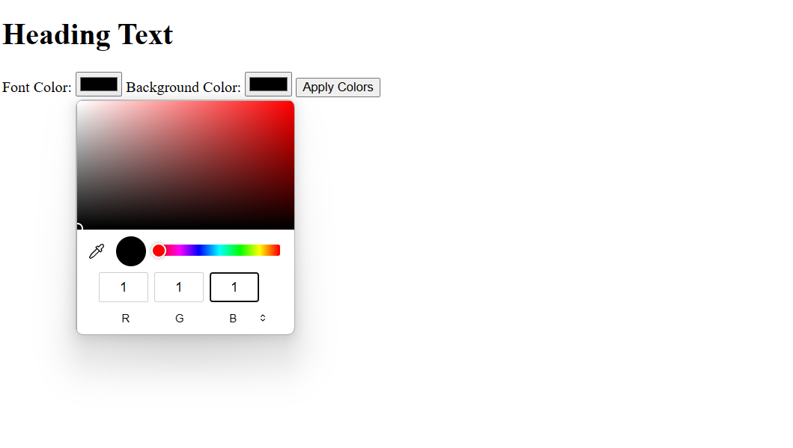

1. Create an array using java script and display the occurences of a specific character[ example; arr=[‘a,’b’,’a’,’c’,’z’] output should be occurences of a is 2]