NAME :- SIDDHI SHEWALE

ROLL NO :- 2213483

CLASS :- TY AIA-2 (Batch – B)

ASSIGNMENT-5

Q-1 Write a Javascript code to append static row to the table on click of button.

CODE :-

<!DOCTYPE html>

<html>

<head>

<title>Table Row Appender</title>

</head>

<body>

<table id="myTable">

<tr>

<th>Name</th>

<th>Age</th>

</tr>

<tr>

<td>Sejal</td>

<td>19</td>

</tr>

<!-- Additional rows will be appended here -->

</table>

<button id="addRowBtn">Add Row</button>

<script>

document.addEventListener("DOMContentLoaded", function() {

const addRowButton = document.getElementById("addRowBtn");

const table = document.getElementById("myTable");

addRowButton.addEventListener("click", function() {

const name = prompt("Enter Name:");

const age = prompt("Enter Age:");

if (name && age) {

const newRow = document.createElement("tr");

const nameCell = document.createElement("td");

const ageCell = document.createElement("td");

nameCell.textContent = name;

ageCell.textContent = age;

newRow.appendChild(nameCell);

newRow.appendChild(ageCell);

table.appendChild(newRow);

} else {

alert("Name and age are required.");

}

});

});

</script>

</body>

</html>

OUTPUT :-

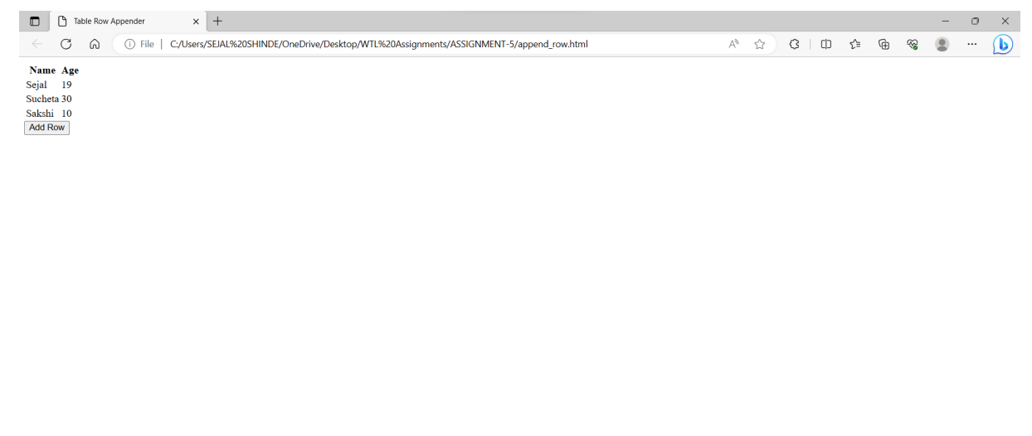

Q-2 Write a Javascript code to append anchor tag that redirects to the new page.

CODE :-

<!DOCTYPE html>

<html>

<head>

<title>Anchor Tag Appender</title>

</head>

<body>

<button id="addAnchorBtn">Add Anchor Tag</button>

<script>

document.addEventListener("DOMContentLoaded", function() {

const addAnchorButton = document.getElementById("addAnchorBtn");

addAnchorButton.addEventListener("click", function() {

const newAnchor = document.createElement("a");

newAnchor.textContent = "Click Me!";

newAnchor.href = "https://mituniversity.ac.in/";

newAnchor.target = "_blank"; // Open link in a new tab

document.body.appendChild(newAnchor);

});

});

</script>

</body>

</html>

OUTPUT :

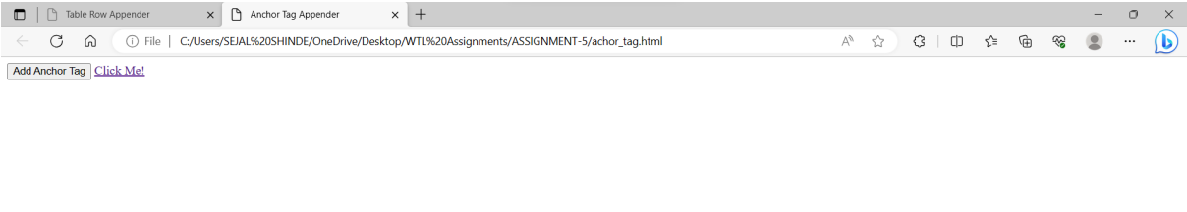question2:

<!DOCTYPE html>

<html lang="en">

<head>

<meta charset="UTF-8">

<meta name="viewport" content="width=device-width, initial-scale=1.0">

<title>Document</title>

</head>

<style>

button{

padding: 10px 20px;

font-size: 16px;

background-color: #a8aeb5;

color: white;

border: none;

cursor: pointer;

}

</style>

<body>

<button id="color_change" onclick="colochange('pink')" onmouseout="colochange('red')" onmouseover="colochange('green')"> click me</button>

<script>

function colochange(color){

document.body.style.backgroundColor=color;

}

</script>

</body>

</html>



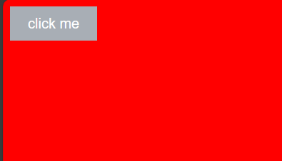

Question 3:

Q-4 Write a Javascript code to change the background color of page onclick of array elements displayed as a list.

CODE :-

<!DOCTYPE html>

<html>

<head>

<title>Background Color Changer</title>

<style>

body {

margin: 0;

padding: 0;

transition: background-color 0.5s;

}

ul {

list-style-type: none;

padding: 0;

}

li {

cursor: pointer;

padding: 10px;

border: 1px solid #ccc;

margin: 5px;

}

</style>

</head>

<body>

<ul id="colorList">

<li onclick="changeBackgroundColor('white')">White</li>

<li onclick="changeBackgroundColor('lightblue')">Light Blue</li>

<li onclick="changeBackgroundColor('lightgreen')">Light Green</li>

<li onclick="changeBackgroundColor('lightpink')">Light Pink</li>

</ul>

<script>

function changeBackgroundColor(color) {

document.body.style.backgroundColor = color;

}

</script>

</body>

</html>

OUTPUT:-

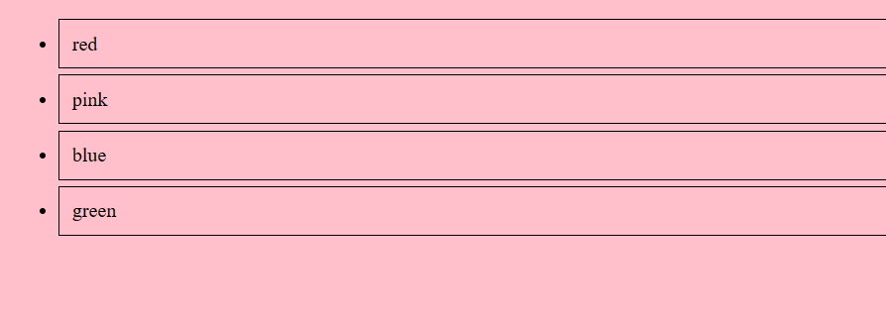

Q-5 EXTRA QUESTION – In this question I have used the concept of append row and color change of button

according to 1.Onmouseover

2.Onmouseout

3.Onclick

CODE :-

<!DOCTYPE html>

<html>

<head>

<title>Table Row Appender</title>

</head>

<body>

<table id="myTable">

<tr>

<th>Product</th>

<th>Price</th>

</tr>

<tr>

<td>Soap</td>

<td>Rs.100</td>

</tr>

<!-- Additional rows will be appended here -->

</table>

<button id="addRowBtn" onmouseover="changeButtonColor('green')" onmouseout="changeButtonColor('blue')"

onclick="addRow()">Add Row</button>

<script>

document.addEventListener("DOMContentLoaded", function() {

const addRowButton = document.getElementById("addRowBtn");

const table = document.getElementById("myTable");

addRowButton.addEventListener("click", addRow);

});

function changeButtonColor(color) {

const button = document.getElementById("addRowBtn");

button.style.backgroundColor = color;

}

function addRow() {

const name = prompt("Enter Product:");

const age = prompt("Enter Price:");

if (name && age) {

const table = document.getElementById("myTable");

const newRow = document.createElement("tr");

const productCell = document.createElement("td");

const priceCell = document.createElement("td");

productCell.textContent = product;

priceCell.textContent = price;

newRow.appendChild(productCell);

newRow.appendChild(priceCell);

table.appendChild(newRow);

} else {

alert("Product and price are required.");

}

}

function confirmAction() {

alert("Data confirmed!");

}

</script>

</body>

</html>

