**Project Title**

A Project Report

submitted in partial fulfillment of the requirements

of

AICTE Internship on AI: Transformative Learning

with

TechSaksham – A joint CSR initiative of Microsoft & SAP

by

**Name of Student, Email id**

Under the Guidance of

**Master P.Raja, Edunet Foundation**

**ACKNOWLEDGEMENT**

We would like to express our sincere gratitude to everyone who has supported us throughout the completion of this thesis.

First and foremost, we extend our heartfelt thanks to our supervisor, Master P. Raja, whose guidance, mentorship, and invaluable support have played a key role in the successful completion of this project. His insightful advice, constructive criticism, and unwavering encouragement have been a continuous source of inspiration throughout the course of this work. The trust and confidence he placed in me fueled my motivation to push forward, and it has been an honor to work under his mentorship over the past year. His assistance extended not only to the technical aspects of the project but also to various other facets of the academic program. His lessons and insightful discussions have not only enriched my knowledge and skills in this project but have also helped shape me into a more responsible and capable professional. Working with him has truly been a privilege.

#### **ABSTRACT**

The **Plant Disease Detection System for Sustainable Agriculture** is a technology-driven solution aimed at assisting farmers in identifying plant diseases effectively and reducing crop failures. In the agricultural domain, plant diseases can significantly impact crop yield, leading to economic losses and food insecurity. Traditional methods of disease identification often require expert intervention, which may not be accessible to all farmers. This project seeks to bridge that gap by providing a user-friendly web application that leverages machine learning and image processing techniques to detect plant diseases.

Farmers can interact with the system by uploading a picture of a plant leaf through the web application. The image is analyzed by a trained machine learning model capable of identifying specific plant diseases. Once the analysis is complete, the type of disease (if any) is displayed on the screen, along with actionable insights or remedies. This streamlined process ensures that farmers can make informed decisions promptly, avoiding the spread of disease and minimizing crop damage.

The project focuses on improving agricultural productivity by enabling early detection and diagnosis of plant diseases. By reducing losses associated with damaged crops, it aims to enhance yield quality and maximize profitability for farmers. Furthermore, the system contributes to sustainable agricultural practices by promoting efficient disease management without excessive dependency on chemical treatments.

Developed under the guidance of **Edunet Foundation**, the project emphasizes accessibility and ease of use, ensuring that even farmers with limited technical expertise can benefit from it. The system has the potential to be further enhanced by incorporating additional plant species, diseases, and real-time mobile integration for broader adoption.

In summary, this Plant Disease Detection System is a step toward empowering farmers with advanced tools to achieve sustainable agriculture and ensure food security, creating a positive impact on both the agricultural economy and the environment.

**TABLE OF CONTENT**

**Abstract I**

**Chapter 1.**  **Introduction 1**

1.1 Problem Statement 1

1.2 Motivation 1

1.3 Objectives 2

1.4. Scope of the Project 2

**Chapter 2.**  **Literature Survey 3**

**Chapter 3.**  **Proposed Methodology**

**Chapter 4.**  **Implementation and Results**

**Chapter 5. Discussion and Conclusion**

**References**

**LIST OF FIGURES**

|  |  |  |
| --- | --- | --- |
| **Figure No.** | **Figure Caption** | **Page No.** |
|  |  |  |
|  |  |  |
|  |  |  |
|  |  |  |
|  |  |  |
|  |  |  |
|  |  |  |
|  |  |  |
|  |  |  |

**LIST OF TABLES**

|  |  |  |
| --- | --- | --- |
| **Table. No.** | **Table Caption** | **Page No.** |
|  |  |  |
|  |  |  |
|  |  |  |
|  |  |  |
|  |  |  |
|  |  |  |
|  |  |  |
|  |  |  |
|  |  |  |

**CHAPTER 1**

**Introduction**

**1.1Problem Statement:**

Plant Disease Detection system focuses at predicting the type of disease that a particular plant has depending upon the image of the plant leaf.

**1.2Motivation:**

Looking at the crop failure which farmers have to face because of damaged crops and the losses they have to face, this idea was chosen to help the farmers**.**

**1.3Objective:**

Objective of this project is to help farmers have a successful yield by predicting the crop disease so that they could take relevant actions regarding the same.

**1.4Scope of the Project:**

• **Disease Identification**: The project focuses on detecting and identifying specific plant diseases through image analysis.

• **Preventive Measures**: By providing early detection, the system can help prevent the spread of diseases, reducing crop damage.

• **Increased Productivity**: Aims to assist farmers in maintaining healthy crops, leading to better yields and higher profits.

**CHAPTER 2**

**Literature Survey**

* 1. **Review relevant literature or previous work in this domain.**

1. Chohan, Murk, et al. "Plant disease detection using deep learning." *International Journal of Recent Technology and Engineering* 9.1 (2020): 909-914.
2. Ramesh, Shima, et al. "Plant disease detection using machine learning." *2018 International conference on design innovations for 3Cs compute communicate control (ICDI3C)*. IEEE, 2018.
3. Chowdhury, Muhammad EH, et al. "Automatic and reliable leaf disease detection using deep learning techniques." *AgriEngineering* 3.2 (2021): 294-312.
4. Harakannanavar, Sunil S., et al. "Plant leaf disease detection using computer vision and machine learning algorithms." *Global Transitions Proceedings* 3.1 (2022): 305-310.
5. Ahmad, Aanis, Dharmendra Saraswat, and Aly El Gamal. "A survey on using deep learning techniques for plant disease diagnosis and recommendations for development of appropriate tools." *Smart Agricultural Technology* 3 (2023): 100083.
6. Kulkarni, Priyanka, and Swaroopa Shastri. "Rice leaf diseases detection using machine learning." *Journal of Scientific Research and Technology* (2024): 17-22.
   1. **Mention any existing models, techniques, or methodologies related to the problem.**
7. **Convolution Nerural Networks** are widely used to address this problem. CNNs can be trained on large datasets of labeled plant images to detect different types of plant diseases.
8. **Transfer Learning** reduces the need for large amounts of labeled data and improves model accuracy by leveraging previously learned features.
9. **K-NN** is another traditional classification technique used in plant disease detection. It works by finding the **k-nearest neighbors** to a given data point and classifying the point based on the majority class of the neighbors.After extracting features like color and texture from plant leaf images, K-NN is used to classify the disease.
   1. **Highlight the gaps or limitations in existing solutions and how your project will address them.**

This plant disease detection system could have limitations when it comes to a variety of species of other crops. Also, sometimes the input image may be blur which could impact the correct prediction of the disease.

The proposed solution for this project can have better advancements such as incorporating more species of plant which can be done by enhancing the quality of the dataset. Image preprocessing could also be used to enhance the quality of the input image which will allow the model to provide more accurate results.

**CHAPTER 3**

**Proposed Methodology**

* 1. **System Design**

**1. Input Layer (Frontend):**

**User Interaction**:

Farmers or users upload an image of a plant leaf via the web application interface. Web interface built using **Streamlit** or another framework for simplicity and interactivity.

**Preprocessing**:

Client-side image validation to ensure the image meets quality standards (e.g., resolution, format).

**2. Processing Layer (Backend):**

* **Image Processing**:
  + Preprocessing techniques (e.g., resizing, normalization) are applied to the image to ensure it is compatible with the machine learning model.
* **Machine Learning Model**:
  + A **Convolutional Neural Network (CNN)** model trained on labeled plant disease datasets.
  + The model predicts the presence of a disease and classifies it into one of the predefined categories.
* **Decision Logic**:
  + The backend processes the model's output and maps it to a user-friendly diagnosis.

**3. Data Storage Layer:**

* **Model Storage**:
  + Store the trained machine learning model in a serialized format (e.g., TensorFlow SavedModel, PyTorch .pt file).

3.2**Requirement Specification**

* + 1. **Hardware Requirements :** None
    2. **Software Requirements:** Tensorflow, keras, numpy, pandas, seaborn, streamlit, jupyter notebooks

**CHAPTER 4**

**Implementation and Result**

* 1. **Snap Shots of Result:**

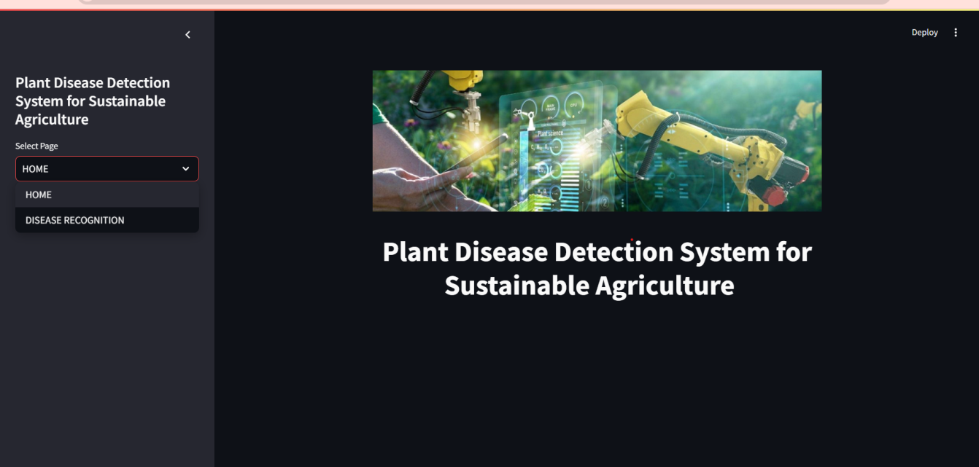

1. This is the homepage of our web application which is built using streamlit as the framework.

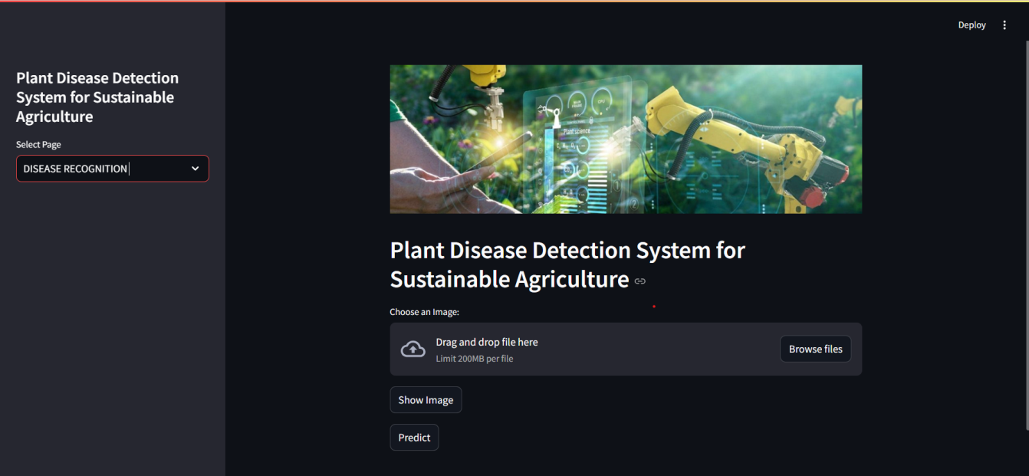

1. Here, using the sidebar, we have navigated to the disease recognition page. It prompts the user to input the image of the leaf using browse files option.

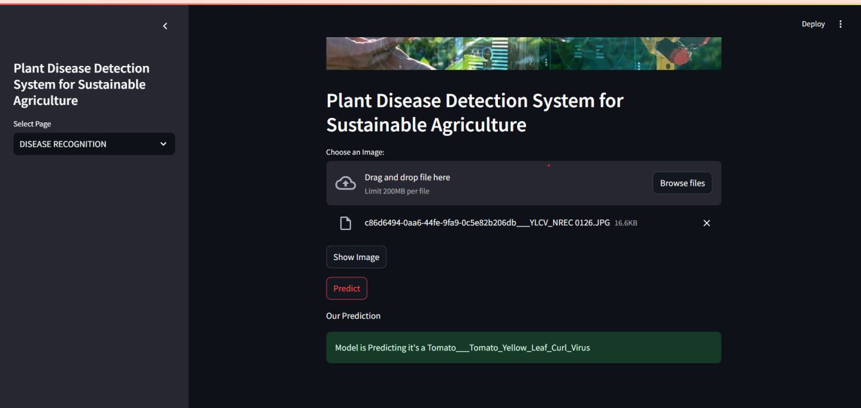

1. Here, once the user has provided an input image to the model, we click on the predict option. The model then predicts the type of disease that can be seen from the input image that the user has provided.
   1. **GitHub Link for Code:**

https://github.com/Siddhi292005/AICTE_project/tree/main

**CHAPTER 5**

**Discussion and Conclusion**

* 1. **Future Work:**

#### 1. **Expanding the Disease Detection Database**

Currently, the model is likely trained on a limited set of plant species and diseases. Expanding the database to include a wider variety of plants and diseases is essential for making the system more comprehensive. This can involve:

* **Adding new plant species**: Incorporating a broader range of agricultural crops will make the system applicable to a wider audience.
* **Incorporating more diseases**: Adding more disease types and their various stages will allow for better classification and prevention strategies.

#### 2. **Improving Model Accuracy and Robustness**

While deep learning models have shown high accuracy, there is always room for improvement in terms of handling:

* **Varied environmental conditions**: Images captured under different lighting conditions, from varying angles, or with partial obstructions may reduce the model's effectiveness. Future work could focus on **data augmentation** and improving the model’s robustness to these variables.
* **Model performance**: Further tuning of model parameters, experimenting with newer neural network architectures (e.g., **DenseNet**, **EfficientNet**), and applying **ensemble methods** can help improve model performance.

#### 3. **Real-Time Disease Detection Using IoT**

Integrating **Internet of Things (IoT)** devices into the system can provide real-time environmental monitoring data such as temperature, humidity, and soil moisture. This can enhance the prediction accuracy and provide early warnings to farmers about potential disease outbreaks due to environmental conditions.

* **Smartphone Integration**: Leveraging smartphone sensors to gather additional data and making the system mobile-friendly for easier use in the field.
* **Real-Time Image Processing**: Exploring edge computing solutions like **Raspberry Pi** or other IoT platforms for real-time image processing could help reduce the reliance on cloud-based solutions, especially in remote areas with poor internet connectivity.
  1. **Conclusion:**

The Plant Disease Detection System for Sustainable Agriculture is an innovative approach that leverages cutting-edge machine learning and computer vision techniques to assist farmers in identifying plant diseases early and accurately. By providing a simple, user-friendly interface where farmers can upload images of their plant leaves, the system utilizes a trained deep learning model to diagnose the plant’s health status. This timely diagnosis empowers farmers to take appropriate action, preventing crop losses and ensuring better yield quality.

Through this project, we have demonstrated the significant potential of artificial intelligence and machine learning in modern agriculture. The system's ability to classify various plant diseases with high accuracy can lead to more informed decisions regarding pest control and disease management, ultimately contributing to higher productivity and profitability for farmers.

The project showcases the importance of integrating technology into agriculture to promote sustainability. By preventing the spread of diseases and reducing the reliance on chemical pesticides, the system not only improves the economic well-being of farmers but also supports environmentally friendly practices.

However, there are still challenges to overcome, such as improving model robustness in diverse field conditions, increasing the dataset diversity, and integrating the system with real-time environmental monitoring tools like IoT sensors and drones. Future enhancements could involve expanding the system's capabilities to handle additional plant species, incorporating disease severity analysis, and exploring edge computing for real-time processing in resource-limited environments.

In conclusion, this plant disease detection system represents a crucial step toward empowering farmers with the tools and knowledge necessary to mitigate the risks associated with plant diseases. With continuous advancements in machine learning, this system can become an indispensable part of smart agriculture solutions, driving a future where technology and agriculture work hand-in-hand for a sustainable and prosperous farming ecosystem.

**REFERENCES**

1. Ming-Hsuan Yang, David J. Kriegman, Narendra Ahuja, “Detecting Faces in Images: A Survey”, IEEE Transactions on Pattern Analysis and Machine Intelligence, Volume. 24, No. 1, 2002.