Semester | B.E. Semester VII – Computer Engineering
Subject | Programming with R Lab
Subject In-charge | Dr. Sanjeev Dwivedi

Student Name | Siddhi Gawade
Roll Number | 24102A2001
Grade and Subject
Teacher’s Signature

Experiment Number | 01
Experiment Title | Problem Statement 1
Resources / Apparatus Required | Hardware:  Computer system | Software:  R Studio
Theory | An environmental monitoring agency collects hourly air-quality and weather readings from different monitoring stations. Due to sensor failure, temporary network interruption, equipment maintenance, and data-entry problems, some pollutant and weather readings are unavailable or invalid.  Before the dataset can be used for pollution analysis, the agency needs an R program that can:  • Identify missing and undefined values.  • Differentiate between NA, NULL, and NaN.  • Summarize missing values in selected variables.  • Replace missing numerical values using suitable methods.  • Replace missing categorical values.  • Handle errors without terminating the complete program.  • Export a cleaned dataset for further analysis.  Develop an R program to clean the air-quality dataset using loops, user-defined functions, and error-handling mechanisms.
GitHub Repository Link | https://github.com/SiddhiGawade/R-programming.git
Program & Output | 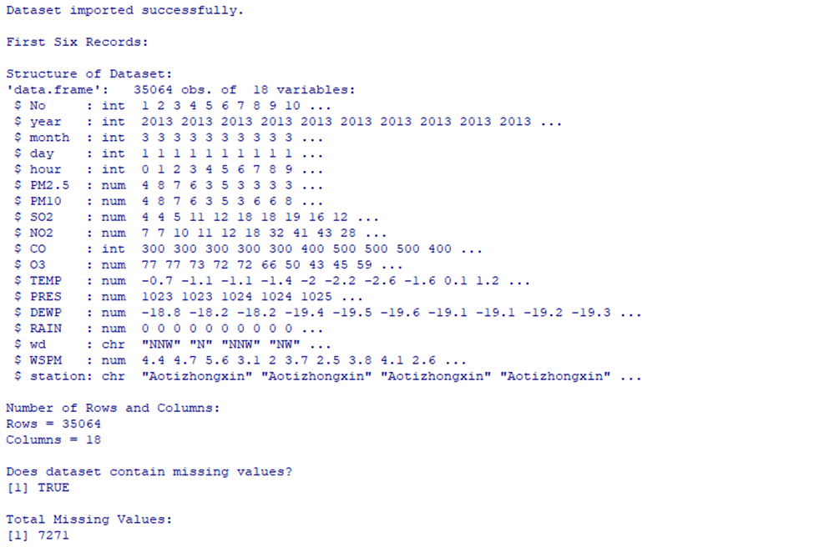  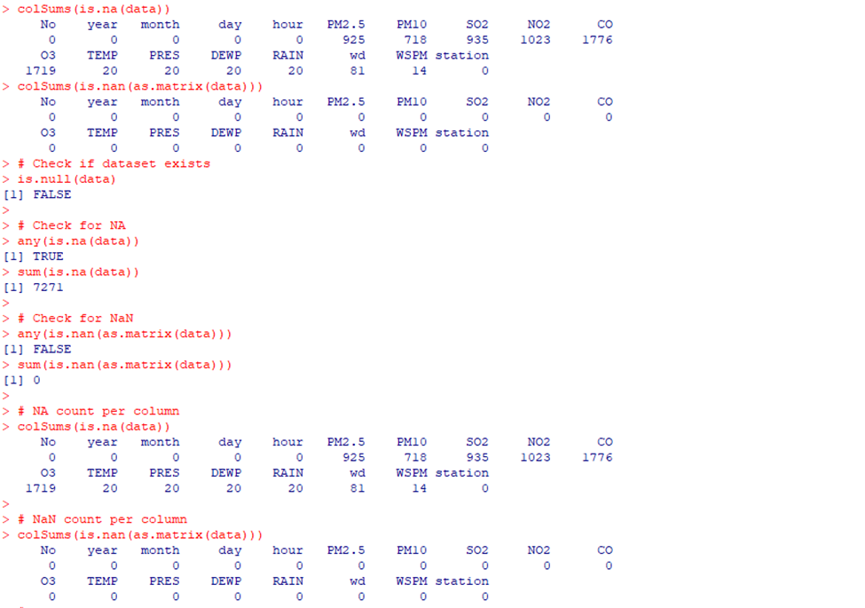  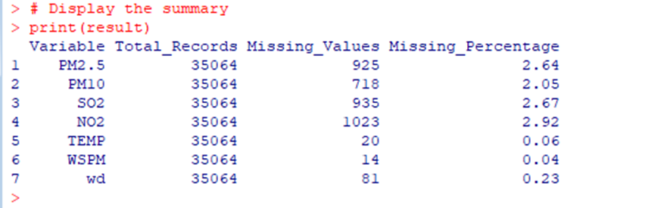  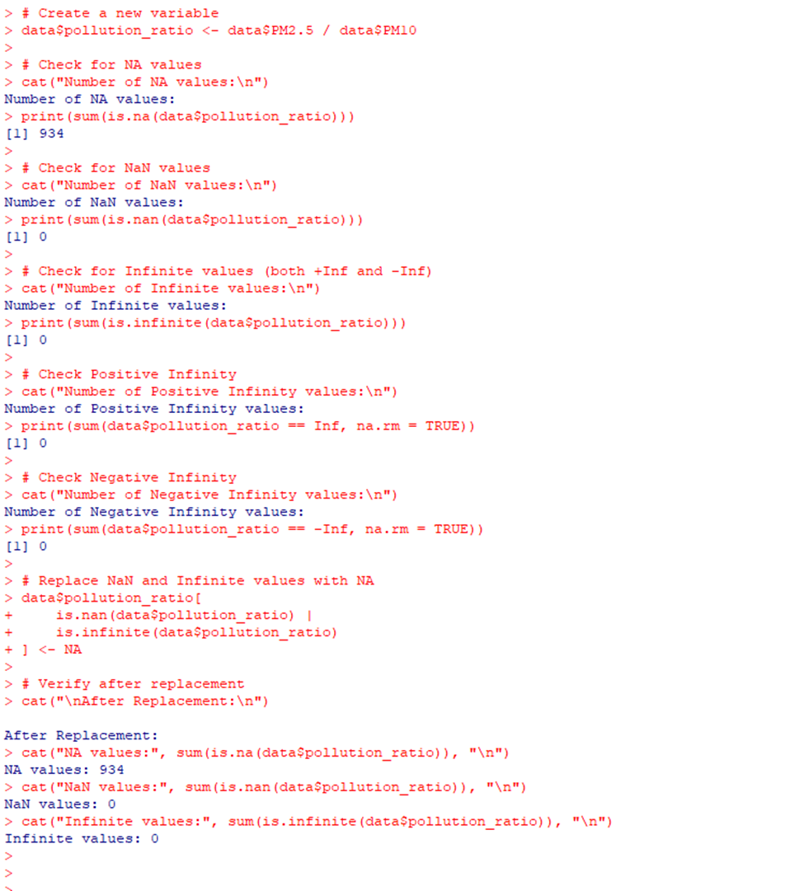  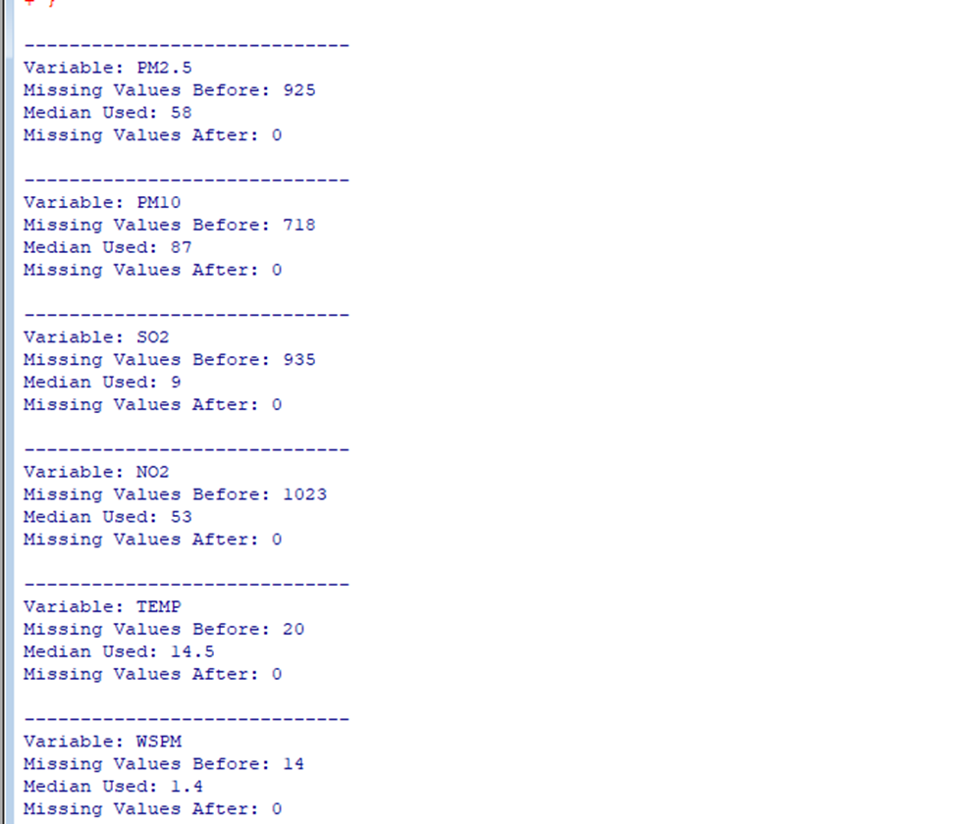  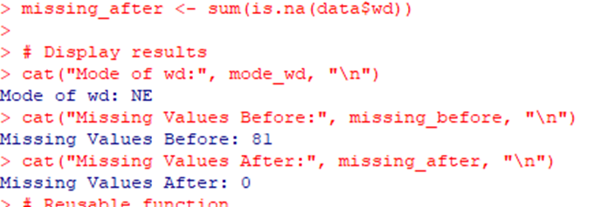  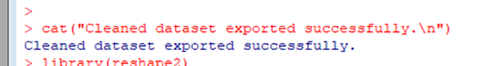  NA / NULL / NaN  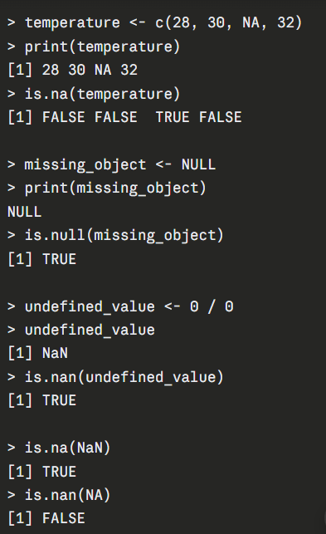  clean_variable()  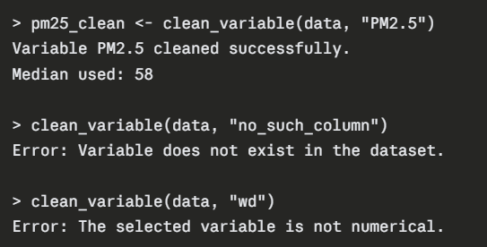  Comparison table  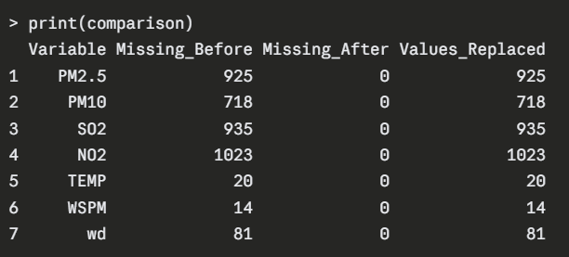  Chart  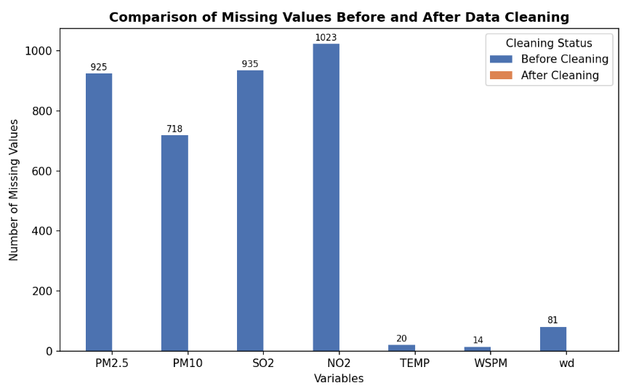
Conclusion: | The R program successfully cleaned the Beijing Aotizhongxin air-quality dataset consisting of 35,064 hourly records across 18 variables. Initial inspection revealed 7,271 missing values distributed across multiple columns, with PM2.5 (925), NO2 (1,023), SO2 (935), and PM10 (718) showing the highest counts. Numerical variables were imputed using the median (e.g., PM2.5 → 58, TEMP → 14.5, WSPM → 1.4), while the categorical variable wd was imputed using its mode ("NE"), reducing all missing counts to zero. The derived pollution_ratio variable initially contained 934 NA values from PM10 divisions but no NaN or infinite results, confirming clean numeric handling. The clean_variable() and tryCatch() mechanisms ensured errors from missing, non-numeric, or invalid columns were handled gracefully without halting execution. The final dataset was exported successfully as cleaned_air_quality_data.csv, confirming that all missing numerical and categorical values were identified, treated, and validated as per the assignment requirements.

