Semester | B.E. Semester VII – Computer Engineering
Subject | Programming with R Lab
Subject In-charge | Dr. Sanjeev Dwivedi

Student Name | Siddhi Gawade
Roll Number | 24102A2001
Grade and Subject
Teacher’s Signature

Experiment Number | 04
Experiment Title | Problem Statement 4
Resources / Apparatus Required | Hardware:  Computer system | Software:  R Studio
Theory | Image classification is a computer vision technique used to assign an image to one of the predefined classes. In this practical, R programming is used along with EBImage for image processing and Keras for deep learning.  EBImage is a Bioconductor package used for reading, processing, manipulating, and displaying images. It represents an image as a multidimensional array containing pixel intensity values. These pixel values are used as input to a machine learning or deep learning model.  Keras is a high-level deep learning framework used to build and train neural network models. It provides functions for preprocessing data, creating neural network architectures, training models, and making predictions.  In this practical, the images are divided into training and testing data. The images are loaded using readImage() from EBImage and combined into suitable arrays using operations such as rbind(). The corresponding class labels are represented numerically, for example:  - 0 → Class A  - 1 → Class C  Since neural networks work better with numerical class representations, one-hot encoding is applied to the class labels. For two classes, the labels can be represented as:  - Class 0 → [1, 0]  - Class 1 → [0, 1]  The to_categorical() function is used for this conversion.  The general workflow of the practical is:  Image Dataset → Image Loading → Image Representation → Training/Test Split → Label Encoding → Keras Model → Training → Prediction → Evaluation  Image classification using CNNs generally involves convolutional layers to extract features such as edges, shapes, textures, and patterns, followed by fully connected layers that use these features to classify the image into the appropriate category.
GitHub Repository Link | https://github.com/SiddhiGawade/R-programming.git
Program & Output | 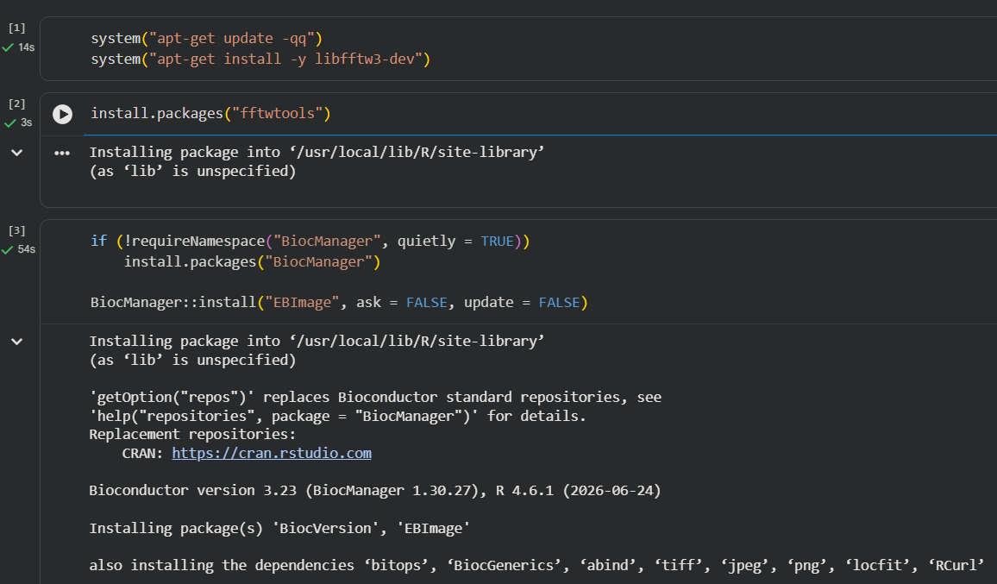  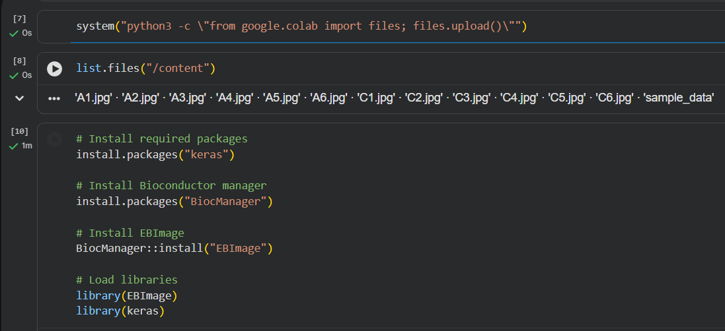  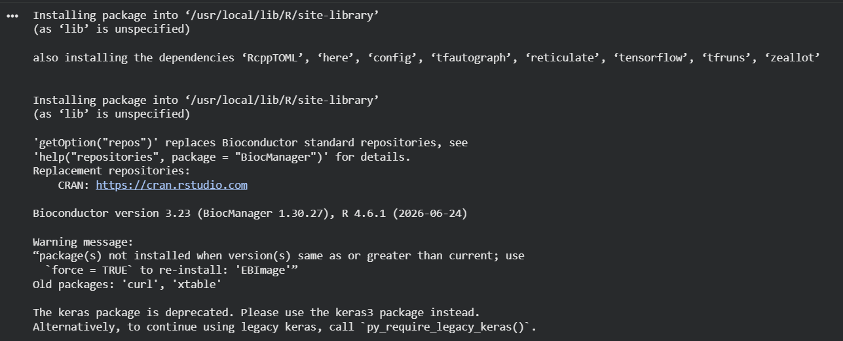  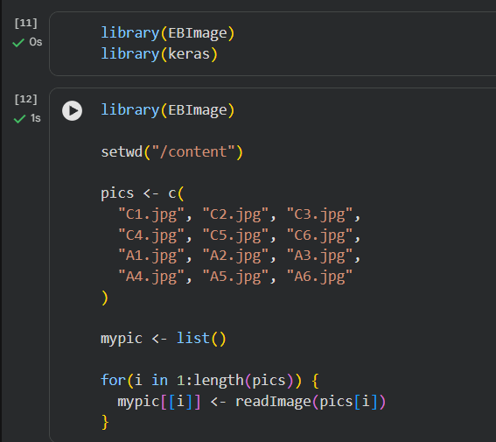  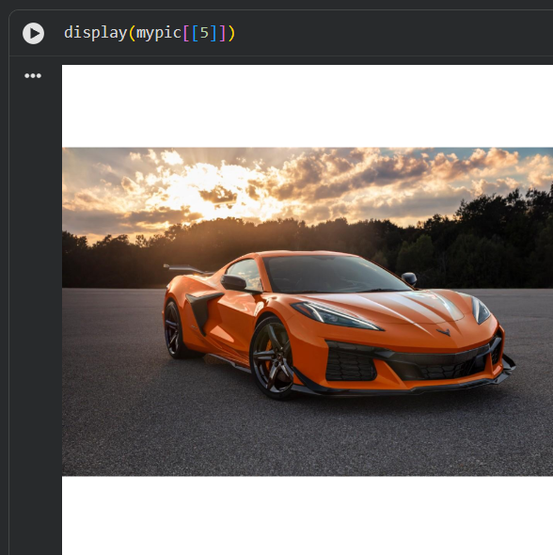  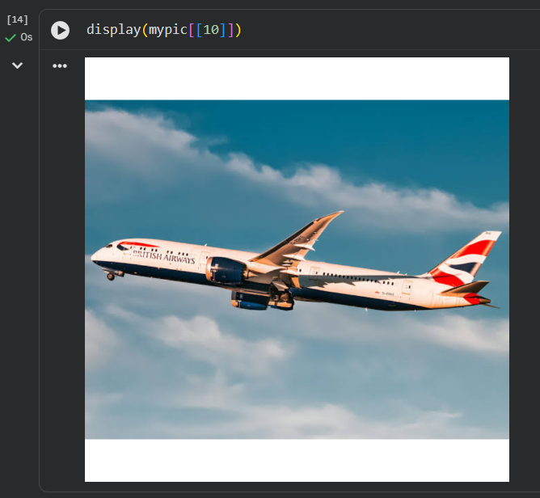  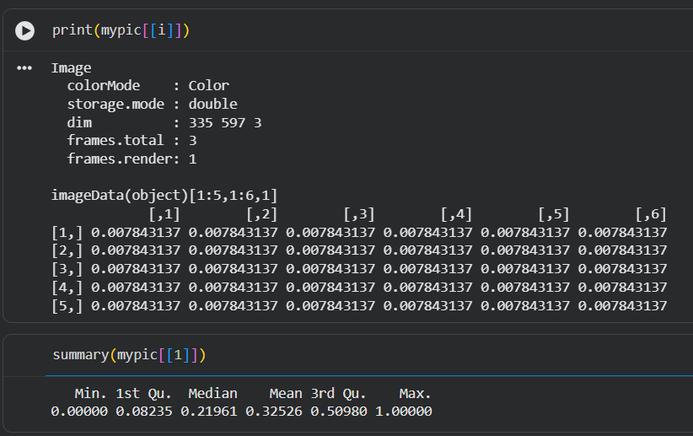  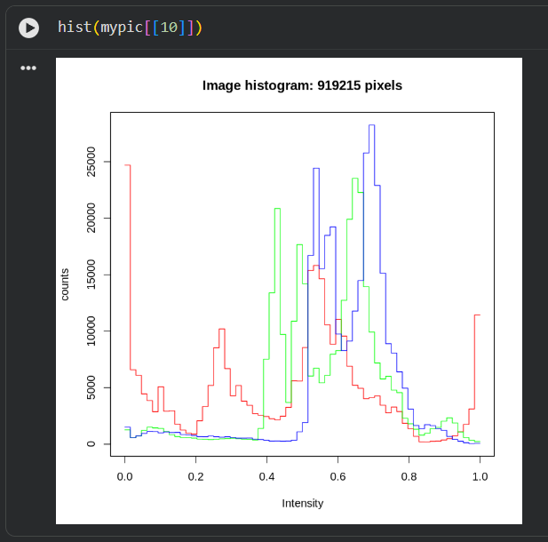  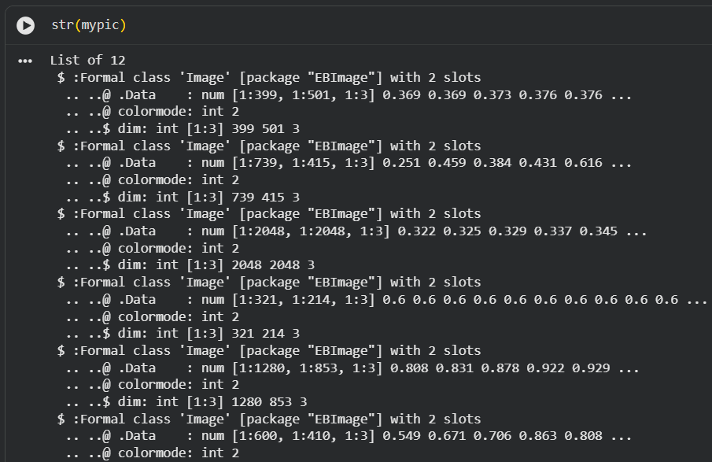  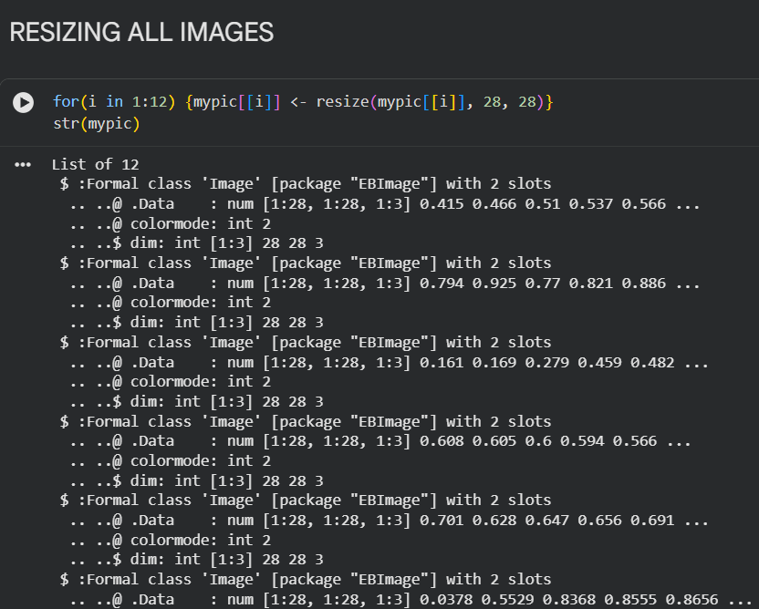  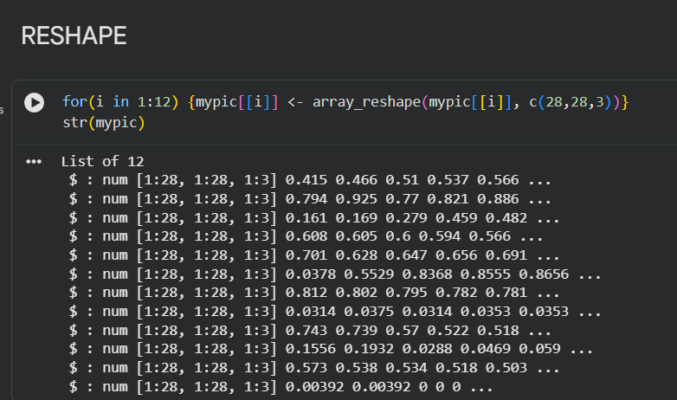  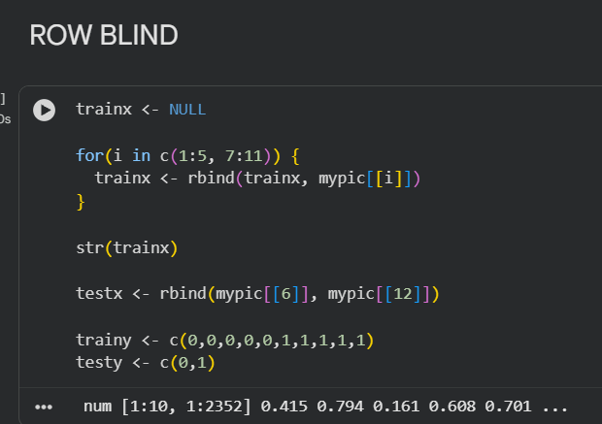  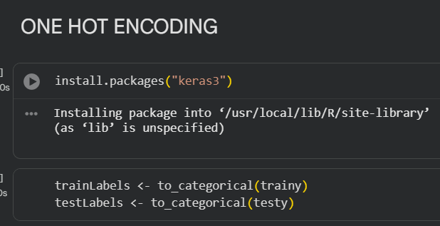  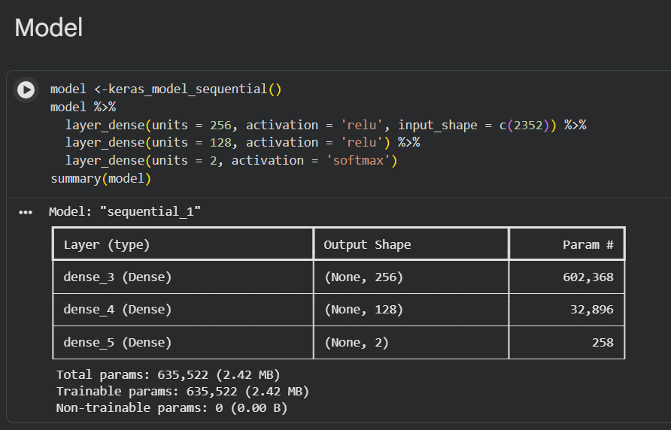  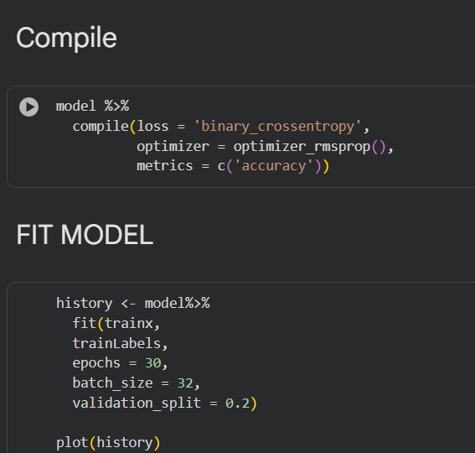  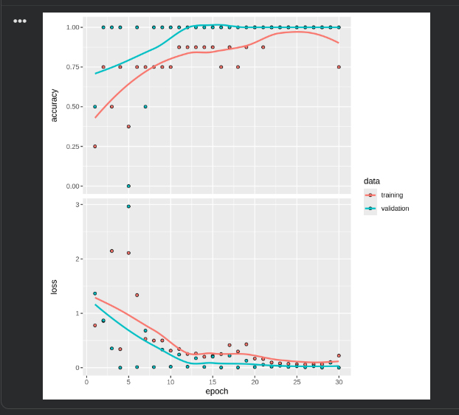  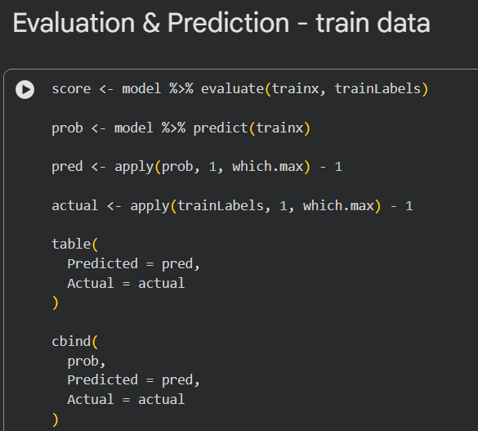  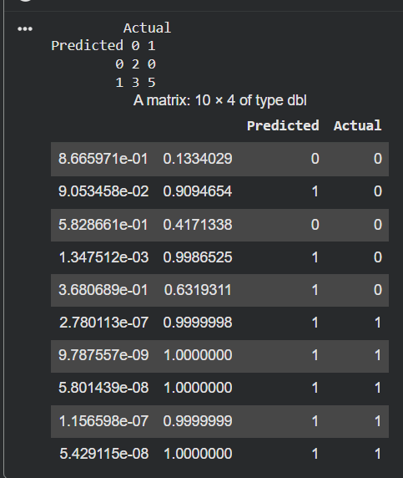  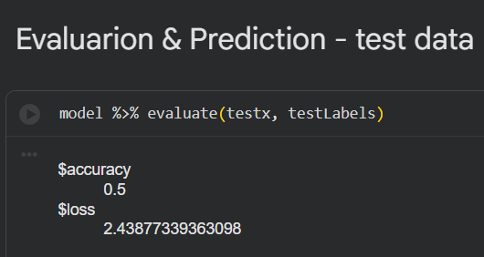
Conclusion: | Thus, the practical demonstrated the basic procedure for image classification using R, EBImage, and Keras. The images were successfully loaded and represented as numerical pixel data using EBImage. The dataset was divided into training and testing sets, and the corresponding class labels were converted into numerical and one-hot encoded form.  Keras provides an effective framework for building and training deep learning models for image classification. This practical helps in understanding the complete workflow from image preprocessing and label encoding to deep learning-based classification, which can be applied to various real-world computer vision applications.

