Semester | B.E. Semester VII – Computer Engineering
Subject | Programming with R Lab
Subject In-charge | Dr. Sanjeev Dwivedi

Student Name | Siddhi Gawade
Roll Number | 24102A2001
Grade and Subject
Teacher’s Signature

Experiment Number | 02
Experiment Title | Problem Statement 2
Resources / Apparatus Required | Hardware:  Computer system | Software:  R Studio
Theory | Data cleaning is an important step in data analysis because real-world datasets can contain missing, invalid, and extreme values. In this practical, R programming techniques such as functions, conditional statements, loops, vectorized operations, error handling, and missing-value detection are used to clean and validate healthcare and demographic datasets. Missing and invalid values are identified using functions such as is.na(), is.nan(), and is.null(), while suitable methods such as median imputation and replacement of invalid values are applied to prepare the data for further analysis.
GitHub Repository Link | https://github.com/SiddhiGawade/R-programming.git
Program & Output | 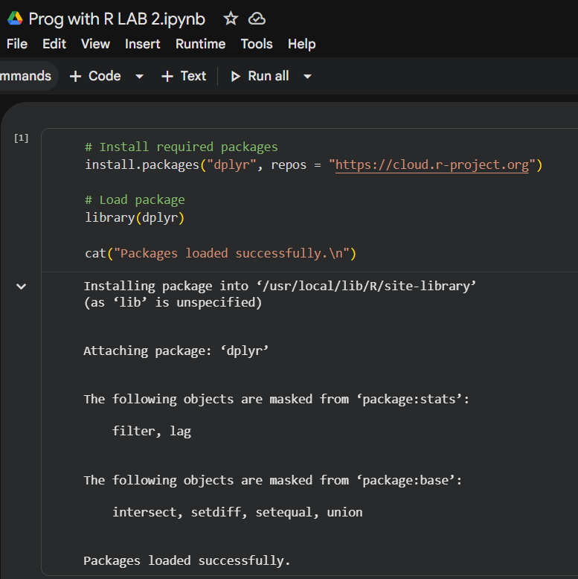  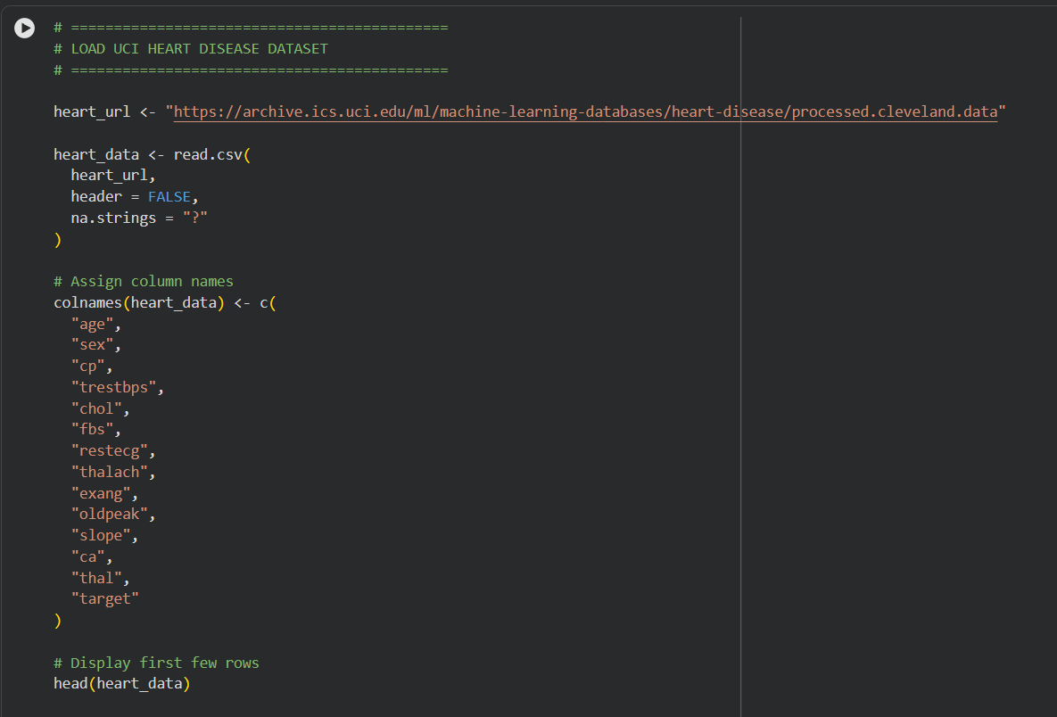  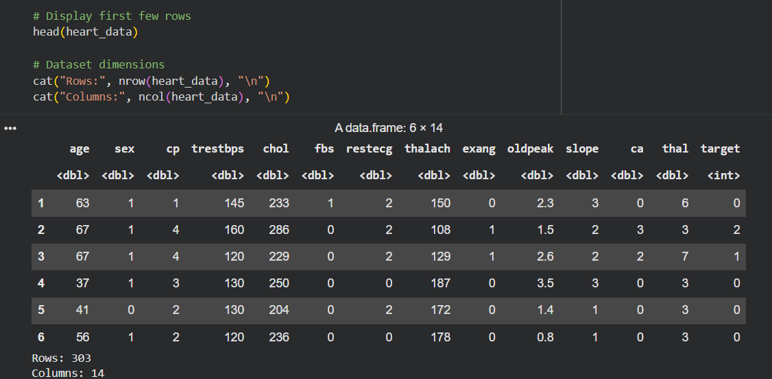  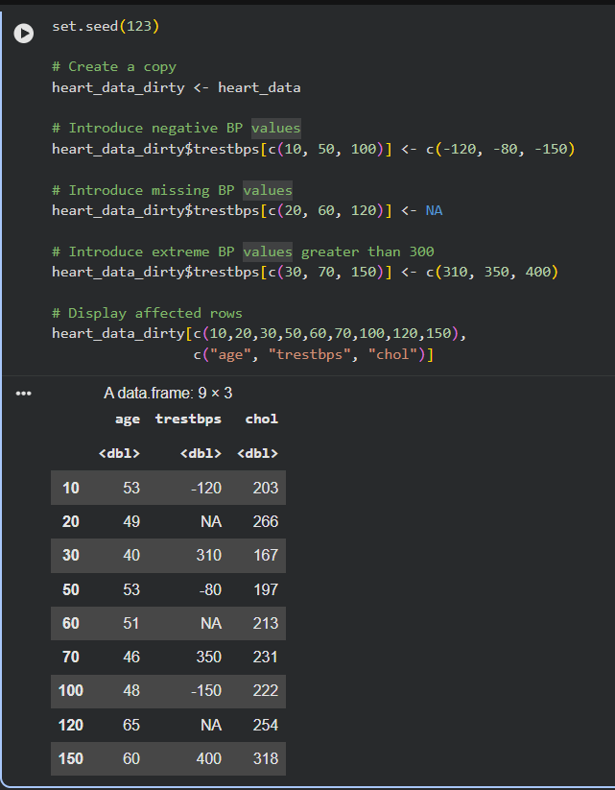  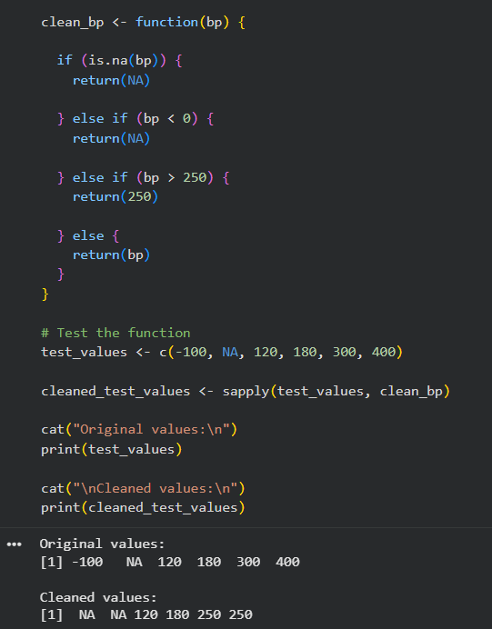  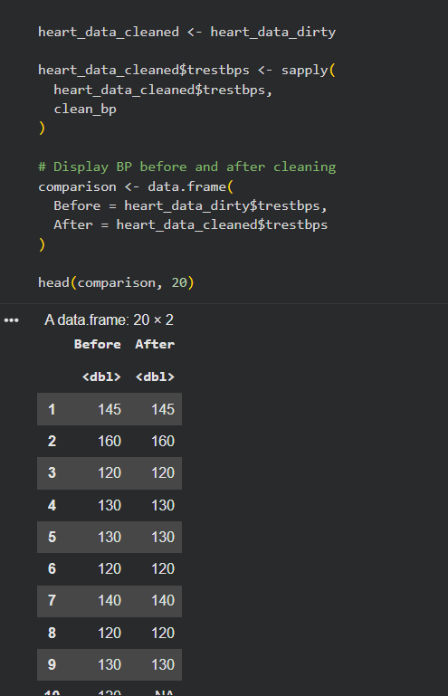  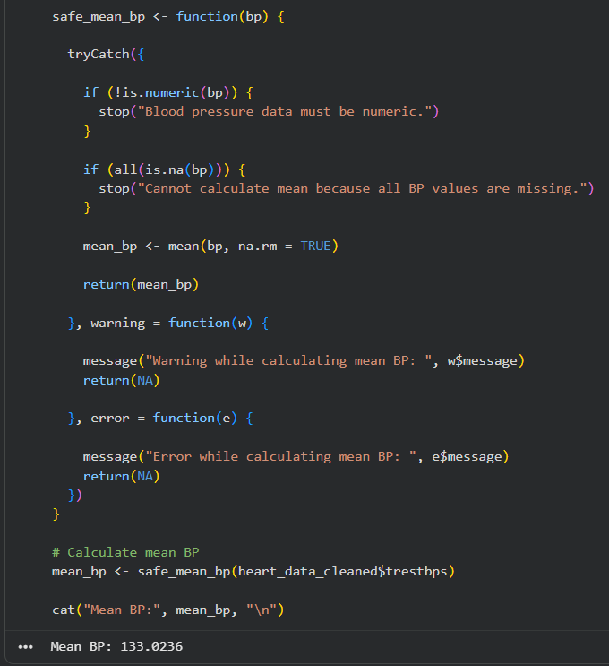  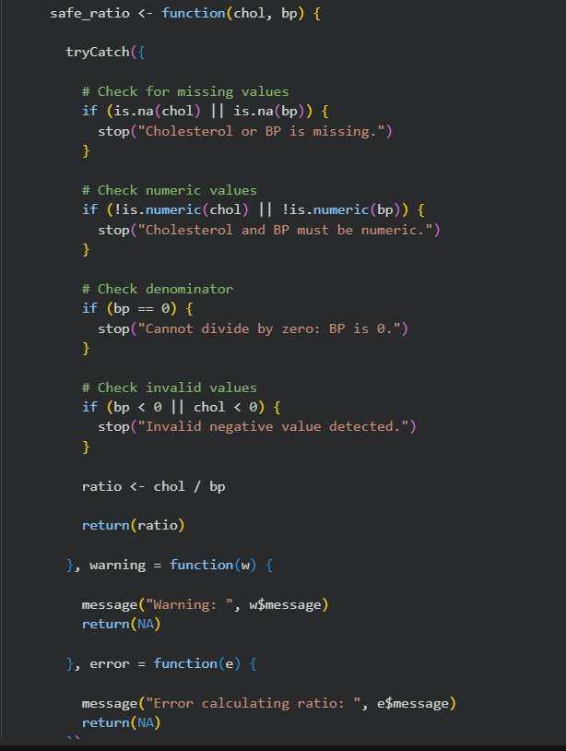  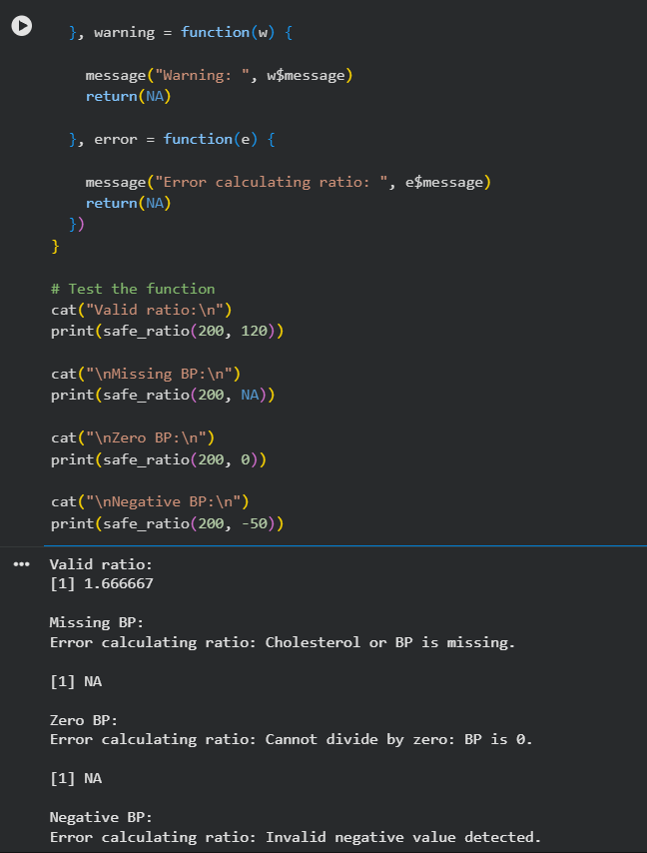  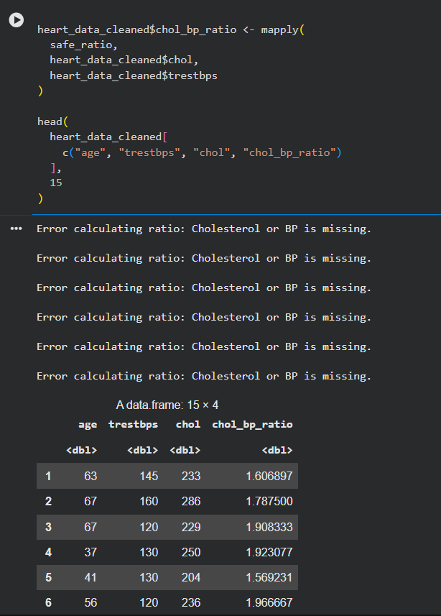  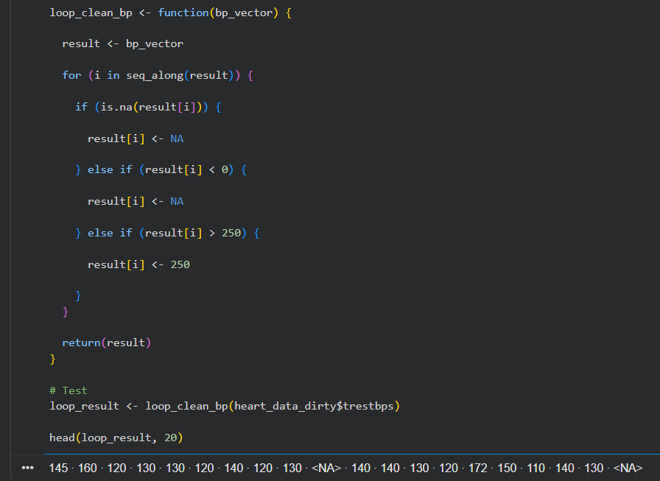  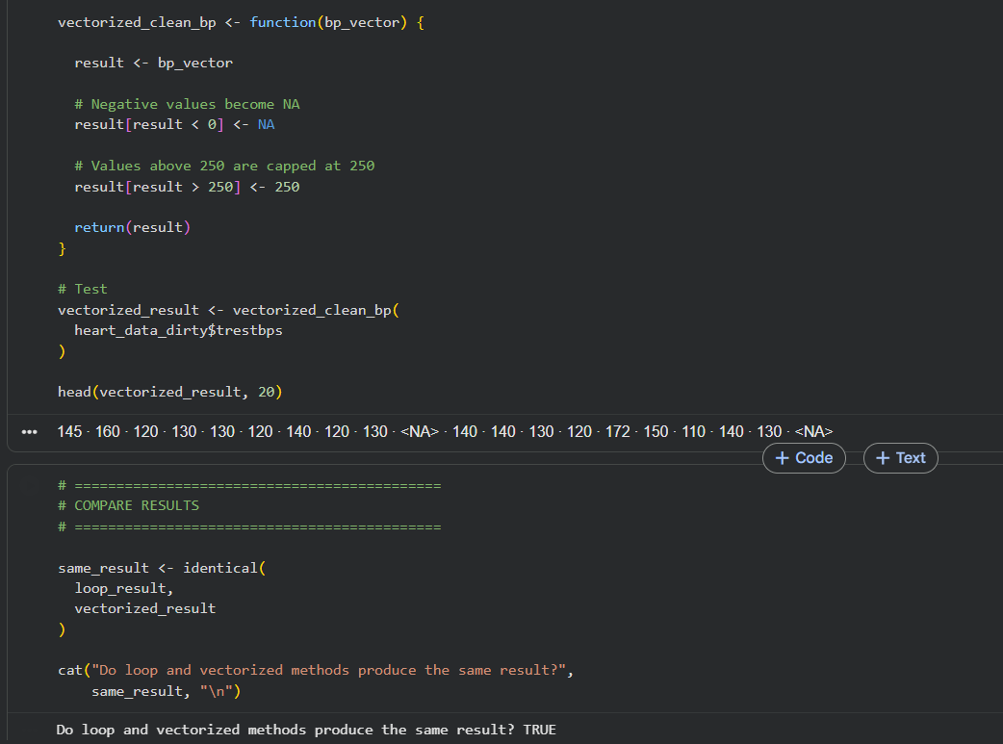  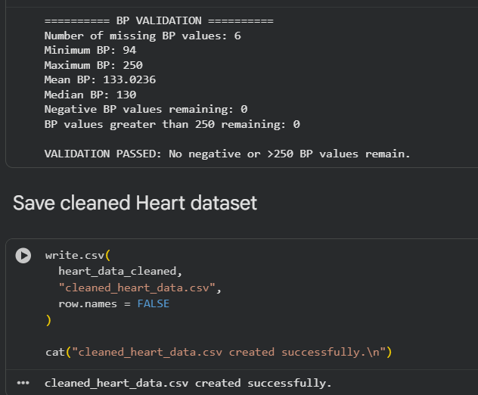  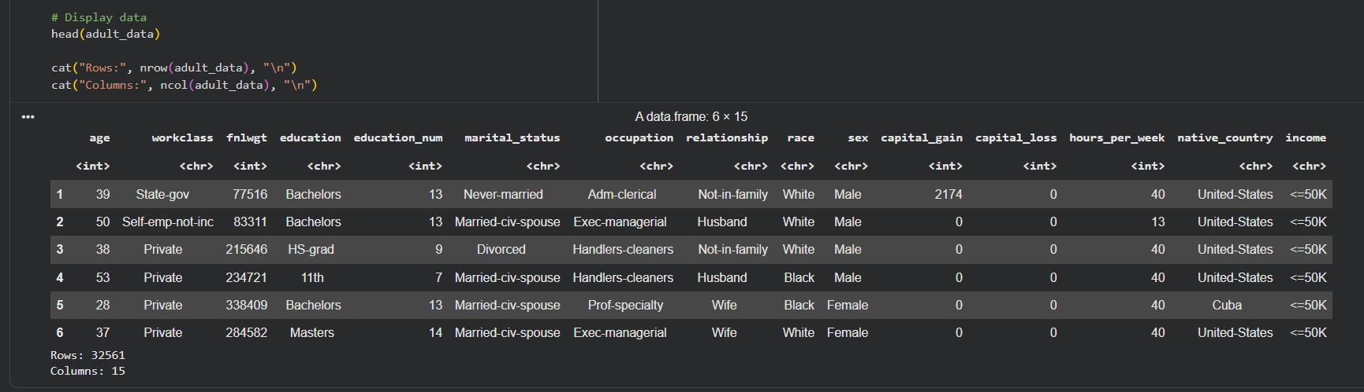  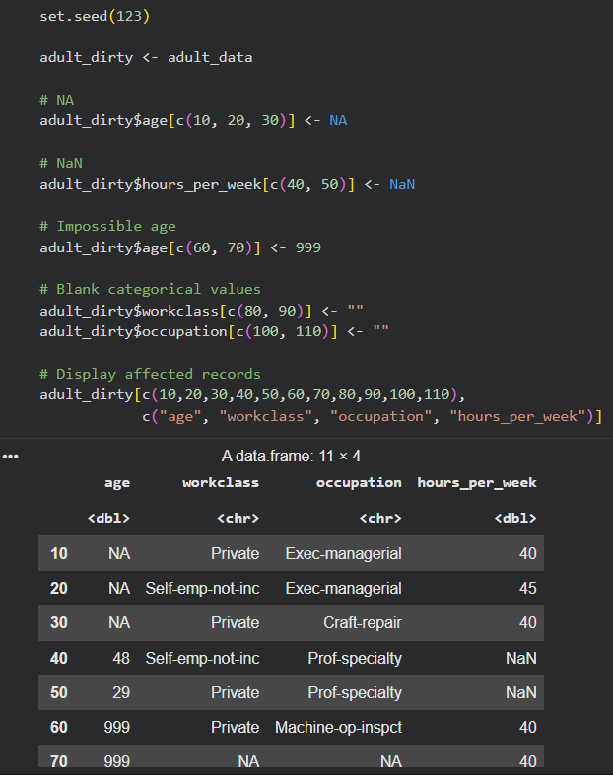  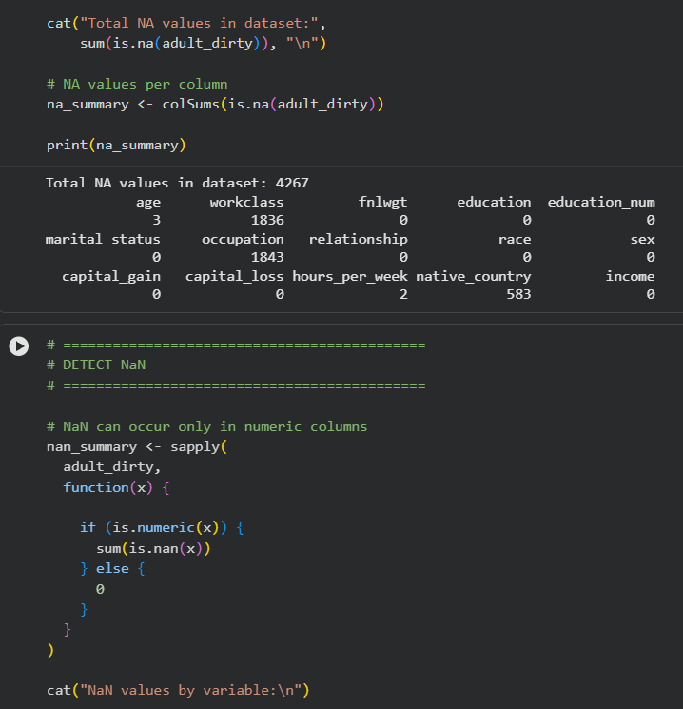  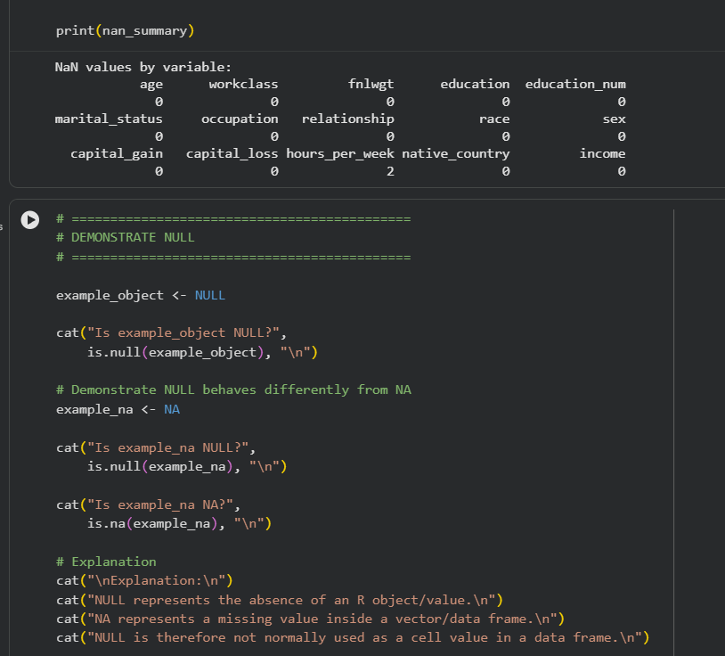  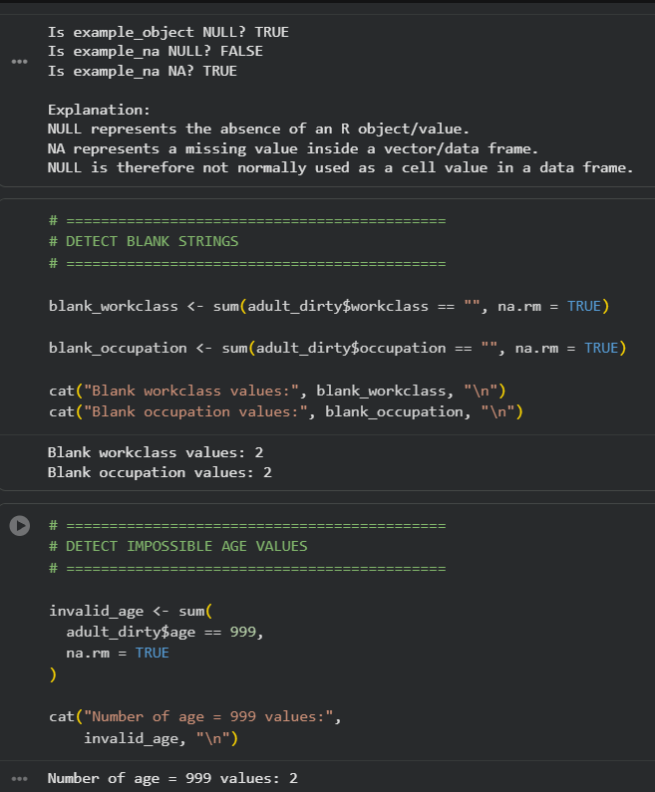  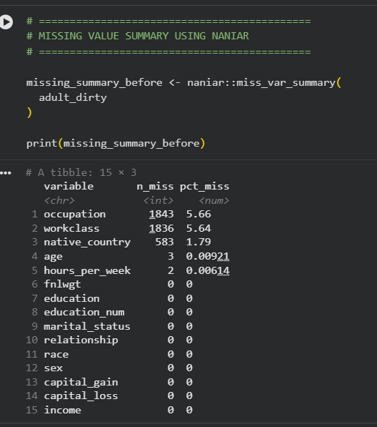  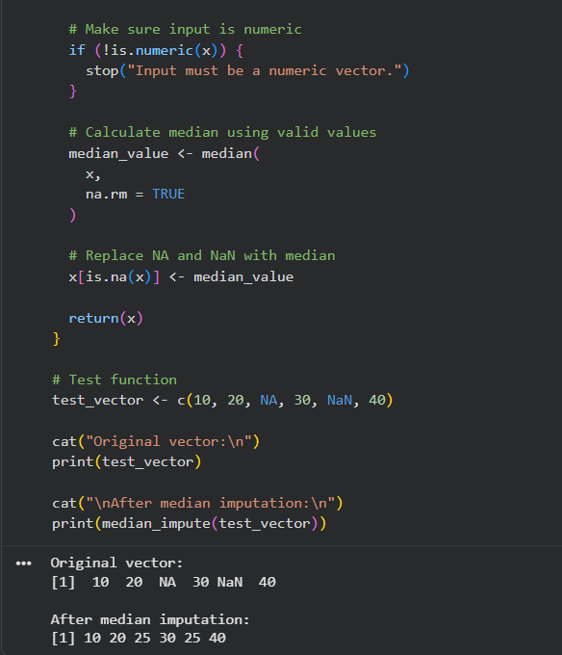  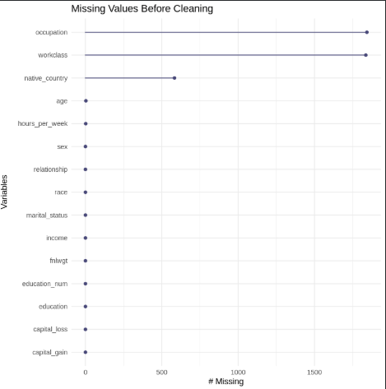  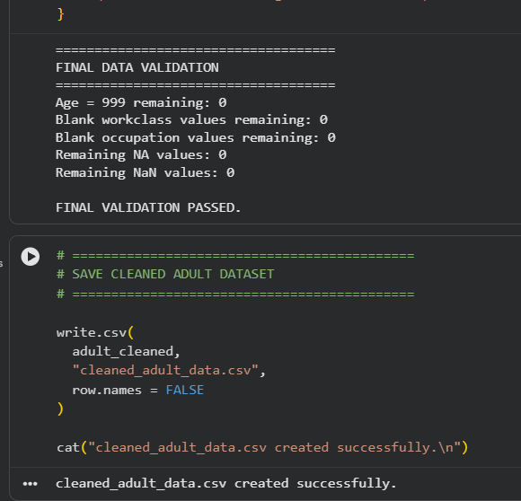
Conclusion: | The practical successfully demonstrated the use of R for data cleaning, missing-value handling, error handling, and data validation. Invalid and missing values were identified and treated using appropriate techniques, and loop-based and vectorized approaches were compared for efficiency. The cleaned datasets were validated using summary and missingness-analysis functions, providing datasets suitable for further statistical or analytical work.

